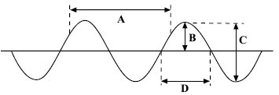**A. Waves in air, fluids and solids**

1. Look at the following wave
   1. What type of wave is shown above?
   2. Which letter represents the amplitude of the wave?
   3. Which letter shows the wavelength?
2. Draw a longitudinal wave and label a compression, rarefaction and the wavelength.
3. The diagram shows a cork floating on a water wave which has a frequency of 0.5 Hz. Which letter shows where the cork will be 2 seconds later?

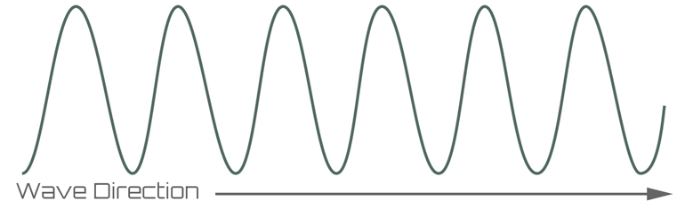

D

A

C

B

1. What is meant by the period of a wave?
2. A wave has a period of 0.25s. Calculate the frequency of this wave. T = 1 / f
3. A sound wave has a frequency of 240Hz and a wavelength of 1.38m. Calculate the velocity of this sound wave. Show clearly the formula you use for this calculation.
4. The diagram shows a ripple tank, used to generate waves in the laboratory. Describe the measurements that must be made in order to calculate the velocity of water waves in the tank.

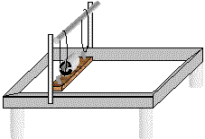

1. (Physics HT only) The sound waves from a noisy jet travel from the air into water. Which property of the wave will not change?
2. (Physics HT only) The Eiffel Tower is made of iron. The speed of sound in iron is 4000m/s. Someone at the top hits the iron with a hammer and the sound can be heard at the bottom 0.08s later. How tall is the Eiffel Tower?
3. (Physics only) The diagram shows a light ray striking a plane mirror. Copy and complete the diagram (include all labels).

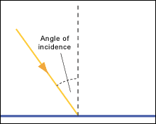

1. (Physics only) When light strikes a black curtain, very little light gets reflected. What happens to the light?
2. (Physics only) Explain why you cannot see your reflection when you look into a piece of white plastic held in front of you.
3. (Physics only) When waves flow from deep water to shallow water the wave can bend (diffract). What happens to the speed of the wave to allow this to happen?

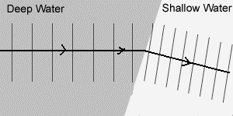

1. (Physics HT only) Describe how sound waves in the air are converted to vibrations in solids by the ear.
2. (Physics HT only) Which of the following represents the frequency range of human hearing?

200Hz to 2000Hz 20Hz to 20 000Hz 2000Hz to 200 000Hz

1. (Physics HT only) What are ultrasound waves?
2. (Physics HT only) The picture shows the ultrasound image of an unborn baby. Explain how ultrasound is able to produce an image from the outside of the mother.

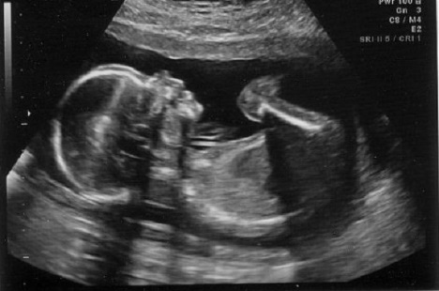

|  |  |  |  |
| --- | --- | --- | --- |
| **Wave type** | **Longitudinal wave** | **Fastest wave** | **Can travel through liquid and solid** |
| **P wave** |  |  |  |
| **S wave** |  |  |  |

1. (Physics HT only)Seismic waves are described as P or S waves. Copy the table and put ticks in the correct column to show the difference in these two seismic waves.
2. (Physics HT only) Describe how P and S seismic waves can be used to show part of the Earth’s core is liquid.

**B. Electromagnetic waves**

1. What type of waves are electromagnetic waves?
2. List the main electromagnetic waves in order from lowest to highest frequency.
3. Which of the following is the speed of electromagnetic waves in vacuum?

300 m/s 300 000m/s 300 000 000m/s

1. Which colour of light has the longest wavelength?
2. Describe one piece of evidence to show that light waves do not need a medium to travel from one place to another.
3. The four surfaces below are heated equally with infrared (IR) radiation.

Matt black

Shiny black

White

Shiny

silver

* 1. Which surface will absorb the more IR radiation?
  2. Which surface will reflect the most IR radiation?

1. The diagrams show three waves travelling from air into different materials. Which wave will be travelling the slowest?

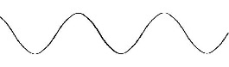

**Light**

**Water**

**X ray**

**Glass**

**Infrared**

**Vacuum**

1. The light wave shown below meets a boundary between glass and air. Continue the light ray to show its path after passing the boundary.

Glass

Air

1. (HT) The wave front below is travelling from air into water. Explain why the wave front bends.



1. Infrared rays strike a black tile. Will the waves mainly be reflected, refracted or absorbed?
2. (HT) Radio waves are transmitted through the air and received by aerials.

a. How are radio waves produced in the transmitter aerial?

b. What is produced in the receiving antenna when radio waves are absorbed?

1. Most electromagnetic waves are produced from energy changes in electron levels. How does gamma wave production differ from this?
2. Which three types of electromagnetic waves can cause damage to cells in the body?
3. What is meant by radiation dose?
4. The chart shows the average radiation dose a UK person is exposed to in a year.
   1. What percentage of the radiation dose comes from natural sources?
   2. Give two reasons why a person could receive a higher dose of background radiation.

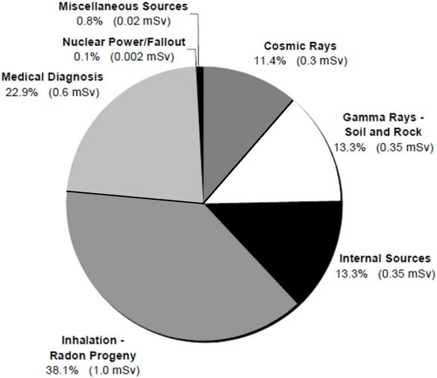

Food and drink

Radon gas

1. State which type of electromagnetic wave would be used for the following applications:

Sun tanning; Television remote; Medical imaging

1. (HT) Explain why radio waves are suitable for transmitting TV images to the home.



F

F

a. Copy and complete the two light rays on the diagram.

b. Label the principle axis, object and focal length on the diagram.

c. Describe the image produced by the above lens.

1. A 12cm object viewed in a convex lens has an image size of 54cm. Calculate the magnification of the lens.
2. Describe the difference between a transparent and a translucent object.
3. A vase is illuminated with green and blue light. What colour would the vase appear if viewed through a red filter?
4. Which colour of light has the shortest wavelength?
5. Copy and complete the ray diagrams.



Green vegetable

White light

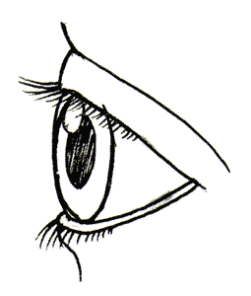

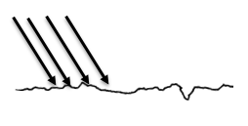

**C. Black body radiation (Physics only)**

1. A black body is  
    a. an object that emits no electromagnetic radiation.  
    b. an object that absorbs all electromagnetic radiation that falls on it.  
    c. an object that only emits invisible electromagnetic radiation.  
    d. an object that absorbs all electromagnetic radiation that falls on it and emits no electromagnetic radiation.
2. Explain how black body radiation differs from reflected radiation.
3. The picture shows a thermal image of a cat. Why can we not see this thermal emission from the cat without using a specialised camera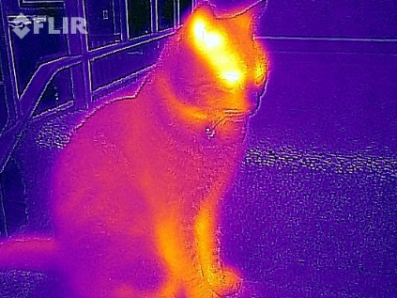?
4. The stone is in the sunshine and emitting radiation. As the stone heats up through the day, how will the nature of the emitted radiation change?
5. If a body absorbs radiation at a faster rate than it emits radiation, what change will happen to the body?
6. 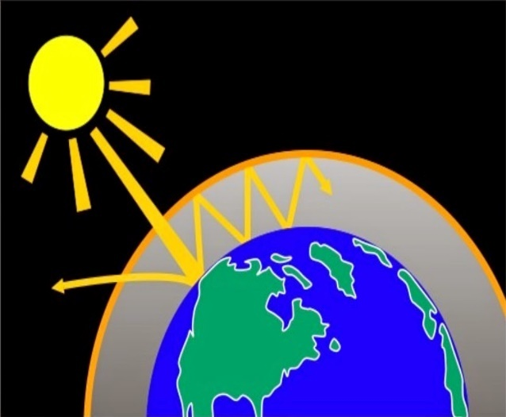The diagram shows how global warming of the Earth can occurs. Explain what is happening in terms of changes to absorbed and emitted radiation.