**A Waves in air, fluids and solids**

1. The diagrams below show two types of wave produced on a slinky spring.

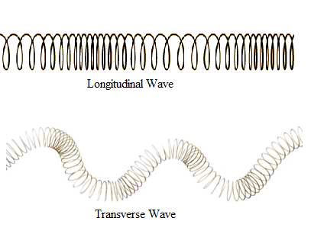

A

B

1. Which one is a transverse wave? (1) **Wave B**

1. What is the name of the other type of wave? (1) **Longitudinal wave**

1. On **both** slinky diagrams, draw an arrow to show the direction of oscillation of the wave. (2)
2. 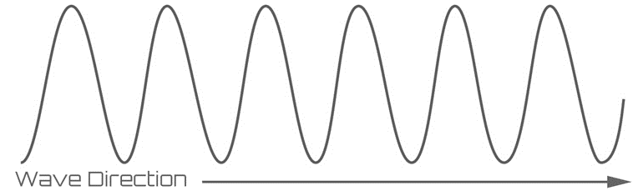a. On the diagram below, label the amplitude (a) and wavelength (λ) of the wave. (2)

**λ**

**a**

b. The wave has a frequency of 200Hz. If wave period (*T*) is given by T = 1/f, calculate the period of

this wave. (1)

**T = 1 / f = 1 / 200**

Period of wave = **0.005s**

1. Radio waves from a distant galaxy are travelling at 3.0 x 108m/s. If they have a wavelength of 28m, calculate the frequency of these waves. (3)

**v = f x λ (1) f = v/λ (1) f = 3.0 x 108**

**28**

Frequency = **10.7 MHz (1)**

1. 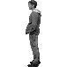The man sees the lightening and hears the thunder 4s later. The lightening hit the ground 1.3km away. Use this information to calculate the speed of sound in air. (2)

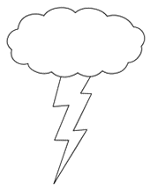

**Speed = distance (1) Speed = 1300**

**time 4**

**Speed of sound in air = 325m/s (1)**

1. 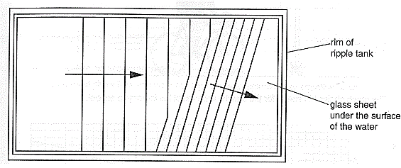The water waves produced in a ripple tank are shown below.

Bar producing the waves

1. The bar producing the waves is vibrating at 2Hz and the waves are 0.03m apart. Calculate the speed of the water waves. (2)

**v = f x λ (1) v = 2 x 0.03 = 0.06**

**Speed of water waves = 0.06m/s (1)**

1. When the wave passes over the glass it refracts. State what will happen to each of the following properties of the wave when it refracts: (3)

Velocity **decreases / slows down**

Wavelength **decreases**

Frequency **remains the same**

1. 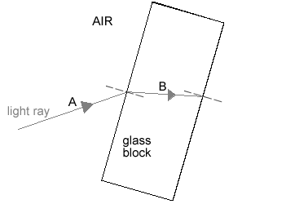The diagram shows a light ray shining on a block of glass.

**D**

**C**

1. What is happening to the light ray at **B**? (1) **Refracting (slowing down)**

1. Continue the ray of light as it leaves the glass block and label this as **C**. (1)
2. Some of the light will be reflected before it enters the block. Draw this reflected ray and label

it **D**. (1)

1. Not all the light that enters the block leaves the block. What has happened to this light that

does not leave the block? (1)

**It has been absorbed by the glass**

1. **(physics only)** Sound waves in the air are converted into vibrations in solids within the ear **(HT).**
2. Describe how the ear changes air vibrations into solid vibrations. (3)

**Compressions in the air caused by sound (1) make the flexible eardrum vibrate (1)**

**Solid bones are connected to the eardrum which also vibrate as the eardrum vibrates (1)**

1. Explain why this process limits the frequency range humans can hear. (3)

**The eardrum and solid bones can only vibrate at specific frequencies (1)**

**Faster or slower vibrations in the air do not produce vibrations in the bones (1)**

**This limits the frequency of sound that can be heard (1)**

1. The diagram below shows ultrasound being used to produce an image of the inside the body.

muscle

fat

skin

Ultrasound emitter/receiver

screen

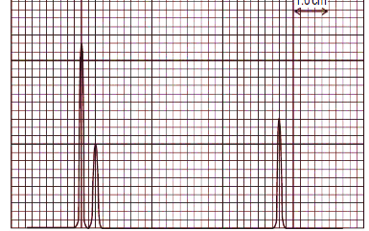

1. Complete the following sentences. Choose from the correct words from the list below. (4)

**media radiated transmitted reflected boundary**

Ultrasound can travel through different materials – solids, liquids and gases. When

ultrasound meets a  **boundary** between two different

**media** some of the ultrasound is **reflected/transmitted** and some is

**transmitted/reflected** . The reflected pulses are seen on the screen.

1. Draw a trace on the screen to show how the ultrasound image will appear. (2)

**Spikes showing strong initial peak (1) then two subsequent peaks reflected from fat and muscle boundaries (1)**

1. The diagram shows how Primary and Secondary seismic waves travel through the Earth.

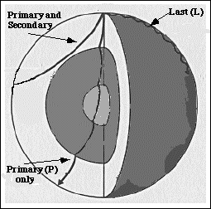

1. What type of waves are S waves? (1)

**Transverse waves**

1. Why do the S waves not travel all the way through the Earth? (1)

**S waves cannot travel through liquids**

1. The P waves bend when they come to a new boundary surface. What is this bending

called? (1)

**Refraction**

d. Explain why the P waves bend in this way. (3)

**There is a difference in density at boundaries between different layers in the Earth(1)**

**When the P wave meets a boundary, one side of the wave slows down before the**

**other side (1)**

**This change in speed causes the wave to bend (1)**

1. Describe how echo sounding is used to locate a shoal of fish under a fishing trawler. (4)

**A sound pulse is sent directly down into the water (1)**

**The sound wave is reflected off the fish and received on board the trawler (1)**

**If the speed of sound in water and the time for the pulse to return are known (1)**

**the depth of the shoal of fish can be calculated using speed = distance/time (1)**

**B Electromagnetic waves**

1. All electromagnetic waves have features in common. The table below lists features of waves. Tick the correct **boxes** that apply to all electromagnetic waves. (3)

|  |  |  |
| --- | --- | --- |
| **Property** | **True** | **False** |
| They are all transverse waves | **✓** |  |
| They have different speeds |  | **✓** |
| They have different frequencies | **✓** |  |
| They all have the same wavelength |  | **✓** |
| They can all be reflected, refracted and transmitted | **✓** |  |
| They can all travel through a vacuum | **✓** |  |

**1 mark / 2 correct responses**

1. The diagram below shows the electromagnetic spectrum. Three of the waves have not been named.

|  |  |  |  |  |  |  |
| --- | --- | --- | --- | --- | --- | --- |
| **Radio** | Microwaves | **Infrared** | Visible light | Ultra-violet | **X rays** | Gamma |

Increasing frequency

1. Fill in the three spaces above with the correct names. (3)
2. Which of the waves above is used in TV remote controls? (1)

**Infrared**

1. Which of the waves above is satellite TV? (1)

**Microwaves**

1. When an infrared heater is switched on, a person a few metres away begins to warm up. Explain what has moved from the heater to the person and how this occurred. (2)

**Energy has moved from the heater to the person (1)**

**This energy is carried by an electromagnetic infrared wave (1)**

1. The diagram shows a wave front being refracted as it enters a block of glass from the air **(HT)**.

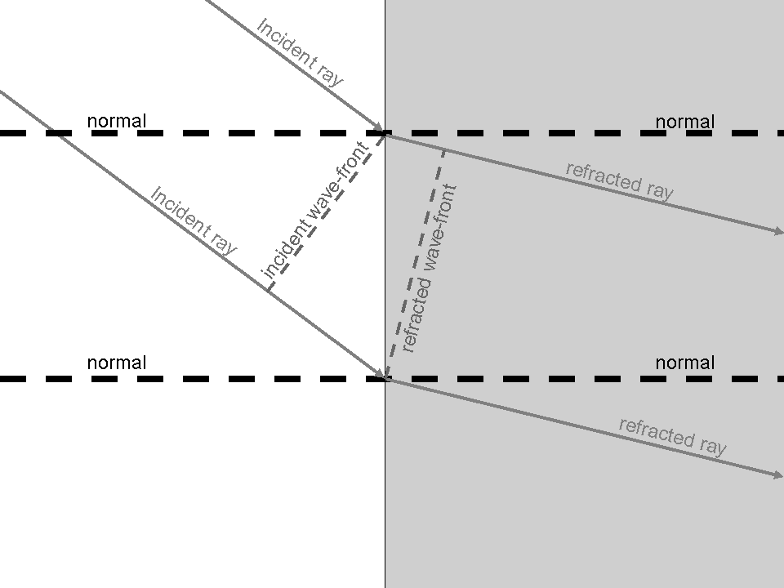

Explain in detail why the ray bends as it enters the glass. (3)

**As the wave travels through the air, the top of the incident ray reaches the glass before the**

**bottom of the incident ray (1)**

**Glass is denser than air so the top of the wave slows down before the bottom of the wave**

**(1)**

**If one side of the wave slows before the other side, the wave will bend (1)**

1. Explain why a green object heats up more in sunlight than a white object **(HT)**. (4)

**A green object only reflects green light (1)**

**Other colours of light are absorbed by the green object causing its temperature to increase (1)**

**A white object reflects all the colours of light (1)**

**More energy is absorbed by the green object therefore its temperature will be higher than the white object (1)**

1. Television and radio broadcasts are sent through the air as radio signals.

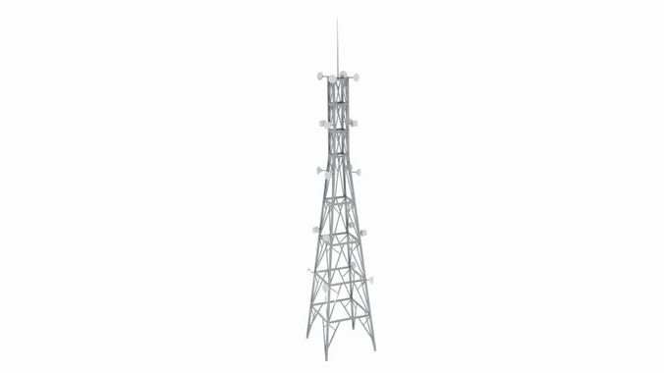

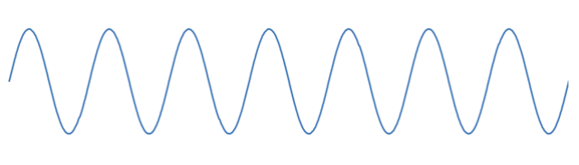

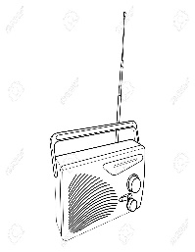

* 1. Why are radio waves suitable to send signals in this way? (1)

**They transmit easily through the atmosphere (1)**

* 1. How is the radio signal produced in the transmitting antenna? (2)

**An alternating current is applied to the antenna (1)**

**These oscillations in the wire produce radio waves (1)**

* 1. What is produced in the aerial of the radio when it receives radio waves? (2)

**An alternating current (1)**

**Of the same frequency as the radio waves it receives (1)**

1. In which part of an atom are gamma waves produced? (1)

**In the nucleus of the atom (1)**

1. The diagram shows the waves that make up the electromagnetic spectrum.

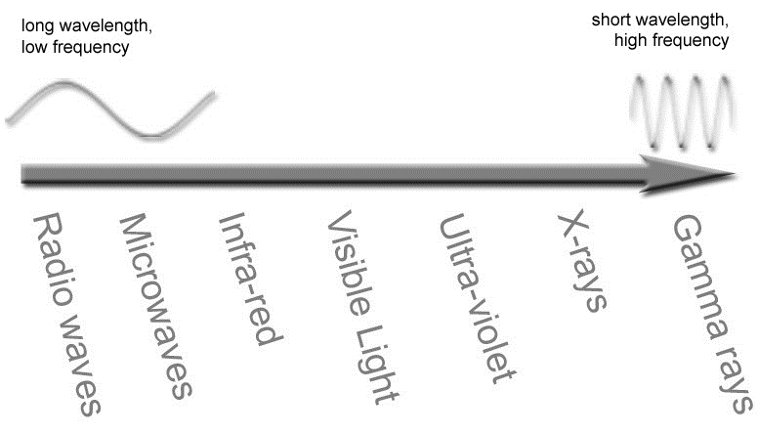

* 1. Circle the waves that are ionising radiations. (3)
  2. What property of the spectrum of waves is shown to be increasing by the arrow? (1)

**Frequency (energy) (1)**

1. What is the meaning of the term ‘radiation dose’? (1)

**A measure of the amount of exposure to radiation (1)**

1. Explain why ionising radiations can be dangerous if the dose becomes high. (2)

**A high dose can lead to mutations in cells of the body/ damage to DNA (1)**

**This can result in cancer caused by damaged genes (1)**

1. The waves shown below represent part of the electromagnetic spectrum.

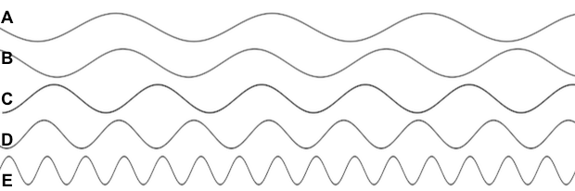

* 1. Which wave is likely to be a radio wave? (1) **Wave A (1)**
  2. Which wave would be carrying the greatest amount of energy? (1) **Wave E (1)**
  3. Which wave could be used for medical imaging? (1) **Wave E (1)**
  4. If the waves represent the colours of visible light, what colour could wave C represent? (1)

**Yellow / Green / Blue (1)**

1. Give the most suitable type of electromagnetic radiation for the applications stated: (5)

|  |  |
| --- | --- |
| **Application** | **Type of electromagnetic radiation** |
| Satellite communications, cooking food | **Microwave** |
| Fluorescent lamps, disinfecting water, security marking | **Ultra violet** |
| Cooking, thermal imaging, short range communications | **Infrared** |
| Sterilising food and medical equipment, cancer treatment | **Gamma** |
| Vision, photography, illumination | **Light** |

1. **Image result for pine tree drawing(physics only)**

**Y**

**X**

**F**

**F**

**2F**

**2F**

* 1. Draw the symbol for a convex lens at the point labelled **X**. (1)
  2. What is the correct name for line **Y**? (1) **Principal axis (1)**
  3. What is the correct name for the distance from point **X** to point **F**? (1) **Focal length (1)**
  4. One ray has been partly drawn. Complete the path of this ray. Put an arrow on this ray (1)
  5. Draw a second ray on the diagram to show how the image position can be found. (1)
  6. Describe the image produced by this lens. (2)

**Inverted, laterally inverted, reduced in size, real (1 mark / two correct responses)**

1. Below are two types of lens. Name each type of lens and complete the three light rays passing through each lens. **(physics only)** (4)
2. **(1)**

Type of lens **Convex** **(1)**  Type of lens **Concave (1)**

1. A convex lens produces an image 35mm tall when a 5mm tall object is viewed. Calculate the magnification produced by this lens. **(physics only)** (2)

**Magnification = image height (1) = 35 = 7**

**object height 5**

**Magnification = x7 (1)**

1. 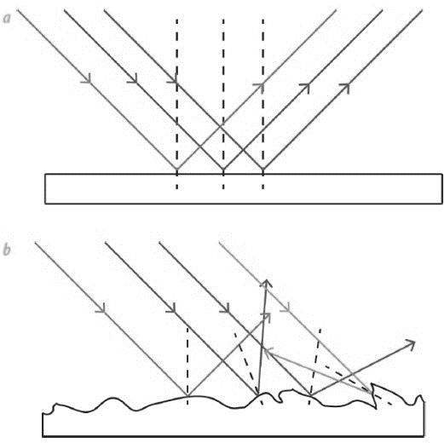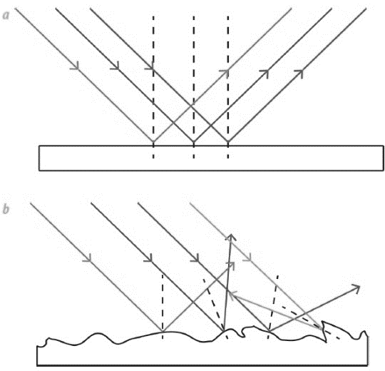The diagrams show light rays being reflected off two types of surface. **(physics only)**

**B**

**A**

* 1. What type of reflection is shown at A and at B? (2)

A **Diffuse reflection (1)** B **Specular reflection (1)**

* 1. Which surface is likely to be a smooth piece of white paper? (1) **A (1)**

1. White light is shining on a green leaf and on a bottle of red juice.

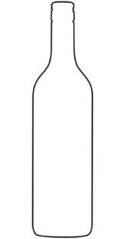

White light

Green light

White light

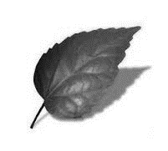

Red light

Describe what is happening to the spectrum colours of light in each diagram. **(physics only)** (4)

**The leaf is reflecting green light (1)**

**All other colours of light are being absorbed by the leaf (1)**

**The red juice is transmitting red light (1)**

**All other colours of light are being absorbed by the juice (1)**

1. If a blue object in a dark room is illuminated with a red light, what colour will the object appear?

**(physics only)** (1)

**It will appear black (1)**

**C Black body radiation (physics only)**

|  |  |  |
| --- | --- | --- |
| **Property** | **True** | **False** |
| A black body absorbs all radiation that falls on it | ✓ |  |
| A black body always reflects radiation at a longer wavelength than that which it receives |  | ✓ |
| A black body is an excellent emitter of radiation | ✓ |  |
| A black body transmits all the radiation that falls on it |  | ✓ |

1. The table describes some properties of a perfect black body. Put a tick in the correct box to show whether the statement is true or false. (4)
2. A piece of iron is heated in a furnace until it is white hot.

How will the radiation emitted from the hot metal, differ from the radiation emitted when the metal was cold? (2)

**Emitted waves will be at a higher frequency / shorter wavelength (1)**

**Emitted waves will be more intense / higher energy (1)**

1. The black cube below is in a warm room. Its temperature is constant.

What is the relationship between radiated and absorbed radiation for this object? (2)

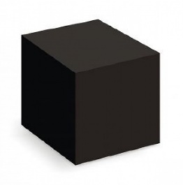

**Black cube will be emitting radiation (1)**

**At the same rate that it is absorbing radiation (1)**

1. 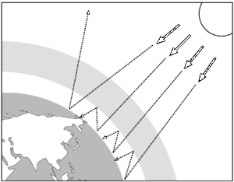The diagram shows how the Earth absorbs and emits radiation.

Use the diagram to help explain how changes between absorbed and emitted radiation could affect the temperature of the Earth. (4)

**If more radiation is absorbed than emitted (1)**

**The average temperature of the Earth will increase (1)**

**Anything which prevents emitted radiation from escaping (1)**

**Will contribute to increasing the Earth’s temperature (1)**