1. **Forces and their Interactions**
2. What is a scalar quantity?
3. Explain how a car can be moving at a constant speed but have changing velocity.
4. State whether the following quantities are scalars or vectors:

Acceleration Mass Momentum Time

1. Gravity is a force that acts at a distance.

Name two other forces that act at a distance.

1. Name three contact forces.
2. A boy has a mass of 40 kg. Calculate the boy’s weight.

Take g = 10 N/kg.

1. Name a piece of scientific equipment that you would use to find the weight of a block in a science laboratory.
2. The object below has two forces acting on it, shown by the arrows.

Draw an arrow to show the resultant force on the object.



1. On The Moon an astronaut has a weight of 130 N. The gravitational field strength on The Moon is 1.7 N/kg. The gravitational field strength on the Earth is 10 N/kg.

Calculate the weight of the astronaut on the Earth.

1. A child cuts out a picture of a snowman on a piece of card. Describe how you could determine the centre of mass of the snowman.
2. Calculate the resultant force acting on the objects below:

**a) 12 N 6 N**

**b)**

**23 N 7 N**

**c) 5 N**

**5 N**

**8 N**

1. **Work Done and Energy Transfer**
2. A piano is pushed across a wooden floor with a force of 2500 N. The piano moves a distance of 3.5 m.

Calculate the work done moving the piano.

1. Work done is usually measured in joules. An alternative unit for work done is (circle the correct answer).

kg/m3  Nm W N/m2 N/kg

3. Describe why a bicycle pump gets hotter when used to pump up a tyre.

1. A box with a weight of 120 N is lifted 1.8 m onto a shelf.

Calculate the work done in lifting the box.

1. When a book is lifted 3 m the work done on the book is 1.2 J.

Calculate the weight of the book.

1. **Forces and Elasticity**

1. What type of energy is stored in a stretched spring?

1. What is the least number of forces required to stretch a spring?
2. A student investigates the stretching of a spring. The student adds weight to the spring and measures the extension. Sketch the force - extension graph the student would expect for the spring.
3. A spring is stretched beyond its elastic limit. Describe the effect that this would have on the spring.
4. Explain how the extension of a spring is determined.
5. Motorcycles use springs for their suspension. The spring is compressed when the motorcycle rides over bumps. A force of 240 N compresses the spring 2 cm. Calculate the spring constant of the motorcycle spring.
6. The graph, below, shows the force-extension graph for a spring.

a) Calculate the spring constant of the spring.

b) Calculate the energy stored in the spring when it is stretched 50 cm.

**D. Moments, Levers and Gears**

1. State the equation used to find the moment of a force.
2. A 30 cm long spanner is used to undo a nut. A force of 20 N is applied to the end of the spanner. Calculate the moment of force applied to the spanner.
3. Two children sit on a see-saw on opposite sides of the pivot. One child has a weight of 340 N and sits 1.2 m from the pivot. If the child has a weight of 420 N how far does this child need to sit from the pivot for the see-saw to be balanced?



1. A crowbar is used to lift up a floor board. The crowbar has a length of 40 cm from the pivot to the end of the crowbar, and the distance from the bend to the lifting point is 12 cm. If the force applied to the end of the crowbar is 300 N, Calculate the size of the force applied to the floor board.
2. A box with a weight of 400 N is raised using a lever 2 m long. The lever rotates around a pivot 50 cm from the lifting end of the lever. Calculate the force applied to the end of the lever.
3. The 30 tooth large cog is made to rotate in a clockwise direction. In which direction will the smaller cog rotate?
4. In the gear system shown, above, the 30 tooth cog rotates once every 5 seconds. The smaller cog has 20 teeth. Calculate how long it will take the smaller cog to complete one revolution.

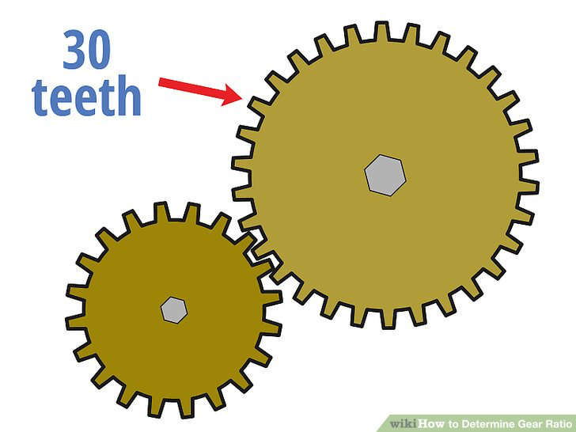

1. Look at the following gear system.

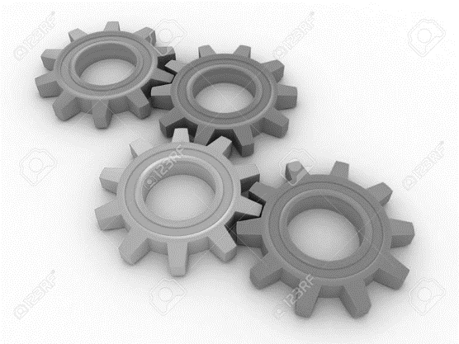

In which direction will the yellow cog rotate if the red cog is made to rotate anti-clockwise?

**E. Pressure and Pressure Differences in Fluids (Physics Only)**

1. In a bath full of water a force of 1250 N acts on an area of 0.5 m2 at the bottom of the bath. Calculate the pressure acting on the bottom of the bath.
2. A pressure of 4000 Pa acts in a hydraulic brake fluid. The surface of the slave cylinder inside the brake system has a surface area of 0.03 m2. Calculate the force acting on the slave cylinder.
3. A beaker is filled to a depth of 10 cm with water. Water has a density of 1000 kg/m3. Calculate the pressure acting at the bottom of the beaker. Take g = 10 N/kg.
4. A scuba diver is diving in the sea. The pressure acting on the scuba diver is 267 800 Pa. Salt water has a density of 1030 kg/m3. Calculate the depth of the scuba diver.
5. A boat floats in sea water (density 1030 kg/m3). The boat has a surface area of 15 m2 in contact with the water and has a pressure of 4120 Pa acting on it. Find the depth the boat floats at. Take g = 10 N/kg.
6. Explain why the atmospheric pressure on the top of Mount Everest is lower than the atmospheric pressure at sea level.

**F. Forces and Motion**

1. State the typical speed of a person
2. Walking
3. Cycling
4. State the equation that links speed, distance and time.
5. Describe the difference between speed and velocity.
6. A car moves round a circular track at 120 mph. Give the average velocity of the car. Explain your answer.
7. A motorcycle travels a distance of 420 miles in 8.5 hours. Give the average speed of the motorcycle.
8. Describe the differences between instantaneous speed and average speed.
9. Describe fully the motion shown in the distance-time graph shown below.
10. Describe how you would find the instantaneous speed of an object from a distance-time graph where the line is a curve. (Higher Tier Only).
11. State the equation that links acceleration, change in velocity and time taken.
12. Describe what is meant by a negative acceleration.
13. Give the units of acceleration.
14. Describe how the distance travelled by an object can be found from a velocity-time graph.
15. Describe fully the motion shown in the velocity-time graph shown below.

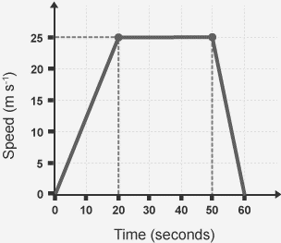

1. A stone is dropped off a cliff. The stone hits the floor at 30 m/s. Calculate the height of the cliff. Take g = 9.8 m/s2.
2. Explain how the motion of a skydiver changes from the moment they jump out of the plane until they land.

**G. Forces, Accelerations and Newton's Laws of Motion**

1. Describe why a cannon ball, when fired from a cannon, does not continue to move with constant velocity.
2. What is the inertia of an object a measure of?
3. State the equation commonly used for Newton's second law.
4. A car has a driving force of 1200 N and a mass of 700 kg. Calculate the acceleration of the car.
5. A skydiver has a weight of 686 N and a mass of 70 kg. Calculate the acceleration of the skydiver the moment he jumps out of the plane.
6. A motorcycle has a driving force of 1400 N and an acceleration of 6 m/s2. Calculate the mass of the motorcycle.
7. A father and his daughter were ice skating. The father has a mass of 75 kg and his daughter has a mass of 30 kg. The father pushed his daughter and she feels a force of 50 N. Calculate the force on the father.
8. A car crashed into a crash barrier. The force exerted by the barrier on the car was 4500 N. Describe the force exerted by the car onto the barrier.

**H. Forces and Braking**

1. Define thinking distance.
2. Complete the equation:

Stopping distance = ____________________ + _____________________

1. Describe how the speed of a vehicle affects the thinking distance.
2. A driver sees a car braking sharply in front of him. The driver takes 0.5 s to react to the stimulus and then brakes. Figure 1 shows the velocity-time graph for the motion of the vehicle from seeing the stimulus to stopping. Calculate the stopping distance of the vehicle.



**Figure 1**

1. 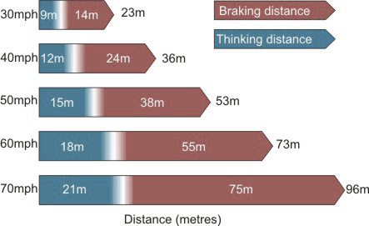The Highway Code shows the stopping distances for vehicles up to 70 mph. In 2011 the government proposed a new 80 mph speed limit for UK motorways. Use the information in the diagram, and your own knowledge, to determine the overall stopping distance of a vehicle at 80 mph.
2. Describe how you could measure the reaction time of a person.
3. Explain the dangers caused by large decelerations of a vehicle.
4. Put the following factors under the correct headings to show whether the factor affects thinking, braking distance or both thinking and braking distance.

**Speed Mass Icy Roads Tiredness**

**Poor Brakes Mobile Phone Use Alcohol Bald Tyres**

|  |  |  |
| --- | --- | --- |
| **Thinking Distance** | **Braking Distance** | **Both** |
|  |  |  |
|  |  |  |
|  |  |  |
|  |  |  |

* + - 1. **Momentum**

1. State the units of momentum.
2. State the equation that links mass, momentum and velocity.
3. Momentum is a conserved quantity. Explain what is meant by a conserved quantity.
4. A football has a mass of 0.75 kg and is kicked with a speed of 12 m/s. Calculate the momentum of the kicked football.
5. Two ice skaters push themselves apart on the ice. Explain how the conservation of momentum applies in the case.
6. A trolley has a mass of 1.2 kg and a speed of 4.5 m/s. The trolley crashes into a stationary trolley f mass 0.8 kg. On impact the two trolleys stick together and move off with speed, v. Calculate the momentum of the trolleys before impact. Calculate the speed of the trolleys after impact.
7. A gymnast falls onto a crash mat. The crash mat reduces the risk of injury to the gymnast. Explain how the crash mat reduces injury.
8. A car of mass 850 kg hit a crash barrier at a speed of 30 m/s. The car stops in 0.1 s. Calculate the force on the car.