1. **Forces and their Interactions**

**1** Quantities that we measure can be grouped into scalars and vectors.

**1a** Describe the difference between scalars and vectors. (2)

…………………………………………………………………………………………………………………………………

…………………………………………………………………………………………………………………………………

…………………………………………………………………………………………………………………………………

…………………………………………………………………………………………………………………………………

**1b** Complete the table by putting the following quantities in the correct place. (2)

**Acceleration Mass Speed Time Displacement**

|  |  |
| --- | --- |
| **Scalar Quantities** | **Vector Quantities** |
|  |  |
|  |  |
|  |  |

**1c** Describe the difference between speed and velocity. (2)

…………………………………………………………………………………………………………………………………

…………………………………………………………………………………………………………………………………

…………………………………………………………………………………………………………………………………

…………………………………………………………………………………………………………………………………

**1d** Explain how a car moving around a traffic island at a steady speed of 20 mph is constantly accelerating. (3)

…………………………………………………………………………………………………………………………………

…………………………………………………………………………………………………………………………………

…………………………………………………………………………………………………………………………………

…………………………………………………………………………………………………………………………………

…………………………………………………………………………………………………………………………………

…………………………………………………………………………………………………………………………………

**2** Forces can be described as contact forces or non-contact forces. Gravity is an example of a non-contact force.

**2ai** Give **one** other example of a non-contact force. (1)

…………………………………………………………………………………………………………………………………

**2aii** Give **two** examples of contact forces. (2)

1. …………………………………………………………………………………………………………………………….

2. …………………………………………………………………………………………………………………………….

**2b** Forces are represented as arrows in a **free body** diagram.

A book being pushed along a table has a number of forces acting upon it.

Draw a free body diagram on the space below to show the forces acting on a book being pushed along a **horizontal** table. (2)

**2c** A student gets a rope and ties it to a sledge.

The student pulls the rope with a force of 15 N at an angle of 30˚ to the horizontal.

Use a scale drawing to determine the size of the horizontal and vertical components of the force applied by the student. (3)

**2d** Two forces act on a box, as shown in the diagram below.

Work out the resultant force on the box. (1)

**35 N**

**120 N**

…………………………………………………………………………………………………………………………………

…………………………………………………………………………………………………………………………………

…………………………………………………………………………………………………………………………………

…………………………………………………………………………………………………………………………………

**Resultant Force:** …………………………………………..

**3** This question is about weight and mass.

**3a** State the equation that links gravitational field strength, mass and weight. (1)

…………………………………………………………………………………………………………………………………

…………………………………………………………………………………………………………………………………

**3bi** An astronaut has a weight of 750 N on Earth, where the gravitational field strength is 9.8 N/kg.

Work out the mass of the astronaut. (2)

…………………………………………………………………………………………………………………………………

…………………………………………………………………………………………………………………………………

…………………………………………………………………………………………………………………………………

…………………………………………………………………………………………………………………………………

**3bii** The astronaut goes to The Moon where the gravitational field strength is 1.6 N/kg.

Work out the weight of the astronaut on The Moon. (2)

…………………………………………………………………………………………………………………………………

…………………………………………………………………………………………………………………………………

…………………………………………………………………………………………………………………………………

…………………………………………………………………………………………………………………………………

**3biii** Give the mass of the astronaut on The Moon.

Explain your answer. (3)

**Mass of astronaut on The Moon:** …………………………………………..

…………………………………………………………………………………………………………………………………

…………………………………………………………………………………………………………………………………

…………………………………………………………………………………………………………………………………

…………………………………………………………………………………………………………………………………

**B. Work Done and Energy Transfer**

**1** This question is about work done.

**1ai** Define the term work done. (1)

…………………………………………………………………………………………………………………………………

…………………………………………………………………………………………………………………………………

**1aii** State the equation that links distance, force and work done. (1)

…………………………………………………………………………………………………………………………………

…………………………………………………………………………………………………………………………………

**1aiii** A crane is used to lift a pallet on a building site. The pallet has a weight of 8500 N and is raised 24 m.

Work out the work done against gravity. (3)

…………………………………………………………………………………………………………………………………

…………………………………………………………………………………………………………………………………

…………………………………………………………………………………………………………………………………

…………………………………………………………………………………………………………………………………

**Work done =** ………………………………... **J**

**1aiv** The crane lifts another pallet up the same vertical distance.

The energy transferred by the crane in lifting the pallet is 30 360 J.

Work out the weight of the pallet. (2)

…………………………………………………………………………………………………………………………………

…………………………………………………………………………………………………………………………………

…………………………………………………………………………………………………………………………………

**Weight =** ………………………………… **N**

**1av** Describe the energy transfers that take place when the crane lifts a pallet. (3)

…………………………………………………………………………………………………………………………………

…………………………………………………………………………………………………………………………………

…………………………………………………………………………………………………………………………………

…………………………………………………………………………………………………………………………………

…………………………………………………………………………………………………………………………………

…………………………………………………………………………………………………………………………………

…………………………………………………………………………………………………………………………………

…………………………………………………………………………………………………………………………………

**2a** A child sits on a sledge at the bottom of a hill. The child is pulled by a friend to the top of the hill that has a height of 12 m. The path to the top of the hill is 34 m in length.

The child has a weight of 300 N and the sledge has a weight of 15 N.

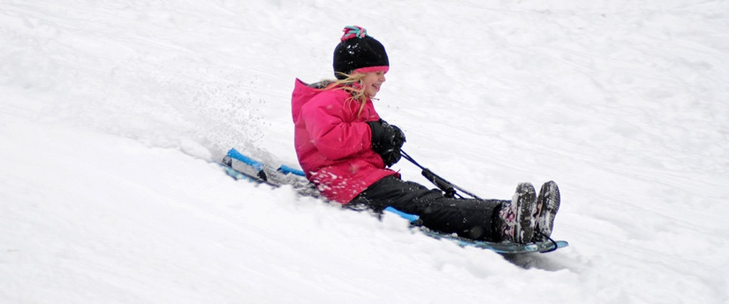 Work out the work done against gravity in pulling the child and the sledge to the top of the hill. (2)

…………………………………………………………………………………………………………………………………

…………………………………………………………………………………………………………………………………

…………………………………………………………………………………………………………………………………

…………………………………………………………………………………………………………………………………

**2b** The children swap places and the other child is now pulled to the top of the hill.

The work done in pulling the second child to the top of the hill was 4620 J.

Work out the weight of the second child. (2)

…………………………………………………………………………………………………………………………………

…………………………………………………………………………………………………………………………………

…………………………………………………………………………………………………………………………………

…………………………………………………………………………………………………………………………………

**2c** Work done is usually measured in joules, J.

Give an alternative unit for work done. (1)

…………………………………………………………………………………………………………………………………

**2d** When a drawing pin is rubbed onto a desk the drawing pin heats up.

Explain why the drawing pin heats up when rubbed. (2)

…………………………………………………………………………………………………………………………………

…………………………………………………………………………………………………………………………………

…………………………………………………………………………………………………………………………………

…………………………………………………………………………………………………………………………………

**C. Forces and Elasticity**

**1a** Springs are used both in tension and compression.

Describe what is meant by tension and compression of a spring. (2)

**Tension:** …………………………………………………………………………………………………………………

……………………………………………………………………………………………………………………………….

**Compression:** ………………………………………………………………………………………………………...

…………………………………………………………………………………………………………………………………

**1b** Complete the table by giving two uses of springs in tension and two uses of springs in compression. (4)

|  |  |
| --- | --- |
| **Uses of Springs in Tension** | **Uses of Springs in Compression** |
|  |  |
|  |  |

**1c** Springs can be used to keep fire doors closed.

When a fire door is opened, the spring is stretched which then applies a force to close the fire door again. **Figure 1** shows how the spring is used.

A force-extension graph for the spring is shown in **Figure 2**.

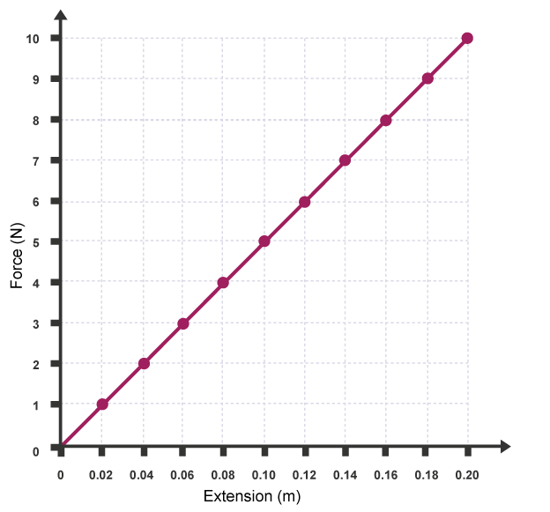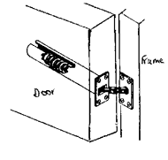 **Figure 1 Figure 2**

**1ci** State the equation used to find the spring constant of a spring. (1)

…………………………………………………………………………………………………………………………………

…………………………………………………………………………………………………………………………………

**1cii** Work out the spring constant of the spring used in **Figure 2.** (2)

…………………………………………………………………………………………………………………………………

…………………………………………………………………………………………………………………………………

…………………………………………………………………………………………………………………………………

…………………………………………………………………………………………………………………………………

**1ciii** When the fire door is fully opened the spring is stretched 25 cm.

Work out the closing force applied by the spring when it is stretched 25 cm. (2)

…………………………………………………………………………………………………………………………………

…………………………………………………………………………………………………………………………………

…………………………………………………………………………………………………………………………………

…………………………………………………………………………………………………………………………………

**1ciiii** The fire door spring is removed from the door for testing.

During testing a force is applied to the spring and the extension is measured. The force applied to the spring is increased until the spring snaps.

Draw the force-extension graph for the test described above. (2)

**Force / N**

**Extension / m**

**1di** Mountain bikes use springs for front suspension.

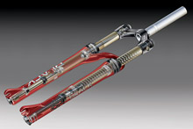

A typical mountain bike spring has a spring constant of 90 000 N/m and can be compressed 6 cm.

Work out the energy stored in the spring when compressed 6 cm. (3)

…………………………………………………………………………………………………………………………………

…………………………………………………………………………………………………………………………………

…………………………………………………………………………………………………………………………………

…………………………………………………………………………………………………………………………………

…………………………………………………………………………………………………………………………………

…………………………………………………………………………………………………………………………………

**1dii** The spring on the mountain bike is changed to adjust the suspension. A new spring is added that has a spring constant of 120 000 N/m.

Work out the distance this new spring has been compressed if it has 2820 J of elastic potential energy. Give your answer in mm. (3)

…………………………………………………………………………………………………………………………………

…………………………………………………………………………………………………………………………………

…………………………………………………………………………………………………………………………………

…………………………………………………………………………………………………………………………………

…………………………………………………………………………………………………………………………………

…………………………………………………………………………………………………………………………………

**D. Moments, Levers and Gears (Physics Only)**

**1** A driver has a flat tyre. The driver uses a spanner to remove the nuts holding the wheel in place.

The spanner has a length of 35 cm and the driver applies a force of 300 N to the end of the spanner.

**1ai** State the equation used to find the moment of the force. (1)

…………………………………………………………………………………………………………………………………

**1aii** Work out the moment of the force applied by the driver to the wheel nut. (2)

…………………………………………………………………………………………………………………………………

…………………………………………………………………………………………………………………………………

…………………………………………………………………………………………………………………………………

…………………………………………………………………………………………………………………………………

**1aiii** Another driver applies a force to the same spanner.

The moment of the force is now 270 Nm.

Work out the size of the force applied by this driver. (2)

…………………………………………………………………………………………………………………………………

…………………………………………………………………………………………………………………………………

…………………………………………………………………………………………………………………………………

…………………………………………………………………………………………………………………………………

**1aiv** Give **two** ways in which the driver can apply a greater moment of the turning force applied to the nut. (2)

**1.** .……………………………………………………………………………………………………………………………

…………………………………………………………………………………………………………………………………

**2.** ..……………………………………………………………………………………………………………………………

…………………………………………………………………………………………………………………………………

**2a** Complete the following sentences.(3)

If a seesaw is balanced the total ………………………… moment ………………………… the total anticlockwise moment.

The moment of a force is measured in units of ………………………… .

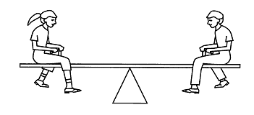**2b** Two children, **Child A** and **Child B**, sit on either side of a see-saw.

**Child A** has a weight of 450 N and sits 1.4 m from the pivot. **Child B** sits 1.6 m from the pivot. The see-saw is balanced.

Work out the weight of **Child B**. (3)

…………………………………………………………………………………………………………………………………

…………………………………………………………………………………………………………………………………

…………………………………………………………………………………………………………………………………

…………………………………………………………………………………………………………………………………

…………………………………………………………………………………………………………………………………

**Weight of Child B:** …………………………… **N**

**3** A crowbar is used to prise up a floorboard.

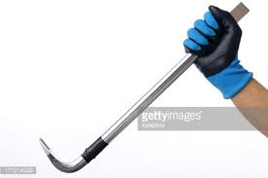 The crowbar is 40 cm long from the pivot, and the floorboard is 12 cm on the other side of the pivot.

A force of 120 N is applied to the end of the crowbar.

Work out the force applied to the floorboard. (3)

…………………………………………………………………………………………………………………………………

…………………………………………………………………………………………………………………………………

…………………………………………………………………………………………………………………………………

…………………………………………………………………………………………………………………………………

…………………………………………………………………………………………………………………………………

**Force on the Floorboard:** …………………………… **N**

**4** A simple gear system is set up as shown in the diagram below.

The large cog has 40 teeth and the smaller cog has 20 teeth.

The large cog is rotated clockwise at a speed of 4 revolutions per minute.

Describe the motion of the smaller cog. (2)

…………………………………………………………………………………………………………………………………

…………………………………………………………………………………………………………………………………

…………………………………………………………………………………………………………………………………

…………………………………………………………………………………………………………………………………

**E. Pressure and Pressure Differences in Fluids (Physics Only)**

**1.** Complete the following sentences.

A fluid can be either a …………………… or a ………………… .

The pressure in a fluid causes a force at ………………………………… to any surface.

**2**. This question is about pressure in a fluid.

**2ai** State the equation that links area, force and pressure. (1)

…………………………………………………………………………………………………………………………………

…………………………………………………………………………………………………………………………………

**2aii** A force of 18 N acts on a surface that has an area of 0.015 m2.

Work out the pressure acting on the surface. (2)

…………………………………………………………………………………………………………………………………

…………………………………………………………………………………………………………………………………

…………………………………………………………………………………………………………………………………

…………………………………………………………………………………………………………………………………

**2b** Circle the two equivalent units for pressure. (1)

**m/s N/m N/m2 m/s2 Pa**

**2d** A surface has an area of 25 cm2.

Convert 25 cm2 into m2. (1)

…………………………………………………………………………………………………………………………………

…………………………………………………………………………………………………………………………………

**3** A stone is dropped into a lake. The lake is 8.2 m deep.

Fresh water has a density of 1000 kg/m3. The gravitational field strength on Earth is 10 N/kg.

**3a** Work out the pressure on the stone at the bottom of the lake. (2)

*Pressure = density x gravitational field strength x height of column*

…………………………………………………………………………………………………………………………………

…………………………………………………………………………………………………………………………………

…………………………………………………………………………………………………………………………………

…………………………………………………………………………………………………………………………………

**Pressure:** ………………………

**3b** Another stone is dropped into the sea.

Sea water has a different density to fresh water.

At a depth of 8.2 m the pressure on the stone is 84 380 Pa.

Work out the density of sea water to three significant figures. (2)

…………………………………………………………………………………………………………………………………

…………………………………………………………………………………………………………………………………

…………………………………………………………………………………………………………………………………

…………………………………………………………………………………………………………………………………

**Density:** ………………………

**4** A student puts three holes into an empty bottle.

The holes are arranged vertically, as shown in the diagram below.

The bottle is then filled with water.

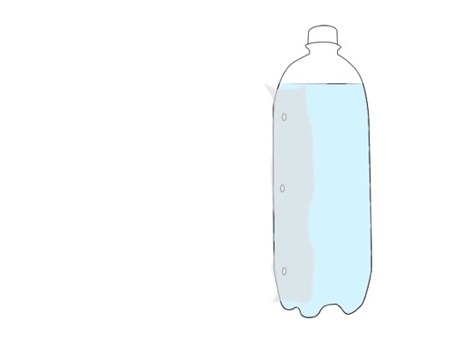

**4ai** Complete the diagram to show how water will leave through the three holes. (1)

**4aii** Explain why the water leaves the bottle in the way that you have drawn, above. (2)

…………………………………………………………………………………………………………………………………

…………………………………………………………………………………………………………………………………

…………………………………………………………………………………………………………………………………

…………………………………………………………………………………………………………………………………

**5** A submarine floats in mid-water at a depth of 47 m, to the top of the submarine.

The submarine has a height of 8.7 m. The surface area of the top and bottom surfaces of the submarine is 250 m2.

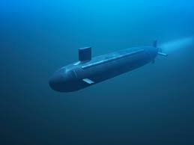

**5ai** Explain why the submarine experiences an upthrust. (2)

…………………………………………………………………………………………………………………………………

…………………………………………………………………………………………………………………………………

…………………………………………………………………………………………………………………………………

…………………………………………………………………………………………………………………………………

**5aii** The density of the water is 1034 kg/m3. Take g = 9.8 N/kg.

Work out the weight of the submarine in kilonewtons, kN. (4)

…………………………………………………………………………………………………………………………………

…………………………………………………………………………………………………………………………………

…………………………………………………………………………………………………………………………………

…………………………………………………………………………………………………………………………………

…………………………………………………………………………………………………………………………………

…………………………………………………………………………………………………………………………………

…………………………………………………………………………………………………………………………………

…………………………………………………………………………………………………………………………………

**Weight of Submarine:** ……………………………… **kN**

**5aiii** Submarines have ballast tanks that holdwater or air inside the submarine.

To surface the submarine puts air into a ballast tank (which expels water from the tank). Explain why this would cause the submarine to surface? (2)

…………………………………………………………………………………………………………………………………

…………………………………………………………………………………………………………………………………

…………………………………………………………………………………………………………………………………

…………………………………………………………………………………………………………………………………

**6** A child inflates a balloon with helium. The balloon is made from rubber.

When the end of the balloon is tied the size of the balloon remains constant.

**6ai** Describe the **two** opposing forces that act on the balloon to keep the balloon the same size. (2)

…………………………………………………………………………………………………………………………………

…………………………………………………………………………………………………………………………………

…………………………………………………………………………………………………………………………………

…………………………………………………………………………………………………………………………………

**6aii** The helium balloon is released and it goes up into the sky.

Describe what happens to the size of the balloon. Explain your answer. (2)

…………………………………………………………………………………………………………………………………

…………………………………………………………………………………………………………………………………

…………………………………………………………………………………………………………………………………

…………………………………………………………………………………………………………………………………

**6b** When mountaineers climb high mountains they usually carry oxygen with them. The mountaineers need to carry oxygen due to changes in atmospheric pressure as you go higher.

Explain how atmospheric pressure varies with height above the Earth's surface. (2)

…………………………………………………………………………………………………………………………………

…………………………………………………………………………………………………………………………………

…………………………………………………………………………………………………………………………………

…………………………………………………………………………………………………………………………………

**6c** Complete the sentence.

For air molecules to create an atmospheric pressure the air molecules must collide with ………………………………………… .

**F. Forces and Motion**

**1a** Describe the difference between distance and displacement. (2)

…………………………………………………………………………………………………………………………………

…………………………………………………………………………………………………………………………………

…………………………………………………………………………………………………………………………………

…………………………………………………………………………………………………………………………………

**1b** A runner runs around an oval shaped running track. The track is 400 m in length.

The runner runs around the track four times.

**1bi** State the distance travelled by the runner, (1)

**Distance:** ……………………………………………………………………………………………………………

**1bii** State the displacement of the runner at the end of the four loops of the track. Explain your answer. (2)

**Displacement:** …………………………………………………………………………………………………………

…………………………………………………………………………………………………………………………………

…………………………………………………………………………………………………………………………………

…………………………………………………………………………………………………………………………………

**2a** Describe the difference between speed of a car and its velocity. (2)

…………………………………………………………………………………………………………………………………

…………………………………………………………………………………………………………………………………

…………………………………………………………………………………………………………………………………

…………………………………………………………………………………………………………………………………

**2b** Complete the table below by giving the typical speeds of a person when walking, running and cycling, in m/s. (3)

|  |  |
| --- | --- |
| **Persons' Activity** | **Speed in m/s** |
| Walking |  |
| Running |  |
| Cycling |  |

**2c** Suggest **three** reasons why the instantaneous speed of a cyclist would differ from the typical speed stated above. (3)

**1.** ……………………………………………………………………………………………………………………………

…………………………………………………………………………………………………………………………………

**2.** .……………………………………………………………………………………………………………………………

…………………………………………………………………………………………………………………………………

**3.** .……………………………………………………………………………………………………………………………

…………………………………………………………………………………………………………………………………

**3a** A person watches a rocket explode at a firework display. The person hears the explosion 2.5 seconds after seeing the rocket explode.

Work out how far away the rocket was when it exploded. (3)



…………………………………………………………………………………………………………………………………

…………………………………………………………………………………………………………………………………

…………………………………………………………………………………………………………………………………

…………………………………………………………………………………………………………………………………

**3b** Children are often told that the time difference between seeing lightning and hearing the thunder is the distance the lightning strike was away, in miles.

The speed of light is 3 x 108 m/s.

The speed of sound is 330 m/s.

One mile is 1604 m.

Explain whether children are told the distance correctly. (3)

…………………………………………………………………………………………………………………………………

…………………………………………………………………………………………………………………………………

…………………………………………………………………………………………………………………………………

…………………………………………………………………………………………………………………………………

…………………………………………………………………………………………………………………………………

…………………………………………………………………………………………………………………………………

…………………………………………………………………………………………………………………………………

…………………………………………………………………………………………………………………………………

**4** Boats use sonar to find the depth of water where they are.

The boats measure the time taken to receive the echo of the sound wave that is produced by the boat.

If it takes 4.7 s to receive the echo and the speed of sound in water is 1498 m/s, work out the depth of the sea at that point. (3)

…………………………………………………………………………………………………………………………………

…………………………………………………………………………………………………………………………………

…………………………………………………………………………………………………………………………………

…………………………………………………………………………………………………………………………………

…………………………………………………………………………………………………………………………………

…………………………………………………………………………………………………………………………………

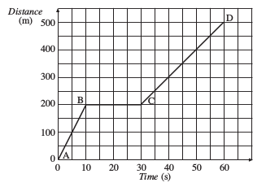**5** The motion of a car is shown in the distance-time graph below.

**5ai** Describe fully the motion of car. (5)

…………………………………………………………………………………………………………………………………

…………………………………………………………………………………………………………………………………

…………………………………………………………………………………………………………………………………

…………………………………………………………………………………………………………………………………

…………………………………………………………………………………………………………………………………

…………………………………………………………………………………………………………………………………

…………………………………………………………………………………………………………………………………

…………………………………………………………………………………………………………………………………

…………………………………………………………………………………………………………………………………

…………………………………………………………………………………………………………………………………

**5aii** A motorbike completes the same journey at a greater average speed.

On the graph, above, add a second line to show the motion of the motorbike. (1)

**6** A car has its speed analysed over a period of one minute. The graph, below, shows the motion of the car.

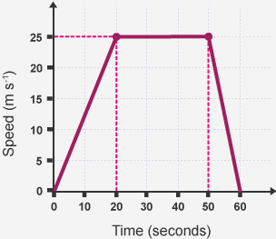

**6ai** State the times when the car was stationary. (1)

…………………………………………………………………………………………………………………………………

**6aii** During which times did the car have the greatest acceleration?

Explain how the graph shows this. (2)

…………………………………………………………………………………………………………………………………

…………………………………………………………………………………………………………………………………

…………………………………………………………………………………………………………………………………

…………………………………………………………………………………………………………………………………

**6aiii** Work out the acceleration of the car for the first 20 seconds of its journey. (2)

…………………………………………………………………………………………………………………………………

…………………………………………………………………………………………………………………………………

…………………………………………………………………………………………………………………………………

…………………………………………………………………………………………………………………………………

**6aiv** Work out the total distance travelled by the car. (3)

…………………………………………………………………………………………………………………………………

…………………………………………………………………………………………………………………………………

…………………………………………………………………………………………………………………………………

…………………………………………………………………………………………………………………………………

…………………………………………………………………………………………………………………………………

…………………………………………………………………………………………………………………………………

**Distance Travelled:** ………………………… **m**

**7a** A stone is dropped off a cliff.

The stone hits the floor at a speed of 21.2 m/s.

The acceleration due to gravity on Earth is 9.8 m/s2.

Work out the height of the cliff. (3)

*v2- u2 = 2 a s*

…………………………………………………………………………………………………………………………………

…………………………………………………………………………………………………………………………………

…………………………………………………………………………………………………………………………………

…………………………………………………………………………………………………………………………………

**Height of Cliff:** ………………………… **m**

**7b** The stone **did not** reach terminal velocity as it fell.

What conditions are required for an object to fall at terminal velocity? (2)

…………………………………………………………………………………………………………………………………

…………………………………………………………………………………………………………………………………

…………………………………………………………………………………………………………………………………

…………………………………………………………………………………………………………………………………

**G. Forces, Acceleration and Newton's Laws of Motion**

**1** This question is about Newton's Laws of Motion.

**1ai** State Newton's First Law of Motion. (1)

…………………………………………………………………………………………………………………………………

…………………………………………………………………………………………………………………………………

**1aii** State the equation used to commonly show Newton's Second Law of motion. (1)

…………………………………………………………………………………………………………………………………

…………………………………………………………………………………………………………………………………

**1aiii** A car crashes into a crash barrier.

The car experiences a force of 27 000 N.

Describe the force acting on the crash barrier. (2)

…………………………………………………………………………………………………………………………………

…………………………………………………………………………………………………………………………………

…………………………………………………………………………………………………………………………………

…………………………………………………………………………………………………………………………………

**1b** A motorbike and rider have a combined mass of 320 kg. The driving force supplied by the motorbike's engine is 6700 N.

Work out the acceleration of the motorbike and rider. (2)

…………………………………………………………………………………………………………………………………

…………………………………………………………………………………………………………………………………

…………………………………………………………………………………………………………………………………

…………………………………………………………………………………………………………………………………

**1c** Give the property of matter that gives an object the tendency to continue at rest or at a steady speed in a straight line. (1)

…………………………………………………………………………………………………………………………………

**1d** A car accelerates from rest until it reaches its top speed along a test track.

Explain how the acceleration of the car changes during its journey. (4)

…………………………………………………………………………………………………………………………………

…………………………………………………………………………………………………………………………………

…………………………………………………………………………………………………………………………………

…………………………………………………………………………………………………………………………………

…………………………………………………………………………………………………………………………………

…………………………………………………………………………………………………………………………………

…………………………………………………………………………………………………………………………………

…………………………………………………………………………………………………………………………………

**2** A ball of mass 6 kg is kicked with a force of 38 N.

Work out the acceleration of the ball. (2)

…………………………………………………………………………………………………………………………………

…………………………………………………………………………………………………………………………………

…………………………………………………………………………………………………………………………………

…………………………………………………………………………………………………………………………………

**3** A father and son go ice skating. The son pushes the father with a force of 70 N.

State the size of the force on the son. Explain your answer. (2)

…………………………………………………………………………………………………………………………………

…………………………………………………………………………………………………………………………………

…………………………………………………………………………………………………………………………………

**H. Forces and Braking**

**1** This question is on the stopping distances of vehicles.

**1ai** State the equation that links braking distance, stopping distance and thinking distance. (1)

…………………………………………………………………………………………………………………………………

…………………………………………………………………………………………………………………………………

**1aii** Define thinking distance. (1)

…………………………………………………………………………………………………………………………………

…………………………………………………………………………………………………………………………………

**1aiii** Define braking distance. (1)

…………………………………………………………………………………………………………………………………

…………………………………………………………………………………………………………………………………

**1aiv** When a car performs an emergency stop from 70 mph the thinking distance is 21 m and the overall stopping distance is 96 m.

Work out the braking distance of the car. (1)

…………………………………………………………………………………………………………………………………

…………………………………………………………………………………………………………………………………

**1bi** Describe how the speed of a car affects the thinking distance. (2)

…………………………………………………………………………………………………………………………………

…………………………………………………………………………………………………………………………………

…………………………………………………………………………………………………………………………………

…………………………………………………………………………………………………………………………………

**1bii** Explain how the speed of a car affects the braking distance. (3)

…………………………………………………………………………………………………………………………………

…………………………………………………………………………………………………………………………………

…………………………………………………………………………………………………………………………………

…………………………………………………………………………………………………………………………………

…………………………………………………………………………………………………………………………………

…………………………………………………………………………………………………………………………………

**1ci** Using a mobile phone changes the stopping distance of a car.

Explain how the stopping distance is affected. (2)

…………………………………………………………………………………………………………………………………

…………………………………………………………………………………………………………………………………

…………………………………………………………………………………………………………………………………

…………………………………………………………………………………………………………………………………

**1cii** Complete the table to give three factors that will increase the thinking distance and three factors that will affect the braking distance of a car. (4)

|  |  |
| --- | --- |
| **Factors Affecting Thinking Distance** | **Factors Affecting Braking Distance** |
|  |  |
|  |  |
|  |  |

**1ciii** State one factor that will reduce the thinking distance of a driver. (1)

…………………………………………………………………………………………………………………………………

…………………………………………………………………………………………………………………………………

**2** The speed limit on roads near schools have been reduced from 30 mph to 20 mph in many areas of the UK.

Give advantages and disadvantages of reducing the speed limit outside schools. (4)

…………………………………………………………………………………………………………………………………

…………………………………………………………………………………………………………………………………

…………………………………………………………………………………………………………………………………

…………………………………………………………………………………………………………………………………

…………………………………………………………………………………………………………………………………

…………………………………………………………………………………………………………………………………

…………………………………………………………………………………………………………………………………

…………………………………………………………………………………………………………………………………

**3** Driverless cars are being tested on rods in Coventry.

Companies that make the driverless cars say that they will make the roads safer.

Some people are worried that it could lead to an increase in the number of road collisions.

Give advantages and disadvantages of driverless cars and explain whether you think that it will make roads safer. (5)

…………………………………………………………………………………………………………………………………

…………………………………………………………………………………………………………………………………

…………………………………………………………………………………………………………………………………

…………………………………………………………………………………………………………………………………

…………………………………………………………………………………………………………………………………

…………………………………………………………………………………………………………………………………

…………………………………………………………………………………………………………………………………

…………………………………………………………………………………………………………………………………

…………………………………………………………………………………………………………………………………

**4a** Explain the difference between thinking distance and reaction time. (2)

…………………………………………………………………………………………………………………………………

…………………………………………………………………………………………………………………………………

…………………………………………………………………………………………………………………………………

…………………………………………………………………………………………………………………………………

**4b** Explain how you could find a persons' reaction time by experiment in a school science laboratory. (5)

You may draw a diagram to help you answer this question.

…………………………………………………………………………………………………………………………………

…………………………………………………………………………………………………………………………………

…………………………………………………………………………………………………………………………………

…………………………………………………………………………………………………………………………………

…………………………………………………………………………………………………………………………………

…………………………………………………………………………………………………………………………………

…………………………………………………………………………………………………………………………………

…………………………………………………………………………………………………………………………………

…………………………………………………………………………………………………………………………………

…………………………………………………………………………………………………………………………………

…………………………………………………………………………………………………………………………………

…………………………………………………………………………………………………………………………………

**I. Momentum**

**1a** State the equation that links mass, momentum and velocity. (1)

…………………………………………………………………………………………………………………………………

…………………………………………………………………………………………………………………………………

**1b** Momentum is a vector quantity. Explain what is meant by a vector quantity. (1)

…………………………………………………………………………………………………………………………………

…………………………………………………………………………………………………………………………………

**1c** Momentum is a conserved quantity.

Describe what is meant by a momentum being a conserved quantity. (1)

…………………………………………………………………………………………………………………………………

…………………………………………………………………………………………………………………………………

…………………………………………………………………………………………………………………………………

…………………………………………………………………………………………………………………………………

**2a** A ball of mass 0.75 kg is kicked and moves off with a speed of 14 m/s.

Work out the momentum of the ball. (2)

…………………………………………………………………………………………………………………………………

…………………………………………………………………………………………………………………………………

…………………………………………………………………………………………………………………………………

…………………………………………………………………………………………………………………………………

**2b** The ball is kicked again and moves off with half the speed.

State the new momentum of the ball. (1)

…………………………………………………………………………………………………………………………………

**2c** Describe how doubling the mass of an object will affect its momentum, at a given speed. (1)

…………………………………………………………………………………………………………………………………

…………………………………………………………………………………………………………………………………

…………………………………………………………………………………………………………………………………

…………………………………………………………………………………………………………………………………

**3a** A car has a mass of 1100 kg and a speed of 30 m/s.

Work out the momentum of the car. (2)

…………………………………………………………………………………………………………………………………

…………………………………………………………………………………………………………………………………

…………………………………………………………………………………………………………………………………

…………………………………………………………………………………………………………………………………

**3b** The car changes speed and now has a momentum of 4760 kgm/s.

Work out the new speed of the car. (2)

…………………………………………………………………………………………………………………………………

…………………………………………………………………………………………………………………………………

…………………………………………………………………………………………………………………………………

…………………………………………………………………………………………………………………………………

**4** In a crash test two identical cars of mass 900 kg move towards each other.

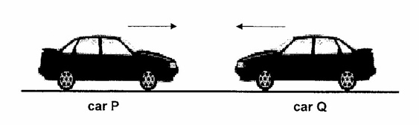

Before impact, **Car P** has a speed of 14 m/s and **Car Q** has a speed of 18 m/s.

**4ai** Work out the total momentum of the two cars before impact. (3)

…………………………………………………………………………………………………………………………………

…………………………………………………………………………………………………………………………………

…………………………………………………………………………………………………………………………………

…………………………………………………………………………………………………………………………………

**4aii** After impact the cars move off together to the left.

Work out the speed that the two cars move off at after impact. (3)

…………………………………………………………………………………………………………………………………

…………………………………………………………………………………………………………………………………

…………………………………………………………………………………………………………………………………

…………………………………………………………………………………………………………………………………

…………………………………………………………………………………………………………………………………

…………………………………………………………………………………………………………………………………

…………………………………………………………………………………………………………………………………

…………………………………………………………………………………………………………………………………

**5** Cars have many features to reduce injury in case of a crash. Seatbelts and crumple zones are two safety features designed to reduce injury in a crash.

**5ai** Give **one** other safety feature designed to reduce injury in a crash. (1)

…………………………………………………………………………………………………………………………………

…………………………………………………………………………………………………………………………………

**5aii** Explain how seatbelts reduce injury in a crash. (4)

…………………………………………………………………………………………………………………………………

…………………………………………………………………………………………………………………………………

…………………………………………………………………………………………………………………………………

…………………………………………………………………………………………………………………………………

…………………………………………………………………………………………………………………………………

…………………………………………………………………………………………………………………………………

…………………………………………………………………………………………………………………………………

…………………………………………………………………………………………………………………………………

**5aiii** In a crash a car goes from 20 m/s to 0 m/s. It takes the car 0.2 s to stop.

The car had a mass of 1265 kg.

Work out the force acting on the car. (3)

…………………………………………………………………………………………………………………………………

…………………………………………………………………………………………………………………………………

…………………………………………………………………………………………………………………………………

…………………………………………………………………………………………………………………………………

…………………………………………………………………………………………………………………………………

…………………………………………………………………………………………………………………………………

…………………………………………………………………………………………………………………………………