1. **Forces and their Interactions**

1. Quantities that we measure can be grouped into scalars and vectors.

a. Describe the difference between scalars and vectors. (2)

**Scalars have magnitude only.**

**Vectors have magnitude and direction.**

b. Complete the table by putting the following quantities in the correct place. (2)

**Acceleration Mass Speed Time Displacement**

|  |  |
| --- | --- |
| **Scalar Quantities** | **Vector Quantities** |
| **Mass** | **Acceleration** |
| **Time** | **Displacement** |
| **Speed** |  |

c. Describe the difference between speed and velocity. (2)

**Speed is a scalar - it has magnitude only.**

**Velocity is a vector - it has magnitude and direction.**

d. Explain how a car moving around a traffic island at a steady speed of 20 mph is constantly accelerating.

(3)

**The direction is constantly changing**

**So, the velocity is changing as it is a vector**

**As acceleration is rate of change of velocity this must also be changing.**

2.Forces can be described as contact forces or non-contact forces. Gravity is an example of a non-contact

force.

a. i)Give **one** other example of a non-contact force. (1)

**Magnetism, electrostatic force**

ii)Give **two** examples of contact forces. (2)

**Air resistance (or drag), Friction, Tension**

b. Forces are represented as arrows in a **free body** diagram.

A book being pushed along a table has a number of forces acting upon it.

Draw a free body diagram on the space below to show the forces acting on a book being pushed along

**Normal**

a **horizontal** table. (4)

**Thrust**

**Friction**

**Weight**

c. A student ties a rope to a sledge.

The student pulls the rope with a force of 15 N at an angle of 30˚ to the horizontal (ground).

Use a scale drawing to determine the size of the horizontal and vertical components of the force

applied by the student. (3)

**Scale drawing done correctly**

**Vertical component is 7.5 N +/- 0.2 N from scale drawing**

**Horizontal component is 13.0 N +/- 0.2 N**

15 N

d. Two forces act on a box, as shown in the diagram below.

Work out the resultant force on the box. (2)

**35 N**

**120 N**

**85 N**

**to the right**

3. This question is about weight and mass.

a. State the equation that links gravitational field strength, mass and weight. (1)

**Weight = mass x gravitational field strength**

b. i) An astronaut has a weight of 750 N on Earth, where the gravitational field strength is 9.8 N/kg.

Work out the mass of the astronaut. (2)

**Mass = weight / gravitational field strength**

**Mass = 76.5 kg**

ii) The astronaut goes to the Moon where the gravitational field strength is 1.6 N/kg.

Work out the weight of the astronaut on The Moon. (2)

**Weight = 76.5 x 1.6**

**Weight = 122.4 N**

iii) Give the mass of the astronaut on the Moon.

Explain your answer. (2)

**Mass = 76.5 kg**

**Mass does not depend on where you are in the Universe**

**B. Work Done and Energy Transfer**

1**.** This question is about work done.

a. i) Define the term work done. (1)

**Work done is the energy transferred when a force moves an object**

ii) State the equation that links distance, force and work done. (1)

**Work done = force x distance**

iii) A crane is used to lift a load on a building site. The load has a weight of 8500 N and is

raised 24 m.

Work out the work done against gravity. (3)

**Work done = force x distance**

**Work done = 8500 x 24**

**Work done = 204,000 J**

iv) The crane lifts another load up the same vertical distance (24 m).

The energy transferred by the crane in lifting the pallet is 30 360 J.

Work out the weight of the pallet. (2)

**Weight = work done / distance**

**Weight = 1265 N**

v) Describe the energy transfers that take place when the crane lifts a load. (3)

**Chemical potential energy from the fuel in the crane**

**Transferred to gravitational potential energy**

**With some energy wasted as heat**

2. A child sits on a sledge at the bottom of a hill. The child is pulled by a friend to the top of the hill that has a

height of 12 m. The path to the top of the hill is 34 m in length.

The child has a weight of 300 N and the sledge has a weight of 15 N.

a. Work out the work done against gravity in pulling the child and the sledge to the top of the hill. (2)

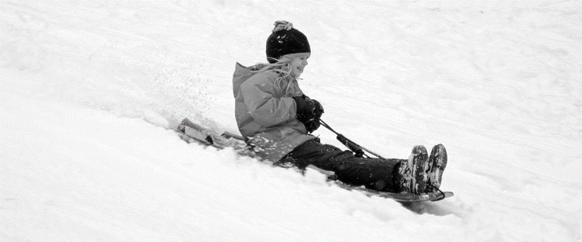

**Work done = force x distance**

**Work done = 315 x 12 = 3780 J**

b**.** The children swap places and the other child is now pulled to the top of the hill.

The work done in pulling the second child to the top of the hill was 4620 J.

Work out the weight of the second child. (2)

**Weight = Work done / distance**

**Weight = 385 N**

c. Work done is usually measured in joules, J.

Give an alternative unit for work done. (1)

**Nm**

d**.** When a pencil eraser is rubbed onto a desk the eraser heats up.

Explain why the eraser heats up when rubbed on the desk. (2)

**Work is being done against frictional forces**

**Which causes a rise in the temperature of the eraser**

**C. Forces and Elasticity**

1Springs are used both in tension and compression.

a. Describe what is meant by tension and compression of a spring. (2)

**Tension is where the spring is being stretched**

**Compression is where the spring is being squashed**

b. Complete the table by giving two uses of springs in tension and two uses of springs in compression. (4)

|  |  |
| --- | --- |
| **Uses of Springs in Tension** | **Uses of Springs in Compression** |
| **Newtonmeter** | **Vehicle suspension spring** |
| **Trampolines** | **Mattress / bed springs** |

Any relevant uses

c**.** Springs can be used to keep fire doors closed.

When a fire door is opened, the spring is stretched which then applies a force to close the fire door

again. **Figure 1** shows how the spring is used.

A force-extension graph for the spring is shown in **Figure 2**.

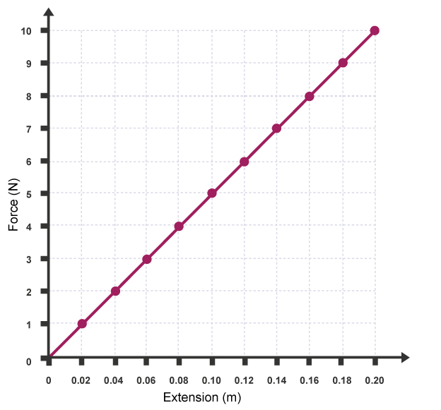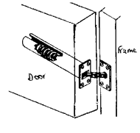 **Figure 1 Figure 2**

c. i) State the equation used to find the spring constant of a spring. (1)

**Force = spring constant x extension**

ii) Work out the spring constant of the spring used in **Figure 2.** (2)

**Spring constant = force / extension**

**Spring constant = 10 / 0.2 = 50 N/m**

iii) When the fire door is fully opened the spring is stretched 25 cm.

Work out the closing force applied by the spring when it is stretched 25 cm. (2)

**Force = 50 x 0.25**

**Force = 12.5 N**

iv) The fire door spring is removed from the door for testing.

During testing a force is applied to the spring and the extension is measured. The force applied to

the spring is increased until the spring snaps.

Draw the force-extension graph for the test described above. (2)

**Force / N**

**Extension / m**

d. i) Mountain bikes use springs for front suspension.

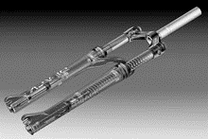

A typical mountain bike spring has a spring constant of 90 000 N/m and can be compressed 6 cm.

Use the formula given to work out the energy stored in the spring when compressed 6 cm. (2)

**Ep = 1/2 k e2**

**Ep = 0.5 x 90 000 x 0.062**

**Ep = 162 J**

ii) The spring on the mountain bike is changed to adjust the suspension. A new spring is added that has

a spring constant of 120 000 N/m.

Work out the distance this new spring has been compressed if it has 2820 J of elastic potential

energy. Give your answer in mm. (2)

**2820 / (0.5 x 120 000) = e2**

**e = √0.047 = 0.22 m**

**D. Moments, Levers and Gears (Physics Only)**

1A driver has a flat tyre. The driver uses a spanner to remove the nuts holding the wheel in place.

The spanner has a length of 35 cm and the driver applies a force of 300 N to the end of the spanner.

a. i) State the equation used to find the moment of the force. (1)

**moment = force x distance**

ii) Work out the moment of the force applied by the driver to the wheel nut. (2)

**moment = 300 x 0.35**

**moment = 105 Nm**

iii) Another driver applies a force to the same spanner.

The moment of the force is now 270 Nm.

Work out the size of the force applied by this driver. (2)

**Force = moment / distance or Force = 270 / 0.35**

**Force = 771 N**

iv) Give **two** ways in which the driver can apply a greater moment of the turning force applied to the

nut. (2)

**Apply the force at a greater distance from the pivot (use a longer spanner)**

**Apply a greater force to the spanner**

2. a. Complete the following sentences. (3)

If a seesaw is balanced the total **clockwise**  moment **equals** the total anticlockwise moment.

The moment of a force is measured in units of **newton metres, Nm.**

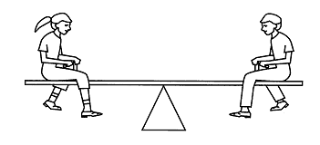 b. Two children, **Child A** and **Child B**, sit on either side of a see-saw.

**Child A** has a weight of 450 N and sits 1.4 m from the pivot. **Child B** sits 1.6 m from the pivot.

The see-saw is balanced.

Work out the weight of **Child B**. (3)

**Anticlockwise moment = clockwise moment**

**450 x 1.4 = weight child B x 1.6**

**Weight Child B = 394 N**

3. A crowbar is used to prise up a floorboard.

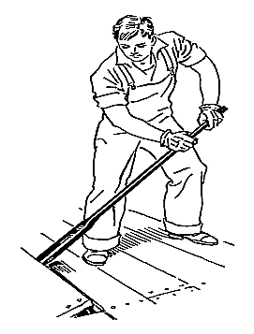 The crowbar is 70 cm long from the pivot, and the floorboard is 12 cm on the other side of the pivot.

A force of 120 N is applied to the end of the crowbar.

Work out the force applied to the floorboard. (3)

**Anticlockwise moment = clockwise moment**

**120 x 0.7 = force x 0.12**

**Force = 700 N**

4**.** A simple gear system is set up as shown in the diagram below.

The large cog has 40 teeth and the smaller cog has 20 teeth.

The large cog is rotated clockwise at a speed of 4 revolutions per minute.

Describe the motion of the smaller cog. (2)

**The smaller cog will rotate anticlockwise**

**The smaller cog will complete 8 revolutions a minute (or will spin faster)**

**E. Pressure and Pressure Differences in Fluids (Physics Only)**

1. Complete the following sentences. (3)

A fluid can be either a  **liquid** or a  **gas**.

The pressure in a fluid causes a force at **right-angles** to any surface.

2. This question is about pressure in a fluid.

a. i) State the equation that links area, force and pressure. (1)

**Pressure = force / area**

ii) A force of 18 N acts on a surface that has an area of 0.015 m2.

Work out the pressure acting on the surface. (2)

**Pressure = 18 / 0.015**

**Pressure = 1200 Pa**

b. Circle the two equivalent units for pressure. (1)

**m/s N/m N/m2 m/s2 Pa**

**c**. A surface has an area of 25 cm2.

Convert 25 cm2 into m2. (1)

**25 cm2 = 0.0025 m2**

3.A stone is dropped into a lake. The lake is 8.2 m deep.

Fresh water has a density of 1000 kg/m3. The gravitational field strength on Earth is 10 N/kg.

a. Work out the pressure on the stone at the bottom of the lake. (2)

***Pressure = density x gravitational field strength x height of column***

**Pressure = 1000 x 10 x 8.2**

**Pressure = 82 000 Pa**

b. Another stone is dropped into the sea.

Sea water has a different density to fresh water.

At a depth of 8.2 m the pressure on the stone is 84 380 Pa.

Work out the density of sea water to three significant figures. (2)

**Density = pressure / (gravitational field strength x height of column)**

**Density = 1030 kg/m3**

4. A student puts three holes into an empty bottle.

The holes are arranged vertically, as shown in the diagram below.

The bottle is then filled with water.

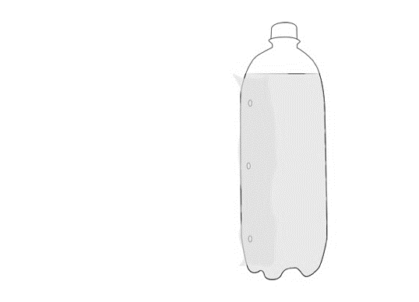

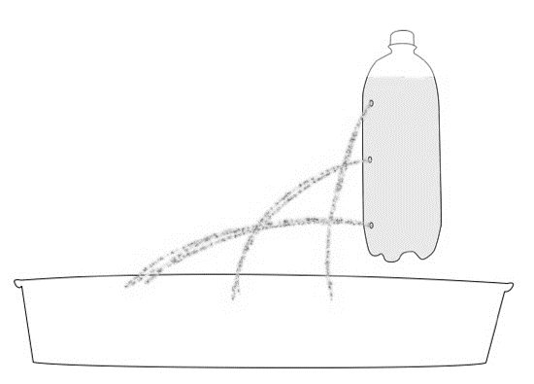 a. i) Complete the diagram to show how water will leave through the three holes. (1)

ii) Explain why the water leaves the bottle in the way that you have drawn, above. (2)

**The water at the bottom of the bottle is under the greatest pressure**

**The liquid at the bottom of the bottle will exert a greater force on the walls of the container.**

5**.** A submarine floats in mid-water at a depth of 47 m, to the top of the submarine.

The submarine has a height of 8.7 m. The surface area of the top and bottom surfaces of the submarine is

250 m2.

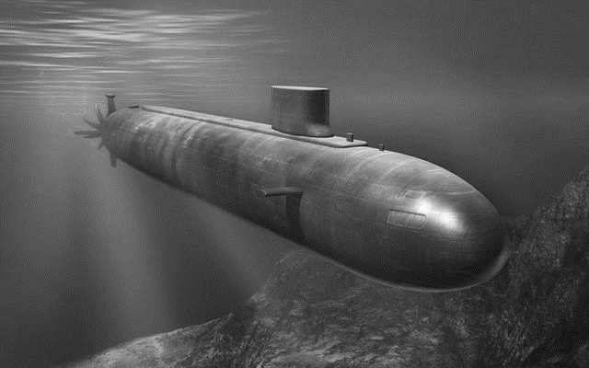

a. i) Explain why the submarine experiences an upthrust. (2)

**There is a difference in pressure between the top of the submarine and the bottom of the**

**submarine**

**The difference in pressure is equal to the upthrust**

ii) The density of the water is 1034 kg/m3. Take g = 9.8 N/kg.

Work out the weight of the submarine in kilonewtons, kN. (4)

**Pressure difference = 1034 x 9.8 x 8.7**

**Pressure difference = 88 159 Pa**

**As pressure = force / area**

**Force = 88159 x 250 = 22 040 kN**

iii) Submarines have ballast tanks that holdwater or air inside the submarine.

To surface, the submarine puts air into a ballast tank (which expels water from the tank). Explain

why this would cause the submarine to surface? (2)

**Filling the ballast tanks with air decreases the weight of the submarine**

**So, the upthrust is now greater than the weight causing the submarine to rise**

6**.** A child inflates a balloon with helium. The balloon is made from rubber.

When the end of the balloon is tied the size of the balloon remains constant.

a. i) Describe the **two** opposing forces that act on the balloon to keep the balloon the same size. (2)

**Force due to air pressure of the air inside the balloon pushing the balloon outwards**

**Force due to outside air pressure pushing the balloon inwards**

ii) The helium balloon is released and it goes up into the sky.

Describe what happens to the size of the balloon (assume the temperature of the balloon remains

constant). Explain your answer. (2)

**The balloon expands**

**As there is a lower pressure as you get higher (so a lower force acting inwards)**

b. When mountaineers climb high mountains they usually carry oxygen with them. The mountaineers

need to carry oxygen due to changes in atmospheric pressure as you go higher.

Explain how atmospheric pressure varies with height above the Earth's surface. (2)

**The higher you go the lower the pressure**

**As there is less weight of air pushing down**

c. Complete the sentence. (1)

For air molecules to create an atmospheric pressure the air molecules must collide with **a surface**.

**F. Forces and Motion**

1 a. Describe the difference between distance and displacement. (2)

**Distance is a scalar quantity - it has magnitude only**

**Displacement is a vector quantity - it has magnitude and direction**

b. An athlete runs around an oval shaped running track. The track is 400 m in length.

The athlete runs around the track four times.

i) State the distance travelled by the athlete. (1)

**1600 m**

ii) State the displacement of the runner at the end of the four loops of the track. Explain your answer. (2)

**Displacement = 0 m**

**As after 4 complete loops the athlete is in the same position**

2 a. Describe the difference between speed of a car and its velocity. (2)

**Speed is how fast an object is moving**

**Velocity is how fast an object is moving and in which direction**

2 b. Complete the table below by giving the typical speeds of a person when walking, running and cycling, in

m/s. (3)

|  |  |
| --- | --- |
| **Persons' Activity** | **Speed in m/s** |
| Walking | **1.5** |
| Running | **3** |
| Cycling | **6** |

2 c. Suggest **three** reasons why the instantaneous speed of a cyclist would differ from the typical speed stated

above. (3)

**Road not always horizontal**

**Traffic conditions may vary**

**Ridingsurface may change**

3. A person watches a rocket explode at a firework display. The person hears the explosion 2.5 seconds after

seeing the rocket explode.

 a. Work out how far away the rocket was when it exploded. (3)

Speed of sound in air = 330m/s

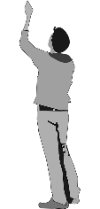

**Distance = speed x time**

**Distance = 330 x 2.5**

**Distance = 825 m**

b. Children are often told that the time difference, in seconds, between seeing lightning and hearing the

thunder is the distance the lightning strike was away, in miles.

The speed of sound is 330 m/s.

One mile is 1604 m.

Explain whether children are told the distance correctly. (3)

**Children not told correctly**

**Sound will travel 330 m every second whereas one mile is 1604 m**

**It will take sound 4.9 seconds to travel one mile (or other suitable calculation)**

4 Boats use sonar to find the depth of water where they are.

They measure the time taken to receive the echo of the sound wave that is sent out from the boat.

If it takes 4.7 s to receive the echo. The speed of sound in water is 1498 m/s.

Work out the depth of the sea at that point. (4)

**Distance = speed x time**

**Distance = 1498 x 4.7**

**Total distance to the sea floor and back = 7 041 m**

**Depth of the sea = 3 520 m**

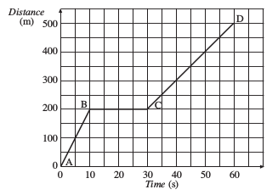5The motion of a car is shown in the distance-time graph below.

a. i) Describe fully the motion of car. (5)

**A to B Constant speed**

**of 20 m/s**

**B to C Stationary (for 20s)**

**C to D Constant speed**

**of 10 m/s**

ii) A motorbike completes the same journey at a greater average speed.

On the graph, above, add a second line to show the motion of the motorbike. (1)

**Line drawn that gets to 500m before 60 s**

**6** A car has its speed analysed over a period of one minute. The graph, below, shows the motion of the car.

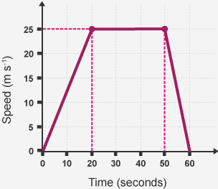

a. i) State the times when the car was stationary. (1)

**0s and 60 s**

ii) During which times did the car have the greatest acceleration?

Explain how the graph shows this. (2)

**50 to 60 s**

**The line on the graph is the steepest**

iii) Work out the acceleration of the car for the first 20 seconds of its journey. (2)

**acceleration = change in velocity / time taken or a = 25 / 20**

**acceleration = 1.25 m/s2**

iv) Work out the total distance travelled by the car. (3)

**Distance travelled = area under the line**

**Distance travelled = (0.5 x 25 x 20) + (25 x 30) + (0.5 x 25 x 10)**

**Distance travelled = 1125 m**

7 A stone is dropped off a cliff.

The stone hits the floor at a speed of 21.2 m/s.

The acceleration due to gravity on Earth is 9.8 m/s2.

a. Work out the height of the cliff. (3)

***v2- u2 = 2 a s***

**As the stone is dropped the initial velocity = 0 m/s**

**21.22 - 02 = 2 x 9.8 x s**

**s = 22.9 m**

b. The stone **did not** reach terminal velocity as it fell.

What conditions are required for an object to fall at terminal velocity? (2)

**Weight is equal in size**

**But opposite in direction to drag / air resistance**

**G. Forces, Acceleration and Newton's Laws of Motion**

1This question is about Newton's Laws of Motion.

a. i) State Newton's First Law of Motion. (1)

**A body will continue with uniform motion unless a resultant force acts upon it**

ii) State the equation used to commonly show Newton's Second Law of motion. (1)

**Force = mass x acceleration**

iii) A car crashes into a crash barrier.

The car experiences a force of 27 000 N.

Describe the force acting on the crash barrier. (2)

**The force acting on the crash barrier is 27 000 N**

**But acting in the opposite direction**

b. A motorbike and rider have a combined mass of 320 kg. The driving force supplied by the motorbike's

engine is 6700 N.

Work out the acceleration of the motorbike and rider. (2)

**Acceleration = force / mass**

**Acceleration = 20.9 m/s2**

c. Give the property of matter that gives an object the tendency to continue at rest or at a steady speed in

a straight line. (1)

**Inertia**

d. A car accelerates from rest until it reaches its top speed along a test track.

Explain how the acceleration of the car changes during its journey. (4)

**Maximum acceleration at the start as no drag force initially**

**As drag increases the acceleration of the car is reduced**

**At top speed driving and resistive forces are balanced, so no resultant force**

**Therefore, no acceleration**

2A ball of mass 0.6 kg is kicked with a force of 38 N.

Work out the acceleration of the ball. (2)

**Acceleration = force / mass or acceleration = 38 / 0.6**

**Acceleration = 63.3 m/s2**

3A father and son go ice skating. The son pushes the father with a force of 70 N.

State the size of the force on the son. Explain your answer. (2)

**- 70 N**

**As Newton's third law states that every action has an equal and opposite reaction**

**H. Forces and Braking**

1 This question is on the stopping distances of vehicles.

a. i) State the equation that links braking distance, stopping distance and thinking distance. (1)

Stopping distance = thinking distance + braking distance

ii) Define thinking distance. (1)

**The distance travelled while reacting to a stimulus until your foot is moved to the brake pedal**

iii) Define braking distance. (1)

**The distance travelled while braking**

iv) When a car performs an emergency stop from 70 mph the thinking distance is 21 m and the overall

stopping distance is 96 m.

Work out the braking distance of the car. (1)

**75 m**

b. i) Describe how the speed of a car affects the thinking distance. (2)

**Increasing speed increases thinking distance**

**Doubling speed doubles thinking distance (or it is directly proportional)**

ii) Explain how the speed of a car affects the braking distance. (3)

**Increasing speed increases braking distance**

**Doubling speed will give four times greater stopping distance**

**As there is four times the kinetic energy, since K.E. = 1/2 m v2**

c. i) Using a mobile phone whilst driving changes the stopping distance of a car.

Explain how the stopping distance is affected. (2)

**Mobile phone use is a distraction**

**So, will increase thinking distance**

ii) Complete the table to give three factors that will increase the thinking distance and three factors that

will affect the braking distance of a car. (4)

|  |  |
| --- | --- |
| **Factors Increasing Thinking Distance** | **Factors Increasing Braking Distance** |
| **Tiredness** | **Increasing the weight of car** |
| **Moving faster/increased speed** | **Icy / wet roads** |
| **Alcohol/non-stimulant drugs (** | **Brakes in poor condition** |

iii) State one factor that will reduce the thinking distance travelled by a car. (1)

**caffeine, as it is a stimulant**

**Going at a slower speed**

2 The speed limit on roads near schools has been reduced from 30 mph to 20 mph in many areas of the

UK.

Give two advantages and two disadvantages of reducing the speed limit outside schools. (4)

|  |  |
| --- | --- |
| **Advantages** | **Disadvantages** |
| * **Number of collisions reduced as stopping distance reduced** * **When pedestrians are involved in a collision the injuries are reduced** | * **It will take drivers longer to make a journey** * **Impatient drivers may perform dangerous overtaking manoeuvres** |

**3** Driverless cars are being tested on roads in Coventry.

Companies that make the driverless cars say that they will make the roads safer.

Some people are worried that it could lead to an increase in the number of road collisions.

Give two advantages and two disadvantages of driverless cars and explain whether you think that it will

make roads safer. (5)

**Advantages**

* **Reduces injuries due to human error**
* **Tiredness / drugs will not affect thinking distance**
* **Driverless cars can react a lot faster than humans**
* **Driverless cars can be programmed to take fewer risks**

**Disadvantages**

* **Computer software may pick up viruses or get hacked**
* **Response of driverless cars only as good as software that is running**
* **Potentially more expensive to make repairs**
* **Drivers may not like the lack of control**

**Explanation given and justified using arguments made previously.**

4. a.Explain the difference between thinking distance and reaction time. (2)

**Thinking distance is how far a vehicle will travel while the driver reacts to a stimulus**

**Reaction time is how long it took the driver to react to the stimulus**

b. Explain how you could find a persons' reaction time by experiment in a school science laboratory. (4)

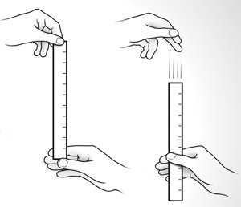 You may draw a diagram to help you answer this question.

**Equipment: Ruler**

**Drop a ruler through the persons' hand**

**Ruler should be placed with the 0 cm mark at the top of the hand**

**When the ruler starts to move, the person closes their hand**

**The distance the ruler moves corresponds to a thinking distance**

**The greater the distance the ruler travels the longer the reaction time**

**I. Momentum**

1a. State the equation that links mass, momentum and velocity. (1)

**Momentum = mass x velocity**

b. Momentum is a vector quantity. Explain what is meant by a vector quantity. (1)

**Vectors have both magnitude and direction**

c. Momentum is a conserved quantity.

Describe what is meant by a momentum being a conserved quantity. (1)

**The momentum before an event equals the momentum afterwards, in a closed system**

2a. A ball of mass 0.75 kg is kicked and moves off with a speed of 14 m/s.

Work out the momentum of the ball. (2)

**Momentum = 0.75 x 14**

**Momentum = 10.5 kgm/s**

b. The ball is kicked again and moves off with half the speed.

State the new momentum of the ball. (1)

**Momentum = 5.25 kgm/s**

c. Describe how doubling the mass of an object will affect its momentum, at a given speed. (1)

**Doubling the mass will double the momentum**

3a. A car has a momentum of 33 000 kgm/s and a speed of 30 m/s.

Work out the mass of the car. (2)

**Mass = 33 000 / 30**

**mass = 1100 kg**

3b The car changes speed and now has a momentum of 4760 kgm/s.

Work out the new speed of the car. (2)

**Velocity = momentum / mass or Velocity = 4760 / 1100**

**Velocity = 4.3 m/s**

4In a crash test two identical cars of mass 900 kg move towards each other.

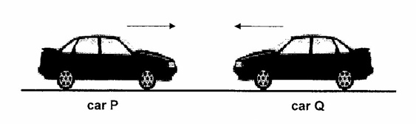

Before impact, **Car P** has a speed of 14 m/s and **Car Q** has a speed of 18 m/s.

a. i) Work out the total momentum of the two cars before impact. (3)

**Taking motion to the right to be positive:**

**Momentum = momentum of Car P + momentum of Car Q**

**Momentum = 900 x 14 - 900 x 18**

**Momentum = - 3600 kgm/s**

ii) After impact the cars move off together to the left.

Work out the speed that the two cars move off at after impact. (3)

**Combined mass = 1800 kg**

**Momentum = mass x velocity or - 3600 = 1800 x velocity**

**Velocity = - 2 m/s or 2 m/s from right to left**

**5** Cars have many features to reduce injury in case of a crash. Seatbelts and crumple zones are two safety

features designed to reduce injury in a crash.

a. i) Give **one** other safety feature designed to reduce injury in a crash. (1)

**One of:**

**Airbags Roll Cage Laminated Glass Head rest**

ii) Explain how seatbelts reduce injury in a crash. (4)

**Seatbelts increase the time of impact as they are designed to stretch a little**

**This reduces the acceleration as acceleration = change in velocity / time taken**

**The force is reduced as force = change in momentum / time taken**

**As the force of impact is reduced the injuries are also reduced**

iii) In a crash a car changes its velocity from from 20 m/s to 0 m/s. It takes the car 0.2 s to stop.

The car had a mass of 1265 kg.

Work out the force acting on the car. (4)

**Force = change in momentum / time taken**

**Change in momentum = 20 – 0 x 1265 = 25 300 kgm/s**

**Force = 25 300 / 0.2**

**Force = 126 500 N**