1. **Energy changes and energy stores part 1 – Energy systems and energy changes**

1. Describe the energy store changes when a rocket firework is lit, goes up in the air and then falls back

to the ground. (4)

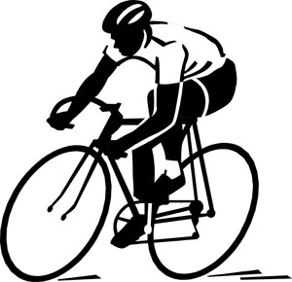2. The cyclist is braking hard to avoid a collision.

Describe the energy store changes as the bicycle and rider decelerate to a stop. (3)

3. When a battery stops working people often say the energy has been used up. Explain why this statement is

not correct. (2)

4. The Sankey diagram shows the simple energy store transfers for a car.

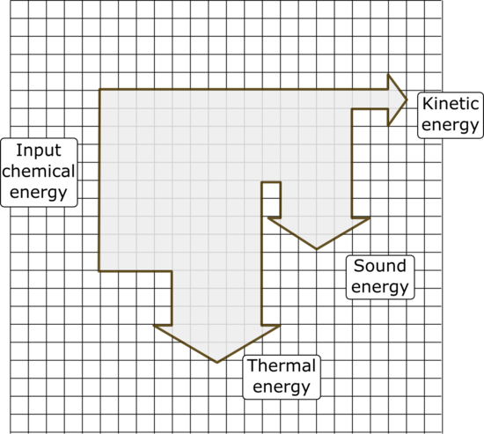

Chemical energy from the petrol = 20 000 J

1. Calculate the amount of useful energy

transferred by the engine. (1)

1. What is the total amount of “wasted” energy

in the system? (1)

5. An eagle has a mass of 4 kg and is flying at a velocity of 35 m/s. Calculate the kinetic energy of the bird. (3)

6. The spring on a car wheel extends by 0.05 m when the wheel goes down a pothole in the road.

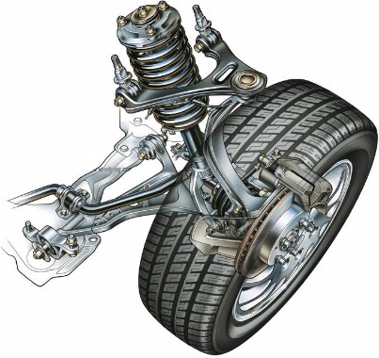

spring

**Ee = ½ k e2**

If the spring constant is 20 kN/m, calculate the elastic potential energy in the spring when it is extended. (2)

7. A 48 kg person diving off a cliff has 3500 J of stored gravitational potential energy. Calculate the height of the

cliff. (3)

**B. Energy changes and energy store part 2 – energy changes in systems and power**

8. A swimming pool contains 30 000 kg of water at 8 oC.

Specific heat capacity of water = 4181 J/kg oC

**ΔE = m x c x Δθ**

1. How much thermal energy is needed to raise the temperature of the water to 15 oC? (3)
2. On a sunny day, the concrete at the side of the pool feels much hotter than the water, even though both have received the same thermal energy from the sun. Explain fully why the concrete is hotter. (2)

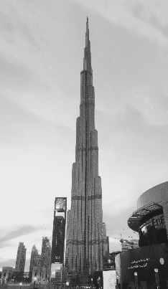9.The lift in the world’s tallest building takes 64 s to reach a height of 828 m.

The maximum mass of the lift and passengers is 900 kg.

1. Calculate the power of the lift. (3)
2. A service lift in this building is used to move furniture to apartments in the tower.

This lift has a 130 kW motor. If the maximum load for this lift is 2 000 kg, how long will it take to reach

the top of the building? (3)

**C. Conservation and dissipation of energy – Energy transfers and efficiency**

10. The diagram represents the energy transfers for an oil-fired power station.

**Generator**

**Turbine**

**Water and steam**

**Oil**

**Useful energy out**

**Energy transferred as movement**

**X**

**Energy transferred as heat**

1. What is the useful energy out? (1)
2. In what form will energy be “wasted” in this process? (1)
3. What useful energy store is represented by the box labelled **X**? (1)

11. Loft insulation reduces heat loss from a home.

Loft insulation can be made out of many different materials.

Give two properties of the insulating material that will affect the amount of heat lost through the roof. (2)

12. A company sells two types of electric drill.

 Drill A Drill B

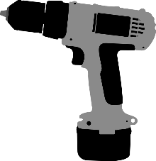

Drill A is a 300 W drill with an output power of 165 W.

Drill B is a 1100 W drill with an output power of 520 W.

Explain which drill is the more efficient at transferring useful energy? (3)

13. Describe two ways you could increase the efficiency of a household central heating system. (2)

**D. National and global energy resources – renewable and non-renewable energy**

**resources and patterns in energy use**

14. Name four renewable and four non-renewable energy resources. (2)

|  |  |
| --- | --- |
| Energy Resources | |
| Renewable resources | Non-renewable resources |
|  |  |
|  |  |
|  |  |
|  |  |

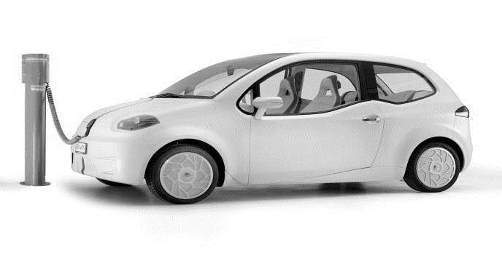15. An electric car uses no fossil fuels to turn its motor.

Themanufacturer claims this car does not contribute to carbon dioxide emissions into the atmosphere.

Explain why the manufacturer’s claim is not true. (3)

16. Explain why fossil fuels are considered to be a more reliable energy resource for electricity production than

the use of wind turbines. (3)

17. Name an appropriate energy source for each of the following uses and describe briefly how it is used for

this purpose. (3)

|  |  |  |
| --- | --- | --- |
| **Use** | **Energy source** | **How it is used** |
| **Producing electricity** |  |  |
| **Transport** |  |  |
| **Heating a hospital** |  |  |

18. Worldwide agreements to reduce CO2 emissions are intended to slow down climate change. Describe how

CO2 emissions contribute to climate change. (4)

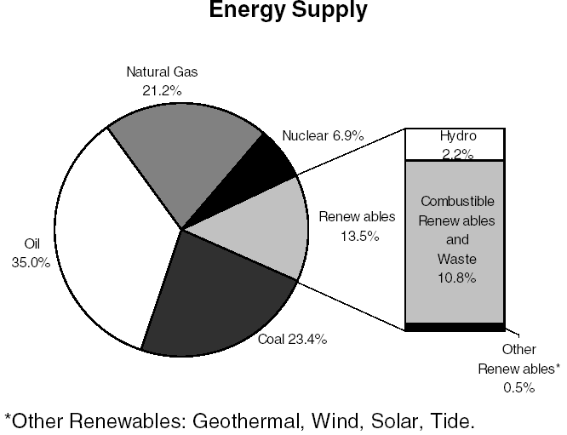19. The chart shows the world’s energy resources usage for 2015.

Discuss the likely changes to the world’s energy supplies over the next 50 years. (6)