1. **Current, Potential Difference and Resistance**

1aA student builds a circuit. The circuit is shown in **Figure 1.**

Label the components shown in **Figure 1.** (3)

**Figure 1**

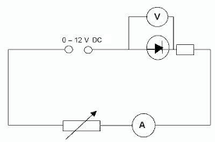

1bA resistor adds resistance to a circuit.

Describe what the effect of adding resistance would have on the current flowing in the circuit. (2)

..............................................................................................................................................

..............................................................................................................................................

.............................................................................................................................................

1cIn another electrical circuit a current of 1.2 A flows for 17 seconds.

Work out the charge flow in the circuit. Give the units of charge. (3)

..............................................................................................................................................

..............................................................................................................................................

.............................................................................................................................................

2 A student sets up the circuit shown in **Figure 2** to measure the resistance of a resistor.

**Figure 2**



0.4 mA

3.6 V

2a(i)Work out the resistance of the resistor in the circuit. (3)

..............................................................................................................................................

..............................................................................................................................................

2a(ii)The student adds a variable resistor into the circuit.

The variable resistor is used to get range of values for the potential difference and the current in

the circuit.

Draw a graph to show how the potential difference and the current across the resistor are linked.

Label this line **A.** (1)

Potential Difference / V

Current / A

2a(iii)The resistor is replaced with a different resistor that has a lower value of resistance.

On the axes given for 2a(ii), draw a line to show how the current and the potential difference are now linked for this new resistor. Label this new resistor line **B**. (1)

2a(iv)A resistor is an ohmic conductor.

Explain what is meant by an ohmic conductor. (1)

..............................................................................................................................................

..............................................................................................................................................

2a(v)State the conditions required for the resistor to obey ohm's law. (1)

..............................................................................................................................................

..............................................................................................................................................

2a(vi) The resistor in **Figure 2** is replaced with a filament lamp.

The graph shown in **Figure 3** shows how the current and potential difference are linked.

**Figure 3**

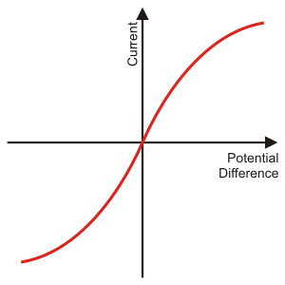

Explain the shape of the current - potential difference graph for a filament lamp. (6)

..............................................................................................................................................

..............................................................................................................................................

.............................................................................................................................................

..............................................................................................................................................

..............................................................................................................................................

.............................................................................................................................................

..............................................................................................................................................

..............................................................................................................................................

1. **Series and Parallel Circuits**

1a(i) A teacher wants to demonstrate the properties of series and parallel circuits.

The teacher sets up a circuit with three identical filament lamps connected in series with a

battery and an open switch.

Draw the circuit that the teacher would set up. (3)

1a(ii)Each filament lamp has a resistance of 14 Ω.

Work out the total resistance of the three filament lamps in series. (2)

..............................................................................................................................................

..............................................................................................................................................

.............................................................................................................................................

1a(iii)The teacher now adds a fourth filament lamp in series with the other three.

Describe the effect that adding this extra filament lamp will have on the circuit. (4)

..............................................................................................................................................

..............................................................................................................................................

.............................................................................................................................................

..............................................................................................................................................

1bThe same four filament lamps are now placed into a parallel circuit.

Describe how adding filament lamps in parallel affects the brightness of the filament lamps

compared to the brightness of a single filament lamp. (1)

..............................................................................................................................................

..............................................................................................................................................

2aSix identical filament lamps are placed in a parallel circuit.

The current through each filament lamp is 3 A.

Calculate the current drawn from the power supply. (2)

..............................................................................................................................................

..............................................................................................................................................

.............................................................................................................................................

2bTwo resistors, **R1** and **R2**, are placed in parallel.

**R1** has a resistance of 120 Ω and **R2** has a resistance of 80 Ω.

The total resistance of the two resistors is less than 80 Ω.

Explain why adding resistors in parallel decreases the total resistance. (4)

..............................................................................................................................................

..............................................................................................................................................

.............................................................................................................................................

..............................................................................................................................................

1. **Domestic Uses and Safety**

1Home electrical wiring uses three core electrical cables.

1aMatch the name, colour and function of each wire. (3)

|  |  |  |  |  |
| --- | --- | --- | --- | --- |
| **Name of Wire** |  | **Colour of Wire** |  | **Function of Wire** |
|  |  |  |  |  |
| Earth |  | Blue |  | Safety Wire |
|  |  |  |  |  |
| Live |  | Brown |  | To supply high voltage |
|  |  |  |  |  |
| Neutral |  | Yellow / Green |  | To complete the circuit |

1b(i)State the potential difference found in each wire when it is operating under normal conditions. (3)

**Live:**

**Earth:**

**Neutral:**

1b(ii)State the frequency of the mains electricity supply. (1)

..............................................................................................................................................

..............................................................................................................................................

1cA live wire can be dangerous even if a switch on the mains circuit is open.

Explain why the live wire can still be dangerous. (3)

..............................................................................................................................................

..............................................................................................................................................

.............................................................................................................................................

..............................................................................................................................................

1d(i)Draw the output trace that you would get from a direct potential difference (dc) supply. (1)

Potential Difference

Time

1d(ii)Draw the output trace that you would get from an alternating potential difference (ac) supply. (1)

Time

Potential Difference

1. **Energy Transfers**

1aA kettle has a power rating of 1.2 kW.

The kettle uses mains electricity at 230 V.

Work out the current flowing through the kettle. (4)

..............................................................................................................................................

..............................................................................................................................................

.............................................................................................................................................

..............................................................................................................................................

1bDescribe the useful energy transfer that takes place in a kettle. (1)

..............................................................................................................................................

..............................................................................................................................................

.............................................................................................................................................

1cAnother kettle has a power rating of 1.5 kW.

This kettle takes 90 seconds to boil the water.

Work out the energy transferred by the kettle in the 90 seconds.

Give the correct unit with your answer. (4)

..............................................................................................................................................

..............................................................................................................................................

.............................................................................................................................................

..............................................................................................................................................

2aAn electric motor is used to raise a lift.

The electric motor is connected to mains electricity at 230 V and has a power rating of 5 kW.

It takes the electric motor 35 seconds to raise the lift 20 meters.

Work out the charge flow in the electric motor. (4)

..............................................................................................................................................

..............................................................................................................................................

.............................................................................................................................................

..............................................................................................................................................

2b(i)Describe the useful energy changes that take place in an electric motor. (1)

..............................................................................................................................................

..............................................................................................................................................

2b(ii) Describe how energy is wasted in an electric motor. (2)

..............................................................................................................................................

..............................................................................................................................................

.............................................................................................................................................

3aAn overhead powerline is used to transmit electricity from power stations to our homes.

A powerline carries a current of 350 A and has a power loss of 4 MW.

Work out the resistance of the powerline. (4)

..............................................................................................................................................

..............................................................................................................................................

.............................................................................................................................................

..............................................................................................................................................

3bExplain why the current through the powerline is made as low as possible in The National

Grid. (4)

..............................................................................................................................................

..............................................................................................................................................

.............................................................................................................................................

..............................................................................................................................................

3c Describe how the current is reduced before transmitting the electricity through the powerlines. (2)

..............................................................................................................................................

..............................................................................................................................................

.............................................................................................................................................

1. **Static Electricity**

1This question is about static electricity.

1a State the **two** types of static charge.(1)

..............................................................................................................................................

..............................................................................................................................................

1b(i)A plastic rod has been given a positive charge by rubbing the plastic rod on a cloth.

Explain how the plastic rod has been given a positive charge in terms of movement of particles.(2)

..............................................................................................................................................

..............................................................................................................................................

1b(ii)The charged plastic rod is placed above some fine dust particles.

Describe the effect that the charged rod will have on the dust. (1)

..............................................................................................................................................

..............................................................................................................................................

1cXavi walks across a carpet.

Once Xavi has crossed the carpet he touches an earthed metal radiator and gets an electric shock.

Explain why Xavi gets an electric shock when he touched the earthed radiator. (3)

..............................................................................................................................................

..............................................................................................................................................

.............................................................................................................................................

..............................................................................................................................................

2Static is used in the spray painting of car doors.

**Figure 1** shows a car door being spray painted using static.

**Figure 1**

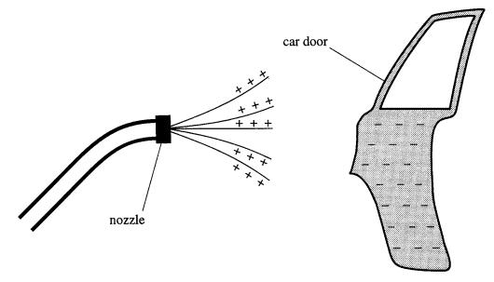

2a(i) Explain why electrostatic spray painting produces a fine spray. (3)

..............................................................................................................................................

..............................................................................................................................................

.............................................................................................................................................

2a(ii)Explain why the car door is given a negative charge. (3)

..............................................................................................................................................

..............................................................................................................................................

.............................................................................................................................................

2a(iii) Suggest an advantage of electrostatic spray painting over the use of tins of spray paint. (1)

..............................................................................................................................................

..............................................................................................................................................

.............................................................................................................................................

2b(i)A droplet of paint has been given a positive charge.

Draw the electric field for this paint droplet. (1)

2b(ii) Describe what would happen if another positively charged particle was placed into this electric

field. (2)

..............................................................................................................................................

..............................................................................................................................................

.............................................................................................................................................

2c A spark is formed when a charged object is earthed.

Explain why a spark forms. (3)

..............................................................................................................................................

..............................................................................................................................................

.............................................................................................................................................