**A. Using the Earth’s resources and sustainable development**

1. Describe two ways that humans use the Earth’s natural resources.
2. Explain what the term finite means and give an example.
3. What three areas do humans process finite resources from?
4. What is meant by the term sustainable development?

**B. Using the Earth’s resources and obtaining potable water**

1. Why is potable water not described as pure water by scientists?
2. What does the method used to produce potable water depend upon?
3. How is most potable water in the UK produced?
4. What two methods can be used for the desalination of salty water?

**C. Waste water treatment**

1. What needs to be removed from sewage and agricultural waste water?
2. What needs to be removed from industrial waste water?
3. What are the four stages in the treatment of sewage?

**D. Alternative methods of extracting metals (HT only)**

1. What type of ores can phytomining and bioleaching be used on?
2. Why are phytomining and bioleaching used?
3. How does phytomining extract metals?
4. Bioleaching uses bacteria to make leachate solutions that contain metal compounds, describe two ways the metals are extracted from these solutions

**E. Life Cycle assessment**

1. Life cycle assessments are carried out to assess the environmental impact of what stages of a product?
2. What areas of life cycle assessments can be easily quantified?
3. Why are value judgements needed in the production of life cycle assessments?

**F. Ways of reducing the use of resources**

1. Name three things that reduce the use of limited resources.
2. Name three materials produced from limited resources.
3. Other than reusing how are glass bottles recycled
4. How are metals recycled?

**G. Corrosion and its prevention, alloys as useful materials (Chemistry Only)**

1. What is corrosion?
2. What is rusting?
3. What is needs to be present for iron to rust?
4. Look at the following diagram and explain the purpose of A, B and C.

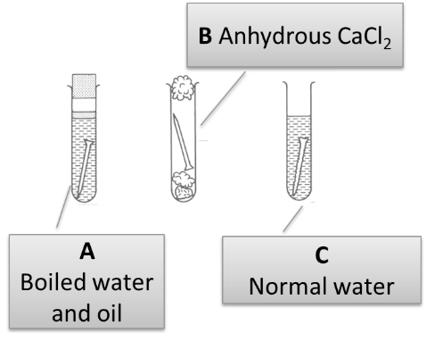

1. Name four methods of preventing corrosion.
2. Why would coating iron with zinc prevent corrosion?
3. Why does aluminium not corrode?
4. Name the metals in the alloy bronze.
5. Name the metals in the alloy brass.
6. Gold jewellery is usually an alloy with which metals?
7. What does the term 24 carat gold mean?
8. What are steels?
9. What are the properties of high carbon steel?
10. What are the properties of low carbon steel?
11. What metals are added to iron to make stainless steel?
12. What are the properties of stainless steel?

**H. Ceramics, polymers and composites (Chemistry only)**

1. How is soda-lime glass made?
2. How is borosilicate glass made?
3. How do soda-lime and borosilicate glass differ?
4. How are clay ceramics made?
5. Give 2 examples of clay ceramics.
6. What are low density and high density poly(ethene) made from?
7. What is a thermosetting polymer?
8. What is a thermosoftening polymer?
9. What is a composite made of?
10. Give 3 examples of composites.

**I. The Haber process and NPK (Chemistry only)**

1. What is a reversible reaction?
2. (HT) Give the balanced symbol equation for the reaction between nitrogen and hydrogen to produce ammonia.
3. (HT) What compromises are made in the reaction conditions for the production of ammonia in the Haber process?
4. What three elements do most fertilisers contain?
5. What is produced when ammonia reacts with nitric acid?
6. Write a balanced symbol equation for the reaction between ammonia and nitric acid.
7. Name two salts which are mined and can be used as fertilisers.
8. State why phosphate rock cannot be used directly as a fertiliser.
9. What can phosphate rock be treated with to produce soluble salts?
10. Name the salt produced when phosphate rock reacts with:
    * 1. Nitric acid
      2. Sulfuric acid
      3. Phosphoric acid.