1. **Using the Earth’s resources and sustainable development**
2. Give two ways that humans utilise the Earth’s natural resources? (2)
3. What is meant by the term finite resources? (2)
4. **Extended response question:**

Look at the table below.

|  |  |  |
| --- | --- | --- |
| Fuel | Reserves in billions of tonnes | Amount used annually in billions of tonnes |
| Natural gas | 200,000 | 5 |
| Oil | 240 | 6 |
| Coal | 880 | 8 |

Show by calculation which fuel, oil or gas will last longer. Explain why the amount of reserves may change and state why the above table does not show that these reserves are finite. (6)

1. What is meant by the term sustainable development and give an example with a justification (4)
2. **Potable water**
3. The two graphs below show the temperature as two samples of ice are heated until they melt. Which of these samples A or B is most likely to show potable water? Explain your choice. (3)

**A** **B**



1. **Extended response question:**

Describe and explain the stages used in the production of potable water from ground water. (6)

1. **Extended response question:**

Describe the two most common methods of producing potable water from salty water and explain why these methods are not used in areas with adequate supplies of ground water. (6)

1. **Waste water treatment**

1. Describe the similarities and differences between the processing of sewage, agricultural and industrial waste water. (4)

2. Give the four stages in the treatment of sewage. (4)

1. **Alternative methods of extracting metals (HT only)**

1. **Extended response question:**

Describe how phytomining and bioleaching are now being used to extract copper and why these methods are being used. (6)

**E. Life cycle assessment**

1. In the given stages below compare the life cycle assessments for a plastic and a paper bag used for shopping, the first stage has been completed for you.

**Extracting and processing raw materials**

Plastic bag – crude oil needs to be extracted from the Earth, this requires energy and may cause pollution

Paper bag – trees need to be cut down and removed, this causes destruction of forests and loss of habitats, but can be sustainable

* + **Manufacturing and packaging** (2)
  + **Use and operation during its lifetime** (2)
  + **Disposal at the end of its useful life**(2)

**F. Ways of reducing the use of resources**

1. Many councils now provide recycling bins to promote recycling. Give three reasons why they do this. (3)

1. Glass bottles can be reused, whereas metal is recycled describe the similarities and differences in these two processes (3)

**G. Corrosion and its prevention, alloys as useful materials (Chemistry only)**

1. Explain how rusting can be prevented (3).
2. Explain why aluminium does not corrode in the same way as iron (2).
3. Explain what is meant by sacrificial protection (2).
4. Design an investigation to show that both air and water are necessary for rusting (4).
5. Explain how to galvanise iron and why this helps to prevent corrosion (4).
6. Steels are alloys of iron containing specific amounts of carbon and other metals. Different steels have different properties and can therefore have different uses. Describe the properties of the following steels and give a use for each (6).
   1. High carbon steel
   2. Low carbon steel
   3. Steel containing chromium and nickel

**H. Ceramics, polymers and composites (Chemistry only)**

1. Explain the difference between soda-lime glass and borosilicate glass (3).
2. Explain how clay ceramics are made, give two examples of a clay ceramic (4).
3. What factors impact upon the properties of polymers? (2)
4. Explain the difference between thermosoftening and thermosetting polymers in terms of their structure (5).

1. Explain how composites are made (4).

**I. The Haber process and NPK (Chemistry only)**

1. Ammonia can be used to produce nitrogen-based fertilisers. It is manufactured on an industrial scale using the Haber process. Explain how ammonia is produced using the Haber process, you should include the following in your response:
   * An equation
   * A source for each raw material
   * The reaction conditions.

(6)

1. The following graph outlines the impact of reaction conditions on the percentage yield of ammonia from the Haber process. Describe the conditions which give the highest yield and explain why there is a compromise on these conditions in industry [4].

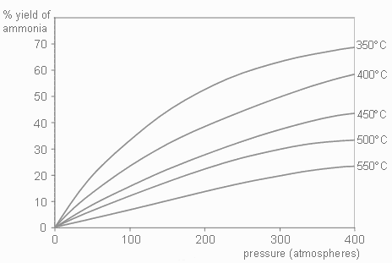

1. Explain what NPK fertilisers are, include the names of the three main elements they contain (3).
2. Describe how ammonia is used in industry. Write a balanced symbol equation for the production of ammonium nitrate (NH4NO3) from ammonia and nitric acid (3).
3. Calculate the percentage (%) of nitrogen in ammonium nitrate (NH4NO3) (3).

Relative atomic masses: N 14; H 1; O 16

1. Explain how the soluble fertiliser calcium nitrate is obtained from insoluble phosphate rock (1).