1. **Rate of Reaction - Calculating Rates of Reaction**
2. A student carried out a reaction between calcium carbonate solid (CaCO3) and hydrochloric acid (HCl) producing dissolved calcium chloride (CaCl2) carbon dioxide and water. Write the balanced symbol equation for this reaction, including state symbols. (3)

CaCO3 (s) + 2HCl (aq) 🡪 CaCl2 (aq) + CO2 (g) + H2O (l)

***All formulae correct [1]***

***Balancing correct (dependent upon first mark) [1]***

***All state symbols correct [1]***

1. Below is a table of results for the reaction, the student measured the volume of gas released every ten seconds

|  |  |
| --- | --- |
| Time in seconds | Volume of carbon dioxide released in cm3 |
| 0 | 0 |
| 10 | 8 |
| 20 | 16 |
| 30 | 22 |
| 40 | 24 |
| 50 | 25 |
| 60 | 26 |
| 70 | 26 |

Calculate the rate of the reaction in the first ten seconds. Give the unit (3)

***8/10 [1] OR 0.8 [2] cm3 [1]***

1. What is the rate of the reaction between 30 and 40 seconds? (2)

***2/10 [1]***

***BUT 0.2 [2]***

1. Is the rate of reaction, faster, slower or the same between 0 and 10 seconds than between 30 and 40 seconds? Explain your answer (2)

***faster [1]***

***Any indication that there are more reacting particles/ORA [1]***

**B. Rate of Reaction - Factors Which Affect The Rate of Chemical Reactions**

1. **Extended response question:**

The student repeated the experiment, this time however he used 2.0 Molar acid rather than 1.0 Molar acid. Describe or draw a labelled diagram to show how the student might carry out the experiment, calculate the rate of reaction that the student might calculate for this new reaction for the first ten seconds and what volume of carbon dioxide would you expect him to collect at the end of the experiment.

Here are his original results (6)

|  |  |
| --- | --- |
| Time in seconds | Volume of carbon dioxide released in cm3 |
| 0 | 0 |
| 10 | 8 |
| 20 | 16 |
| 30 | 22 |
| 40 | 24 |
| 50 | 25 |
| 60 | 26 |
| 70 | 26 |

***Method***

***Container e.g. conical flask containing calcium carbonate and hydrochloric acid [1]***

***Method of transferring gas produced to vessel for measuring volume e.g. delivery tube [1]***

***Labelled vessel for measuring volume e.g. gas syringe/upturned measuring cylinder [1]***

***Rate of reaction***

***16/10 [1] OR 1.6 [2]***

***New volume of carbon dioxide***

***52 (cm3) [1]***

1. Give two other ways that the student might decrease the rate of reaction other than changing the concentration. (2)

***Any two from decrease temperature/decrease surface area/remove a catalyst [2]***

1. **Rate of Reaction – Collision Theory And Activation Energy**
2. What two requirements must be met for reacting particles to react? (2)

***They must collide, [1] with sufficient energy [1]***

1. What is the activation energy of a reaction (2)

***The minimum amount of energy [1] particles must have in order to react [1]***

1. For the reaction below explain what would happen to the rate of the reaction and why if the solid magnesium was cut into smaller pieces. (4)

Hydrochloric acid + magnesium 🡪 magnesium chloride + hydrogen

***Rate of reaction would increase [1] surface area of magnesium has increased[1] frequency of collisions increases [1] larger surface area to volume ratio [1]***

1. A student calculated that the surface area had been increased to three times it’s original size. Describe and explain what you think would happen to the rate of reaction. (2)

***The rate of reaction would increase by three [1] as the frequency of collisions would increase by three [1]***

1. **Rate of Reaction – Catalysts**
2. What is the name given to catalysts in biological systems? (1)

***Enzymes (1)***

1. How do catalysts increase the rate of a chemical reaction. (2)

***They provide a different/ alternative pathway for the reaction (1)***

***That has a lower activation energy (1)***

1. For the energy profile below decide which reaction(s) are catalysed, which reaction was the original reaction without a catalyst and which is the best catalyst to use for the reaction. Explain your decisions. (4)

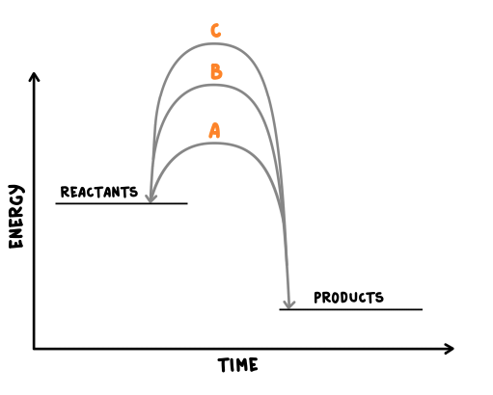

***C is the uncatalysed reaction [1] as it has the highest activation energy [1]***

***A is the best catalyst to use [1] as it lowers the activation energy the most [1]***

1. **Reversible reactions and dynamic equilibrium**

1.Name the reaction shown below and describe what it shows (2)

W + X 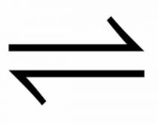 Y + Z

***Reversible reaction (1)***

***The products of the reaction can react to form the original reactants (1)***

1. Other than changing the pressure, for the reaction below describe and explain how you would produce more ammonia NH3 (2)

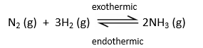

***Decrease the temperature [1]***

***The forward reaction is exothermic [1]***

1. For the reaction below, 135 kJ of energy is put in to make the anhydrous copper sulfate. How much energy will be released if the same amount of water is added to the anhydrous copper sulfate as was removed in the forward reaction. Explain your answer. (2)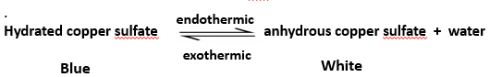

***135Kj [1]***

***The same amount of energy is transferred in each direction/case [1]***

1. Describe the apparatus and what is happening if a reaction is said to be in equilibrium? (3)

***The forward and reverse reactions [1]***

***Happen at the same rate [1]***

***The apparatus prevents the escape of reactants and products [1]***

1. **The effect of changing concentration, temperature or pressure on equilibrium (HT only)**
2. A student is investigating the following reaction



Describe what would happen if the student increased the concentration of reactants, then the concentration of products and explain why you think this. (6)

***If concentration of reactants is increased then more products will be formed [1] until equilibrium is reached again [1]***

***If concentration of products is increased then more reactants will be formed [1] until equilibrium is reached again [1]***

***Due to Le Chatelier’s principal [1] if a change is made then system responds to counteract the change [1]***

1. A reaction is at equilibrium, the reactants are iodine gas I2 and hydrogen gas H2, the product is hydrogen iodide gas HI. When the temperature of the system is increased more iodine and hydrogen are produced.

Write the balanced symbol equation for this reaction and include the directions of the endothermic and exothermic reactions and the state symbols (4).

***exothermic***

I2 (g) + H2 (g)  2HI (g)

***endothermic***

***Symbol equation with reversible sign [1]***

***Balanced [1]***

***State symbols [1]***

***Exothermic and endothermic in the correct place [1]***

1. Explain what would happen in the following equilibrium reaction if we increased the pressure. (3)

N2 (g) + 3H2 (g)  2NH3 (g)

***Equilibrium would move to the right/we would get more ammonia [1]***

***There are less molecules/moles on the right hand side [1]***

***Any further explanation using Le Chatelier’s principal [1]***