1. **Crude Oil, Hydrocarbons and Alkanes**

1. What is the formula of an alkane with eight hydrogens? Draw its structural formula (2)

***C3H8 [1]***

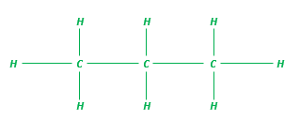 [1]

2. Describe what crude oil is, how it is made and what it is made of. (6)

***Any six from -***

***Crude oil is a finite resource [1], it is the remains of an ancient biomass (accept plankton) [1] that was buried in mud [1] it is a mixture of lots of compounds [1] mostly hydrocarbons [1] made of hydrogen and carbon [1] only[1] most of which are alkanes [1]***

3. Give the name and formulae for the first two alkanes in the homologous series. (2)

***Methane CH4 [1]***

***Ethane C2H6 [1]***

1. **Fractional Distillation And Petrochemicals**

1. Name three of the fractions separated in fractional distillation (3)

***Any three from***

***Petrol, diesel oil, kerosene, heavy fuel oil, liquefied petroleum gases (LPG) [3]***

2. Explain how fractional distillation separates these fractions. (4)

***Fractions evaporate [1] at different boiling points [1] these condense [1] at different points in the column [1]***

3. Why are there so many natural and synthetic carbon compounds? (1)

***Carbon atoms can make families of similar compounds [1]***

4. Name two materials produced by the petrochemical industry. (2)

***Any two from***

***Solvents, lubricants, polymers, detergents [2]***

1. **Properties of Hydrocarbons**

1. Hydrocarbons in crude oil vary in their size. Describe how increasing molecular size of hydrocarbons alters the boiling point, viscosity and flammability of hydrocarbons. (3)

***Increasing size, increases boiling point [1], increases viscosity [1] and decreases flammability [1]***

2. Describe what happens to the carbon and hydrogen atoms in a hydrocarbon during combustion. (3)

***Bonds between carbon and hydrogens break [1] bonds between carbons and carbons break [1] both carbon and hydrogen are then oxidised [1] forming carbon dioxide and water [1]***

3. Write the balanced symbol equation for the complete combustion of pentane gas C5H12 (3)

***C5H12 (g) + 8O2 (g) 5CO2 (g) + 6H2O (g)***

***Correct formulae [1]***

***Correct balancing [1]***

***Correct state symbols [1] / allow (l) for water as the state symbol.***

1. **Cracking and Alkenes**

1. Name two types of cracking and explain why scientists might want to crack hydrocarbons. (4)

***Catalytic cracking [1] steam cracking [1] produces smaller [1] more useful molecules [1]***

2. The cracking of hydrocarbons can make alkanes and one other type of chemical. Name this chemical and describe a chemical test that could be used to identify between this chemical and the alkane. Give the positive test result as part of your answer. (3)

***Alkene [1] add bromine water [1] orange/brown to colourless [1]***

3. A scientist carried out an experiment to crack a hydrocarbon, here is the symbol equation for the reaction. The chemical that was cracked was C12H26 . One of the products was C2H4., hat is the formula of the other product? (2)

***C10 [1] H22 [1]***

1. **Structure, Formula And Reactions of Alkenes (Chemistry only)**

1. Alkenes are hydrocarbons with a double carbon – carbon bond. Give the general formula of the

alkenes and explain why they are called unsaturated. (2)

***CnH2n [1] they contain two fewer hydrogen atoms than alkanes with the same number of carbon atoms [1]***

2. Butene is an alkene that contains four carbon atoms. Write out its formula and draw its structural formula. (2)

***C4H8  [1]***

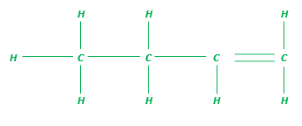***[1]***

3. In a reaction, propene was reacted with water. Write a balanced symbol equation for the reaction, then name and draw the structural formula of the product made. (3)

***C3H6 + H2O C3H5OH [1]***

***Propanol [1]***

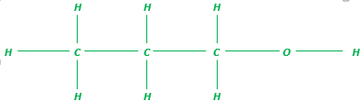 ***[1]***

1. **Alcohols (Chemistry only)**

1. Ethanol C2H5OH is made during fermentation. Draw the structural formula of ethanol, describe the conditions needed for fermentation and explain why one of the conditions is the absence of oxygen. (6)

|  |  |  |  |
| --- | --- | --- | --- |
| ***0 marks*** | ***Level 1 (1–2 marks)*** | ***Level 2 (3–4 marks)*** | ***Level 3 (5–6 marks)*** |
| ***No relevant content*** | ***OR***  ***Between 25OC and 45OC/yeast/water***  ***OR***  ***Ethanol will oxidise to ethanoic acid*** | ***Two of the relevant pieces of information.*** | ***All three relevant pieces of information.*** |

1. **Carboxylic acids (Chemistry only)**

1. Draw the structure of propanoic acid and indicate the functional group. (3)

***Correct number of carbon atoms [1]***

***Correct number of hydrogen atoms [1]***

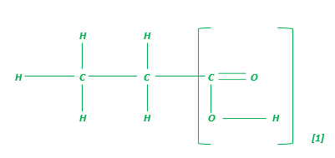

2. Describe what you would see if calcium carbonate was added to propanoic acid and compare this to the reaction of calcium carbonate with nitric acid. Explain the difference in the reactions. (6)

|  |  |  |  |
| --- | --- | --- | --- |
| ***0 marks*** | ***Level 1 (1–2 marks)*** | ***Level 2 (3–4 marks)*** | ***Level 3 (5–6 marks)*** |
| ***No relevant content*** | ***Bubbles of gas or carbon dioxide given off***  ***OR***  ***Correct identification of propanoic acid as a weak acid and nitric acid as a strong acid***  ***OR***  ***Correct explanation of greater ionisation in nitric acid/ORA*** | ***Two of the relevant pieces of information.*** | ***All three relevant pieces of information.*** |

1. **Addition polymerisation (Chemistry only)**

1. Explain what happens during addition polymerisation. (3)

***Many small molecules (monomers) [1] join together [1] to make very large molecules***

***(polymers) [1]***

2. Below is the monomer vinyl chloride. Draw the structural formula for the addition polymer it will make and show the repeating unit. (4)

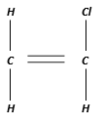

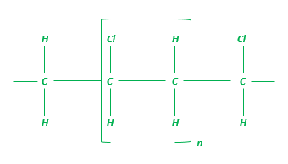

***Correct sequencing of chlorines [1]***

***Correctly labelled repeating unit [1]***

***Correct use of n [1]***

***Spare bonds at end of structure [1] this mark is lost if H appears both ends***

1. **Condensation polymerisation and Amino Acids (Chemistry only HT only)**

1. Explain what happens during condensation polymerization. (3)

***Monomers with functional groups [1] join together [1] losing small molecules [1]***

2. Propane diol polymerises with butanedioc acid to produce a polyester. Explain using a symbol equation how these monomers produce a condensation polymer (polyester). (3)

Propane diol HO – CH2 – CH2 – CH2 – OH

Butanedioc acid HOOC – CH2 - CH2 –COOH



***Correct repeating unit [1]***

***Correct reactants and water as a product [1]***

***Correct use of n [1]***

3. How are polypeptide chains formed? (2)

***Amino acids react [1] by condensation polymerization [1]***

1. **DNA and other naturally occurring polymers**

1. Describe fully the structure of DNA. (4)

***Two polymer chains [1]***

***Made from four different monomers [1]***

***Called nucleotides [1]***

***Double helix [1]***