1. **Rate of Reaction - Calculating Rates of Reaction**
2. A student carried out a reaction between calcium carbonate solid (CaCO3) and hydrochloric acid (HCl) producing dissolved calcium chloride (CaCl2) carbon dioxide and water. Write the balanced symbol equation for this reaction, including state symbols. (3)
3. Below is a table of results for the reaction, the student measured the volume of gas released every ten seconds:

|  |  |
| --- | --- |
| Time in seconds | Volume of carbon dioxide released in cm3 |
| 0 | 0 |
| 10 | 8 |
| 20 | 16 |
| 30 | 22 |
| 40 | 24 |
| 50 | 25 |
| 60 | 26 |
| 70 | 26 |

Calculate the rate of the reaction in the first ten seconds. Give the unit (3)

1. What is the rate of the reaction between 30 and 40 seconds? (2)
2. Is the rate of reaction, faster, slower or the same between 0 and 10 seconds than between 30 and 40 seconds? Explain your answer. (2)

**B. Rate of Reaction - Factors Which Affect The Rate of Chemical Reactions**

1. **Extended response question:**

The student repeated the experiment, this time however he used 2.0 Molar acid rather than 1.0 Molar acid. Describe or draw a labelled diagram to show how the student might carry out the experiment, calculate the rate of reaction that the student might calculate for this new reaction for the first ten seconds and what volume of carbon dioxide would you expect him to collect at the end of the experiment.

Here are his original results: (6)

|  |  |
| --- | --- |
| Time in seconds | Volume of carbon dioxide released in cm3 |
| 0 | 0 |
| 10 | 8 |
| 20 | 16 |
| 30 | 22 |
| 40 | 24 |
| 50 | 25 |
| 60 | 26 |
| 70 | 26 |

1. Give two other ways that the student might decrease the rate of reaction other than changing the concentration. (2)
2. **Rate of Reaction – Collision Theory And Activation Energy**
3. What two requirements must be met for reacting particles to react? (2)
4. What is the activation energy of a reaction? (2)
5. For the reaction below explain what would happen to the rate of the reaction and why if the solid magnesium was cut into smaller pieces. (4)

Hydrochloric acid + magnesium 🡪 magnesium chloride + hydrogen

1. A student calculated that the surface area had been increased to three times it’s original size. Describe and explain what you think would happen to the rate of reaction. (2)
2. **Rate of Reaction – Catalysts**
3. What is the name given to catalysts in biological systems? (1)
4. How do catalysts increase the rate of a chemical reaction. (2)
5. For the energy profile below decide which reaction(s) are catalysed, which reaction was the original reaction without a catalyst and which is the best catalyst to use for the reaction. Explain your decisions. (4)

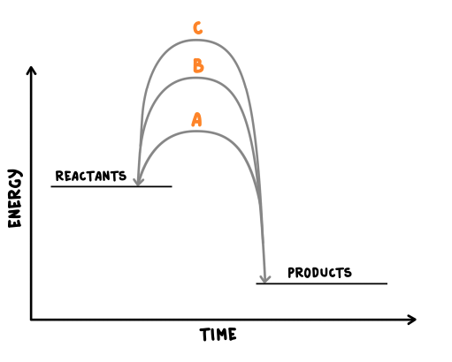

1. **Reversible reactions and dynamic equilibrium**
   * + 1. Name the reaction shown below and describe what it shows. (2)

W + X 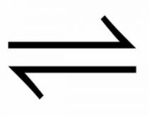 Y + Z

1. Other than changing the pressure, for the reaction below describe and explain how you would produce more ammonia NH3. (2)

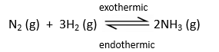

1. For the reaction below, 135 kJ of energy is put in to make the anhydrous copper sulfate. How much energy will be released if the same amount of water is added to the anhydrous copper sulfate as was removed in the forward reaction. Explain your answer. (2)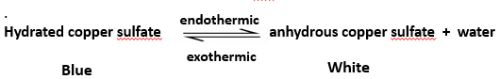
2. Describe the apparatus and what is happening if a reaction is said to be in equilibrium? (3)
3. **The effect of changing concentration, temperature or pressure on equilibrium (HT only)**
4. A student is investigating the following reaction:



Describe what would happen if the student increased the concentration of reactants, then the concentration of products and explain why you think this. (6)

1. A reaction is at equilibrium, the reactants are iodine gas I2 and hydrogen gas H2, the product is hydrogen iodide gas HI. When the temperature of the system is increased more iodine and hydrogen are produced.

Write the balanced symbol equation for this reaction and include the directions of the endothermic and exothermic reactions and the state symbols. (4)

1. Explain what would happen in the following equilibrium reaction if we increased the pressure. (3)

N2 (g) + 3H2 (g)  2NH3 (g)