1. **Reactivity of metals – The reactivity series, metal oxides and extractions**

1. Three metals, X, Y and Z were put into water. The reactions are shown below:

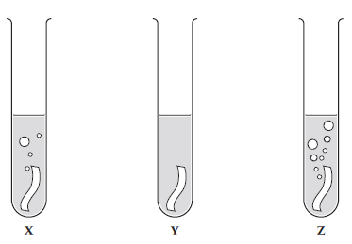

a) Use the diagrams to put metals X, Y and Z in order of reactivity, starting with the most reactive. (1)

 .............................................................................................................................................

b) When a metal reacts with water, it produces hydrogen gas and a metal hydroxide. Describe how you

can test for the products. (2)

 .............................................................................................................................................

.............................................................................................................................................

      ..............................................................................................................................................

 .............................................................................................................................................

c) Give two variables that should be controlled in this investigation. (2)

 .............................................................................................................................................

.............................................................................................................................................

       ..............................................................................................................................................

 .............................................................................................................................................

2. A piece of magnesium ribbon was added to dilute hydrochloric acid.

a) Give two observations that are evidence for a chemical reaction taking place. (2)

 .............................................................................................................................................

.............................................................................................................................................

       ..............................................................................................................................................

 .............................................................................................................................................

b) Write the word and balanced symbol equation, including state symbols, for the reaction. (4)

 .............................................................................................................................................

.............................................................................................................................................

       ..............................................................................................................................................

3. The reaction between aluminium powder and iron(III) oxide (Fe2O3) is used in the rail industry.

a) Write a word equation and balanced symbol equation for the reaction that takes place. (3)

 .............................................................................................................................................

.............................................................................................................................................

       ..............................................................................................................................................

b) Compare the reaction above to the reaction with powdered aluminium and copper(II) oxide and

explain why there is a difference. (2)

 .............................................................................................................................................

.............................................................................................................................................

      ..............................................................................................................................................

4. A student carried out some displacement reactions using three metals and three sulfate solutions.

The results are shown in the table below:

|  |  |  |  |
| --- | --- | --- | --- |
|  | **Iron sulfate**  **(FeSO4)** | **Copper sulfate**  **(CuSO4)** | **Magnesium sulfate (MgSO4)** |
| **Iron (Fe)** |  | **✓** | ✗ |
| **Copper (Cu)** | ✗ |  | ✗ |
| **Magnesium (Mg)** | **✓** | **✓** |  |

1. i) Explain what is observed when iron reacts with copper sulfate. (2)

 .............................................................................................................................................

.............................................................................................................................................

 ..............................................................................................................................................

 .............................................................................................................................................

ii) HT: Write an ionic equation for the reaction between iron and copper sulfate solution. (2)

 .............................................................................................................................................

.............................................................................................................................................

       ..............................................................................................................................................

1. Explain why there is no observation between copper and iron sulfate. (2)

 .............................................................................................................................................

.............................................................................................................................................

 ..............................................................................................................................................

 .............................................................................................................................................

1. i) Explain what is observed when magnesium reacts with iron sulfate. (2)

 .............................................................................................................................................

.............................................................................................................................................

 ..............................................................................................................................................

 .............................................................................................................................................

ii) HT: Write a half equation to show the reduction of iron ions (Fe2+) when magnesium reacts with

iron sulfate. Use the half equation to explain why Fe2+ ions are reduced. (2)

 .............................................................................................................................................

.............................................................................................................................................

       ..............................................................................................................................................

 .............................................................................................................................................

1. **Reactions of metals part 1 – Metals & acids and strong & weak acids (HT)**

1. Zinc reacts with hydrochloric acid.

a) Write a word and a balanced symbol equation with state symbols to show this reaction. (2)

zinc + hydrochloric acid → zinc chloride + hydrogen

 .............................................................................................................................................

.............................................................................................................................................

      ..............................................................................................................................................

b) HT: write an ionic equation for the reaction. (2)

 .............................................................................................................................................

.............................................................................................................................................

c) HT: Give both half equations to show the electron transfers taking place. (2)

 .............................................................................................................................................

.............................................................................................................................................

d) HT: Explain why this reaction is a redox reaction. (4)

 .............................................................................................................................................

.............................................................................................................................................

       ..............................................................................................................................................

 .............................................................................................................................................

2. a) HT: Explain why ethanoic acid (found in vinegar) is described as a weak acid, whereas nitric acid is a

strong acid. (4)

 .............................................................................................................................................

.............................................................................................................................................

       ..............................................................................................................................................

 .............................................................................................................................................

 .............................................................................................................................................

 .............................................................................................................................................

b) HT: Magnesium reacts with ethanoic acid and nitric acid. What difference would you see if

magnesium carbonate was reacted with ethanoic acid of the same concentration as nitric acid? (2)

 .............................................................................................................................................

.............................................................................................................................................

      ..............................................................................................................................................

 .............................................................................................................................................

1. **Reactions of metals part 2 – pH scale, neutralisation, salt and titration (chem)**

1. Magnesium carbonate reacts with nitric acid. The equation is shown below:

MgCO3(aq) + 2 HNO3(aq) ---> Mg(NO3)2(aq) + H2O(l) + CO2(g)

***Extended writing:***

Plan a method to produce dry crystals of magnesium nitrate. (6)

 .............................................................................................................................................

.............................................................................................................................................

       ..............................................................................................................................................

 .............................................................................................................................................

.............................................................................................................................................

       ..............................................................................................................................................

 .............................................................................................................................................

.............................................................................................................................................

    ..............................................................................................................................................

2. i) HT: You are given a 0.50mol/dm3 solution of nitric acid (strong) and ethanoic acid (weak). Calculate

the concentration of each acid, giving your answer in g/dm3 to 3 significant figures. (2)

 .............................................................................................................................................

.............................................................................................................................................

       ..............................................................................................................................................

 .............................................................................................................................................

ii) The solution of ethanoic acid has a pH of 4 and the solution of nitric acid a pH of 1. How many times

greater is the concentration of H+ ions in the nitric acid compared to the concentration in the

ethanoic acid? (1)

 .............................................................................................................................................

.............................................................................................................................................

3. **CHEMISTRY ONLY:**

a) A titration is carried out between hydrochloric acid and sodium hydroxide.

The following results show the volumes of acid added to neutralize the sodium hydroxide.

|  |  |  |  |  |
| --- | --- | --- | --- | --- |
|  | **Rough** | **Trial 1** | **Trial 2** | **Trial 3** |
| **Volume of acid added (cm3)** | 15.70 | 15.30 | 15.25 | 15.30 |

Calculate the mean volume of solution added and explain your answer. (3)

 .............................................................................................................................................

.............................................................................................................................................

       ..............................................................................................................................................

       ..............................................................................................................................................

b) HT: In another investigation, it takes 27.00cm3 of hydrochloric acid to neutralise 25.00cm3 of

sodium hydroxide at a concentration of 1.0 mol/dm3. Calculate the concentration of hydrochloric

acid in g/cm3. (4)

 .............................................................................................................................................

.............................................................................................................................................

       ..............................................................................................................................................

 .............................................................................................................................................

 .............................................................................................................................................

1. **Electrolysis part 1 – Electrolysis of a molten and solution**

1. The diagram shows how molten lead bromide is electrolysed.

Lead bromide contains Pb2+ and Br- ions.

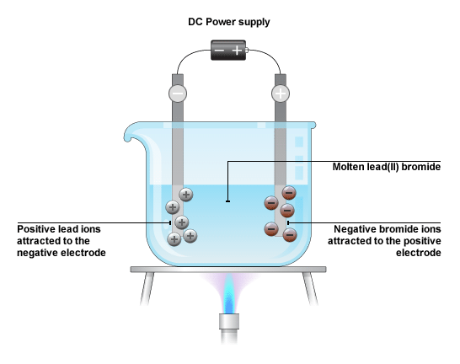

a) Explain why molten lead bromide conducts electricity. (1)

 .............................................................................................................................................

.............................................................................................................................................

      ..............................................................................................................................................

b) HT: Write the half equations, including the state symbols for the changes at the anode and

cathode. (4)

 .............................................................................................................................................

.............................................................................................................................................

      ..............................................................................................................................................

2. The diagram shows how sodium chloride is electrolysed in the laboratory:

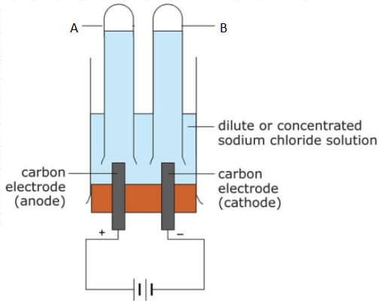

a) Name the products A and B? (2)

 .............................................................................................................................................

.............................................................................................................................................

       ..............................................................................................................................................

b) Give one use of substance A. (1)

 .............................................................................................................................................

.............................................................................................................................................

       ..............................................................................................................................................

c) A few drops of universal indicator was added to the solution after the reaction and it turned blue.

Explain why. (2)

 .............................................................................................................................................

.............................................................................................................................................

       ..............................................................................................................................................

       ..............................................................................................................................................

d) HT: Write the half equations, including the state symbols for the changes as the anode and

cathode. (4)

 .............................................................................................................................................

.............................................................................................................................................

       ..............................................................................................................................................

       ..............................................................................................................................................

1. **Electrolysis part 2 – Using electrolysis to extract metals**

1. Aluminium is extracted from Aluminium oxide (Al2O3) by electrolysis.

Aluminium contains Al3+ and O2- ions.

a) Suggest why aluminium was only discovered in the 1800s, despite it being a common

element in the Earth’s crust. (3)

 .............................................................................................................................................

.............................................................................................................................................

       ..............................................................................................................................................

       ..............................................................................................................................................

       ..............................................................................................................................................

The following diagram shows how aluminium is extracted from aluminium oxide by electrolysis:

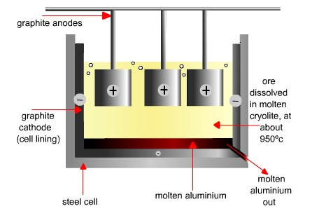

b) Why is molten aluminium oxide dissolved in molten cryolite? (2)

 .............................................................................................................................................

.............................................................................................................................................

      ..............................................................................................................................................

       ..............................................................................................................................................

c) Why are the carbon anodes replaced regularly in the industrial electrolysis of aluminium oxide? (2)

 .............................................................................................................................................

.............................................................................................................................................

       ..............................................................................................................................................

       ..............................................................................................................................................

d) HT: Write half equations for the changes at each electrode and explain which of the ions are

oxidised and reduced. (4)

 .............................................................................................................................................

.............................................................................................................................................

      ..............................................................................................................................................

 .............................................................................................................................................

.............................................................................................................................................

       ..............................................................................................................................................