1. **Reactivity of metals – The reactivity series, metal oxides and extractions**

1. Three metals, X, Y and Z were put into water. The reactions are shown below:

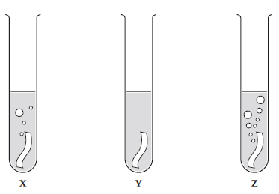

a) Use the diagrams to put metals X, Y and Z in order of reactivity, starting with the most reactive. (1)

b) When a metal reacts with water, it produces hydrogen gas and a metal hydroxide. Describe how you

can test for the products. (2)

c) Give two variables that should be controlled in this investigation. (2)

2. A piece of magnesium ribbon was added to dilute hydrochloric acid.

a) Give two observations that are evidence for a chemical reaction taking place. (2)

b) Write the word and balanced symbol equation, including state symbols, for the reaction. (4)

3. The reaction between aluminium powder and iron(III) oxide (Fe2O3) is used in the rail industry.

a) Write a word equation and balanced symbol equation for the reaction that takes place. (3)

b) Compare the reaction above to the reaction with powdered aluminium and copper(II) oxide and

explain why there is a difference. (2)

4. A student carried out some displacement reactions using three metals and three sulfate solutions.

The results are shown in the table below:

|  |  |  |  |
| --- | --- | --- | --- |
|  | **Iron sulfate**  **(FeSO4)** | **Copper sulfate**  **(CuSO4)** | **Magnesium sulfate (MgSO4)** |
| **Iron (Fe)** |  | **✓** | ✗ |
| **Copper (Cu)** | ✗ |  | ✗ |
| **Magnesium (Mg)** | **✓** | **✓** |  |

1. i) Explain what is observed when iron reacts with copper sulfate. (2)

ii) HT: Write an ionic equation for the reaction between iron and copper sulfate solution. (2)

1. Explain why there is no observation between copper and iron sulfate. (2)
2. i) Explain what is observed when magnesium reacts with iron sulfate. (2)

ii) HT: Write a half equation to show the reduction of iron ions (Fe2+) when magnesium reacts with

iron sulfate. Use the half equation to explain why Fe2+ ions are reduced. (2)

1. **Reactions of metals part 1 – Metals & acids and strong & weak acids (HT)**

1. Zinc reacts with hydrochloric acid.

a) Write a word and a balanced symbol equation with state symbols to show this reaction. (2)

zinc + hydrochloric acid → zinc chloride + hydrogen

b) HT: write an ionic equation for the reaction. (2)

c) HT: Give both half equations to show the electron transfers taking place. (2)

d) HT: Explain why this reaction is a redox reaction. (4)

2. a) HT: Explain why ethanoic acid (found in vinegar) is described as a weak acid, whereas nitric acid is a

strong acid. (4)

b) HT: Magnesium reacts with ethanoic acid and nitric acid. What difference would you see if

magnesium carbonate was reacted with ethanoic acid of the same concentration as nitric acid? (2)

1. **Reactions of metals part 2 – pH scale, neutralisation, salt and titration (chem)**

1. Magnesium carbonate reacts with nitric acid. The equation is shown below:

MgCO3(aq) + 2 HNO3(aq) ---> Mg(NO3)2(aq) + H2O(l) + CO2(g)

***Extended writing:***

Plan a method to produce dry crystals of magnesium nitrate. (6)

2. i) HT: You are given a 0.50mol/dm3 solution of nitric acid (strong) and ethanoic acid (weak). Calculate

the concentration of each acid, giving your answer in g/dm3 to 3 significant figures. (2)

ii) The solution of ethanoic acid has a pH of 4 and the solution of nitric acid a pH of 1. How many times

greater is the concentration of H+ ions in the nitric acid compared to the concentration in the

ethanoic acid? (1)

3. **CHEMISTRY ONLY:**

a) A titration is carried out between hydrochloric acid and sodium hydroxide.

The following results show the volumes of acid added to neutralize the sodium hydroxide.

|  |  |  |  |  |
| --- | --- | --- | --- | --- |
|  | **Rough** | **Trial 1** | **Trial 2** | **Trial 3** |
| **Volume of acid added (cm3)** | 15.70 | 15.30 | 15.25 | 15.30 |

Calculate the mean volume of solution added and explain your answer. (3)

b) HT: In another investigation, it takes 27.00cm3 of hydrochloric acid to neutralise 25.00cm3 of

sodium hydroxide at a concentration of 1.0 mol/dm3. Calculate the concentration of hydrochloric

acid in g/cm3. (4)

1. **Electrolysis part 1 – Electrolysis of a molten and solution**

1. The diagram shows how molten lead bromide is electrolysed.

Lead bromide contains Pb2+ and Br- ions.

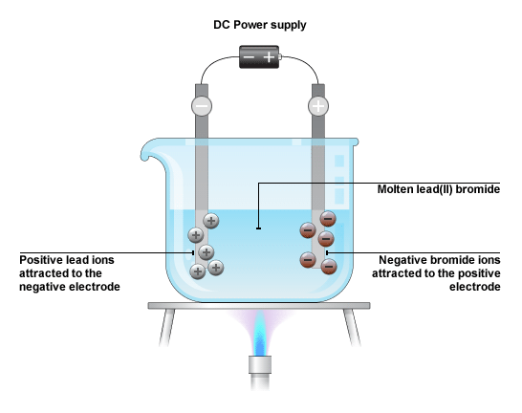

a) Explain why molten lead bromide conducts electricity. (1)

b) HT: Write the half equations, including the state symbols for the changes at the anode and

cathode. (4)

2. The diagram shows how sodium chloride is electrolysed in the laboratory:

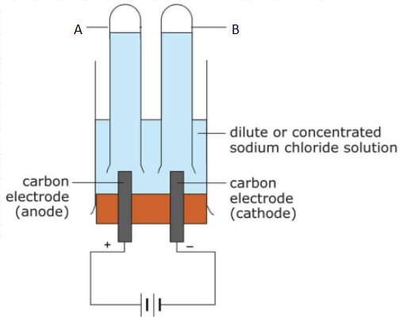

a) Name the products A and B? (2)

b) Give one use of substance A. (1)

c) A few drops of universal indicator was added to the solution after the reaction and it turned blue.

Explain why. (2)

d) HT: Write the half equations, including the state symbols for the changes as the anode and

cathode. (4)

1. **Electrolysis part 2 – Using electrolysis to extract metals**

1. Aluminium is extracted from Aluminium oxide (Al2O3) by electrolysis.

Aluminium contains Al3+ and O2- ions.

a) Suggest why aluminium was only discovered in the 1800s, despite it being a common

element in the Earth’s crust. (3)

The following diagram shows how aluminium is extracted from aluminium oxide by electrolysis:

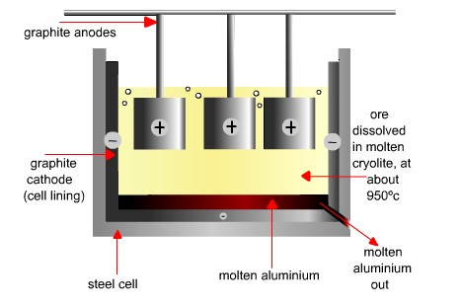

b) Why is molten aluminium oxide dissolved in molten cryolite? (2)

c) Why are the carbon anodes replaced regularly in the industrial electrolysis of aluminium oxide? (2)

d) HT: Write half equations for the changes at each electrode and explain which of the ions are

oxidised and reduced. (4)