1. **Reactivity of metals – The reactivity series, metal oxides and extractions**

1. Three metals, X, Y and Z were put into water. The reactions are shown below:

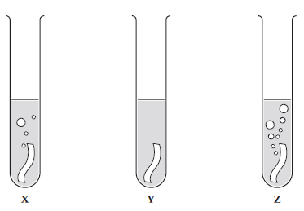

a) Use the diagrams to put metals X, Y and Z in order of reactivity, starting with the most reactive. (1)

***Z X Y (1)***

b) When a metal reacts with water, it produces hydrogen gas and a metal hydroxide. Describe how you

can test for the products. (2)

***Hydrogen – gives a squeak pop with a lit splint (1)***

***Metal hydroxide – turns blue with litmus/purple with universal indicator (1)***

c) Give two variables that should be controlled in this investigation. (2)

***any two from:***

***• same temperature of the water***

***• same mass / number of moles of the metal***

***• same surface area of the metal***

2. A piece of magnesium ribbon was added to dilute hydrochloric acid.

a) Give two observations that are evidence for a chemical reaction taking place. (2)

***Any two from: gas given off / fizzing, magnesium gets smaller then disappears / thermal energy***

***released / surroundings get warmer/ temperature increases (2)***

b) Write the word and balanced symbol equation, including state symbols, for the reaction. (4)

***magnesium + sulfuric acid → magnesium sulfate + hydrogen [1]***

***Mg(s) + H2SO4(aq) → MgSO4(aq) + H2(g) [1 – formula equation/1 – balancing/1 – state symbols]***

3. The reaction between aluminium powder and iron(III) oxide (Fe2O3) is used in the rail industry.

a) Write a word equation and balanced symbol equation for the reaction that takes place. (3)

***Aluminium + iron(III) oxide → aluminium oxide + iron (1)***

***2Al + Fe2O3 → Al2O3 + 2Fe (2)***

b) Compare the reaction above to the reaction with powdered aluminium and copper(II) oxide and

explain why there is a difference. (1)

***Aluminium reacts more vigorously with copper(II) oxide than with iron(III) oxide. (1)***

***Copper is lower than iron in the reactivity series, so the reaction is more violent. (1)***

4. A student carried out some displacement reactions using three metals and three sulfate solutions.

The results are shown in the table below:

|  |  |  |  |
| --- | --- | --- | --- |
|  | **Iron sulfate**  **(FeSO4)** | **Copper sulfate**  **(CuSO4)** | **Magnesium sulfate (MgSO4)** |
| **Iron (Fe)** |  | **✓** | ✗ |
| **Copper (Cu)** | ✗ |  | ✗ |
| **Magnesium (Mg)** | **✓** | **✓** |  |

1. i) Explain what is observed when iron reacts with copper sulfate. (2)

***iron nail turns (from grey to) brown (1)***

***solution turns (from blue to) pale green (1)***

ii) HT: Write an ionic equation for the reaction between iron and copper sulfate solution. (2)

***Fe + Cu2+ → Fe2+ + Cu (1 mark for reactants and 1 mark for products)***

1. Explain why there is no observation between copper and iron sulfate. (2)

***Copper does not react with iron sulfate (1) (because) copper is less reactive than iron (1)***

1. i) Explain what is observed when magnesium reacts with iron sulfate. (2)

***magnesium ribbon turns (from silver to) grey (1)***

***solution turns (from colourless to) pale green (1)***

ii) HT: Write a half equation to show the reduction of iron ions (Fe2+) when magnesium reacts with

iron sulfate. Use the half equation to explain why Fe2+ ions are reduced.

***Fe2+ + 2e- → Fe (1)***

***(Fe2+ ions are reduced because they have) gained electrons (1))***

1. **Reactions of metals part 1 – Metals & acids and strong & weak acids (HT)**

1. Zinc reacts with hydrochloric acid.

a) Write a word and a balanced symbol equation, with state symbols, to show this reaction. (3)

zinc + hydrochloric acid → zinc chloride + hydrogen (1)

***Zn(s) + 2HCl(aq) → ZnCl2(aq) + H2(g) [2]***

b) HT: write an ionic equation for the reaction. (2)

***Zn(s) + 2H+(aq) → Zn2+(aq) + H2 (g) [2]***

c) HT: Give both half equations to show the electron transfers taking place. (2)

***Zn → Zn2+ + 2e− [1] 2H+ + 2e− → H2 [1]***

d) HT: Explain why this reaction is a redox reaction. (4)

***Each zinc atom loses two electrons, [1] to two hydrogen ions, [1] zinc***

***atoms oxidised as lose electrons, [1] hydrogen ions reduced as gain electrons [1]***

2. a) HT: Explain why ethanoic acid (found in vinegar) is described as a weak acid, whereas nitric acid is a

strong acid. (4)

***Any 4 from (accept dissociate for ionise)***

***Ethanoic acid does not ionise completely when added to water, [1] reaction is reversible, [1]***

***majority of molecules remain intact, [1] only a small fraction form H+(aq) ions [1]. Therefore,***

***ethanoic acid does not produce as high a concentration of H+(aq) ions as a strong acid of equal***

***concentration. [1] Nitric acid is a strong acid, because its molecules ionise completely in water [1]***

b) HT: Magnesium reacts with ethanoic acid and nitric acid. What difference would you see if

magnesium carbonate was reacted with ethanoic acid of the same concentration as nitric acid? (2)

***Effervescence/ fizzing with ethanoic acid (1) would be slower (than with nitric acid) (1)***

1. **Reactions of metals part 2 – pH scale, neutralisation, salt and titration (chem)**

1. Magnesium carbonate reacts with nitric acid. The equation is shown below:

MgCO3(aq) + 2 HNO3(aq) ---> Mg(NO3)2(aq) + H2O(l) + CO2(g)

***Extended writing:***

Plan a method to produce dry crystals of magnesium nitrate. (6)

|  |  |  |  |
| --- | --- | --- | --- |
| ***0 marks*** | ***Level 1 (1–2 marks)*** | ***Level 2 (3–4 marks)*** | ***Level 3 (5–6 marks)*** |
| ***No relevant content*** | ***Magnesium carbonate is added to nitric acid.*** | ***Excess magnesium carbonate is added to dilute nitric acid. The excess magnesium carbonate is filtered off.*** | ***Excess magnesium carbonate is added to dilute nitric acid. The excess magnesium carbonate is filtered off. The saturated solution is heated for a few minutes to evaporate some of the water and left in a warm place until dry crystals are formed or the crystals are dried on filter paper.*** |

2. i) HT: You are given a 0.50mol/dm3 solution of nitric acid (strong) and ethanoic acid (weak). Calculate

the concentration of each acid, giving your answer in g/dm3 to 3 significant figures. (2)

***31.5 g/dm3 nitric acid (1)***

***30.0 g/dm3 ethanoic acid (1)***

ii) The solution of ethanoic acid has a pH of 4 and the solution of nitric acid a pH of 1. How many times

greater is the concentration of H+ ions in the nitric acid compared to the concentration in the

ethanoic acid?

***1,000 times greater (1)***

3. **CHEMISTRY ONLY:**

a) A titration is carried out between hydrochloric acid and sodium hydroxide.

The following results show the volumes of acid added to neutralize the sodium hydroxide.

|  |  |  |  |  |
| --- | --- | --- | --- | --- |
|  | **Rough** | **Trial 1** | **Trial 2** | **Trial 3** |
| **Volume of acid added (cm3)** | 15.70 | 15.30 | 15.25 | 15.30 |

Calculate the mean volume of solution added and explain your answer. (3)

***(15.3 + 15.25 + 15.3) ÷ 3 = 15.28 cm3 (2 – 1 mark for method and 1 mark for answer with unit)***

***Volume of rough titration has been disregarded) (1)***

b) HT: In another investigation, it takes 27.00cm3 of hydrochloric acid to neutralise 25.00cm3 of

sodium hydroxide at a concentration of 1.0 mol/dm3. Calculate the concentration of hydrochloric

acid in g/cm3. (4)

***Number of moles of sodium hydroxide = concentration × volume***

***= 1 mol/dm3 × (25 ÷ 1000) dm3 = 0.025 mol (1)  
 The equation for the reaction shows that 1 mole of sodium hydroxide reacts with 1 mole of***

***hydrochloric acid. So there is 0.025 mol of HCl in 27 cm3 of solution.  
 So the concentration of HCl in mol/dm3 = number of moles ÷ volume***

***= 0.025 mol ÷ (27 ÷ 1000) dm3 = 0.925 mol/dm3 (1)  
 The mass of 1 mole of HCl is (1 + 35.5) = 36.5 g (1)  
 So the concentration in g/dm3 = 36.5 g/mol × 0.925 mol/dm3 = 33.8 g/dm3 (1)***

1. **Electrolysis part 1 – Electrolysis of a molten and solution**

1. The diagram shows how molten lead bromide is electrolysed.

Lead bromide contains Pb2+ and Br- ions.

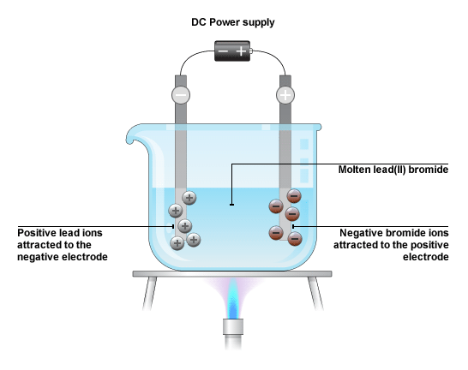

a) Explain why molten lead bromide conducts electricity. (1)

***The ions are free to move/carry the electrical charge (1)***

b) HT: Write the half equations, including the state symbols for the changes at the anode and

cathode. (4)

***2Br- → Br2 + 2e- (2)***

***Pb2+ + 2e- → Pb (2)***

2. The diagram shows how sodium chloride is electrolysed in the laboratory:

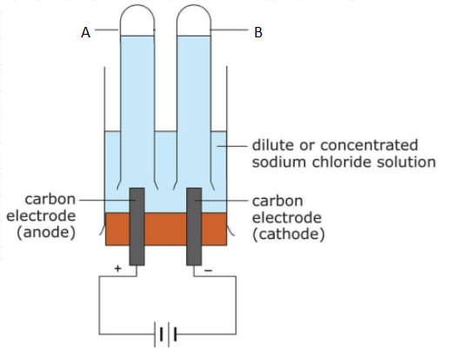

a) Name the products A and B? (2)

***A: chlorine (1)***

***B: hydrogen (1)***

b) Give one use of substance A. (1)

***To make bleach/plastics/used for sterlising water (any one for 1 mark)***

c) A few drops of universal indicator was added to the solution after the reaction and it turned blue.

Explain why. (2)

***The solution is alkaline (1) because sodium hydroxide (ions) is produced (1)***

d) HT: Write the half equations, including the state symbols for the changes as the anode and

cathode. (4)

***anode: 2Cl−(aq) → Cl2(g) + 2e− or 2Cl−(aq) − 2e– → Cl2(g) (2)***

***cathode: 2H+(aq) + 2e− → H2(g) (2)***

1. **Electrolysis part 2 – Using electrolysis to extract metals**

1. Aluminium is extracted from Aluminium oxide (Al2O3) by electrolysis.

Aluminium contains Al3+ and O2- ions.

a) Suggest why aluminium was only discovered in the 1800s, despite it being a common

element in the Earth’s crust. (3)

***Aluminium in its ore is bonded to other elements in compounds difficult to break down. [1]***

***Aluminium could only be extracted once electrical cells used to pass electricity were made [1]***

***Aluminium could then be made from one of its molten compounds by electrolysis. [1]***

The following diagram shows how aluminium is extracted from aluminium oxide by electrolysis:

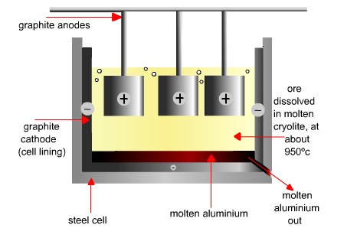

b) Why is molten aluminium oxide dissolved in molten cryolite? (2)

***To melt at a lower temperature (1) and therefore save on costs (1)***

c) Why are the carbon anodes replaced regularly in the industrial electrolysis of aluminium oxide? (2)

***Any two from***

***Oxygen produced at the hot carbon anodes [1] reacts with the carbon to produce carbon dioxide,***

***burning away anodes. [1]***

d) HT: Write half equations for the changes at each electrode and explain which of the ions are

oxidised and reduced. (4)

***cathode: Al3+ + 3e− → Al [1] Al3+ ions gain electrons - reduced [1]***

***anode: 2O2− → O2 + 4e− [1] O2− ions lose electrons - oxidised [1]***