1. **Changes of State – States of matter**

1. Explain why different substances have different melting points. (2)

 .............................................................................................................................................

.............................................................................................................................................

      ..............................................................................................................................................

1. Describe the general properties of solids, liquids and gases, including the arrangement and movement of particles. (4)

.............................................................................................................................................

.............................................................................................................................................

      ..............................................................................................................................................

      .............................................................................................................................................

.............................................................................................................................................

  .............................................................................................................................................

.............................................................................................................................................

      ..............................................................................................................................................

1. **Extended response question:**

Describe what happens to particles during changes of state as a gas is cooled down to a temperature below its freezing point. (6)

.............................................................................................................................................

.............................................................................................................................................

      ..............................................................................................................................................

      .............................................................................................................................................

.............................................................................................................................................

 .............................................................................................................................................

.............................................................................................................................................

      ..............................................................................................................................................

      .............................................................................................................................................

.............................................................................................................................................

1. Evaporation is the change of state that occurs when some liquid changes into a gas. Many factors can affect the rate of evaporation. Plan an investigation into one factor that might affect the rate of evaporation using wet cotton wool and a high resolution digital balance. (5)

.............................................................................................................................................

.............................................................................................................................................

      ..............................................................................................................................................

      .............................................................................................................................................

.............................................................................................................................................

  .............................................................................................................................................

.............................................................................................................................................

      ..............................................................................................................................................

.............................................................................................................................................

      ..............................................................................................................................................

1. **Ionic Bonding part 1 – Joining of atoms and Ionic compounds**

1. Explain the charges on the following ions:

1. Na+

 .............................................................................................................................................

.............................................................................................................................................

1. O2-

 ..............................................................................................................................................

.............................................................................................................................................

2. Sodium chloride NaCl and sodium oxide has ionic bonds.

1. Draw dot and cross diagrams to show what happens to sodium and chlorine atoms when they react to form sodium chloride. You only need to show the outer electrons in your diagrams. (3)
2. Draw dot and cross diagrams to show what happens to sodium and oxygen atoms when they react to form sodium oxide. (3)

3. What is the chemical formula for:

1. Calcium oxide (1)

.............................................................................................................................................

1. Magnesium fluoride (1)

.............................................................................................................................................

1. Aluminum oxide (1)

.............................................................................................................................................

**C.** **Ionic Bonding part 2 – Properties of ionic compounds**

1. Explain why ionic compounds have high melting points and boiling points. (2)

 .............................................................................................................................................

.............................................................................................................................................

       ..............................................................................................................................................

2. Why can ionic compounds conduct electricity when they are molten or dissolved in water? (1)

 .............................................................................................................................................

.............................................................................................................................................

      ..............................................................................................................................................

3. Why is seawater a better conductor of electricity than freshwater? (1)

.............................................................................................................................................

**D.** **Covalent Bonding part 1 – Joining of atoms and small molecules**

1. Draw a diagram to represent the covalent bonding between two chlorine atoms. (2)
2. The melting point of ammonia, NH3 is -78°C and its boiling point is 33°C. What state is ammonia at 20°C? (1)

.............................................................................................................................................

1. Why don’t simple molecular substances conduct electricity? (1)

.............................................................................................................................................

1. Nitrogen gas has a very strong triple covalent bond holding the atoms together. Explain why nitrogen has a boiling point of -196°C. (2)

 .............................................................................................................................................

.............................................................................................................................................

       ..............................................................................................................................................

1. Describe what is meant by intermolecular forces. (1)

.............................................................................................................................................

**E.** **Covalent Bonding part 2 – Giant structures**

1. Graphite is sometimes used to reduce the friction between two surfaces that rub together. Explain how it does this. (2)

.............................................................................................................................................

.............................................................................................................................................

       ..............................................................................................................................................

1. **Extended response question:**

Describe how the structures of diamond and graphite are similar and explain why graphite can conduct electricity, but diamond cannot. (6)

.............................................................................................................................................

.............................................................................................................................................

 ..............................................................................................................................................

       .............................................................................................................................................

.............................................................................................................................................

 .............................................................................................................................................

.............................................................................................................................................

      ..............................................................................................................................................

      .............................................................................................................................................

.............................................................................................................................................

1. State which properties of graphene make it useful in the manufacture of bullet-proof vests. (2)

.............................................................................................................................................

.............................................................................................................................................

       ..............................................................................................................................................

1. Explain why Graphene is such a good conductor of electricity (5)

.............................................................................................................................................

.............................................................................................................................................

      ..............................................................................................................................................

      .............................................................................................................................................

.............................................................................................................................................

 .............................................................................................................................................

.............................................................................................................................................

      ..............................................................................................................................................

      .............................................................................................................................................

.............................................................................................................................................

1. Ethene C2H4 can be polymerised to Poly(ethene).

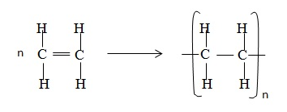

1. Explain in terms of its structure why ethene is a gas at room temperature. (2)

.............................................................................................................................................

.............................................................................................................................................

..............................................................................................................................................

1. Explain in terms of its structure why poly(ethene) is a polymer. (2)

.............................................................................................................................................

.............................................................................................................................................

..............................................................................................................................................

1. Explain why poly(ethene) has a high melting point. (1)

**F.** **Metallic Bonding part 1 – Joining of atoms**

1. This diagram shows a model of metallic bonding:

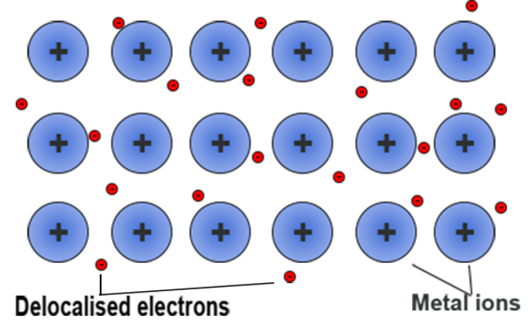

1. Why are the particles that makeup a metal described as positively charged ions? (3)

.............................................................................................................................................

.............................................................................................................................................

..............................................................................................................................................

..............................................................................................................................................

1. What are delocalised electrons? (2)

.............................................................................................................................................

.............................................................................................................................................

..............................................................................................................................................

1. Explain the bonding in a metal using the theory of metallic bonding (4)

.............................................................................................................................................

.............................................................................................................................................

..............................................................................................................................................

.............................................................................................................................................

.............................................................................................................................................

..............................................................................................................................................

**G.** **Metallic Bonding part 2 – Properties of metals and alloys**

1. Copper can be hammered into shape. The structure of copper metal can be represented by the

following diagram:

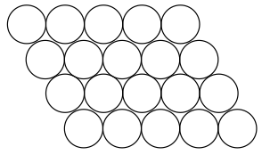

1. Explain why copper can be hammered into shape. (1)

.............................................................................................................................................

1. Copper can be mixed with zinc to make the alloy brass. Brass is much harder than copper. Explain why. (2)

.............................................................................................................................................

.............................................................................................................................................

..............................................................................................................................................

1. **Extended response question:**

Copper is a good metal for making a kettle because it has a high melting point. Explain why copper has a high melting point. You should describe the structure and bonding of a metal in your answer. (6)

.............................................................................................................................................

.............................................................................................................................................

      ..............................................................................................................................................

       .............................................................................................................................................

.............................................................................................................................................

 .............................................................................................................................................

.............................................................................................................................................

      ..............................................................................................................................................

      .............................................................................................................................................

1. Explain why magnesium sulfide has melting point of 2000°C, whereas sodium chloride has one of 801°C. (3)

.............................................................................................................................................

.............................................................................................................................................

      ..............................................................................................................................................

       .............................................................................................................................................

.............................................................................................................................................

 .............................................................................................................................................

.............................................................................................................................................

**H.** **Nanoparticles – Chemistry only**

1. How many nanometres make up 1 millimetre? (1)

.............................................................................................................................................

1. What is a nanoparticle (1)

.............................................................................................................................................

..............................................................................................................................................

3. Explain why nanoparticles would make very efficient catalysts. (2)

.............................................................................................................................................

.............................................................................................................................................

..............................................................................................................................................

4. Describe one social and one economic benefit of nanoscience. (2)

.............................................................................................................................................

.............................................................................................................................................

..............................................................................................................................................

.............................................................................................................................................