**­­**

**  
­­**

**GCSE Combined Science**

**Student Answer Booklet**

**Chemical Analysis**

**Contents:**

1. ANSWERS Multiple Choice Quiz
2. ANSWERS Exam Practice

**Level 1 ANSWERS**

**GCSE Chemistry – Chemical analysis**

1. **c**
2. **b**
3. **d**
4. **c**
5. **d**
6. **b**
7. **a**
8. **a**
9. **c**
10. **c**
11. **d**
12. **b**
13. **c**
14. **c**
15. **a**
16. **c**
17. **a**
18. **b**
19. **d**
20. **a**

**Chemical Analysis Exam practice answers**

**Chromatogram analysis question**

(c)     **A**

1

(d)     *(distance moved by dye A)* 38 (mm)

allow values in range 36-40

1

*(distance from start line to solvent front)*

102 (mm)

allow values in range 101-103

1

https://app.doublestruck.eu/content/AG_CHM/HTML/M/MSP182F04_files/img01.png

allow ecf from Table 1

1

0.37254 …

allow values in range 0.35 − 0.39

1

0.37

1

accept 0.37 with no working shown for **5** marks

[9]

**Gas test question**

(a)     Air

2

Steel

1

(b)

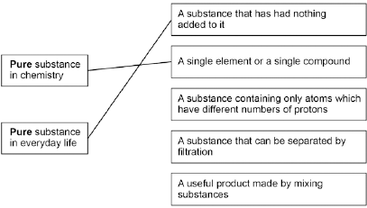

Allow **1** mark for the correct meanings linked to context but incorrect way around

1

(c)     Damp litmus paper turns white

1

**Cation test question:**

(a)     copper (II) → blue

iron (III) → brown

more than one line from any box negates the mark

1

1

(b)     aluminium

allow correct answer shown in box if answer line blank

1

(c)     (i)      yellow

allow orange

1

(ii)     lilac

allow purple

1

(iii)    one colour masks the other

allow colours mixed

1

[6]

**Flame spectrometry question**

(e)     calcium ions

allow Ca2+

1

sodium ions

allow Na+

1

**Chemical analysis question:**

(a)     lithium

allow Li+ / Li

1

yellow

allow orange

1

(b)     silver nitrate (solution)

incorrect test = **0** marks

ignore (nitric) acid

do **not** allow other named acids

1

white precipitate

1

(c)     blue precipitate (with sodium hydroxide) indicates copper ions

allow Cu2+

1

and white precipitate (with barium chloride) indicates sulfate ions

allow SO42-

accept compound X is copper sulfate / CuSO4 for **1** mark

1

but iron(II) ions produce a green precipitate (with sodium hydroxide)

1

[7]