1. **Atoms, Elements, Compounds and Mixtures part 1 – Atoms, Elements, Compounds, Word and Symbol Equations**
2. How many different types of atoms are there?
3. What does it mean if a compound ends in –ide?
4. What does it mean if a compound ends in –ate?
5. What does a chemical reaction involve?
6. Name the following substances:

* NaCl
* NaSO4

1. Why is it useful to have symbols for atoms of different elements?
2. What is the difference between an element and a compound?
3. Why is it difficult to separate a compound?
4. Solid sodium reacts with water to form a sodium hydroxide (NaOH) solution and hydrogen gas.

a) Write a word equation to represent this reaction.

b) Give the balance symbol equation for the reaction.

1. **HT only:**

When magnesium reacts with sulfuric acid, the hydrogen ions in the acid will be displaced from the solution by magnesium.

Balance the following ionic equation:

Mg(s) + H+(aq) → Mg2+(aq) + H2(g)

**B. Atoms, Elements, Compounds and Mixtures part 2 – Separating Techniques**

1. What is the difference between a compound and a mixture?
2. Describe the method used to collect the salt from a mixture of sand and salt.
3. What process is used to purify seawater to obtain usable water?
4. Describe how the following equipment is used to separate water and ethanol.

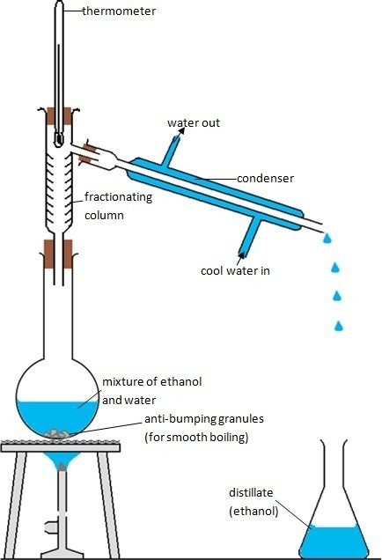

1. A mixture and six colours are tested using chromatography. The following chromatogram was produced:

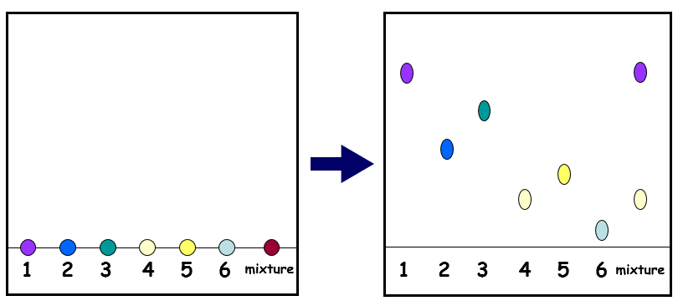

1. What can you conclude about the mixture?
2. Why do the inks separate?
3. **Atomic Model part 1 – History of the Atom**
4. What was the earliest model of the atom?
5. Which subatomic particle did JJ. Thomson discover?
6. Which early atomic model does the following diagram show:

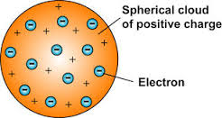

1. Name Rutherford’s experiment.
2. State two ways in which Rutherford changed Thomson’s model of the atom.
3. How did Bohr adapt the nuclear model?
4. Explain why Bohr revised Rutherford’s model of the atom.
5. **Atomic Model part 2 – Size and Mass of Atoms and Atomic Structure**
6. Name three subatomic particles and their charges.
7. Complete the sentence ‘All atoms of one type of element have the same number of…’
8. What does the atomic number tell us about an atom?
9. What does the mass number tell us about an atom?
10. How is an isotope different to an atom?
11. What is the electron configuration for sodium?
12. Why is the overall charge of an atom zero?
13. Draw the electron configuration for a chlorine atom.
14. Write the electron configuration for potassium.
15. How many electrons does potassium have on its highest energy level?
16. Calculate how many protons, electrons and neutrons there are in:

a) A silver atom with atomic number 47 and mass number 108

b) 

1. The atomic radius of a bromine atom is 9 x 10 -11m.

a) Give its atomic radius in nanometres.

b) Calculate the radius of the nucleus (in nm), given that it will be about 1/10,000 the radius of

the atom. Give your answer in standard form.

1. **Periodic Table part 1 – History of the Periodic Table**
2. How are elements arranged in the periodic table?
3. What are the columns of the periodic table called?
4. What are the rows of a periodic table called?
5. What does the column an element is in tell you about the atoms?
6. What does the row an element is in tell you about the atoms?
7. Which side of the periodic table are the non-metals found?
8. How were elements classified before the discovery of subatomic particles?
9. What was the problem with early periodic tables?
10. How did Mendeleev overcome these problems?
11. Why is the order based on atomic masses not always correct?
12. What do we call elements that tend to form positive ions?
13. **Periodic Table part 2 – Group 0, group 1 and group 7**
14. What are the elements in Group 0 called?
15. What are the elements in Group 1 called?
16. What are the elements in Group 7 called?
17. What happens to the boiling point of elements in Group 0 as you go down the group?
18. Why are the elements in Group 0 so unreactive?
19. Why do all elements in Group 1 react in a similar way to each other?
20. What happens to the reactivity of the elements as you go down Group 1?
21. Write a word equation for the reaction between sodium and oxygen.
22. Why do all the elements in Group 7 react in a similar way to each other?
23. Halogens are diatomic. What does the word ‘diatomic’ mean?
24. What happens to the reactivity as you go down Group 7?
25. What happens to the melting point and boiling point as you go down Group 7?
26. Write a word equation for the reaction between lithium and chlorine.
27. Write a balanced chemical equation for the reaction between lithium and chlorine gas.
28. **Periodic Table part 3 – Transition metals Chemistry only**
29. Where are transition metals found on the periodic table?
30. How do the melting points of transition metals compare to Group 1 metals?
31. How do the densities of transition metals compare to Group 1 metals?
32. How does the strength of transition metals compare to Group 1 metals?
33. Describe the differences between the reactions of the alkali metals and the reactions of transition metals.
34. State two typical properties of transition metals.
35. State one use of transition metals.
36. Explain why copper is used for plumbing.