**Q1.**

Measles is a serious disease. A person can die from measles.

The table below shows the number of medically confirmed cases of measles in England and Wales between 2012 and 2015

|  |  |
| --- | --- |
| **Year** | **Number of medically confirmed cases of measles** |
| 2012 | 2030 |
| 2013 | 1843 |
| 2014 | 121 |
| 2015 | 91 |

(a)  Suggest **one** reason why the actual number of cases of measles in England and Wales might be higher than is shown in the table above

___________________________________________________________________

___________________________________________________________________

**(1)**

(b)  Calculate the percentage decrease in the number of medically confirmed cases of measles between 2012 and 2015

___________________________________________________________________

___________________________________________________________________

___________________________________________________________________

___________________________________________________________________

Percentage decrease = _______________________ %

**(2)**

(c)  One reason for the decrease in the number of cases of measles is that more children were vaccinated against the disease.

Vaccinating a large proportion of the population reduces the spread of the measles virus.

Explain why.

___________________________________________________________________

___________________________________________________________________

___________________________________________________________________

___________________________________________________________________

**(2)**

(d)  The graph below shows the concentration of measles antibodies in the blood of a boy.

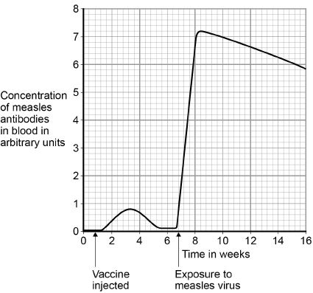

Explain the differences between antibody production after the vaccine injection and after exposure to the measles virus.

You should include data from the graph above

___________________________________________________________________

___________________________________________________________________

___________________________________________________________________

___________________________________________________________________

___________________________________________________________________

___________________________________________________________________

___________________________________________________________________

___________________________________________________________________

___________________________________________________________________

___________________________________________________________________

___________________________________________________________________

___________________________________________________________________

**(6)**

**(Total 11 marks)**

**Q2.**

People can be immunised against a pathogen by injecting them with a vaccine.

(a)     What does a vaccine contain?

___________________________________________________________________

___________________________________________________________________

**(1)**

(b)     A person was injected with a vaccine. A few weeks later the person was exposed to the pathogen they had been immunised against.

The graph shows how the concentration of antibodies in the blood changed after injection of the vaccine and after exposure to the pathogen.

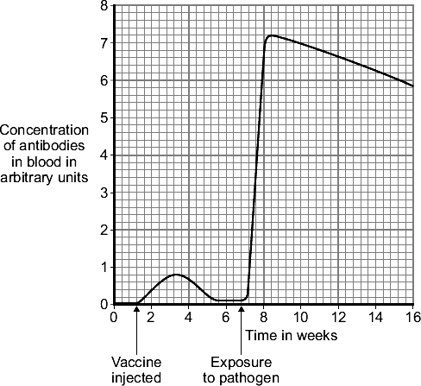

(i)      Describe in detail the differences between antibody production after the injection of the vaccine **and** after the person was exposed to the pathogen.

______________________________________________________________

______________________________________________________________

______________________________________________________________

______________________________________________________________

______________________________________________________________

______________________________________________________________

______________________________________________________________

______________________________________________________________

**(3)**

(ii)     Suggest an explanation for the differences you have described in part (b)(i).

______________________________________________________________

______________________________________________________________

______________________________________________________________

______________________________________________________________

______________________________________________________________

______________________________________________________________

______________________________________________________________

______________________________________________________________

**(3)**

**(Total 7 marks)**

Mark schemes

**Q1.**

(a)  any **one** from:

•   not everyone would go to the doctor

*allow not all cases recorded*

*allow only medically confirmed cases recorded*

*ignore some cases are unknown*

•   sample will not always be sent for analysis

•   some cases not tested / diagnosed / confirmed

*allow idea that doctor may make a judgemental error or mis-diagnosis*

**1**

(b)  

*allow for* ***1*** *mark:*



**1**

96 / 95.5

*allow* ***2*** *marks for correct rounding of 95.51724138*

*allow* ***1*** *mark for correct calculation using incorrect subtraction* ***only*** *if working shown*

**1**

*an answer of 96 / 95.5 scores* ***2*** *marks*

*allow* ***1*** *mark only for 95 or other incorrect rounding*

(c)  most people are **immune** so do **not become ill** (from infection)

*allow herd / community immunity so do not become ill (from infection)*

*allow most people are immune so do not become infected*

*ignore most people are immune so don’t get / catch it*

**1**

less chance of **non-immune** / **unvaccinated** individuals being exposed to pathogen / measles / virus

*reference to an organism is needed*

*allow ‘it’ for the measles virus*

*allow fewer people to pass it on to non-immune people*

**1**

(d)  **Level 3:** Relevant points (comparisons / reasons) are identified, given in detail and logically linked to form a clear account.

**5−6**

**Level 2:** Relevant points (comparisons / reasons) are identified and there are attempts at logical linking. The resulting account is not fully clear.

**3−4**

**Level 1:** Points are identified and stated simply, but their relevance is not clear and there is no attempt at logical linking.

**1−2**

**No relevant content**

**0**

**Indicative content**

**differences (after exposure to measles virus):**

•   greater number / higher concentration of antibodies produced

•   quantitative statement, e.g. 9 times higher **or** 0.8 to 7.2

•   antibodies produced sooner − idea of immediate response

•   antibodies produced quicker

•   antibodies stay (in higher concentration) for longer

**explanation**

•   white blood cells / leucocytes / lymphocytes / B cells

    ignore phagocytes / macrophages

•   reference to previous exposure (of white blood cells) to pathogen / virus

•   (white blood cells) recognise pathogen / virus / antigen

•   memory cells

•   production of specific / correct antibodies

**[11]**

**Q2.**

(a)     dead / inactive form of pathogen / microorganism / bacterium / virus

*ignore disease (for organism)*

*ignore toxins / antibodies*

**1**

(b)      (i)      any **three** from:

(after exposure):

•     greater number of antibodies produced / higher concentration

•     antibodies stay (in higher concentration) for longer

•     antibodies produced quicker

•     quantitative, eg 9 times higher / 0.8 to 7.2

*scores* ***2*** *marks for increased to 9 times higher / from 0.8 to 7.2*

**3**

(ii)     white cells

*allow lymphocytes / leucocytes*

*do* ***not*** *accept phagocytes / macrophage*

**1**

have had previous exposure to pathogen / recognise pathogen on re-entry /  
familiar with pathogen / reference to memory cells

*ignore knows how to kill pathogen  
ignore live pathogen introduced on exposure*

**1**

therefore antibodies produced (more) rapidly

*this marking point dependent on previous marking point*

**1**

**[7]**

Examiner reports

**Q1.**

(a)  76% of students achieved this mark. Common correct responses included not all cases of measles being recorded or diagnosed, or people not going to see the doctor. There were some confused ideas that deaths would not be recorded.

(b)  34% of students were awarded both marks. The most common error was in rounding the final answer, for example an answer of 95 gained one mark only.

Quite a lot of students used the alternative method given on the right hand side of the mark scheme. Many gave an answer of 4.5% for one mark. Only a few continued and subtracted this value from 100 to give the correct final answer.

(c)  This was a demanding question targeting the highest-attaining students. 8% of students achieved at least one mark. The question asked for an explanation of why vaccinating a large proportion of a population reduced the spread of the measles virus.

The first marking point required a reference to most people being immune and linking this to the fact that they would not become ill. Students usually missed this mark because they said they would not catch the virus, which is incorrect. Many were familiar with the term ‘herd immunity’, but few could clearly explain it.

The second marking point was for the idea that there would then be fewer people with the disease to pass the virus on to unvaccinated people. This mark did need a reference to the chance of an organism being passed on, disease was insufficient.

Many responses included correct biological facts, but they were not relevant to the question being asked. For example, many students gave a description of what a vaccine is, or described the immune response in general terms.

(d)  This was a ‘level marked’, ‘extended response’ question. The command word was ‘Explain’, so the main discriminator between the three different levels was the quality of linking ideas. Students were asked to explain the differences between antibody production after the injection of a vaccine and after exposure to the measles virus. Therefore comparisons between the two exposures and clear explanations in terms of the immune response were needed for level 3.

Students who only gave simple statements or a description of the graph, without comparisons or explanations, could only attain level 1. 53% of students gave a level 1 response.

Some students only gave comparisons. These could achieve three marks, if sufficient comparisons were made. The most common comparisons given were that more antibodies were produced at a faster rate after exposure. On their own these comparisons achieved two marks. If a correct quantitative statement was also given this was sufficient for three marks.

To achieve four marks explanations for the differences were required. 34% of students achieved three or more marks. Very few students gave a level 3 response, but this was targeted at grades 8−9.

Many responses showed a misunderstanding of antibodies, antigens, antitoxins and phagocytosis. Incorrect graph readings were often seen.

**Q2.**

﻿

 (a)     Most students knew that a dead or inactive form of a pathogen is used in a vaccine. However, some students gave weak answers which gave ‘disease’ or ‘germ’ rather than pathogen. A surprising number gave ‘antibody’ or ‘antigen’.

(b)     Students continue to confuse the command terms ‘describe’ and ‘explain’. Significant numbers repeated themselves in part (b)(i) and (b)(ii).

(i)     A surprisingly large number of students could not describe the differences shown in the graph. Many students obviously did not use the graph at all and gave descriptions of the immune response, rather than the differences between antibody production after vaccination and exposure to pathogen. To gain credit, comparisons should have been given. Some students attempted a comparative response but in terms of the pathogen being killed quicker rather than producing antibodies quicker.

(ii)     Many students stated that the smaller and slower response to the vaccine is because the vaccine is at a lower concentration or volume than later exposure to the pathogen. There were frequent references to white blood cells or antibodies knowing how to kill the pathogen. Many students stated that more antibodies were produced after exposure because the pathogen was more dangerous and had to be killed, whereas the vaccine was not dangerous so did not warrant a response.