**Q1.**

**Figure 1** shows a root hair viewed using a microscope.

**Figure 1**

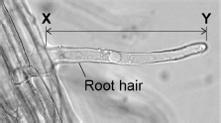

(a)  The root hair was viewed at a magnification of ×50

The image length of the root hair **X–Y** is 43 mm

Calculate the real length of the root hair in micrometres (µm).

___________________________________________________________________

___________________________________________________________________

___________________________________________________________________

___________________________________________________________________

___________________________________________________________________

___________________________________________________________________

Real length = ___________________________ µm

**(4)**

(b)  A microscope has a ×5 eyepiece lens.

Describe how to use this microscope to observe a prepared slide of root hair cells at a magnification of ×50

___________________________________________________________________

___________________________________________________________________

___________________________________________________________________

___________________________________________________________________

___________________________________________________________________

___________________________________________________________________

___________________________________________________________________

___________________________________________________________________

___________________________________________________________________

___________________________________________________________________

___________________________________________________________________

___________________________________________________________________

**(4)**

Root hair cells absorb water and mineral ions from the soil.

A scientist investigated the rate of nitrate ion uptake by two seedlings.

**Figure 2** shows how the investigation was set up.

**Figure 2**

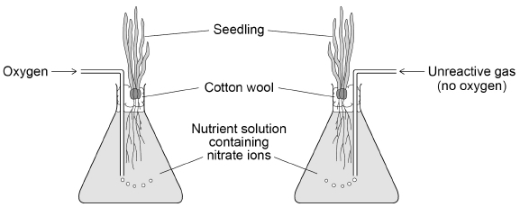

The scientist determined the mass of nitrate ions absorbed by each seedling every 30 minutes for 4 hours.

The table shows the results.

|  |  |  |
| --- | --- | --- |
| **Time in hours** | **Total mass of nitrate ions absorbed by seedling in arbitrary units** | |
| **With oxygen added** | **With no oxygen added** |
| 0 | 0 | 0 |
| 0.5 | 100 | 60 |
| 1.0 | 145 | 95 |
| 1.5 | 170 | 105 |
| 2.0 | 195 | 115 |
| 2.5 | 215 | 120 |
| 3.0 | 235 | 125 |
| 3.5 | 250 | 130 |
| 4.0 | 265 | 130 |

(c)  Describe the changes in the rate of absorption of nitrate ions for the seedling with **no** oxygen added.

Use information from the table.

___________________________________________________________________

___________________________________________________________________

___________________________________________________________________

___________________________________________________________________

___________________________________________________________________

___________________________________________________________________

**(3)**

(d)  Explain what the results in the table above show about how nitrate ions are absorbed.

___________________________________________________________________

___________________________________________________________________

___________________________________________________________________

___________________________________________________________________

___________________________________________________________________

___________________________________________________________________

___________________________________________________________________

___________________________________________________________________

**(4)**

(e)  Nitrate ions are essential for plants to grow.

Describe how nitrate ions are used in a plant to help the plant grow.

___________________________________________________________________

___________________________________________________________________

___________________________________________________________________

___________________________________________________________________

___________________________________________________________________

___________________________________________________________________

**(3)**

**(Total 18 marks)**

**Q2.**

Plants have tissues that are specialised for the transport of food and water molecules.

(a)     Which is a description of the role of the xylem?

Tick **one** box.

|  |  |
| --- | --- |
| Transports dissolved sugars using translocation |  |
| Transports starch in the transpiration stream |  |
| Transports water in the transpiration stream |  |
| Transports water using translocation |  |

**(1)**

(b)     Which is a description of the role of the pholem?

Tick **one** box.

|  |  |
| --- | --- |
| Transports dissolved sugars in the transpiration stream |  |
| Transports dissolved sugars using translocation |  |
| Transports starch using translocation |  |
| Transports water in the transpiration stream |  |

**(1)**

In plants water is lost through stomata.

**Figure 1** shows stomata on the lower surface of a leaf.

**Figure 1**

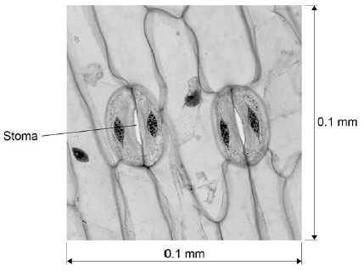

(c)     Calculate the number of stomata per mm2 for the leaf shown in **Figure 1**.

___________________________________________________________________

___________________________________________________________________

___________________________________________________________________

___________________________________________________________________

Number of stomata = ____________________

**(2)**

(d)     Most plants have more stomata on the lower surface of a leaf than on the upper surface.

Explain why there are more stomata on the lower surface of a leaf.

___________________________________________________________________

___________________________________________________________________

___________________________________________________________________

___________________________________________________________________

___________________________________________________________________

___________________________________________________________________

___________________________________________________________________

**(3)**

(e)     Particles can move into and out of cells by different processes.

**Figure 2** shows different particles inside and outside a root hair cell.

**Figure 2**

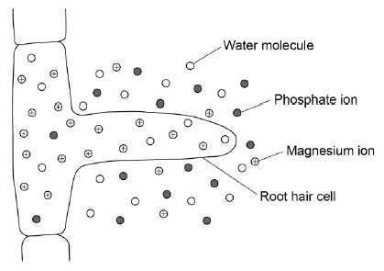

Explain the processes by which the different particles would enter the root hair cell.

___________________________________________________________________

___________________________________________________________________

___________________________________________________________________

___________________________________________________________________

___________________________________________________________________

___________________________________________________________________

___________________________________________________________________

___________________________________________________________________

___________________________________________________________________

___________________________________________________________________

___________________________________________________________________

___________________________________________________________________

**(6)**

**(Total 13 marks)**

**Q3.**

This question is about cell structures.

(a)  Draw **one** line from each cell structure to the type of cell where the structure is found.

|  |  |  |
| --- | --- | --- |
| **Cell Structure** |  | **Type of cell where the structure is found** |
|  | | |
| Nucleus |  | Prokaryotic cells |
|  | | |
| Permanent vacuole |  | Plant cells only |
|  | | |
| Plasmid |  | Eukaryotic cells |

**(2)**

(b)  **Figure 1** shows a plant cell.

**Figure 1**

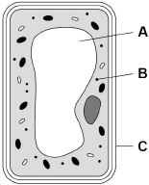

What are the names of structures **A**, **B** and **C**?

Tick **one** box.

|  |  |  |  |
| --- | --- | --- | --- |
| **Structure A** | **Structure B** | **Structure C** |  |
| Chloroplast | Vacuole | Cell wall |  |
| Nucleus | Chloroplast | Cell membrane |  |
| Vacuole | Mitochondrion | Cell membrane |  |
| Vacuole | Ribosome | Cell wall |  |

**(1)**

A student observed slides of onion cells using a microscope.

**Figure 2** shows two of the slides the student observed.

**Figure 2**

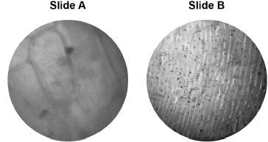

The cells on the slides are **not** clear to see.

(c)  Describe how the student should adjust the microscope to see the cells on Slide A more clearly.

___________________________________________________________________

___________________________________________________________________

**(1)**

(d)  Describe how the student should adjust the microscope to see the cells on Slide B more clearly.

___________________________________________________________________

___________________________________________________________________

___________________________________________________________________

**(2)**

(e)  The student made the necessary adjustments to get a clear image.

**Figure 3** shows the student’s drawing of one of the cells.

**Figure 3**

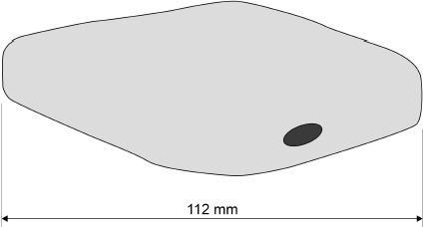

The real length of the cell was 280 micrometres (µm).

Calculate the magnification of the drawing.

___________________________________________________________________

___________________________________________________________________

___________________________________________________________________

___________________________________________________________________

___________________________________________________________________

Magnification = × _________________________

**(3)**

**(Total 9 marks)**

**Q4.**

The image below shows some muscle cells from the wall of the stomach, as seen through a light microscope.

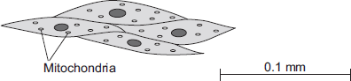

(a)     Describe the function of muscle cells in the wall of the stomach.

___________________________________________________________________

___________________________________________________________________

___________________________________________________________________

___________________________________________________________________

**(2)**

(b)     The figure above is highly magnified.

The scale bar in the figure above represents 0.1 mm.

Use a ruler to measure the length of the scale bar and then calculate the magnification of the figure above.

___________________________________________________________________

___________________________________________________________________

___________________________________________________________________

___________________________________________________________________

Magnification = _______________ times

**(2)**

(c)     The muscle cells in **Figure above** contain many mitochondria.

What is the function of mitochondria?

___________________________________________________________________

___________________________________________________________________

___________________________________________________________________

___________________________________________________________________

**(2)**

(d)     The muscle cells also contain many ribosomes. The ribosomes cannot be seen in the figure above.

(i)      What is the function of a ribosome?

______________________________________________________________

______________________________________________________________

**(1)**

(ii)     Suggest why the ribosomes **cannot** be seen through a light microscope.

______________________________________________________________

______________________________________________________________

**(1)**

**(Total 8 marks)**

Mark schemes

**Q1.**

(a)  

**1**

(size of real object =) 

**1**

(size of real object =) 0.86 (mm)

**1**

(size of real object =) 860 (µm)

*an answer of 860 (µm) scores 4 marks*

*allow correct conversion of their calculated value*

*if no other marks awarded allow 1 mark for*



**1**

(b)  **Level 2:** Scientifically relevant facts, events or processes are identified and given in detail to form an accurate account.

**3−4**

**Level 1:** Facts, events or processes are identified and simply stated but their relevance is not clear.

**1−2**

**No relevant content**

**0**

**Indicative content**

•   place slide on stage

•   use lowest power / ×4 objective lens (initially)

•   adjust mirror **or** switch light on so light passes through slide

•   move stage as close to lens as possible

•   slide must not touch lens

•   turn focussing knob so slide moves away from lens

•   turn focussing knob until image comes into focus

•   use fine focus to get clear image

•   change objective lens to ×10

•   ×5 eyepiece and ×10 objective lenses (gives total magnification of ×50)

•   refocus slide using focussing knob

For Level 2 reference to how to focus the slide / cells **and** achieve magnification of ×50 is required

(c)  any **three** from:

•   (rate) fastest in the first 0.5 hours

*allow fastest rate is 120 units per hour (at start)*

•   (rate gradually) decreases after first 0.5 hours

*allow mean rate over 3.5 hours is 37.14 units per hour*

**or**

•   (rate gradually) decreases throughout the investigation

•   rate is constant between 1.0 and 2.0 hours

**or**

•   rate is constant between 2.0 and 3.5 hours

•   (rate) becomes zero between 3.0 and 3.5 hours

*allow (rate) is zero after 3.5 hours*

*allow 'it’ for rate*

**3**

(d)  more nitrate ions are absorbed in the presence of oxygen

*allow nitrate ions absorbed faster in the presence of oxygen*

**1**

(which suggests) they are absorbed by active transport / uptake

**1**

which requires energy from respiration

*do* ***not*** *accept energy produced / created / made*

**1**

some nitrate ions absorbed by diffusion

**or**

some nitrate ions absorbed (by active transport / uptake) requiring energy from anaerobic respiration

**or**

some nitrate ions absorbed by active transport / uptake using oxygen already dissolved in the solution

**1**

(e)  nitrate ions are used with glucose

**1**

to form amino acids

**1**

(which are) used to synthesise proteins (needed for growth)

**1**

**[18]**

**Q2.**

(a)     transports water in the transpiration stream

**1**

(b)     transports dissolved sugars using translocation

**1**

(c)     2/(0.1 × 0.1)

**or**

2/ 0.01

**1**

200

*an answer of 200 scores* ***2*** *marks*

**1**

(d)     cooler around lower surface

**1**

more humid around lower surface

*allow converse argument for upper surface of leaf if qualified*

**1**

(so) less water evaporated

*allow less breeze around lower surface*

**1**

(e)

|  |  |
| --- | --- |
| **Level 3:** Relevant points (correct processes / explanations) are identified, given in detail and linked logically to form a clear account. | 5-6 |
| **Level 2:** Relevant points (correct processes / explanations) are identified and there are attempts at logical thinking. The resulting account is not fully clear. | 3-4 |
| **Level 1:** Points are identified and stated simply, but their relevance is not clear and there is no attempt at logical thinking. | 1-2 |
| No relevant content | 0 |
| **Indicative content**  •   water is absorbed by osmosis  •   osmosis is a passive process, or described  •   water in soil is at a higher concentration than inside cell  •   water moves down concentration gradient  •   through a partially permeable membrane  •   phosphate ions absorbed by diffusion  •   diffusion is a passive process, or described  •   phosphate ions are in a higher concentration in soil than inside cells  •   magnesium ions are absorbed by active transport  •   magnesium ions are in lower concentration in soil than inside cells  •   magnesium ions move from an area of lower concentration to an area of higher concentration inside the cells  •   magnesium ions move up the concentration gradient  •   process requires energy  •   energy from respiration |  |

**6**

**[13]**

**Q3.**

(a)

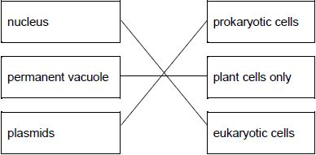

*allow* ***1*** *mark for one or two correct links*

**2**

(b)

|  |  |  |
| --- | --- | --- |
| vacuole | ribosome | cell wall |

*tick box takes precedence*

*if no tick is given, look at both the figure and the circling of words in the table*

*if writing is seen on the figure and in the table both must be correct*

**1**

(c)  turn the (fine focusing) knob until the cells are in focus

*allow focus it*

*do* ***not*** *accept increase magnification*

*ignore decrease magnification*

*ignore clear*

*ignore references to resolution / illumination*

*ignore zoom in / out*

**1**

(d)  (rotate the) nosepiece / objective lens

*allow change the (objective / eyepiece) lens*

**1**

to a higher power (lens)

*allow (to) increase the magnification*

*a comparator is required*

*ignore change / adjust the magnification*

*allow stronger or more powerful lens*

*ignore references to resolution / illumination unqualified*

*ignore zoom in / out*

*ignore references to an electron microscope*

**1**

(e)  conversion of units:

(112 mm ⟶) 112 000 (µm)

**or**

(280 µm ⟶) 0.28 (mm)

**1**



**or**



*allow* ***1*** *mark for no conversion of units 112 / 280*

***or***

*incorrect value from step 1 correctly substituted*

**1**

400 (×)

*do* ***not*** *accept if units are given*

*if no other mark scored allow* ***1*** *mark for:*



*a triangle with words or letters in is insufficient, as the correct rearrangement is needed*

**1**

*an answer of 400 (×) scores* ***3*** *marks*

**[9]**

**Q4.**

(a)     contract / shorten

*ignore relax*

*do* ***not*** *allow expand*

**1**

to churn / move / mix food

*accept peristalsis / mechanical digestion*

*ignore movement unqualified*

**1**

(b)     400

*acceptable range 390-410*

*allow 1 mark for answer in range of 39 to 41*

*allow 1 mark for answer in range of 3900 to 4100*

**2**

(c)     to transfer energy for use

*allow to release / give / supply / provide energy*

*do* ***not*** *allow to ‘make’ / ߢproduce’ / ‘create’ energy*

*allow to make ATP*

*ignore to store energy*

**1**

by (aerobic) respiration **or** from glucose

*do* ***not*** *allow anaerobic*

*energy released* ***for*** *respiration = max 1 mark*

**1**

(d)     (i)      to make protein / enzyme

*ignore ‘antibody’ or other named protein*

**1**

(ii)     too small / very small

*allow light microscope does not have sufficient magnification / resolution*

*allow ribosomes are smaller than mitochondria*

*ignore not sensitive enough*

*ignore ribosomes are transparent*

**1**

**[8]**

Examiner reports

**Q1.**

(a)  Around 38% of students gained full marks for calculating the length of the root hair in micrometres. Around 33% of students scored three marks because they made an error with the unit conversion. As mentioned earlier, more students are showing their working for the calculation.

The first marking point was for substitution into the equation given in the specification. The second marking point was for reorganisation of the equation to calculate the real length of the root hair. The third marking point was for correctly calculating the length in mm. The final mark was for converting this value to µm. This was an independent marking point, so a conversion of their incorrectly calculated length could gain this mark. This was often awarded. The most common errors related to incorrectly reorganising the equation, or an incorrect unit conversion.

(b)  This extended response question highlighted that many students either did not understand how to use a light microscope, or could not explain the procedure in a clear step by step way.

Some students had not read the question carefully. Instead of starting with a prepared slide, they explained how they would prepare a slide, which was not creditworthy. Knowledge of the names of the parts of a microscope was poor.

If students only said that the ×10 objective lens should be used to give a total magnification of ×50, they gained one mark. In order to access Level 2, a detailed method in a logical sequence was needed, as well as a description of how to achieve a magnification of ×50. 9% of students achieved Level 2. Many responses lacked detail, or gave confused accounts of how to focus a microscope.

(c)  This question asked students to describe the changes in the rate of absorption of ions for the seedling with no oxygen added. Many students compared the seedlings with and without oxygen, saying the rate of absorption with oxygen was faster. This is a correct statement, but does not answer the question. Others described the change in mass of the ions absorbed, rather than the rate.

A fifth of students scored one or more marks. Where one mark was awarded, it was usually for saying that the rate gradually decreased as time went by. Students always find it more difficult to interpret data when it is given in a table, rather than displayed as a graph. It might help if students sketched the data as a graph, so the changes in rate would be more obvious. Alternatively they could calculate the rate at each time point.

(d)  Around 79% of students scored one mark for saying that more nitrate ions are absorbed in the presence of oxygen. Stating that the ions were absorbed better was insufficient as at this level the idea of more or faster was required. Only a few went on to explain that this was because the ions were absorbed by active transport, which requires energy from respiration. The last marking point was rarely seen.

(e)  Students found this question difficult and approximately 11% scored one or more marks. A direct description, of how nitrate ions are used to help plants grow, was required. Although nitrate ions are used to form other substances in a plant, the direct link between the formation of proteins for growth was needed.

Many students gave a description of nitrate ion uptake and transport in the plant, but this did not answer the question. Reference to active transport was often seen. Many thought that nitrate ions are transported in phloem. The use of nitrates as a food or as a source of energy was often stated. Some thought that nitrates contain glucose.

**Q3.**

**Foundation**

(a)  57% of students demonstrated a good understanding of prokaryotic and eukaryotic cells and were awarded two marks. To achieve both marks all three structures had to be correctly linked to the type of cell where each structure is found.

When only one mark was awarded it was usually for identifying the nucleus as being found in eukaryotic cells.

(b)  59% of students were awarded the mark for identifying the vacuole, ribosome and cell wall in the plant cell.

Students were asked to tick one box, but some labelled the diagram, whilst others circled the names of the structures in the table.

(c)  17% of students achieved this mark. The cells on slide A appeared large, but blurred. The required response was a reference to focusing the image.

Many students referred to zooming in or out, to altering the magnification or using an electron microscope. All of these were ignored. However, if they said increase the magnification this was incorrect and negated a correct answer of focusing the image.

(d)  The cells on slide B appeared small but in focus. The required response was a description of how to obtain a larger image. There were two marks available for this question:

•   one was for reference to changing the lens

•   one was for stating that the new lens would have a higher power or magnification.

3% of students achieved two marks, and 23% obtained one mark, usually for saying increase the magnification.

Changing or using a better magnification was insufficient. Many students referred to zooming in or out or said use an electron microscope, both of which were ignored.

(e)  There were three marks available for this question.

•   The first mark was for conversion of units. Many students did not attempt a conversion but could still go on to achieve two marks. A range of different errors were made which included multiplying or dividing by 10, 100 or 10 000, rather than by 1000. Some did not appreciate that a micrometre is smaller than a millimetre.

•   The second mark was for correctly substituting into the rearranged equation to calculate magnification. This mark was allowed even if their initial conversion was incorrect.

•   The final mark was for an answer of 400. Some students added a unit to their answer and this negated the mark.

33% of students achieved all three marks, and 33% achieved two marks. 24% of students scored zero. This was often for 280 ÷ 112 = 2.5

**Higher**

(a)  Students demonstrated a good understanding of prokaryotic and eukaryotic cells. 87% of students achieved two marks. To gain both marks all three structures had to be correctly linked to the type of cell where each structure is found.

When only one mark was awarded it was usually for identifying the nucleus as being found in eukaryotic cells.

(b)  Students demonstrated a good understanding of cell structure. 80% of students were awarded the mark for identifying the vacuole, ribosome and cell wall in the plant cell.

Students were asked to tick one box, but some labelled the diagram, whilst others circled the names of the structures in the table.

(c)  27% of students achieved this mark. The cells on slide A appeared large, but blurred. The required response was a reference to focusing the image.

Many students referred to zooming in or out, to altering the magnification or using an electron microscope. All of these were ignored. However, if they said increase the magnification this was incorrect and negated a correct answer of focusing the image.

(d)  The cells on slide B appeared small but in focus. The required response was a description of how to obtain a larger image. There were two marks available for this question.

•   One was for reference to changing the lens.

•   One was for stating that the new lens would have a higher power or magnification.

45% of students obtained a mark. Where a mark was awarded it was usually for saying increase the magnification.

Changing or using a better magnification was insufficient. Many students referred to zooming in or out or said use an electron microscope, both of which were ignored.

(e)  There were three marks available for this question.

•   The first mark was for conversion of units. Many students did not attempt a conversion but could still go on to achieve two marks. A range of different errors were made which included multiplying or dividing by 10, 100 or 10 000, rather than by 1000. Some did not appreciate that a micrometre is smaller than a millimetre.

•   The second mark was for correctly substituting into the rearranged equation to calculate magnification. This mark was allowed even if their initial conversion was incorrect.

•   The final mark was for an answer of 400. Some students added a unit to their answer and this negated the mark.

22% of students achieved two marks. 56% of students scored zero marks. This was often for 280 ÷ 112 = 2.5

**Q4.**

This question was about cell structure and function, based on a drawing of some muscle cells from the wall of the stomach.

(a)     Just over two-thirds of students scored at least one mark for describing the function of the muscle cells either in terms of their ability to contract or with respect to their use in the stomach for churning food. Relatively few gave both points. A large number spoiled their answer by stating that the muscles ‘contract and expand’, while others clearly knew nothing about muscle and suggested they might ‘secrete acid’ or, alternatively, ‘protect the body from acid’.

(b)     The mathematical requirements given in section 3.7 of the Specification include the statement: *‘All students should be able to.......Understand number size and scale and the quantitative relationship between units’*. A very common error in calculating the magnification of the drawing of the muscle cells was to mix units by measuring the scale bar as 4 centimetres (rather than 40 millimetres) and then dividing this by the 0.1 millimetres that it represented. This gave an answer of ‘40’ instead of the correct 400. Despite the instruction in the question to ‘*use a ruler to measure the length of the scale bar...*’, many students measured one or more of the cells in the diagram and scored no marks. Thus success in this question was limited, with only about a quarter scoring full marks.

(c)     The function of mitochondria in respiration and in releasing energy was well known, although often only one of these points was made and many spoiled their answer by including the phrase ‘making energy’ which, of course, defies the fundamental physical law of conservation of energy. Another common error was to state that energy was released ‘for respiration’ rather than by *respiration*. Thus only one-third of students scored both of the marks available.

(d)     (i)      Around three quarters of students knew that ribosomes were the site of protein synthesis and that they were too small to be visible in a light microscope, although some suggested that they were merely ‘transparent’.

(ii)     Around three quarters of students knew that ribosomes were the site of protein synthesis and that they were too small to be visible in a light microscope, although some suggested that they were merely ‘transparent’.