**Name: ___________________________________**

**Magnification & Orders of Magnitude PPQs**

**Q1**

**Figure 2** shows diagrams of a plant cell and three types of microorganism.

**Figure 2**

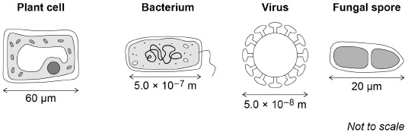

(a)  Calculate how many times longer the plant cell is than the bacterium.

___________________________________________________________________

___________________________________________________________________

___________________________________________________________________

___________________________________________________________________

___________________________________________________________________

Number of times longer = _______________________

**(3)**

(b)   In the school laboratory, a student could observe a fungal spore but not a virus.

Give a reason why.

Use information from **Figure 2**.

___________________________________________________________________

___________________________________________________________________

___________________________________________________________________

**(1)**

**Q2.**

**Figure 1** shows guard cells around open stomata magnified 800 times.

**Figure 1**

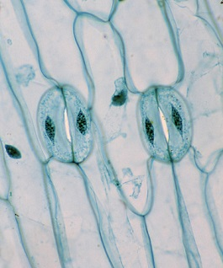

  The image size of one of the guard cells is 26 millimetres long.

Calculate the real length of the guard cell in micrometres.

Include the equation you are using to calculate your answer.

___________________________________________________________________

___________________________________________________________________

___________________________________________________________________

___________________________________________________________________

___________________________________________________________________

___________________________________________________________________

Real length of guard cell = __________________ micrometres

**(3)**

**Q3.**

The figure below shows four different types of cell.

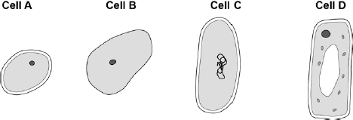

(a)     Which cell is a plant cell?

Give **one** reason for your answer.

Cell _________

Reason ____________________________________________________________

**(2)**

(b)     Which cell is an animal cell?

Give **one** reason for your answer.

Cell _________

Reason ____________________________________________________________

**(2)**

(c)     Which cell is a prokaryotic cell?

Give **one** reason for your answer.

Cell _________

Reason ____________________________________________________________

**(2)**

(d)     A scientist observed a cell using an electron microscope.

The size of the image was 25 mm.

The magnification was × 100 000

Calculate the real size of the cell.

Use the equation:



Give your answer in micrometres.

___________________________________________________________________

___________________________________________________________________

___________________________________________________________________

Real size = __________________ micrometres

**(3)**

**Q4.**

**Figure 1** shows a cell viewed through a light microscope.

**Figure 1**

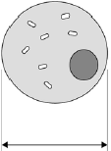

The size of the real cell is 0.03 mm.

         Calculate the magnification of the microscope.

Use **Figure 1** to help you answer.

___________________________________________________________________

___________________________________________________________________

Magnification = ________________________

**(2)**

**Magnification & Orders of Magnitude PPQs**

Mark Scheme

**Q1.**

(a)

*an answer of 120 scores* ***3*** *marks*

(plant cell)

(60 µm = ) 6.0 × 10−5 m

**or**

(bacterial cell)

(5.0 × 10−7 m) = 0.5 µm

**1**



**or**



*allow incorrectly / not converted value for length correctly substituted*

**1**

(=) 120

*allow a correctly calculated value using an incorrectly / not converted value for length*

**1**

(b)   a virus is too small to be seen under a light microscope

**or**

needs an electron microscope to see a virus

*ignore a virus is too small to see*

**1**

**Q2.**





**1**

= 0.0325 (millimetres)

*allow 0.0325 (millimetres) for* ***2*** *marks*

**1**

= 32.5 (micrometres)

*allow* ***1*** *mark for incorrect length × 1000*

**1**

*an answer of 32.5* ***or*** *33 (micrometres) scores* ***3*** *marks*

**Q3.**

(a)     **D**

**1**

any **one** from:

•        has chloroplasts

•        has a (large) vacuole

*ignore has a (cell) wall*

**1**

(b)     **B**

**1**

does **not** have a (cell) wall

*allow has only a nucleus, (cell) membrane* ***and*** *cytoplasm*

**1**

(c)     **C**

**1**

any **one** from:

•        genetic material is not in a nucleus

*allow no nucleus*

•        has a single loop of DNA

**1**

(d)     real size = 25 / 100 000

**1**

0.00025

**1**

(conversion to) 0.25 (µm)

*allow 0.25 (µm) with no working shown for* ***3*** *marks*

**1**

**Q4.**



= 29 ÷ 0.03

**1**

= 967

**1**

*allow 967 with no working shown for* ***2*** *marks*