**Q1.**

Some animals have a single circulatory system.

(a)     Why is the human heart referred to as part of a dual circulatory system?

___________________________________________________________________

___________________________________________________________________

**(1)**

Below is a diagram of a human heart.

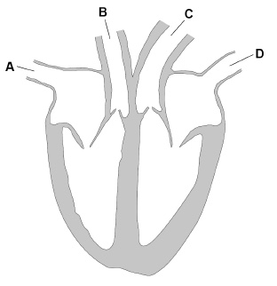

(b)     Which label shows the pulmonary vein?

Tick **one** box.

|  |  |  |  |  |  |  |  |
| --- | --- | --- | --- | --- | --- | --- | --- |
| **A** |  | **B** |  | **C** |  | **D** |  |

**(1)**

(c)     Which blood vessel takes oxygenated blood away from the heart?

Tick **one** box.

|  |  |  |  |  |  |  |  |
| --- | --- | --- | --- | --- | --- | --- | --- |
| **A** |  | **B** |  | **C** |  | **D** |  |

**(1)**

(d)     Name the blood vessels that deliver oxygen to the capillaries in heart muscle.

___________________________________________________________________

**(1)**

(e)     Pacemaker cells are a group of cells that control heart rate.

Where in the heart are the pacemaker cells located?

___________________________________________________________________

**(1)**

(f)      What type of signal is sent from the pacemaker cells to the heart muscle?

___________________________________________________________________

___________________________________________________________________

**(1)**

In a scientific investigation over 44 000 men were monitored for 12 years.

The men were divided into four groups based on their number of hours of physical activity they did per week.

The results are shown in the table.

|  |  |  |  |  |
| --- | --- | --- | --- | --- |
| **Group** | **W** | **X** | **Y** | **Z** |
| Mean number of hours of physical activity per week | 1 | 5 | 12 | 24 |
| Percentage who are smokers | 14 | 11 | 9 | 7 |
| Percentage with high cholesterol | 11 | 10 | 11 | 11 |
| Percentage with family history of heart disease | 12 | 12 | 12 | 12 |
| Mean percentage of fat in diet | 34 | 33 | 32 | 30 |
| Number of cases of heart disease | 423 | 370 | 336 | 294 |

(g)     Give **two** other factors which may affect the risk of heart disease.

You should **not** refer to the factors shown in the table.

1. _________________________________________________________________

___________________________________________________________________

2. _________________________________________________________________

___________________________________________________________________

**(2)**

(h)     Evaluate whether the data shows that increased hours of physical activity reduces the risk of heart disease.

___________________________________________________________________

___________________________________________________________________

___________________________________________________________________

___________________________________________________________________

___________________________________________________________________

___________________________________________________________________

___________________________________________________________________

___________________________________________________________________

___________________________________________________________________

___________________________________________________________________

___________________________________________________________________

___________________________________________________________________

___________________________________________________________________

___________________________________________________________________

**(6)**

**(Total 14 marks)**

**Q2.**

LDL is one form of cholesterol found in the blood.

People with a high concentration of LDL in their blood may be treated with drugs called statins.

A high concentration of LDL cholesterol in the blood may result in an increased risk of heart and circulatory diseases.

The graph shows the effects of the treatment of one person with four different statins,   
**A**, **B**, **C** and **D**, over a period of 8 years. The arrows show when each new treatment was started.

Each treatment was continued until the next treatment was started.

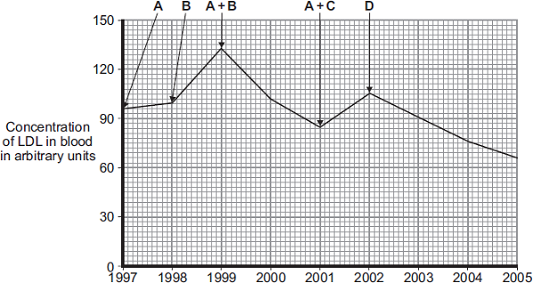

Year

Compare the effectiveness of the five treatments in reducing the risk of heart and   
circulatory diseases for this person.

_______________________________________________________________________

_______________________________________________________________________

_______________________________________________________________________

_______________________________________________________________________

_______________________________________________________________________

_______________________________________________________________________

_______________________________________________________________________

_______________________________________________________________________

_______________________________________________________________________

_______________________________________________________________________

_______________________________________________________________________

_______________________________________________________________________

**(Total 4 marks)**

Mark schemes

**Q1.**

(a)     blood enters the heart twice on each journey around the body

*allow blood circulates once to the lungs (for oxygen) and then around the body*

**1**

(b)     **D**

**1**

(c)     **C**

**1**

(d)     coronary artery / arteries

**1**

(e)     right atrium

**1**

(f)     electrical

**1**

(g)      any **two** from:

•        rest of diet

*allow an example such as fibre or saturated fat or alcohol intake*

•        weight

*allow obesity*

•        age

•        type of activity

•        gender

•        blood pressure

**2**

(h)

|  |  |
| --- | --- |
| **Level 3:** A judgement, strongly linked and logically supported by a sufficient range of correct reasons, is given. | 5-6 |
| **Level 2:** A conclusion, supported by some relevant reasons is given. | 3-4 |
| **Level 1:** Relevant points are made. If there is a conclusion, this is asserted, but not logically linked to the points made. | 1-2 |
| No relevant content | 0 |
| **Indicative content**  **for**  •   as hours of activity increase, number of cases of heart disease decrease  •   increasing hours of exercise from low numbers to slightly higher (groups **W-X**) seems to reduce cases more than increasing activity from groups **Y-Z**  •   cholesterol and family history do not correlate with heart disease  **against**  •   other factors also increase / decrease / correlate with changing hours of exercise  •   smoking correlates with changing hours of exercise  •   smoking correlates with heart disease  •   % fat in diet also correlates with lack of exercise and heart disease  •   limitations such as only studied men, not women / children  •   unknown how many people are in each category or what percentage (of each group) had heart disease |  |

**6**

**[14]**

**Q2.**

A + B most effective (treatment)

*ignore descriptions of LDL levels*

**1**

D is (the most) effective (treatment)

*D is the best single (treatment)*

**1**

neither A nor B (alone) are effective

*allow increase risk of heart disease instead of not effective*

**1**

can’t tell if C is effective  
**OR**A + C is not effective

**1**

**[4]**

Examiner reports

**Q2.**

It was disappointing that so many students either failed to read the information properly or failed to answer the question that was asked. The question referred to comparing the effectiveness of the treatments in reducing the risk of disease. Unfortunately, a large proportion of students simply described the effect of the treatments in raising or lowering blood cholesterol levels. As a result there were many students who filled the available space with clear comparisons but who gained no marks, as the response did not match the question. A further misconception was to believe that when treatments were changed this was the cause of the change in blood cholesterol levels. Students are expected to be able to ‘evaluate the effect of statins’, ‘given data to work from’ as described in the specification and it was clear that many were unprepared for this type of question.

Those who did tackle the question as intended and used the information often scored good marks, however there were some of these students who appeared to believe that a fall in blood cholesterol concentration caused an increase in risk of heart disease. Another common error was to describe, for example, that statin A has ‘less effect’ or was ‘not very effective’. This left examiners assuming that the student believed statin A reduced the risk of heart disease, rather than increased the risk. This was a clear misinterpretation of the data, perhaps through weak language skills, and was not credited.