  B7 PPQ
  Year 11 Revision
  Name: | ________________________
  Class: | ________________________
  Date: | ________________________

Time: | 128 minutes
Marks: | 120 marks
Comments:

Q1.
This question is about biodiversity.
A farmer:
• grows only wheat crops
• has used all his small fields to make a few large fields
• cuts down trees in his woodlands to burn as fuel.
(a) What are two ways the farmer could increase biodiversity on his farm?
Tick (✓) two boxes.

Cut down trees to grow wheat | 
Plant hedgerows around his fields
Plant many different crops in his fields
Put fences around his fields
Put fertiliser on his wheat crop
(2)
Students investigated the effect of cutting down trees in the woodland.
This is the method used.
1. Mark out a 10 m by 10 m area where trees have been removed.
2. Place a 1 m × 1 m quadrat at six random positions in the area.
3. Record the number of plant species present.
4. Record the number of invertebrate species seen among dead leaves on the ground.
5. Repeat steps 1 to 4 in an area where there are trees.
(b) Suggest one improvement the students could make to their method.
___________________________________________________________________
___________________________________________________________________
(1)
(c) The students made this prediction:

‘There will be more invertebrate species living in the area where there are trees.’
Explain why the students’ prediction may be correct.
___________________________________________________________________
___________________________________________________________________
___________________________________________________________________
___________________________________________________________________
(2)
The table below shows the students’ results.

Quadrat | Number of plant species |  | Number of invertebrate species
Quadrat | Area with no trees | Area with trees | Area with no trees | Area with trees
1 | 8 | 2 | 4 | 10
2 | 6 | 2 | 3 | 6
3 | 7 | 0 | 4 | 8
4 | 6 | 3 | 5 | 14
5 | 20 | 4 | 2 | 9
6 | 8 | 1 | 6 | 13
Mean | 7 | 2 | 4 | 10
(d) The students decided that one result was anomalous.
Draw a ring around the anomalous result in the table above.
(1)
(e) How does removing trees affect the number of invertebrate species living among the dead leaves on the ground?
Use the table above.
___________________________________________________________________
___________________________________________________________________
(1)
(f) There were more plant species growing in the area where there were no trees.
Explain why.
___________________________________________________________________
___________________________________________________________________
___________________________________________________________________
___________________________________________________________________
___________________________________________________________________
___________________________________________________________________
(3)
(Total 10 marks)
Q2.
There is a need to grow enough food for all the people in the world.
Growing enough food affects habitats and biodiversity.
(a) What is meant by the term biodiversity?
___________________________________________________________________
___________________________________________________________________
(1)
Peat bogs are being destroyed because peat is used by humans.
Destroying peat bogs also reduces biodiversity.
(b) Give one use of peat taken from peat bogs.
___________________________________________________________________
___________________________________________________________________
(1)
(c) Explain why the use of peat is harmful to the environment.
Do not refer to biodiversity in your answer.
___________________________________________________________________
___________________________________________________________________
___________________________________________________________________
___________________________________________________________________
(2)
(d) Intensive farming, where a single crop is grown on a large area of land year after year, is more cost effective for farmers.
It is efficient to use fertilisers and to burn the waste so the land is ready to use the next year.
Planting a single crop reduces biodiversity.
Suggest two ways that this type of farming can damage the environment.
Do not refer to biodiversity in your answer.
1. _________________________________________________________________
___________________________________________________________________
2. _________________________________________________________________
___________________________________________________________________
(2)
(e) Most of the world’s production of antibiotics is used in farming.
Antibiotics are given to animals to prevent the spread of disease.
Explain how the widespread use of antibiotics in farming is a threat to human life.
___________________________________________________________________
___________________________________________________________________
___________________________________________________________________
___________________________________________________________________
___________________________________________________________________
___________________________________________________________________
___________________________________________________________________
___________________________________________________________________
___________________________________________________________________
___________________________________________________________________
(4)
(Total 10 marks)
Q3.
Figure 1 shows a food chain in a garden.
Figure 1

 |  | 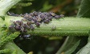 |  | 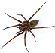 |  | 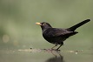
bean plant | → | blackfly | → | spider | → | blackbird
(a) Which term describes the spider in this food chain?
Tick (✓) one box.

Primary consumer | 
Producer
Secondary consumer
Tertiary consumer
(1)
(b) Many of the spiders in the garden died.
What is likely to happen to the number of blackflies in the garden?
Tick (✓) one box.

Decrease
Increase
Stay the same
(1)
(c) Give a reason for your answer to part (b).
___________________________________________________________________
___________________________________________________________________
(1)
The table shows the estimated biomass of organisms in the garden.

Organism | Biomass in g
Bean plants | 225
Blackflies | 115
Spiders | 65
Blackbirds | 10
(d) What conclusion can be made about biomass in food chains?
___________________________________________________________________
___________________________________________________________________
(1)
(e) Complete Figure 2.
You should:
• label the y-axis
• plot the data from the table above.
Figure 2
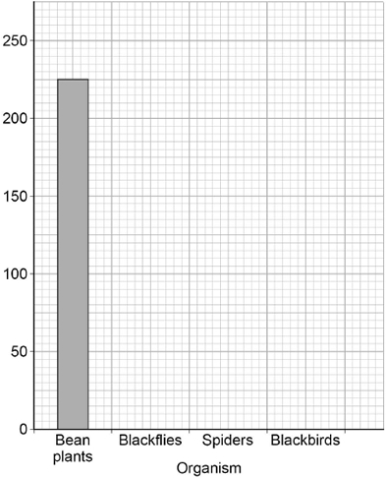
(3)
(f) Explain why a garden is not a stable community.
___________________________________________________________________
___________________________________________________________________
___________________________________________________________________
___________________________________________________________________
(2)
(Total 9 marks)
Q4.
Some students estimated the population of daisies in a school field.
This is the method used.
1. Find a place where some daisies are growing.
2. Put the quadrat down.
3. Count and record the number of daisies in the quadrat.
4. Repeat steps 1–3 at four different places in the field.
5. Calculate the mean number of daisies per quadrat.
6. Use the data to estimate the total number of daisies in the field.
(a) Which two improvements would increase the validity of this method?
Tick (✓) two boxes.

Do not put any quadrats near trees.
Repeat for another ten quadrats.
Use a long tape measure.
Use a random method to place the quadrats.
Use the same person to place all the quadrats.
(2)
(b) With an improved method the students calculated the mean number of daisy plants to be 7.65 per quadrat.
The students used a quadrat measuring 50 cm × 50 cm
The diagram shows the school site and the dimensions of the school field.
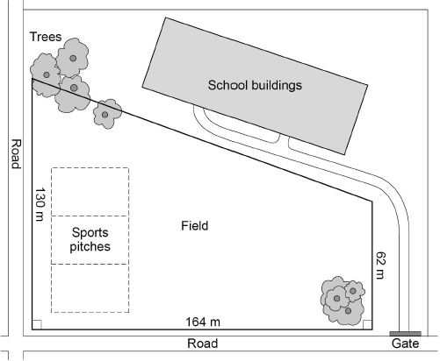
Calculate the population of daisy plants on the school field.
Give your answer in standard form to 2 significant figures.
___________________________________________________________________
___________________________________________________________________
___________________________________________________________________
___________________________________________________________________
___________________________________________________________________
___________________________________________________________________
___________________________________________________________________
___________________________________________________________________
___________________________________________________________________
___________________________________________________________________
Population of daisy plants = ______________________
(5)
(c) The students noticed a very uneven distribution of daisy plants in the field.
Explain how different biotic factors and abiotic factors could have caused an uneven distribution of daisy plants.
Use the diagram above.
___________________________________________________________________
___________________________________________________________________
___________________________________________________________________
___________________________________________________________________
___________________________________________________________________
___________________________________________________________________
___________________________________________________________________
___________________________________________________________________
___________________________________________________________________
___________________________________________________________________
___________________________________________________________________
___________________________________________________________________
(6)
(Total 13 marks)
Q5.
Every year scientists have recorded the date when migrating birds arrived at summer breeding grounds in the UK.
The records show that for every 1 °C increase in mean global temperature, the birds arrived one day earlier.
(a) What will the birds be competing for when they arrive at their UK breeding grounds?
Tick two boxes.

Eggs
Food
Light
Mates
Oxygen
(2)
(b) Birds that arrive early might survive better than birds that arrive later.
Suggest one reason why.
___________________________________________________________________
___________________________________________________________________
(1)
(c) Global temperatures are increasing every year.
This is because of an increase of greenhouse gases in the atmosphere.
Name one greenhouse gas.
___________________________________________________________________
(1)
(d) Global warming affects the migration of animals.
Give one other effect of global warming.
___________________________________________________________________
___________________________________________________________________
(1)
(e) Which two human activities cause global warming?
Tick two boxes.

Burning fossil fuels
Eating vegetables
Farming cows
Turning off lights
Using too much water
(2)
(f) Which gas in the atmosphere causes acid rain?
Tick one box.

Carbon monoxide
Oxygen
Ozone
Sulfur dioxide
(1)
(Total 8 marks)
Q6.
Many biotic and abiotic factors can affect the growth of plants.
(a) Are the factors in Table 1 biotic or abiotic?
Tick one box for each factor.
Table 1

Factor | Biotic | Abiotic
Diseases
Herbivores
Temperature
Water
(2)
Two students investigated the effect of light intensity on the distribution of small plants.
The plants are growing under a tree in a park.
The students made the following hypothesis:
‘As you move outwards from a tree there will be more plant growth.’
(b) Explain why the students thought their hypothesis would be correct.
___________________________________________________________________
___________________________________________________________________
___________________________________________________________________
___________________________________________________________________
___________________________________________________________________
___________________________________________________________________
___________________________________________________________________
___________________________________________________________________
(3)
(c) The students used two pieces of equipment.
Give the scientific name of each piece of equipment.
A square frame measuring 0.5 m × 0.5 m ____________________________
An electronic device to measure light intensity ____________________________
(2)
This is the method used.
1. Fix one end of a tape measure at the base of the tree.
2. Fix the other end of the tape measure 11 metres from the tree.
3. At 0 metres put the square frame on the ground.
4. Identify all the plant species growing inside the frame./p>
5. Estimate and record the percentage cover of each plant species.
6. Measure the light intensity inside the frame.
7. Put the square frame on the ground every 2 metres along the tape to 10 metres.
8. Repeat steps 4 − 6 in every frame.
The diagram below shows the equipment in this investigation.
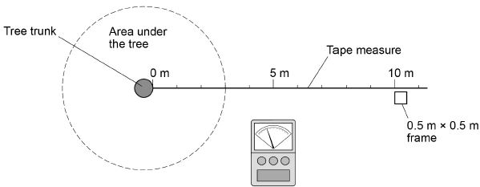
(d) Calculate the total area sampled.
___________________________________________________________________
___________________________________________________________________
Total area sampled = ______________________ m²
(1)
(e) The whole investigation was done as quickly as possible on the same day.
Suggest one reason why.
___________________________________________________________________
___________________________________________________________________
(1)
(f) Give one way the investigation could be improved.
___________________________________________________________________
___________________________________________________________________
(1)
Table 2 shows the results.
Table 2

 | Distance from tree in metres
 | 0 | 2 | 4 | 6 | 8 | 10
Percentage cover of grass | 15 | 50 | 35 | 16 | 15 | 15
Percentage cover of plantain | 0 | 5 | 10 | 40 | 25 | 30
Percentage cover of daisy | 0 | 0 | 0 | 4 | 20 | 10
Percentage cover of clover | 1 | 10 | 25 | 40 | 40 | 45
Total percentage cover of plants | 16 | 65 | 70 | 100 | 100 | 100
Light intensity in arbitrary units | 37 | 59 | 150 | 175 | >200 | >200
(g) Which plant species in Table 2 will only grow at high light intensity?
___________________________________________________________________
(1)
(h) What conclusion can be made about the relationship between light intensity and the total percentage cover of plants?
Use data from Table 2 in your answer.
___________________________________________________________________
___________________________________________________________________
___________________________________________________________________
___________________________________________________________________
(2)
(i) Light intensity might not be the cause of this pattern of plant distribution.
Suggest one different factor that may cause these results.
Give one reason for your answer.
Factor _____________________________________________________________
Reason ____________________________________________________________
___________________________________________________________________
(2)
(Total 15 marks)
Q7.
This question is about ecology.
(a) Give two abiotic (non-living) factors which will affect the growth of plants on a school playing field.
Give a reason why each factor will affect the growth of the plants.
Abiotic factor 1 ______________________________________________________
Reason ____________________________________________________________
___________________________________________________________________
Abiotic factor 2 ______________________________________________________
Reason ____________________________________________________________
___________________________________________________________________
(4)
Students were studying the ecology of their playing field.
They wanted to count the population of ruby tiger moths.
Figure 1 shows the moth trap they used.
Figure 1
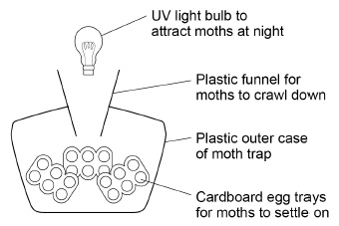
This is the method used.
1. Set up the moth trap on the playing field.
2. Leave the trap for several days with the light on.
3. Take the trap to the laboratory and carefully remove the egg trays.
4. Count the number of ruby tiger moths.
5. Release the moths on the playing field.
(b) The students needed other equipment to identify the ruby tiger moths.
What two other pieces of equipment did the students need?
Tick two boxes.

Electron microscope | 
Hand lens
Moth guide
Quadrat
Tape measure
(2)
(c) Suggest one reason why the moths were counted in the laboratory.
___________________________________________________________________
(1)
(d) Suggest one hazard in using the moth trap.
___________________________________________________________________
(1)
(e) What precaution should the students take to minimise the hazard you suggested in part (d)?
___________________________________________________________________
(1)
Figure 2 shows a caterpillar of the ruby tiger moth.
The head is sometimes bright orange in colour or there is a red stripe on the back.
Figure 2
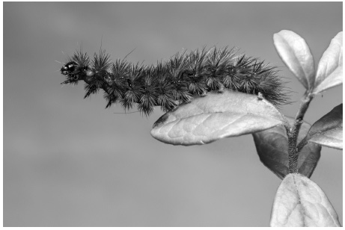
(f) Give one reason why caterpillars of the ruby tiger moth have very few predators.
___________________________________________________________________
___________________________________________________________________
(1)
(Total 10 marks)
Q8.
On a school field:
• one area of the soil was usually wet
• another area of the soil was usually dry.
Students investigated the effect of water in the soil on the number of buttercup plants growing in each area.
On the field the students marked out:
• an area of 10 m by 10 m on the wet soil
• an area of 10 m by 10 m on the dry soil.
(a) Describe how a quadrat can be used to measure the size of the buttercup population on the wet soil area.
___________________________________________________________________
___________________________________________________________________
___________________________________________________________________
___________________________________________________________________
___________________________________________________________________
___________________________________________________________________
___________________________________________________________________
___________________________________________________________________
___________________________________________________________________
___________________________________________________________________
___________________________________________________________________
___________________________________________________________________
(4)
(b) What type of factor is water in the soil?
Tick (✓) one box.

A biotic factor
A control factor
An abiotic factor
(1)
(c) Give two factors which might affect the number of buttercups growing on the school field.
Do not refer to water in your answer.
1 _________________________________________________________________
2 _________________________________________________________________
(2)
(d) Complete the sentence.
Choose the answer from the box.

a control | the dependent | the independent
In this investigation the number of buttercups in each quadrat was
______________________________ variable.
(1)
The diagram below shows a quadrat on an area of the school field.
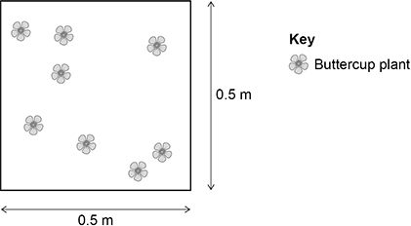
(e) Calculate the area of the quadrat.
___________________________________________________________________
___________________________________________________________________
___________________________________________________________________
Area of the quadrat = _______________ m²
(1)
(f) The mean number of buttercups in one quadrat was 8
Calculate the number of buttercups per m²
Use your answer from part (e)
___________________________________________________________________
___________________________________________________________________
___________________________________________________________________
Number of buttercups = _______________ per m²
(2)
In a laboratory another group of students investigated the effect of soil acidity on the growth of beans.
This is the method used.
1. Put soil with a neutral pH in two large boxes.
2. Add acid to the soil in one box.
3. Plant some bean seeds in each box.
4. Water the seeds over 3 weeks.
5. After 3 weeks, measure the height of the bean plants in each box.
6. Calculate the mean height of bean plants in each box.
(g) Give two improvements the students could make to the method to give more valid results.
1 _________________________________________________________________
___________________________________________________________________
2 _________________________________________________________________
___________________________________________________________________
(2)
The students then carried out a valid investigation.
The table below shows the students’ results.

 | Height of bean plants in cm
Bean plant | Acid soil | Neutral soil
1 | 8 | 11
2 | 6 | 12
3 | 4 | 11
4 | 10 | 17
5 | 7 | 19
Mean | 7 | X
(h) Calculate mean value X in the table above.
___________________________________________________________________
___________________________________________________________________
___________________________________________________________________
X = _______________ cm
(2)
(i) What conclusion can the students make about the effect of acid soil on the growth of bean plants?
___________________________________________________________________
___________________________________________________________________
(1)
(Total 16 marks)
Q9.
On a school field:
• one area of the soil was usually wet
• another area of the soil was usually dry.
Students investigated the effect of water in the soil on the number of buttercup plants growing in each area.
(a) Water is an abiotic factor.
Name one biotic factor which may affect the number of buttercups growing on the field.
___________________________________________________________________
(1)
(b) Describe a method to investigate if the amount of water in the soil affects the number of buttercups in the field.
___________________________________________________________________
___________________________________________________________________
___________________________________________________________________
___________________________________________________________________
___________________________________________________________________
___________________________________________________________________
___________________________________________________________________
___________________________________________________________________
___________________________________________________________________
___________________________________________________________________
___________________________________________________________________
___________________________________________________________________
(6)
(Total 7 marks)
Q10.
Some students estimated the population of daisy plants in a field.
This is the method used.
1. Place a quadrat randomly on the field.
2. Count and record the number of daisy plants in the quadrat.
3. Repeat steps 1 and 2 another four times.
(a) How could the students have made sure the quadrats were placed randomly?
___________________________________________________________________
___________________________________________________________________
(1)
(b) Describe the piece of equipment called a quadrat.
___________________________________________________________________
___________________________________________________________________
(1)
The table shows the results.

Quadrat number | Number of daisy plants
1 | 8
2 | 11
3 | 4
4 | 6
5 | 16
Mean | X
(c) Calculate mean value X.
___________________________________________________________________
___________________________________________________________________
X = _______________________ daisy plants
(1)
(d) The field is a rectangle 100 m wide and 150 m long.
Calculate the area of the field.
___________________________________________________________________
Area = _______________________ m²
(1)
(e) The quadrat used by the students had an area of 1.0 m²
Estimate the population of daisy plants in the field.
Use your answers to part (c) and part (d).
___________________________________________________________________
___________________________________________________________________
___________________________________________________________________
___________________________________________________________________
Estimated population = _______________________ daisy plants
(2)
(f) More daisy plants grew in some parts of the field compared to other areas of the field.
Give two biotic factors that may affect where daisy plants grow in the field.
1 _________________________________________________________________
2 _________________________________________________________________
(2)
(g) The students noticed that the daisy plants growing near a building were smaller.
Explain why smaller daisy plants grew near the building.
___________________________________________________________________
___________________________________________________________________
___________________________________________________________________
___________________________________________________________________
(2)
(Total 10 marks)
Q11.
Moose are animals that eat grass.
Figure 1 shows a moose.
Figure 1
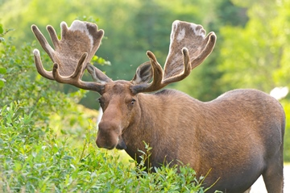
© Wildnerdpix/iStock/Thinkstock
Figure 2 shows a food chain.
Figure 2
Grass Moose Wolves
(a) What word describes the grass in Figure 2?
Tick one box.

Consumer | 
Predator
Prey
Producer
(1)
(b) What word describes the wolves in Figure 2?
Tick one box.

Communities
Predators
Prey
Producers
(1)
(c) Figure 3 and Figure 4 show how the moose population and the wolf population changed in one area.
Figure 3
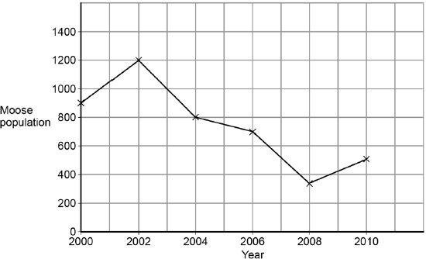
Figure 4
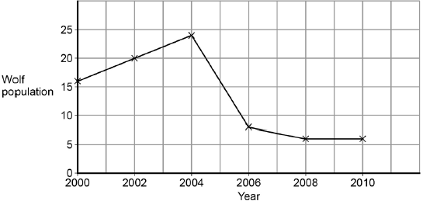
Look at Figure 3.
In this area the moose population reached its peak in 2002.
What was the size of the moose population in 2002?
___________________________________________________________________
(1)
(d) Look at Figure 4.
How long after the moose population peak did the wolf population peak occur?
___________________ years
(1)
(e) When the moose population increases, the wolf population increases soon after.
Why does the wolf population increase?
Tick one box.

There is more competition for moose
There is more food for wolves
Other animals prey on moose
There are more predators of wolves
(1)
(f) Abiotic factors and biotic factors can affect the size of the wolf population.
Which of these are biotic factors?
Tick two boxes.

Carbon dioxide levels
Humans hunting
Light intensity
Soil type
Viruses
(2)
(Total 7 marks)
Q12.
Global warming may reduce biodiversity in some areas.
(a) What is biodiversity?
Tick one box.

The different habitats in an ecosystem
The interaction of living and non-living factors in a habitat
The interdependence of organisms on Earth
The total number of organisms in an ecosystem
The variety of different species on Earth
(1)
(b) What gases cause global warming?
Tick two boxes.

Carbon dioxide
Methane
Nitrogen
Oxygen
Water vapour
(2)
(c) Give two effects of global warming that could reduce biodiversity in an area.
1. _________________________________________________________________
___________________________________________________________________
2. _________________________________________________________________
___________________________________________________________________
(2)
(Total 5 marks)

