  B6 PPQ
  Year 11 Revision
  Name: | ________________________
  Class: | ________________________
  Date: | ________________________

Time: | 135 minutes
Marks: | 125 marks
Comments:

Q1.
A human body cell contains 46 chromosomes.
(a) How many chromosomes does a human sperm cell contain?
Tick (✓) one box.

22 |  | 23 |  | 46
(1)
(b) Draw one line from each word to the meaning of that word.

Word |  | Meaning
 |  | A small ring of DNA in the cytoplasm
Gene
 |  | All the genetic material of an organism
Genome
 |  | A small section of DNA which codes for a protein
Nucleus
 |  | A structure which contains chromosomes
(3)
Some plants contain a harmful chemical called PTC.
Some people can taste PTC.
(c) Suggest one advantage of being able to taste PTC.
___________________________________________________________________
___________________________________________________________________
(1)
Only people with a dominant allele T can taste PTC.
People with only the allele t cannot taste PTC.
(d) A person has the genotype Tt.
What word describes the person’s genotype?
Tick (✓) one box.

Heterozygous
Phenotype
Recessive
(1)
(e) Give the genotype of a person who cannot taste PTC.
___________________________________________________________________
(1)
(f) A woman and a man plan to have a child.
The woman and the man both have the genotype Tt.
Complete the figure below to show the possible genotypes of the child.
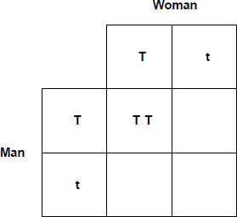
(2)
(g) What is the chance of the child being able to taste PTC?
Use the figure above.
Tick (✓) one box.

25% |  | 50% |  | 75% |  | 100%
(1)
(Total 10 marks)
Q2.
Figure 1 shows one species of bird on a bird feeder.
Figure 1
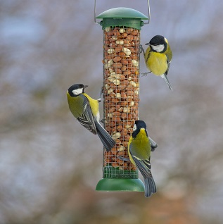
The birds use their beaks to reach nuts inside the bird feeder.
Cats sometimes eat the birds.
(a) Give the food chain for the birds, cats and nuts.
___________________________________________________________________
(2)
(b) Which organism in the food chain you gave in part (a) is the primary consumer?
___________________________________________________________________
(1)
(c) Cats are one biotic factor that affects the size of the bird population.
Which two of the following are biotic factors?
Tick (✓) two boxes.

Food
Pathogens
Sunlight
Temperature
Water
(2)
Figure 2 shows the mean beak length of this species of bird from 1982 to 2007.
Figure 2
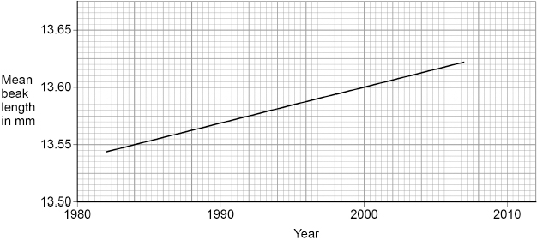
(d) What was the mean beak length in 2000?
Mean beak length = _______________ mm
(1)
(e) What type of adaptation is beak length?
Tick (✓) one box.

Behavioural
Chemical
Structural
(1)
Figure 2 shows evidence of evolution in this species of bird.
(f) Scientists have concluded that beak length in this species of bird is increasing.
Complete the sentences about the evolution of this species of bird.
Choose answers from the box.

excretion | generation | mutation
reproduction | respiration | variation
The difference in beak length in the bird population
is called ____________________.
A change in a gene affects the beak length.
Change in a gene is called _________________________.
The birds with the longest beaks get more food.
Getting more food improves a bird’s chances of
survival and _________________________.
This process of evolution takes place over more
than one _________________________.
(4)
(g) Birds of this species:
• live for about 3 years
• produce up to 24 eggs every year.
Why is evolution easier to study in birds than in humans?
Tick (✓) one box.

Birds breed less frequently than humans.
Birds have a shorter life cycle than humans.
Birds have fewer offspring than humans.
(1)
(h) Bacteria also provide evidence for evolution.
Which statement describes evidence for evolution?
Tick (✓) one box.

Bacteria can become resistant to antibiotics.
Decomposition can be caused by bacteria.
Some bacteria are pathogens.
(1)
(Total 13 marks)
Q3.
A fossil was found in rocks. The rocks were formed from mud.
The fossil is of the fungus Ourasphaira giraldae.
(a) What is the genus of the fungus?
___________________________________________________________________
(1)
(b) Why was the mud important during the formation of the fossil?
Tick (✓) one box.

The fungus completely decayed in the mud.
The mud stopped oxygen reaching the fungus.
There was water in the mud around the fungus.
(1)
The estimated age of the fossil is in the range from 8.9 × 10⁸ years old to 1.1 × 10⁹ years old.
(c) Calculate the size of the range of the estimated age of the fossil.
___________________________________________________________________
___________________________________________________________________
___________________________________________________________________
Size of range = _______________ years
(1)
(d) Humans did not exist when the fungus was alive.
Suggest one other reason why an accurate estimation of when this species of fungus existed is not known.
___________________________________________________________________
___________________________________________________________________
(1)
Carl Woese developed the three-domain system of classification.
(e) Fungi are not in the domain Archaea.
Which domain are fungi classified in?
___________________________________________________________________
(1)
(f) Which two characteristics are features of organisms in the domain Archaea?
Tick (✓) two boxes.

Can only survive in light
Can survive in extreme environments
Cells contain chloroplasts
Cells do not have a cell wall
Cytoplasm contains DNA
(2)
(g) Carl Linnaeus lived in the 1700s.
Carl Linnaeus classified living things into groups depending on their appearance.
Give three types of evidence that are used now to classify living things.
Do not refer to appearance in your answer.
1 _________________________________________________________________
___________________________________________________________________
2 _________________________________________________________________
___________________________________________________________________
3 _________________________________________________________________
___________________________________________________________________
(3)
(Total 10 marks)
Q4.
Figure 1 shows one species of bird on a bird feeder.
Figure 1
The birds use their beaks to reach nuts inside the bird feeder.
Figure 2 shows the mean beak length of this species of bird in the UK.
This species of bird often visits bird feeders.
Figure 2
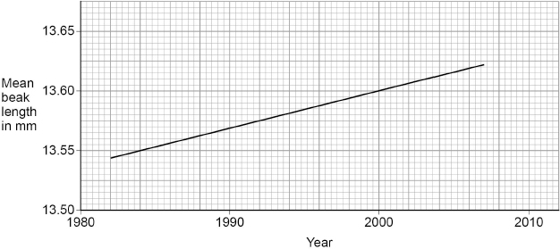
(a) Determine the rate of change in beak length from 1984 to 2000.
Use Figure 2.
___________________________________________________________________
___________________________________________________________________
___________________________________________________________________
___________________________________________________________________
___________________________________________________________________
___________________________________________________________________
Rate of change = _______________ mm/year
(3)
(b) Explain the process of evolution that could cause the trend in Figure 2.
___________________________________________________________________
___________________________________________________________________
___________________________________________________________________
___________________________________________________________________
___________________________________________________________________
___________________________________________________________________
___________________________________________________________________
___________________________________________________________________
___________________________________________________________________
___________________________________________________________________
___________________________________________________________________
___________________________________________________________________
(6)
(c) Birds of this species:
• live for about 3 years
• produce up to 24 eggs every year.
Explain why evolution is easier to study in this species of bird than in humans.
___________________________________________________________________
___________________________________________________________________
___________________________________________________________________
___________________________________________________________________
___________________________________________________________________
___________________________________________________________________
___________________________________________________________________
(3)
(d) Birds of this species are found in different parts of the world.
Describe evidence that would show two individual birds are the same species.
___________________________________________________________________
___________________________________________________________________
___________________________________________________________________
___________________________________________________________________
___________________________________________________________________
___________________________________________________________________
___________________________________________________________________
(3)
(Total 15 marks)
Q5.
This question is about genetic disorders.
(a) Some people are heterozygous for a genetic disorder.
Define the term ‘heterozygous’.
___________________________________________________________________
___________________________________________________________________
(1)
(b) The figure below shows the inheritance of a genetic disorder in a family.
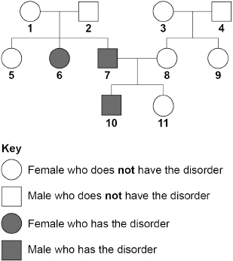
Person 7 and person 8 plan to have another child.
Determine the probability that the child will be a male who has the disorder.
You should:
• draw a Punnett square diagram
• identify the genotype of person 7 and the genotype of person 8
• identify the phenotype of each offspring genotype
• use the symbols:
H = dominant allele
h = recessive allele

Probability of having a male child with the disorder = _______________
(6)
(c) Polydactyly is a different inherited disorder.
Two parents do not have any alleles for polydactyly in their ordinary body cells.
These parents produced a child with polydactyly.
Explain how polydactyly suddenly occurred in this family.
___________________________________________________________________
___________________________________________________________________
___________________________________________________________________
___________________________________________________________________
___________________________________________________________________
___________________________________________________________________
___________________________________________________________________
___________________________________________________________________
___________________________________________________________________
___________________________________________________________________
(4)
(Total 11 marks)
Q6.
This question is about DNA and genes.
(a) Which diagram represents a DNA molecule?
Tick (✓) one box.
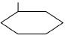 |  | 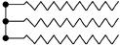
(1)
(b) Describe the structure of a DNA molecule.
___________________________________________________________________
___________________________________________________________________
(1)
(c) A gene is a small section of DNA on a chromosome.
Complete the sentences.
A gene codes for a particular sequence of _______________.
This sequence makes a specific _______________.
(2)
(d) What is meant by the term genome?
___________________________________________________________________
___________________________________________________________________
(1)
(e) The complete human genome is now known.
Which important scientific advance was made using knowledge of the human genome?
Tick (✓) one box.

Discovering antibiotic resistant bacteria
Finding more foods to eat from tropical forests
Tracing how aboriginal people spread across Australia
Working out when the last ice age ended
(1)
A student found six different snails of one species in his garden.
The diagram below shows the snails.
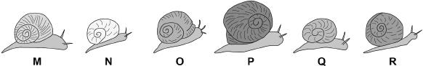
(f) All the snails are different.
What scientific term describes differences in characteristics between individuals of a species?
___________________________________________________________________
(1)
(g) A change in DNA has caused snail P to be very different from the other five snails.
Suggest why there might be an increasing number of snails similar to snail P in each future generation.
___________________________________________________________________
___________________________________________________________________
___________________________________________________________________
___________________________________________________________________
(2)
(Total 9 marks)
Q7.
There is a need to grow enough food for all the people in the world.
Growing enough food affects habitats and biodiversity.
(a) What is meant by the term biodiversity?
___________________________________________________________________
___________________________________________________________________
(1)
Peat bogs are being destroyed because peat is used by humans.
Destroying peat bogs also reduces biodiversity.
(b) Give one use of peat taken from peat bogs.
___________________________________________________________________
___________________________________________________________________
(1)
(c) Explain why the use of peat is harmful to the environment.
Do not refer to biodiversity in your answer.
___________________________________________________________________
___________________________________________________________________
___________________________________________________________________
___________________________________________________________________
(2)
(d) Intensive farming, where a single crop is grown on a large area of land year after year, is more cost effective for farmers.
It is efficient to use fertilisers and to burn the waste so the land is ready to use the next year.
Planting a single crop reduces biodiversity.
Suggest two ways that this type of farming can damage the environment.
Do not refer to biodiversity in your answer.
1. _________________________________________________________________
___________________________________________________________________
2. _________________________________________________________________
___________________________________________________________________
(2)
(e) Most of the world’s production of antibiotics is used in farming.
Antibiotics are given to animals to prevent the spread of disease.
Explain how the widespread use of antibiotics in farming is a threat to human life.
___________________________________________________________________
___________________________________________________________________
___________________________________________________________________
___________________________________________________________________
___________________________________________________________________
___________________________________________________________________
___________________________________________________________________
___________________________________________________________________
___________________________________________________________________
___________________________________________________________________
(4)
(Total 10 marks)
Q8.
This question is about inheritance.
Humans have 23 pairs of chromosomes in each body cell.
One pair of chromosomes determines sex.
(a) Complete diagram below.
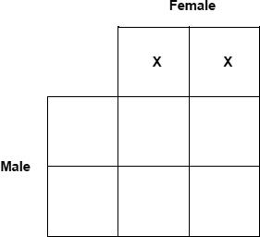
(2)
(b) In some families all children are the same sex.
Give the reason why.
___________________________________________________________________
___________________________________________________________________
(1)
Cystic fibrosis (CF) is an inherited disorder.
(c) A man and a woman do not have CF.
The man and the woman have a child who has CF.
Draw a Punnett square diagram to find the probability that their next child will have CF.
Use the symbols:
T = dominant allele
t = recessive allele
Draw a ring around the genotype of any children with CF.

Probability = _______________
(4)
Embryo screening for CF can be done by two methods.
Method 1
• The woman becomes pregnant by sexual intercourse.
• After 10 weeks of pregnancy a fine needle is inserted into the uterus.
• A sample of the fluid surrounding the embryo is taken.
• The DNA of the embryo is tested for CF.
The screening is done free by specialist hospitals for couples who are at risk of having a child with CF.
There is a small risk of miscarriage.
Method 2
• The couple use In Vitro Fertilisation (IVF) to produce a small number of embryos.
• Each embryo is tested for CF.
• One or two embryos without CF are implanted in the woman’s uterus.
In 2017 the success rate for having a baby by IVF for women under 35 years was 30%
IVF is a stressful, invasive procedure.
In most UK areas the free public health service does not provide IVF for all women asking for it.
(d) Suggest three reasons for choosing Method 1 instead of Method 2.
1. _________________________________________________________________
___________________________________________________________________
2. _________________________________________________________________
___________________________________________________________________
3. _________________________________________________________________
___________________________________________________________________
(3)
(e) Suggest one advantage of Method 2.
___________________________________________________________________
___________________________________________________________________
(1)
(Total 11 marks)
Q9.
(a) Vectors are used in the process of genetic engineering.
Which two statements are correct?
Tick (✓) two boxes.

Vectors are enzymes used to ‘cut open’ the DNA molecule. | 
Vectors are used to insert genes into cells.
Vectors are used to isolate the required gene.
Vectors are used to stimulate cell division.
Vectors are usually plasmids or viruses.
(2)
(b) Scientists have genetically engineered a variety of wheat to be resistant to herbicides.
The herbicide resistant variety of wheat will give a higher yield than the non-herbicide resistant variety.
Explain why.
___________________________________________________________________
___________________________________________________________________
___________________________________________________________________
___________________________________________________________________
___________________________________________________________________
___________________________________________________________________
(3)
(c) Give two examples of genetic engineering in use today.
Do not refer to herbicide resistance in your answer.
1 _________________________________________________________________
___________________________________________________________________
2 _________________________________________________________________
___________________________________________________________________
(2)
(d) Scientists working on the ‘Human Genome Project’ have now mapped the entire genetic code of humans.
Explain one way this could be important for people in the future.
___________________________________________________________________
___________________________________________________________________
___________________________________________________________________
___________________________________________________________________
(2)
(Total 9 marks)
Q10.
Scientists have removed microorganisms from inside rocks in caves in Mexico.
The microorganisms have been trapped there for between 10 000 and 50 000 years.
The caves are dark, very hot, humid and acidic.
(a) Why are these microorganisms called extremophiles?
Tick two boxes.

They are thousands of years old
They survive in high humidity
They survive in high temperatures
They survive in the dark
They survive inside rocks
They survive where it is acidic
(2)
The microorganisms have been inactive for thousands of years but the scientists have reactivated them.
The diagram below shows the results of enzyme analysis on four enzymes, A, B, C and D.
Three of the enzymes were from microorganisms found in the soil near the caves.
One of the enzymes was from a reactivated microorganism from the caves.
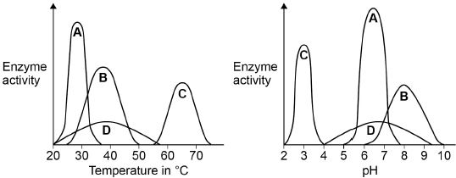
(b) Which enzyme comes from the microorganism from the caves?
Tick one box.

A |  | B |  | C |  | D
(1)
(c) Give the reasons for your answer to part (b)
___________________________________________________________________
___________________________________________________________________
___________________________________________________________________
(1)
(d) Carl Woese developed the ‘three-domain system’ of classification.
Describe the ‘three-domain system’ of classification.
___________________________________________________________________
___________________________________________________________________
___________________________________________________________________
___________________________________________________________________
___________________________________________________________________
___________________________________________________________________
(3)
(e) Most of the microorganisms from the caves were classified as belonging to the Archaea domain of the ‘three-domain system’.
Suggest why.
___________________________________________________________________
___________________________________________________________________
(1)
(Total 8 marks)
Q11.
Living things can be classified into groups.
(a) Scientists look at structures inside cells to classify living things.
Suggest one structure found in cells that can be used to classify living things.
___________________________________________________________________
(1)
(b) The table below shows one system for classifying humans.

X | Animalia
Phylum | Chordata
Class | Mammalia
Order | Primates
Family | Hominidae
Genus | Homo
Species | Sapiens
Who devised this system of classification?
Tick one box.

Darwin | 
Linnaeus
Wallace
Woese
(1)
(c) Look at the table above.
X is the largest category in this classification.
Name category X.
___________________________________________________________________
(1)
(d) Give the binomial name of humans.
Use information in the table above.
___________________________________________________________________
(1)
(e) Suggest one way that classification systems are useful to scientists.
___________________________________________________________________
(1)
(Total 5 marks)
Q12.
The figure below shows a carp.
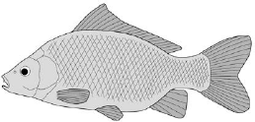
(a) A mutation causes a blue colour in some carp.
What is a mutation?
___________________________________________________________________
___________________________________________________________________
(1)
(b) Suggest how a mutation could cause a different colour in carp.
___________________________________________________________________
___________________________________________________________________
(1)
(c) Two alleles control the body colour of carp:
• brown (B)
• blue (b).
The brown allele is dominant to the blue allele.
Two carp that are heterozygous for colour are crossed and produce 2.6 × 10⁵ offspring.
Approximately how many of the offspring are expected to be blue?
Draw a genetic diagram to explain your answer.
Give your answer in standard form.
Number of offspring expected to be blue = ___________
(5)
(d) A scientist wanted to find out whether a brown carp has the genotype BB or Bb.
Describe what genetic cross a scientist could do to determine this.
___________________________________________________________________
___________________________________________________________________
___________________________________________________________________
___________________________________________________________________
___________________________________________________________________
___________________________________________________________________
(2)
(Total 9 marks)
Q13.
In the 18th century a binomial system of grouping similar organisms was developed.
Before the binomial system was developed the common briar rose had the following names:
• Rosa sylvestris inodora seu canina
• Rosa sylvestris alba cum rubore folio glabro.
In the binomial system, the same rose is called Rosa canina.
(a) One advantage of the binomial system is that the name is shorter than the names used before this system.
Suggest two other advantages of the binomial system.
1. _________________________________________________________________
___________________________________________________________________
2. _________________________________________________________________
___________________________________________________________________
(2)
(b) Classification systems have changed in the last 50 years.
Give one reason why we now have more information to classify organisms.
___________________________________________________________________
___________________________________________________________________
(1)
(c) ‘Archaea’ is one of the groups in the three-domain system of classification.
Give two features of the domain Archaea.
1. _________________________________________________________________
___________________________________________________________________
2. _________________________________________________________________
___________________________________________________________________
(2)
(Total 5 marks)

