  B5 PPQ
  Year 11 Revision
  Name: | ________________________
  Class: | ________________________
  Date: | ________________________

Time: | 128 minutes
Marks: | 119 marks
Comments:

Q1.
The figure below shows glands in the human body.
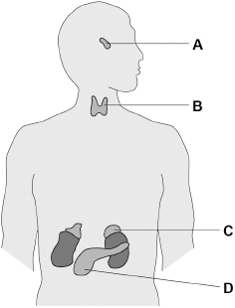
(a) Which organ system includes the glands shown in the figure above?
___________________________________________________________________
(1)
(b) Which gland produces insulin?
Tick (✓) one box.

A |  | B |  | C |  | D
(1)
(c) Which gland produces hormones that stimulate the other glands to produce hormones?
Tick (✓) one box.

A |  | B |  | C |  | D
(1)
(d) How do hormones travel from one gland to another gland?
___________________________________________________________________
___________________________________________________________________
(1)
(e) Name two glands involved in human reproduction.
Do not refer to glands shown on the figure above in your answer.
1 _________________________________________________________________
2 _________________________________________________________________
(2)
(f) Ovulation test kits can help women know when they are most fertile.
Ovulation test kits detect the increase in the hormone that stimulates ovulation.
Which hormone is detected by ovulation test kits?
Tick (✓) one box.

Follicle stimulating hormone (FSH)
Luteinising hormone (LH)
Oestrogen
Progesterone
(1)
(g) A new contraceptive drug for men is being tested.
The drug:
• is given in one injection
• stops sperm being able to fertilise eggs
• is effective for up to 13 years.
Evaluate the use of the new drug compared with existing contraceptive methods.
___________________________________________________________________
___________________________________________________________________
___________________________________________________________________
___________________________________________________________________
___________________________________________________________________
___________________________________________________________________
___________________________________________________________________
___________________________________________________________________
___________________________________________________________________
___________________________________________________________________
___________________________________________________________________
___________________________________________________________________
(6)
(Total 13 marks)
Q2.
Caffeine is a drug that decreases reaction time.
A group of sixteen students investigated the effect of caffeine on reaction time.
The students were all 15-year-old girls.
The group was divided into 8 pairs of students.
This is the method used.
1. Student A starts two stopwatches at the same time.
2. Student A then gives one of the stopwatches to Student B.
3. Student A says “stop” at the same time as stopping her stopwatch. Student B stops her stopwatch as quickly as possible after Student A says “stop”.
4. The difference in time shown on the two stopwatches is recorded. This is the reaction time of Student B.
5. Student B drinks a caffeinated drink.
6. The students wait 15 minutes and then repeat steps 1 to 4.
(a) Suggest one control variable the students should have used in the investigation.
Do not refer to age or sex in your answer.
___________________________________________________________________
___________________________________________________________________
(1)
(b) Suggest two sources of random error when using this method to measure a person’s reaction time.
1 _________________________________________________________________
___________________________________________________________________
___________________________________________________________________
2 _________________________________________________________________
___________________________________________________________________
___________________________________________________________________
(2)
The table below shows the results.

Student pair | Decrease in reaction time after drinking the caffeinated drink in seconds
1 | 0.039
2 | 0.021
3 | 0.027
4 | 0.041
5 | 0.022
6 | 0.036
7 | 0.024
8 | 0.097
(c) Why can a mode not be determined for the data in the table above?
___________________________________________________________________
___________________________________________________________________
(1)
(d) The students decided the result from pair 8 was anomalous.
The students calculated that the mean decrease in reaction time was 0.030 seconds.
Describe how the students calculated the mean decrease in reaction time.
___________________________________________________________________
___________________________________________________________________
___________________________________________________________________
(1)
(e) Caffeine causes the release of adrenaline.
Adrenaline affects heart rate.
Explain how the effect of adrenaline on heart rate might cause reaction time to decrease.
___________________________________________________________________
___________________________________________________________________
___________________________________________________________________
___________________________________________________________________
___________________________________________________________________
___________________________________________________________________
___________________________________________________________________
___________________________________________________________________
(4)
Adenosine is a different chemical made by the body.
Adenosine binds to receptors on relay neurones.
Adenosine decreases the number of impulses in relay neurones.
The figure below shows how caffeine binds to adenosine receptors on a relay neurone.
When caffeine binds to adenosine receptors it blocks the receptor so adenosine cannot bind.
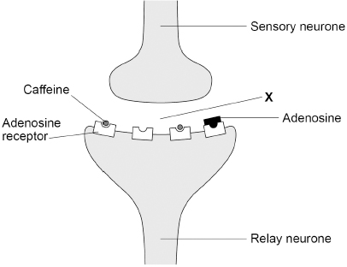
(f) Label X shows the gap between the sensory neurone and the relay neurone.
What is the name of the gap labelled X?
___________________________________________________________________
(1)
(g) Suggest why reaction time decreases when caffeine binds to adenosine receptors.
___________________________________________________________________
___________________________________________________________________
___________________________________________________________________
___________________________________________________________________
___________________________________________________________________
___________________________________________________________________
(2)
(Total 12 marks)
Q3.
This question is about reproduction.
(a) Which two statements are true for sexual reproduction in humans?
Tick (✓) two boxes.

Gametes are formed.
Offspring are clones.
Offspring are genetically identical to parents.
Only one parent is involved.
Sperm and egg fuse.
(2)
(b) Humans reproduce by sexual reproduction.
Complete the diagram below to show the inheritance of sex.
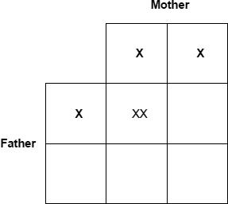
(3)
(c) Draw a ring around the genotype of all male children in the diagram above.
(1)
(d) When children reach puberty, reproductive hormones cause changes in their bodies.
Draw one line from each hormone to the change the hormone causes at puberty.

Hormone |  | Change the hormone causes at puberty
 |  | Breasts develop
Oestrogen
 |  | Skin turns lighter
 |  | Voice becomes deeper
Testosterone
 |  | Wisdom teeth appear
(2)
A woman does not want to become pregnant.
She considers two methods of contraception.
(e) Draw one line from each method of contraception to how the method prevents pregnancy.

Method of contraception |  | How the method prevents pregnancy
 |  | Embryos do not implant in the uterus
Condom
 |  | Hormones stop eggs maturing
 |  | Sperm are killed
Oral contraceptive (the pill)
 |  | Sperm do not reach the egg
(2)
(f) Give one advantage and one disadvantage of taking oral contraceptives to prevent pregnancy.
Advantage __________________________________________________________
___________________________________________________________________
Disadvantage _______________________________________________________
___________________________________________________________________
(2)
(Total 12 marks)
Q4.
Human reactions are a response to an external change.
(a) Reflex actions help to protect the body against damage.
The diagram below shows the nervous pathway for a reflex action.
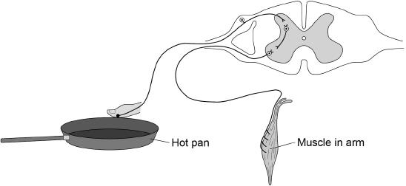
A stimulus from the hot pan will cause the muscle in the arm to contract and move the finger away.
Describe how the stimulus from the hot pan reaches the muscle in the arm.
___________________________________________________________________
___________________________________________________________________
___________________________________________________________________
___________________________________________________________________
___________________________________________________________________
___________________________________________________________________
___________________________________________________________________
___________________________________________________________________
(4)
(b) A student investigated whether using the right hand or the left hand had an effect on reaction time.
The student only tested right-handed people.
Describe a method for the student’s investigation.
Include details of the test you would use for reaction time.
___________________________________________________________________
___________________________________________________________________
___________________________________________________________________
___________________________________________________________________
___________________________________________________________________
___________________________________________________________________
___________________________________________________________________
___________________________________________________________________
___________________________________________________________________
___________________________________________________________________
___________________________________________________________________
___________________________________________________________________
(4)
A different student carried out an investigation to see if playing tennis improved reaction time.
The student used two groups of six people.
The table below shows the results.

Person | Reaction time in seconds
Person | People who play tennis | People who do not play tennis
1 | 0.2 | 0.3
2 | 0.4 | 0.4
3 | 0.3 | 0.6
4 | 0.4 | 0.5
5 | 0.2 | 0.3
6 | 0.3 | 0.2
Mean | X | 0.4
(c) Calculate mean value X in the table above.
___________________________________________________________________
___________________________________________________________________
___________________________________________________________________
X = _______________ seconds
(2)
(d) What is the dependent variable in the student’s investigation?
___________________________________________________________________
(1)
The student concluded:

‘Playing tennis improves reaction time.’
(e) Give one piece of evidence which supports the conclusion.
___________________________________________________________________
___________________________________________________________________
(1)
(f) Give one piece of evidence which does not support the conclusion.
___________________________________________________________________
___________________________________________________________________
(1)
(Total 13 marks)
Q5.
(a) In sexual reproduction, cells divide by meiosis to form gametes.
Which two statements are true for cell division by meiosis?
Tick (✓) two boxes.

Daughter cells have two sets of chromosomes.
Four daughter cells are formed.
The daughter cells are genetically identical.
The DNA replicates twice.
The parent cell divides twice.
(2)
Hormones are released from endocrine glands.
Each hormone travels in the bloodstream to a target organ.
The diagram below shows the position of endocrine glands in a female.
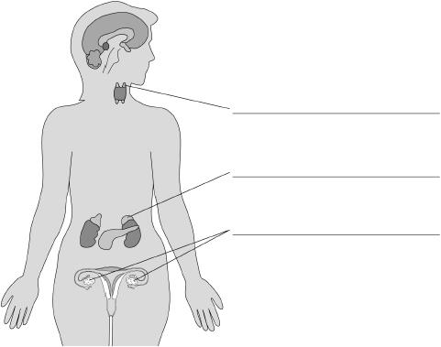
(b) Label the endocrine glands on the diagram above.
(3)
(c) Complete the table below.

Hormone | Name of gland which releases hormone | Target organ of hormone
Luteinising hormone (LH) | Pituitary gland
 | Adrenal gland
Glucagon
(3)
Millions of geranium plants are sold each year in garden centres.
Geraniums can be reproduced asexually or sexually.
The image below shows a potted geranium plant.
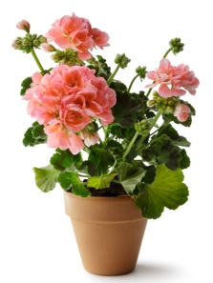
Garden centres usually grow new geranium plants by asexual reproduction.
(d) Suggest two advantages for garden centres of growing geraniums by asexual reproduction compared with sexual reproduction.
1. _________________________________________________________________
___________________________________________________________________
2. _________________________________________________________________
___________________________________________________________________
(2)
(e) Suggest two disadvantages for garden centres of growing geraniums by asexual reproduction compared with sexual reproduction.
1. _________________________________________________________________
___________________________________________________________________
2. _________________________________________________________________
___________________________________________________________________
(2)
(Total 12 marks)
Q6.
Conditions inside the human body are controlled.
(a) What is the control of conditions inside the body called?
Tick (✓) one box.

Excretion | 
Fertilisation
Homeostasis
Osmosis
(1)
(b) What are the two ways information is sent to control body conditions?
Tick (✓) two boxes.

By antigens
By hormones
By muscles
By nerve impulses
By red blood cells
(2)
(c) One condition in the body that needs to be controlled is the level of water.
Give one other condition in the human body that needs to be controlled.
___________________________________________________________________
___________________________________________________________________
(1)
The graph shows the volumes of water taken in and lost by one person.
The volume for water taken in on a hot day has not been plotted on the bar graph.
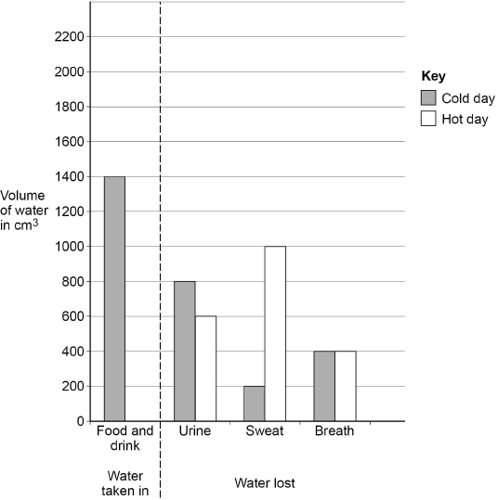
(d) The person lost 1400 cm³ of water on the cold day.
How much extra water did they lose on the hot day?
___________________________________________________________________
___________________________________________________________________
___________________________________________________________________
___________________________________________________________________
Extra volume of water lost = _______________________ cm³
(2)
(e) Explain why the volume of water lost on a hot day is higher than on a cold day.
___________________________________________________________________
___________________________________________________________________
___________________________________________________________________
___________________________________________________________________
(2)
(f) A boy drank 750 cm³ of water.
His total intake of water for that day was 3000 cm³
Calculate the percentage of the boy’s total intake that the 750 cm³ represents.
___________________________________________________________________
___________________________________________________________________
___________________________________________________________________
___________________________________________________________________
Percentage = _______________________ %
(2)
(Total 10 marks)
Q7.
This question is about homeostasis.
(a) Define the term homeostasis.
___________________________________________________________________
___________________________________________________________________
___________________________________________________________________
___________________________________________________________________
(2)
(b) Name the hormone released if the blood glucose concentration falls too low.
___________________________________________________________________
(1)
Two people were sent to a hospital to find out if they have diabetes.
This is the method used at the hospital.
• Do not eat or drink after midnight. This is called fasting.
• Measure blood glucose concentration at 9.30 am
• Drink a glucose solution at 10.00 am
• Measure blood glucose concentration for the next 3 hours.
The graph shows the results.
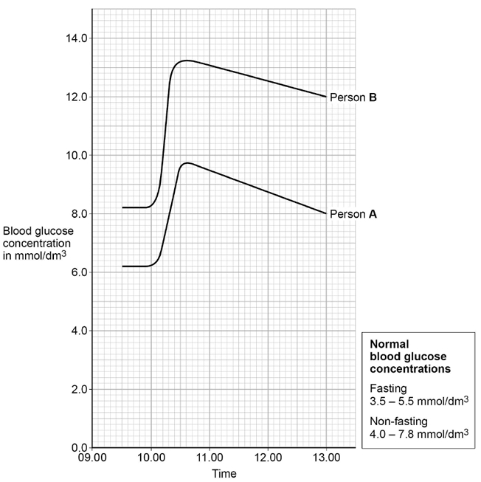
Person A and person B have diabetes.
(c) Describe how the graph above shows that person B has diabetes.
Use data from the graph.
___________________________________________________________________
___________________________________________________________________
___________________________________________________________________
___________________________________________________________________
___________________________________________________________________
___________________________________________________________________
(3)
(d) Person A and person B had a test to measure the concentration of insulin in their blood when they were fasting.
The table shows the results.

Person | Fasting blood insulin concentration in arbitrary units
A | 280
B | 20
Normal range | 50–175
Suggest which type of diabetes person A and person B have.
Give a reason for each answer.
Person A
Type of diabetes _____________________________________________________
Reason ____________________________________________________________
___________________________________________________________________
Person B
Type of diabetes _____________________________________________________
Reason ____________________________________________________________
___________________________________________________________________
(2)
(e) Toxic hypoglycaemia syndrome (THS) has caused the deaths of hundreds of starving children in some tropical countries.
• The starving children have had nothing to eat all day.
• The starving children then eat many lychee fruits.
• The lychee fruits contain a molecule which stops an enzyme in the liver working.
• This enzyme normally converts stored fats into glucose.
Children who have eaten during the day are not affected by eating many lychee fruits.
Starving children may die from eating many lychee fruits but children who have eaten during the day are not affected.
Explain why.
___________________________________________________________________
___________________________________________________________________
___________________________________________________________________
___________________________________________________________________
___________________________________________________________________
___________________________________________________________________
___________________________________________________________________
___________________________________________________________________
___________________________________________________________________
___________________________________________________________________
___________________________________________________________________
___________________________________________________________________
(6)
(Total 14 marks)
Q8.
This question is about the nervous system.
The diagram below shows a reflex arc.
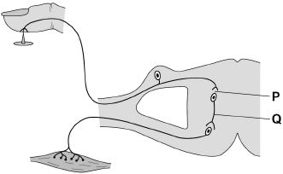
(a) Name parts P and Q shown on the diagram above.
P _________________________________________________________________
Q _________________________________________________________________
(2)
(b) Compare how information is transferred along a neurone with how information is transferred across gap P.
___________________________________________________________________
___________________________________________________________________
___________________________________________________________________
___________________________________________________________________
(2)
(c) Why does a conscious action take longer than a reflex action?
___________________________________________________________________
___________________________________________________________________
(1)
(d) Information travels at 120 metres per second in neurones.
Calculate the time it would take for the information to travel 1.6 m along a neurone.
Give your answer in milliseconds.
___________________________________________________________________
___________________________________________________________________
___________________________________________________________________
Time = ______________________ ms
(3)
(e) Doctors tested people of different ages to time how long it took between touching a sharp pin and the arm muscle contracting.
The table below shows the results.

Age in years | Time for muscle to contract in milliseconds
30 | 18.9
40 | 20.2
50 | 23.1
60 | 26.7
70 | 31.3
80 | 37.0
Describe the relationship between age in years and time for the muscle to contract.
___________________________________________________________________
___________________________________________________________________
___________________________________________________________________
___________________________________________________________________
(2)
(Total 10 marks)
Q9.
The graph below shows how hormone concentrations vary during a normal human menstrual cycle if a woman does not become pregnant.
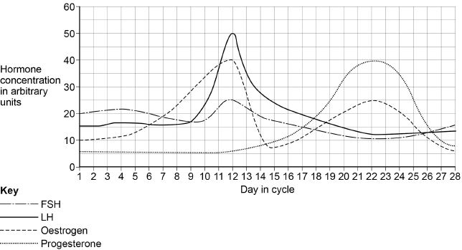
(a) Calculate the rate of increase in LH concentration between day 9 and day 12
Give your answer in arbitrary units per hour.
Give your answer to 2 significant figures.
___________________________________________________________________
___________________________________________________________________
___________________________________________________________________
Rate = _____________________ arbitrary units per hour
(2)
(b) Describe the sequence of hormone interactions in the menstrual cycle.
Name where each hormone is produced.
___________________________________________________________________
___________________________________________________________________
___________________________________________________________________
___________________________________________________________________
___________________________________________________________________
___________________________________________________________________
___________________________________________________________________
___________________________________________________________________
___________________________________________________________________
___________________________________________________________________
___________________________________________________________________
___________________________________________________________________
(5)
(c) Progesterone is used in some contraceptives.
Suggest one advantage of using a progesterone patch rather than a progesterone oral contraceptive.
___________________________________________________________________
___________________________________________________________________
(1)
(Total 8 marks)
Q10.
This question is about the human nervous system.
(a) A ball is thrown towards a boy.
As the ball is thrown, information passes along a pathway to allow the boy to catch the ball.
Draw one line from each action to the correct part of the pathway.

Action |  | Part of the pathway
 |  | Coordinator
Retina cells in the eye detect the light from the ball
 |  | Effector
The impulse reaches the brain which ‘sees’ the ball and sends an impulse to the arm muscle
 |  | Response
The muscle in the arm contracts
 |  | Receptor
The arm stretches to catch the ball
 |  | Stimulus
(3)
Students in a college made this hypothesis:
‘reaction time will increase as the time you have been awake increases.’
The students set up an investigation to test their hypothesis.
This is the method used.
1. Find 5 volunteers willing to stay awake for 24 hours.
2. Keep the volunteers in a room where they can study, use an exercise bike or watch TV as they wish.
3. Provide food, water, coffee and tea as requested.
4. Measure the volunteers’ reaction time every 4 hours using a computer program.
(b) What was the independent variable in this investigation?
___________________________________________________________________
(1)
The students used a computer program to test reaction time.
(c) Describe one other method that can be used to measure reaction time.
___________________________________________________________________
___________________________________________________________________
___________________________________________________________________
___________________________________________________________________
___________________________________________________________________
___________________________________________________________________
(3)
(d) Which method would you choose to use at your school?
Tick one box.

Computer program | 
Method described in part (c)
Give one reason for your choice.
___________________________________________________________________
___________________________________________________________________
(1)
The table shows the students’ results.

Time awake in hours | Reaction time in seconds
Time awake in hours | Volunteer
Time awake in hours | A | B | C | D | E | Mean
0 | 0.25 | 0.33 | 0.35 | 0.21 | 0.27 | 0.28
4 | 0.20 | 0.30 | 0.31 | 0.19 | 0.26 | 0.25
8 | 0.21 | 0.28 | 0.33 | 0.20 | 0.27 | 0.26
12 | 0.26 | 0.40 | 0.58 | 0.22 | 0.30 | 0.35
16 | 0.44 | 0.49 | 0.83 | 0.27 | 0.75 | X
20 | 0.64 | 0.55 | 1.11 | 0.39 | 1.40 | 0.82
24 | 0.92 | 0.61 | 1.15 | 0.45 | 1.35 | 0.90
(e) Calculate value X in the table.
Give your answer to 2 significant figures.
___________________________________________________________________
___________________________________________________________________
X = ____________________ seconds
(2)
(f) Describe the pattern of results for mean reaction time as the time awake increases.
___________________________________________________________________
___________________________________________________________________
___________________________________________________________________
___________________________________________________________________
(2)
(g) Do these results support the students’ hypothesis: ‘reaction time will increase as the time you have been awake increases’?
Give one reason for your answer.
___________________________________________________________________
___________________________________________________________________
(1)
(g) Give two ways the students could improve their investigation to make it more valid.
1. _________________________________________________________________
___________________________________________________________________
2. _________________________________________________________________
___________________________________________________________________
(2)
(Total 15 marks)

