  B4 PPQ
  Year 11 Revision
  Name: | ________________________
  Class: | ________________________
  Date: | ________________________

Time: | 108 minutes
Marks: | 102 marks
Comments:

Q1.
Anaerobic respiration in yeast is called fermentation.
The equation for fermentation is:
glucose → ethanol + carbon dioxide
(a) How does the equation show that fermentation is an anaerobic reaction?
___________________________________________________________________
___________________________________________________________________
(1)
Fermentation in yeast is used in the manufacture of beer, wine and bread.
(b) Why is fermentation used when making beer and wine?
___________________________________________________________________
___________________________________________________________________
(1)
(c) Explain why fermentation is used when making bread.
___________________________________________________________________
___________________________________________________________________
___________________________________________________________________
___________________________________________________________________
(2)
A student investigated fermentation in yeast.
Figure 1 shows the apparatus.
Figure 1
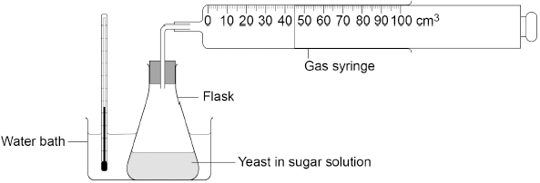
This is the method used.
1. Mix yeast with sugar solution in a flask.
2. Put the flask in a water bath at 35 °C.
3. After 10 minutes attach a gas syringe to the flask.
4. Record the volume of carbon dioxide collected every 5 minutes for 1 hour.
(d) What volume of carbon dioxide has been collected in the gas syringe in the figure above?
Volume of carbon dioxide = _______________ cm³
(1)
(e) Why did the student wait 10 minutes before attaching the gas syringe?
Tick (✓) one box.

To allow time for the mixture to reach 35 °C | 
To allow time for the sugar to dissolve
To allow time to draw a results table
(1)
Figure 2 shows the results.
Figure 2
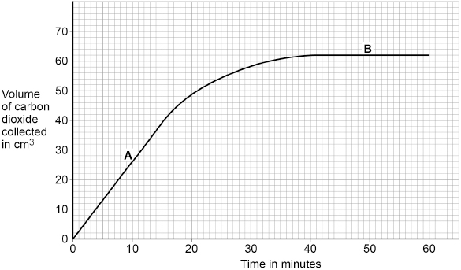
(f) A and B are different parts of the graph in Figure 2.
Draw one line from each part of the graph to the description of the reaction.

Part of the graph |  | Description of the reaction
 |  | Carbon dioxide is not being produced
A
 |  | Carbon dioxide production is fastest
B
 |  | Carbon dioxide production is slowing down
(2)
The equation for fermentation is repeated here.
glucose → ethanol + carbon dioxide
(g) Suggest one reason why fermentation in the flask stopped.
___________________________________________________________________
___________________________________________________________________
(1)
(h) Fermentation is controlled by enzymes.
The investigation was repeated at 2 °C and at 75 °C.
No carbon dioxide was produced at either of these temperatures.
Suggest why no carbon dioxide was produced at 2 °C or at 75 °C.
Reason at 2 °C ______________________________________________________
___________________________________________________________________
Reason at 75 °C _____________________________________________________
___________________________________________________________________
(2)
(i) Anaerobic respiration also happens in animal cells.
Complete the equation for anaerobic respiration in animal cells.
Choose answers from the box.

carbon dioxide | ethanol | glucose | lactic acid | water
______________________________ → ______________________________
(2)
(Total 13 marks)
Q2.
Plants absorb light for photosynthesis.
(a) Which is the equation for photosynthesis?
Tick (✓) one box.

C₆H₁₂O₆ + 6 O₂ → 6 CO₂ + 6 H₂O
6 CO₂ + 6 H₂O → C₆H₁₂O₆ + 6 O₂
6 H₂O + 6 O₂ → C₆H₁₂O₆ + 6 CO₂
6 O₂ + 6 CO₂ → C₆H₁₂O₆ + 6 H₂O
(1)
A student investigated the effect of light intensity on the rate of photosynthesis.
Figure 1 shows the apparatus.
Figure 1
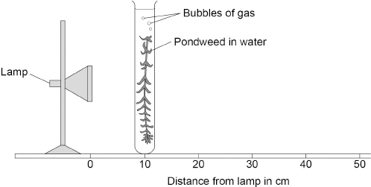
This is the method used.
1. Set up the apparatus as shown in Figure 1.
2. Place the pondweed 10 cm away from the lamp.
3. Switch on the lamp.
4. Record the number of bubbles of gas produced in 5 minutes.
5. Repeat steps 2 to 4 with the pondweed at different distances from the lamp.
(b) What was the independent variable in this investigation?
Tick (✓) one box.

Distance of the pondweed from the lamp
Length of the piece of pondweed
Number of bubbles of gas produced
Time taken to collect the gas
(1)
The lamp gets warm when it is on. This causes the temperature of the water to increase.
(c) Explain how an increase in temperature would affect the results of this investigation.
___________________________________________________________________
___________________________________________________________________
___________________________________________________________________
___________________________________________________________________
(2)
(d) Suggest one way the investigation could be improved so the temperature of the water does not increase.
___________________________________________________________________
___________________________________________________________________
(1)
(e) Suggest two improvements to the investigation so the results would be more valid.
Do not refer to controlling the temperature of the water.
1 _________________________________________________________________
___________________________________________________________________
2 _________________________________________________________________
___________________________________________________________________
(2)
The table below shows the results.

Distance of pondweed from the lamp in cm | Number of bubbles of gas produced in 5 minutes
10 | 120
20 | 56
30 | 31
40 | 16
50 | 10
(f) Calculate the rate of photosynthesis when the pondweed was 40 cm from the lamp.
Give the rate of photosynthesis as the number of bubbles of gas produced per minute.
___________________________________________________________________
___________________________________________________________________
Rate = _______________ bubbles of gas produced per minute
(1)
(g) Give one conclusion that can be made from the table above.
___________________________________________________________________
___________________________________________________________________
___________________________________________________________________
(1)
(h) Plot the data from the table above on Figure 2.
Draw a line of best fit.
Figure 2
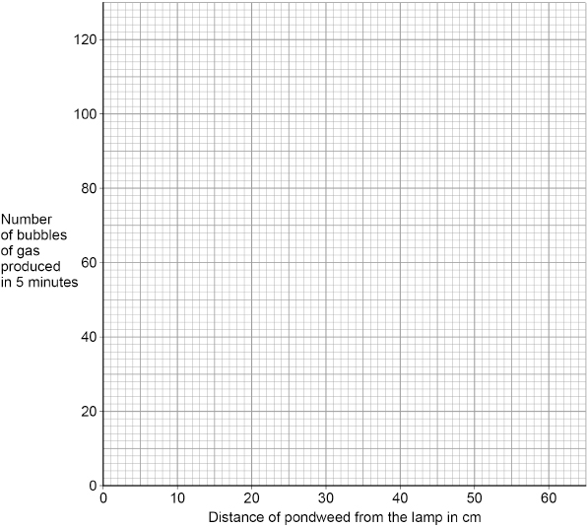
(3)
(i) Predict the number of bubbles that would be produced in 5 minutes if the pondweed was 60 cm from the lamp.
Use Figure 2.
Number of bubbles produced in 5 minutes = _______________
(1)
(Total 13 marks)
Q3.
Fermentation in yeast is used in the manufacture of bread and alcoholic drinks.
The equation for fermentation is:
glucose → ethanol + carbon dioxide
(a) Fermentation is an exothermic reaction.
What does exothermic mean?
___________________________________________________________________
___________________________________________________________________
(1)
A student investigated the effect of temperature on fermentation in yeast.
The figure below shows the apparatus.
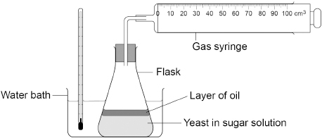
This is the method used.
1. Mix yeast with sugar solution in a flask.
2. Pour a layer of oil over the surface of the mixture.
3. Put the flask in a water bath at 2 °C and leave for 20 minutes.
4. Attach a gas syringe.
5. Record the volume of gas collected every 5 minutes for 30 minutes.
6. After 30 minutes move the flask to a water bath at 35 °C.
7. Continue to record the volume of gas collected every 5 minutes.
(b) Suggest why a layer of oil was needed on the surface of the mixture.
___________________________________________________________________
___________________________________________________________________
(1)
(c) Suggest why the mixture was left for 20 minutes before the gas syringe was attached.
___________________________________________________________________
___________________________________________________________________
(1)
Steps 1 to 4 of the method were repeated at 35 °C.
The volume of gas collected was recorded every 5 minutes for 45 minutes.
Table 1 shows the results for both flasks for the first 30 minutes.
Table 2 shows the results for the last 15 minutes, when both flasks were at 35 °C.

Table 1
Time in minutes | Volume of gas collected in cm³
Time in minutes | Flask at 2 °C | Flask at 35 °C
0 | 0 | 0
5 | 0 | 26
10 | 0 | 52
15 | 0 | 78
20 | 0 | 98
25 | 0 | 108
30 | 0 | 115

Table 2
Time in minutes | Volume of gas collected in cm³
Time in minutes | Flask at 2 °C  moved to 35 °C | Flask kept at 35 °C
35 | 2 | 120
40 | 7 | 123
45 | 22 | 124
(d) Explain the results from 0 minutes to 45 minutes for the flask that was at 2 °C and was then moved to 35 °C.
Use Table 1 and Table 2.
___________________________________________________________________
___________________________________________________________________
___________________________________________________________________
___________________________________________________________________
___________________________________________________________________
___________________________________________________________________
(3)
(e) Explain the results from 0 minutes to 45 minutes for the flask kept at 35 °C.
Use Table 1 and Table 2.
___________________________________________________________________
___________________________________________________________________
___________________________________________________________________
___________________________________________________________________
___________________________________________________________________
___________________________________________________________________
___________________________________________________________________
___________________________________________________________________
(4)
(Total 10 marks)
Q4.
This question is about photosynthesis and food production.
(a) How can oxygen production be used to show the rate of photosynthesis?
___________________________________________________________________
___________________________________________________________________
___________________________________________________________________
(1)
Scientists investigated factors affecting the rate of photosynthesis in tomato plants.
The tomato plants were growing in a commercial greenhouse in the UK during winter.
The graph below shows the results.
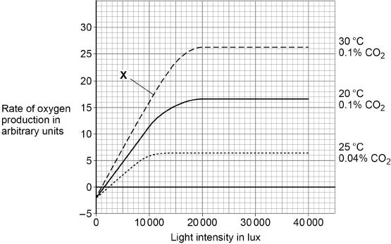
The percentage of carbon dioxide in the Earth’s atmosphere is 0.04%
(b) Name the factor that is limiting the rate of photosynthesis at point X.
___________________________________________________________________
(1)
Farmers growing tomatoes commercially try to control the rate of photosynthesis and make maximum profit.
A farmer can control the temperature and carbon dioxide concentration in a greenhouse.
(c) What is the minimum light intensity a farmer should use to get the maximum rate of photosynthesis shown in above graph?
Light intensity = _______________ lux
(1)
(d) The light intensity you gave in part (c) may not give the farmer maximum profit.
Explain why.
___________________________________________________________________
___________________________________________________________________
___________________________________________________________________
___________________________________________________________________
___________________________________________________________________
___________________________________________________________________
(3)
(e) Explain the results when the light intensity was 0 lux.
Use the diagram above.
___________________________________________________________________
___________________________________________________________________
___________________________________________________________________
___________________________________________________________________
___________________________________________________________________
___________________________________________________________________
___________________________________________________________________
(4)
(Total 10 marks)
Q5.
Mineral ions are important chemicals in an ecosystem.
(a) Plants take in nitrate ions dissolved in water.
Which part of a plant takes in nitrate ions?
___________________________________________________________________
(1)
(b) Name two chemicals that are cycled between plants, the soil and the air.
Do not refer to nitrogen or nitrates in your answer.
1. _________________________________________________________________
2. _________________________________________________________________
(2)
(c) All the chemicals in a plant are recycled when the plant dies.
Describe how:
• microorganisms recycle chemicals
• the chemicals are used again by new plants.
___________________________________________________________________
___________________________________________________________________
___________________________________________________________________
___________________________________________________________________
___________________________________________________________________
___________________________________________________________________
___________________________________________________________________
___________________________________________________________________
___________________________________________________________________
___________________________________________________________________
___________________________________________________________________
___________________________________________________________________
(6)
(Total 9 marks)
Q6.
A student investigated the effect of light intensity on the rate of photosynthesis.
Figure 1 shows some of the apparatus used.
Figure 1
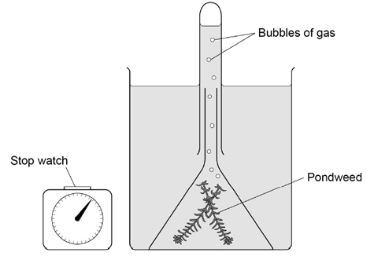
(a) Name the gas produced by the pondweed in the light.
___________________________________________________________________
(1)
(b) Describe one way the student could change the intensity of light reaching the pondweed.
___________________________________________________________________
___________________________________________________________________
___________________________________________________________________
(2)
(c) Describe how the student could use the apparatus in Figure 1 to measure the rate of photosynthesis.
___________________________________________________________________
___________________________________________________________________
___________________________________________________________________
___________________________________________________________________
(2)
Figure 2 shows the student’s results.
Figure 2
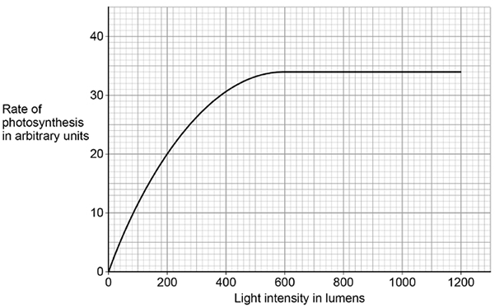
(d) What was the maximum rate of photosynthesis?
Maximum rate = ____________________ arbitrary units
(1)
(e) At which light intensity was light a limiting factor?
Tick (✓) one box.

200 lumens | 
600 lumens
1200 lumens
(1)
(f) Light intensity can affect the rate of photosynthesis.
Give one other factor that can affect the rate of photosynthesis.
___________________________________________________________________
(1)
(Total 8 marks)
Q7.
Respiration can happen aerobically or anaerobically.
Respiration transfers energy from glucose.
(a) Draw one line from each type of respiration in human cells to the correct information.

Type of respiration  in human cells |  | Information
 |  | Produces ethanol
Aerobic respiration |  | Uses oxygen
Anaerobic respiration |  | Uses carbon dioxide
 |  | Produces lactic acid
(2)
(b) The table below shows the amount of energy released by aerobic and anaerobic respiration.

Energy in kJ transferred
from 1 g of glucose
Aerobic respiration | 16.1
Anaerobic respiration | 1.2
Suggest why human cells might respire anaerobically, even though only a small amount of energy is transferred.
___________________________________________________________________
___________________________________________________________________
(1)
(c) Yeast is used in the brewing and baking industries.
Why is yeast used in these industries?
___________________________________________________________________
___________________________________________________________________
___________________________________________________________________
___________________________________________________________________
___________________________________________________________________
___________________________________________________________________
___________________________________________________________________
___________________________________________________________________
(4)
(Total 7 marks)
Q8.
The UK contains large areas of peat bogs that have been present for thousands of years.
(a) Peat is removed from peat bogs.
The peat can be mixed with air and added to garden compost.
The release of carbon dioxide from peat is a problem.
Give two other reasons why gardeners should use less peat-based compost in the future.
1. _________________________________________________________________
___________________________________________________________________
2. _________________________________________________________________
___________________________________________________________________
(2)
(b) Explain why mixing peat with air leads to the release of carbon dioxide.
___________________________________________________________________
___________________________________________________________________
___________________________________________________________________
___________________________________________________________________
___________________________________________________________________
___________________________________________________________________
___________________________________________________________________
___________________________________________________________________
(4)
(Total 6 marks)
Q9.
A student ran on a treadmill for 5 minutes.
The speed of the treadmill was set at 12 km per hour.
The graph below shows the effect of the run on the student’s heart rate.
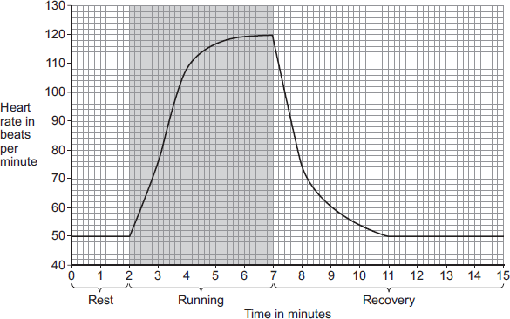
(a) (i) What was the student’s heart rate at rest?
_______________ beats per minute
(1)
(ii) After the end of the run, how long did it take for the student’s heart rate to return to the resting heart rate?
_______________ minutes
(1)
(b) During the run, the student’s muscles needed larger amounts of some substances than they needed at rest.
(i) Which two of the following substances were needed in larger amounts during the run?
Tick () two boxes.

carbon dioxide | 
glucose
lactic acid
oxygen
protein
(2)
(ii) Why are the two substances you chose in part (b)(i) needed in larger amounts during the run?
Tick () one box.

To help make more muscle fibres
To release more energy
To help the muscles to cool down
(1)
(c) After exercise, a fit person recovers faster than an unfit person.
Let the student’s heart rate at the end of exercise = a.
Let the student’s heart rate after 2 minutes of recovery = b.
The table below shows how the difference between a and b, (a − b), is related to a person’s level of fitness.

(a − b) | Level of fitness
< 22 | Unfit
22 to 52 | Normal fitness
53 to 58 | Fit
59 to 65 | Very fit
> 65 | Top athlete
What is the student’s level of fitness?
Use information from the graph and the table.
a = _______________ beats per minute
b = _______________ beats per minute
(a − b) = _______________ beats per minute
Level of fitness = __________________________________
(3)
(d) The student repeated the run with the treadmill set at 16 km per hour.
The student’s heart rate took 3 minutes longer to return to the normal resting rate than when running at 12 km per hour.
Give reasons why it took longer to recover after running faster.
___________________________________________________________________
___________________________________________________________________
___________________________________________________________________
___________________________________________________________________
___________________________________________________________________
___________________________________________________________________
___________________________________________________________________
___________________________________________________________________
___________________________________________________________________
___________________________________________________________________
(4)
(Total 12 marks)
Q10.
This question is about photosynthesis.
(a) What is the correct balanced equation for photosynthesis?
Tick one box.

C₆H₁₂O₆ + 6O₂ ⟶ 6CO₂ + 6H₂O
O₂ + H₂O ⟶ C₆H₁₂O₆ + CO₂
6CO₂ + 6H₂O ⟶ C₆H₁₂O₆ + 6O₂
6O₂ + 6CO₂ ⟶ 6H₂O + C₆H₁₂O₆
(1)
(b) What type of reaction is photosynthesis?
Tick one box.

Aerobic
Endothermic
Exothermic
Oxidation
(1)
A student investigated the effect of light intensity on the rate of photosynthesis.
The diagram below shows the apparatus used.
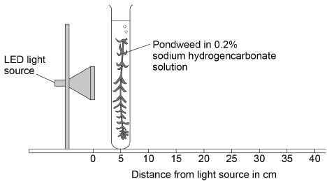
Sodium hydrogencarbonate solution releases carbon dioxide gas for the pondweed.
This is the method used.
1. Place the pondweed at 5 cm from the light source.
2. Measure the rate of photosynthesis by counting the number of bubbles produced in 1 minute.
3. Repeat with the pondweed at 10 cm and at 20 cm from the light source.
(c) Counting the number of bubbles produced in 1 minute is not an accurate way to measure the rate of photosynthesis.
Suggest two ways the method could be improved to measure the rate of photosynthesis more accurately.
1. _________________________________________________________________
___________________________________________________________________
2. _________________________________________________________________
___________________________________________________________________
(2)
(d) The LED light source does not get hot.
Explain why it is important that the pondweed remains at a constant temperature.
___________________________________________________________________
___________________________________________________________________
___________________________________________________________________
___________________________________________________________________
(2)
(e) Light intensity can be calculated using the inverse square law:
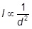
Where I is light intensity and d is the distance of the pondweed from the light source.
The student placed the pondweed at 5, 10 and 20 cm from the light source.
Explain how light intensity changes as the distance of the pondweed from the light source is doubled.
You must include calculations in your answer.
___________________________________________________________________
___________________________________________________________________
___________________________________________________________________
___________________________________________________________________
___________________________________________________________________
___________________________________________________________________
(3)
(f) The student’s results are shown in the table below

Distance of the pondweed from the light source in cm | Number of bubbles produced in 1 minute
5 | 129
10 | 31
20 | 8
Predict how many bubbles of gas would be produced in 1 minute if the pondweed was placed 40 cm from the light source.
Give a reason for your prediction.
___________________________________________________________________
___________________________________________________________________
___________________________________________________________________
___________________________________________________________________
(2)
(g) Describe how the student could change the method to investigate the effect of carbon dioxide concentration on the rate of photosynthesis.
You should include:
• how to change the independent variable
• two control variables.
Use the diagram above to help you answer this question.
___________________________________________________________________
___________________________________________________________________
___________________________________________________________________
___________________________________________________________________
___________________________________________________________________
___________________________________________________________________
(3)
(Total 14 marks)

