  B3 PPQ
  Year 11 Revision
  Name: | ________________________
  Class: | ________________________
  Date: | ________________________

Time: | 101 minutes
Marks: | 94 marks
Comments:

Q1.
Antibiotics are used to treat bacterial infections.
(a) Which substance is used as an antibiotic?
Tick (✓) one box.

Aspirin | 
Digitalis
Penicillin
(1)
Gonorrhoea and chlamydia are two sexually transmitted infections.
Gonorrhoea and chlamydia infections can be treated with antibiotics.
(b) Give one symptom of gonorrhoea.
___________________________________________________________________
___________________________________________________________________
(1)
A scientist investigated which antibiotics were most effective at treating gonorrhoea and chlamydia.
This is the method used.
1. Grow gonorrhoea bacteria in a Petri dish.
2. Prepare four different antibiotic solutions, A, B, C and D, of the same concentration.
3. Cut four filter paper discs to the same size.
4. Soak each paper disc in a different antibiotic solution.
5. Put the four paper discs into the Petri dish.
6. Repeat steps 3 to 5 using a Petri dish with chlamydia bacteria growing in it.
7. Keep both Petri dishes at 25 °C for 3 days.
(c) Give two control variables used in this investigation.
1 _________________________________________________________________
___________________________________________________________________
2 _________________________________________________________________
___________________________________________________________________
(2)
The figure below shows the results.
A clear area around a paper disc is where the antibiotic has killed the bacteria.
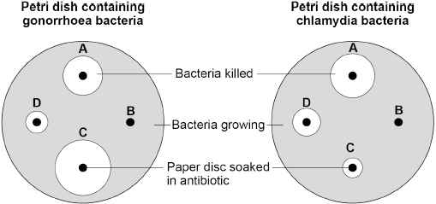
(d) Which antibiotic did not kill either type of bacterium?
Tick (✓) one box.

A |  | B |  | C |  | D
(1)
(e) Which antibiotic would be the most effective to treat a person with a gonorrhoea infection?
Tick (✓) one box.

A |  | B |  | C |  | D
(1)
(f) Which antibiotic would be the most effective to treat a person who had both gonorrhoea and chlamydia infections?
Tick (✓) one box.

A |  | B |  | C |  | D
(1)
(g) Antibiotics cannot be used to treat HIV infections.
Suggest one reason why.
___________________________________________________________________
___________________________________________________________________
(1)
Fungi can cause an infection of the fingernails and toenails.
Fungal nail infections can spread from one person to another person.
(h) Some people go to nail salons to have their nails shaped and painted.
Suggest one way workers in nail salons can reduce the risk of infections being spread.
___________________________________________________________________
___________________________________________________________________
(1)
(i) Suggest one reason why fungal infection of toenails is more common than fungal infection of fingernails.
___________________________________________________________________
___________________________________________________________________
(1)
(Total 10 marks)
Q2.
Pathogens are microorganisms that cause diseases.
Gonorrhoea, malaria and measles are three diseases in humans.
(a) Draw one line from each disease to the pathogen that causes the disease.

Disease |  | Pathogen
 |  | Bacterium
Gonorrhoea
 |  | Fungus
Malaria
 |  | Protist
Measles
 |  | Virus
(3)
(b) Malaria is transmitted by mosquitos.
Male mosquitos can be sterilised so they are infertile.
The spread of malaria is reduced by releasing sterile mosquitos into the environment.
Explain how releasing sterile mosquitos reduces the spread of malaria.
___________________________________________________________________
___________________________________________________________________
___________________________________________________________________
___________________________________________________________________
___________________________________________________________________
(2)
Pathogens also cause diseases in plants.
The figure below shows a rose black spot fungal spore and a tobacco mosaic virus.
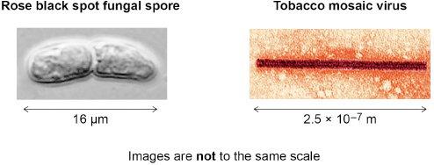
(c) Name the piece of equipment used to view the virus.
___________________________________________________________________
(1)
(d) How many times longer is the fungal spore than the virus?
Use the figure above.
___________________________________________________________________
___________________________________________________________________
___________________________________________________________________
___________________________________________________________________
___________________________________________________________________
Number of times longer = _______________
(3)
(e) Explain why plants infected with tobacco mosaic virus grow slowly.
___________________________________________________________________
___________________________________________________________________
___________________________________________________________________
___________________________________________________________________
___________________________________________________________________
___________________________________________________________________
(3)
(Total 12 marks)
Q3.
The figure below shows glands in the human body.
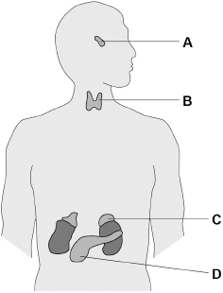
(a) Which organ system includes the glands shown in the figure above?
___________________________________________________________________
(1)
(b) Which gland produces insulin?
Tick (✓) one box.

A |  | B |  | C |  | D
(1)
(c) Which gland produces hormones that stimulate the other glands to produce hormones?
Tick (✓) one box.

A |  | B |  | C |  | D
(1)
(d) How do hormones travel from one gland to another gland?
___________________________________________________________________
___________________________________________________________________
(1)
(e) Name two glands involved in human reproduction.
Do not refer to glands shown on the figure above in your answer.
1 _________________________________________________________________
2 _________________________________________________________________
(2)
(f) Ovulation test kits can help women know when they are most fertile.
Ovulation test kits detect the increase in the hormone that stimulates ovulation.
Which hormone is detected by ovulation test kits?
Tick (✓) one box.

Follicle stimulating hormone (FSH)
Luteinising hormone (LH)
Oestrogen
Progesterone
(1)
(g) A new contraceptive drug for men is being tested.
The drug:
• is given in one injection
• stops sperm being able to fertilise eggs
• is effective for up to 13 years.
Evaluate the use of the new drug compared with existing contraceptive methods.
___________________________________________________________________
___________________________________________________________________
___________________________________________________________________
___________________________________________________________________
___________________________________________________________________
___________________________________________________________________
___________________________________________________________________
___________________________________________________________________
___________________________________________________________________
___________________________________________________________________
___________________________________________________________________
___________________________________________________________________
(6)
(Total 13 marks)
Q4.
New drugs are tested before they can be licensed for use with patients.
Figure 1 shows how much time the different stages of testing took for one new drug.
Figure 1
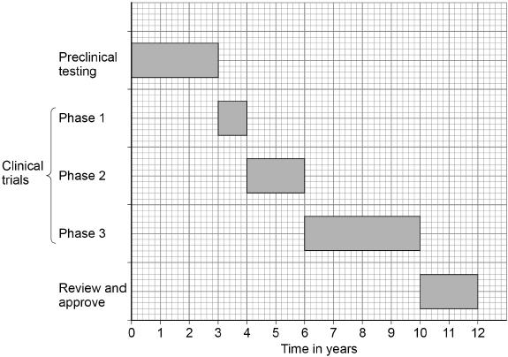
(a) Preclinical testing is done in a laboratory.
What is the drug tested on in a laboratory?
Give one example.
___________________________________________________________________
(1)
(b) How many years did the clinical trials take for the drug in Figure 1?
___________________________________________________________________
___________________________________________________________________
Time for clinical trials = _______________ years
(1)
(c) During Phase 1 clinical trials, the drug is tested on healthy volunteers using low doses.
What is the main purpose of Phase 1 testing?
Tick (✓) one box.

To find the best dose to use.
To see if the drug is safe to use.
To see if the drug works.
(1)
During clinical trials, half of the patients are given a placebo in a double blind trial.
(d) What is a placebo?
___________________________________________________________________
___________________________________________________________________
(1)
(e) Who knows which patients are given the placebo and which patients are given the drug in a double blind trial?
Tick (✓) one box.

Not the patients or the doctors
The patients and the doctors
The patients but not the doctors
(1)
Paracetamol and ibuprofen are two medicines used to reduce a high body temperature.
Doctors investigated which medicine was more effective at reducing high body temperature in 200 children who were ill.
The children were put into two groups, which were matched for:
• age
• gender
• body mass.
Each group had 100 children.
This is the method used.
1. Measure the body temperature of each child before any medicine is given.
2. Give children in Group 1 paracetamol.
3. Give children in Group 2 ibuprofen.
4. Measure the body temperature of each child every hour after the medicine is given.
(f) Give two control variables in this investigation.
1. _________________________________________________________________
2. _________________________________________________________________
(2)
(g) None of the children was given a placebo.
Suggest one reason why.
___________________________________________________________________
___________________________________________________________________
(1)
Figure 2 shows the results.
Figure 2
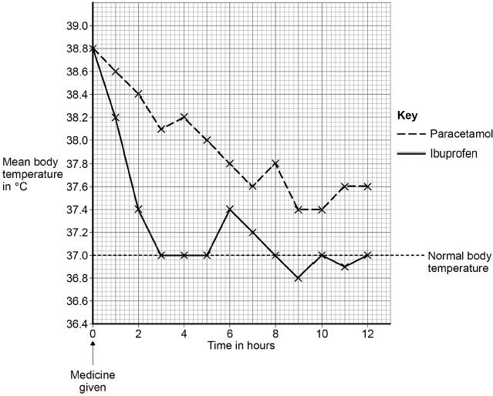
(h) What was the mean body temperature after 6 hours for the children given ibuprofen?
Mean body temperature = _______________ °C
(1)
(i) The doctors concluded that children with a high body temperature should be given ibuprofen and not paracetamol.
Give two reasons for the doctors’ conclusion.
Use Figure 2.
1. _________________________________________________________________
___________________________________________________________________
2. _________________________________________________________________
___________________________________________________________________
(2)
(Total 11 marks)
Q5.
Cells are the basic units of all forms of life.
(a) Describe four differences between a bacterial cell and a plant cell.
1. _________________________________________________________________
___________________________________________________________________
2. _________________________________________________________________
___________________________________________________________________
3. _________________________________________________________________
___________________________________________________________________
4. _________________________________________________________________
___________________________________________________________________
(4)
(b) Gonorrhoea is a bacterial disease.
A new vaccine is being developed against gonorrhoea.
Describe how a vaccine would work to prevent gonorrhoea.
___________________________________________________________________
___________________________________________________________________
___________________________________________________________________
___________________________________________________________________
___________________________________________________________________
___________________________________________________________________
___________________________________________________________________
___________________________________________________________________
(4)
Another disease caused by bacteria is salmonella food poisoning.
In the UK, chickens are vaccinated against Salmonella bacteria to reduce the number of cases of food poisoning in humans.
(c) Explain how vaccinating chickens reduces the number of cases of salmonella food poisoning.
___________________________________________________________________
___________________________________________________________________
___________________________________________________________________
___________________________________________________________________
(2)
(d) Give one way that the spread of salmonella food poisoning from one human to another is controlled.
Do not refer to vaccination in your answer.
___________________________________________________________________
___________________________________________________________________
(1)
(e) The number of cases of salmonella food poisoning is usually higher in summer than in winter.
Suggest one reason why.
___________________________________________________________________
___________________________________________________________________
(1)
(Total 12 marks)
Q6.
New drugs are tested and trialled before they can be licensed to treat patients.
The graph below shows how much time the different stages of testing took for one new drug.
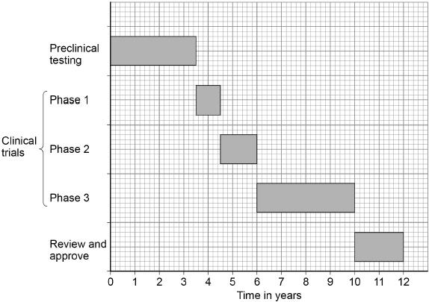
(a) How much more time did the clinical trials take compared with the preclinical testing?
Tick (✓) one box.

3 years
3.5 years
5 years
6.5 years
(1)
During Phase 1 clinical trials low doses of the drug are tested on healthy volunteers.
(b) Suggest one reason why low doses of the drug are used in Phase 1 clinical trials.
___________________________________________________________________
___________________________________________________________________
(1)
(c) Suggest two reasons why healthy volunteers are used in Phase 1 clinical trials.
1. _________________________________________________________________
___________________________________________________________________
___________________________________________________________________
2. _________________________________________________________________
___________________________________________________________________
___________________________________________________________________
(2)
(d) The results of clinical trials can only be published after peer review by other scientists.
Suggest one reason why the results must be reviewed by other scientists.
___________________________________________________________________
___________________________________________________________________
(1)
(e) A drug is only licensed for the medical conditions it was tested to treat in the clinical trials.
Drug regulations:
• control what drugs a doctor can prescribe
• ensure doctors can prescribe a drug with confidence
• protect patients.
AMD is an eye condition that can result in very poor vision.
Doctors treat approximately 40 000 new cases of AMD each year.
Two drugs licensed to treat AMD in the UK are drug A and drug B.
In many other countries drug C is used to treat AMD. Drug C is only licensed in the UK to treat cancer.
The cost per injection for each drug is:
• drug A £561
• drug B £800
• drug C £28
The number of injections required to treat AMD is the same for each drug.
In 2018 the High Court in the UK gave permission for drug C to be used to treat AMD.
Evaluate the decision to allow the use of drug C to treat AMD in the UK.
___________________________________________________________________
___________________________________________________________________
___________________________________________________________________
___________________________________________________________________
___________________________________________________________________
___________________________________________________________________
___________________________________________________________________
___________________________________________________________________
___________________________________________________________________
___________________________________________________________________
___________________________________________________________________
___________________________________________________________________
(6)
(Total 11 marks)
Q7.
Malaria is a disease transmitted by mosquitos.
The graph shows information about the number of deaths from malaria.
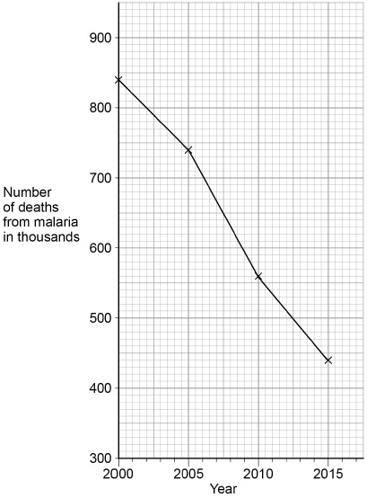
(a) Calculate the decrease in the number of deaths between 2000 and 2015.
___________________________________________________________________
___________________________________________________________________
Decrease in number of deaths = ____________________
(2)
(b) Which time period shows the greatest decrease in the number of deaths?
Tick (✓) one box.

2000 to 2005 | 
2005 to 2010
2010 to 2015
(1)
(c) A student looked at the graph above and concluded that there were 800 000 deaths from malaria in 2002.
Suggest one reason why this conclusion might not be correct.
___________________________________________________________________
___________________________________________________________________
(1)
(d) What type of pathogen causes malaria?
Tick (✓) one box.

Bacterium
Fungus
Protist
Virus
(1)
(e) Scientists are developing a vaccine against malaria.
Suggest how a vaccine against malaria could reduce the spread of the disease.
___________________________________________________________________
___________________________________________________________________
___________________________________________________________________
___________________________________________________________________
(2)
(f) Give one way of controlling the spread of malaria.
Do not refer to a vaccine in your answer.
___________________________________________________________________
___________________________________________________________________
(1)
(Total 8 marks)
Q8.
Measles is a serious disease. A person can die from measles.
The table below shows the number of medically confirmed cases of measles in England and Wales between 2012 and 2015

Year | Number of medically confirmed cases of measles
2012 | 2030
2013 | 1843
2014 | 121
2015 | 91
(a) Suggest one reason why the actual number of cases of measles in England and Wales might be higher than is shown in the table above
___________________________________________________________________
___________________________________________________________________
(1)
(b) Calculate the percentage decrease in the number of medically confirmed cases of measles between 2012 and 2015
___________________________________________________________________
___________________________________________________________________
___________________________________________________________________
___________________________________________________________________
Percentage decrease = _______________________ %
(2)
(c) One reason for the decrease in the number of cases of measles is that more children were vaccinated against the disease.
Vaccinating a large proportion of the population reduces the spread of the measles virus.
Explain why.
___________________________________________________________________
___________________________________________________________________
___________________________________________________________________
___________________________________________________________________
(2)
(d) The graph below shows the concentration of measles antibodies in the blood of a boy.
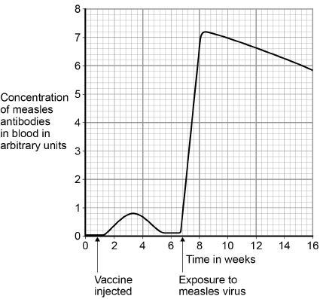
Explain the differences between antibody production after the vaccine injection and after exposure to the measles virus.
You should include data from the graph above
___________________________________________________________________
___________________________________________________________________
___________________________________________________________________
___________________________________________________________________
___________________________________________________________________
___________________________________________________________________
___________________________________________________________________
___________________________________________________________________
___________________________________________________________________
___________________________________________________________________
___________________________________________________________________
___________________________________________________________________
(6)
(Total 11 marks)
Q9.
Pseudomonas bacteria cause infections in hospital patients.
A new strain of Pseudomonas bacteria has evolved. This new strain can only be killed by one antibiotic called fluroquinolone.
Scientists want to prevent the new strain of Pseudomonas from spreading in the human population.
Explain the advice doctors should be given to prevent the spread of the new strain.
_______________________________________________________________________
_______________________________________________________________________
_______________________________________________________________________
_______________________________________________________________________
_______________________________________________________________________
_______________________________________________________________________
_______________________________________________________________________
_______________________________________________________________________
_______________________________________________________________________
_______________________________________________________________________
_______________________________________________________________________
_______________________________________________________________________
(Total 6 marks)

