  B1 PPQ
  Year 11 Revision
  Name: | ________________________
  Class: | ________________________
  Date: | ________________________

Time: | 194 minutes
Marks: | 180 marks
Comments:

Q1.
This question is about gold and compounds of gold.
In the alpha particle scattering experiment alpha particles are fired at gold foil.
Alpha particles are positively charged.
The diagram below shows the results.
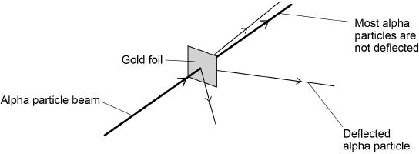
(a) Some alpha particles are deflected.
Complete the sentence.
Choose the answer from the box.

negatively charged | not charged | positively charged
Some alpha particles are deflected because the nucleus of the
atom is ____________________.
(1)
(b) Why are most alpha particles not deflected?
Tick (✓) one box.

The atom is a tiny sphere that cannot be divided. | 
The atom is mainly empty space.
The electrons orbit the nucleus at specific distances.
(1)
(c) What was one conclusion from the alpha particle scattering experiment?
Tick (✓) one box.

The mass is concentrated at the centre of the atom.
The mass is concentrated at the edge of the atom.
The mass is spread evenly throughout the atom.
(1)
Gold reacts with the elements in Group 7 of the periodic table.
(d) What are Group 7 elements known as?
Tick (✓) one box.

Alkali metals
Halogens
Noble gases
(1)
(e) Fluorine, chlorine and bromine react with gold.
Which element will be the most reactive with gold?
Tick (✓) one box.

Fluorine |  | Chlorine |  | Bromine
(1)
(f) 3.94 g of gold reacts with chlorine to produce 6.07 g of gold chloride.
The word equation for the reaction is:

gold + chlorine → gold chloride
Calculate the mass of chlorine that reacts with 3.94 g of gold.
___________________________________________________________________
___________________________________________________________________
Mass = _______________ g
(1)
(g) Calculate the relative formula mass (M_{r}) of gold chloride (AuCl₃).
Relative atomic masses (A_{r}): Cl = 35.5 Au = 197
___________________________________________________________________
___________________________________________________________________
___________________________________________________________________
___________________________________________________________________
Relative formula mass (M_{r}) = _______________
(2)
(Total 8 marks)
Q2.
This question is about the periodic table and argon.
(a) What order did scientists use to arrange elements in early periodic tables?
Tick (✓) one box.

Atomic weight of element | 
Number of neutrons in an atom of element
Size of atoms of element
Year element was discovered
(1)
(b) In early periodic tables some elements were placed in the wrong groups.
Mendeleev overcame some of these problems in his periodic table.
Complete the sentence.
Mendeleev did this by leaving __________________ for elements that had not
been discovered.
(1)
(c) What is the name of the group that contains argon?
Tick (✓) one box.

Alkali metals
Halogens
Noble gases
(1)
(d) An atom of argon is represented as
Determine the number of protons and the number of neutrons in one atom of argon.
Number of protons _________________
Number of neutrons _______________
(2)
(e) Different atoms of argon are, and
What is the name given to these different atoms of argon?
Tick (✓) one box.

Fullerenes
Ions
Isotopes
Molecules
(1)
(f) What is the electronic structure of an argon atom, ?
Tick (✓) one box.

2 |  | 2, 8 |  | 2, 8, 2 |  | 2, 8, 8
(1)
(g) Why is argon unreactive?
___________________________________________________________________
___________________________________________________________________
(1)
(Total 8 marks)
Q3.
Sodium and potassium are Group 1 elements.
(a) What is the name of Group 1 elements?
Tick (✓) one box.

Alkali metals
Halogens
Noble gases
(1)
(b) Figure 1 represents the melting points of Group 1 elements.
Figure 1
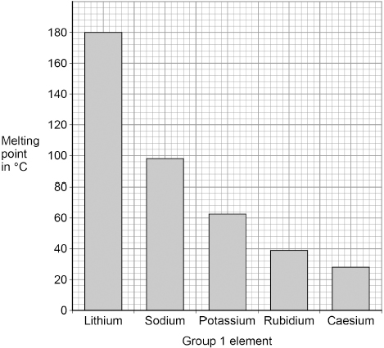
What is the melting point of sodium?
Melting point of sodium = _______________ °C
(1)
(c) Sodium reacts with water to produce sodium hydroxide and hydrogen.
Balance the equation for the reaction.
_____ Na + 2 H₂O → 2 NaOH + H₂
(1)
(d) Calculate the relative formula mass (M_{r}) of sodium hydroxide (NaOH).
Relative atomic masses (A_{r}): H = 1 O = 16 Na = 23
___________________________________________________________________
___________________________________________________________________
___________________________________________________________________
Relative formula mass (M_{r}) = __________
(2)
(e) Sodium and potassium both react with water.
Figure 2 shows sodium reacting with water.
Figure 2
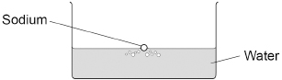
Compare what is seen when sodium reacts with water and when potassium reacts with water.
___________________________________________________________________
___________________________________________________________________
___________________________________________________________________
___________________________________________________________________
___________________________________________________________________
___________________________________________________________________
___________________________________________________________________
___________________________________________________________________
(4)
(Total 9 marks)
Q4.
This question is about the periodic table.
(a) Figure 1 shows part of Mendeleev’s version of the periodic table.
Figure 1
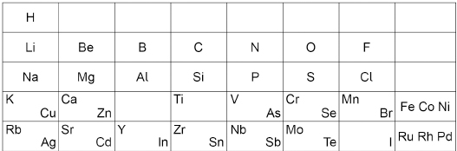
Which group of elements had not been discovered when Mendeleev’s version of the periodic table was published?
___________________________________________________________________
(1)
Figure 2 represents different models of the atom.
Figure 2
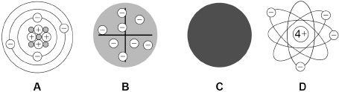
(b) Which model represents the plum pudding model?
Tick (✓) one box.

A |  | B |  | C |  | D
(1)
(c) Which model resulted from Chadwick’s experimental work?
Tick (✓) one box.

A |  | B |  | C |  | D
(1)
Potassium has different isotopes.
(d) What is meant by ‘isotopes’?
You should refer to subatomic particles.
___________________________________________________________________
___________________________________________________________________
___________________________________________________________________
___________________________________________________________________
(2)
(e) The table below shows the mass numbers and the percentage abundance of two isotopes of potassium.

Mass number | Percentage abundance
39 | 93.1
41 | 6.9
Calculate the relative atomic mass (A_{r}) of potassium.
Give your answer to 1 decimal place.
___________________________________________________________________
___________________________________________________________________
___________________________________________________________________
___________________________________________________________________
___________________________________________________________________
Relative atomic mass (1 decimal place) = __________
(3)
(Total 8 marks)
Q5.
Figure 1 shows two models of the atom.
Figure 1
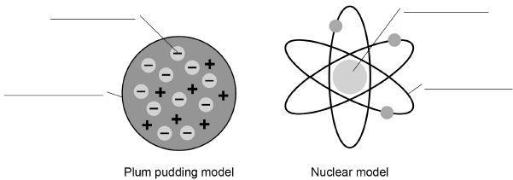
(a) Write the labels on Figure 1
Choose the answers from the box.

atom | electron | nucleus
neutron | orbit | proton
(4)
(b) Explain why the total positive charge in every atom of an element is always the same.
___________________________________________________________________
___________________________________________________________________
___________________________________________________________________
___________________________________________________________________
(2)
(c) The results from the alpha particle scattering experiment led to the nuclear model.
Alpha particles were fired at a thin film of gold at a speed of 7% of the speed of light.
Determine the speed of the alpha particles.
Speed of light = 300 000 000 m/s
___________________________________________________________________
___________________________________________________________________
Speed = _____________________ m/s
(2)
(d) Figure 2 shows two atoms represented as solid spheres.
Figure 2
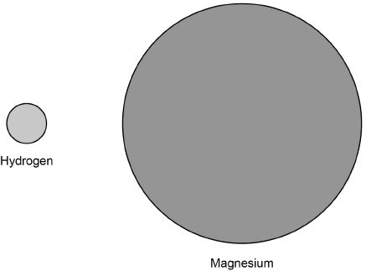
A hydrogen atom has a radius of 2.5 × 10⁻¹¹ m
Determine the radius of a magnesium atom.
Use measurements from Figure 2
___________________________________________________________________
___________________________________________________________________
Radius = _____________________ m
(2)
(Total 10 marks)
Q6.
This question is about atoms and chemical elements.
Mendeleev’s periodic table has groups of elements with similar properties.
Figure 1 shows part of Mendeleev’s periodic table.
Figure 1
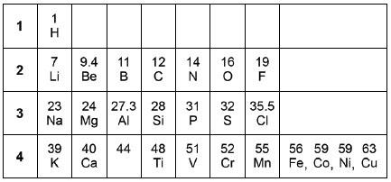
(a) Compare Mendeleev’s periodic table with the modern periodic table.
Which group is missing from Mendeleev’s periodic table?
Tick one box.

Group 1 | 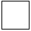
Group 2
Group 7
Group 0
(1)
(b) In the early periodic tables some elements were placed in the wrong groups.
Mendeleev overcame some of these problems in his periodic table.
Give two ways Mendeleev did this.
1. _________________________________________________________________
___________________________________________________________________
2. _________________________________________________________________
___________________________________________________________________
(2)
Atoms were thought to be tiny spheres that could not be divided.
(c) Draw one line from each scientist to the discovery the scientist made.

Scientist |  | Discovery the scientist made
 |  | Discovered electrons
Neils Bohr |  | Electrons orbit the nucleus
 |  | Existence of neutrons
James Chadwick |  | Mass of atom concentrated at centre
 |  | Proton found in nucleus
(2)
(d) A beam of electrons, neutrons and protons can be separated by passing them through an electric field.
Figure 2 shows the directions of the three particles after entering the electric field.
Figure 2
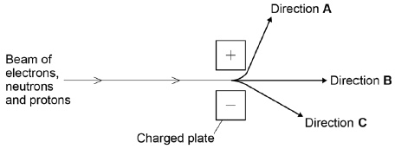
Charged particles are attracted to the oppositely charged plate in the electric field.
Which direction, A, B or C, does each particle follow?
Complete the table.

Particle | Direction
Electron
Neutron
Proton
(2)
(e) Calculate the mass of one atom of sodium.
Use the equation:
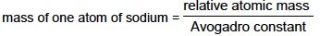
Avogadro constant = 6.02 × 10²³
Give your answer to 2 significant figures.
___________________________________________________________________
___________________________________________________________________
___________________________________________________________________
___________________________________________________________________
___________________________________________________________________
Mass = ____________________ g
(3)
(f) The radius of a sodium atom is 227 picometres.
1 picometre = 10^{–12} metres (m)
The radius of a nucleus is 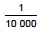 of that of the atom.
Which calculation shows the radius of a sodium atom’s nucleus?
Tick one box.

227 × 10 000 m
227 × m
227 × 10^{–12} × 10 000 m
227 × 10^{–12} × m
(1)
(Total 11 marks)
Q7.
This question is about gold and compounds of gold.
(a) In the alpha particle scattering experiment alpha particles are fired at gold foil.
Alpha particles are positively charged.
The diagram below shows the results.
What two conclusions can be made from the results?
Tick (✓) two boxes.

Atoms are balls of positive charge with embedded electrons.
Atoms are tiny spheres that cannot be divided.
Atoms have a positively charged nucleus.
Mass is concentrated in the nucleus in the centre of atoms.
Neutrons exist within the nucleus.
(2)
(b) The gold foil is:
• 4.00 × 10^{–7} metres thick
• 2400 atoms thick.
What is the diameter of one gold atom in metres?
Give your answer to 3 significant figures.
___________________________________________________________________
___________________________________________________________________
___________________________________________________________________
___________________________________________________________________
___________________________________________________________________
___________________________________________________________________
Diameter of one gold atom (3 significant figures) = _______________ m
(3)
(c) Gold reacts with the elements in Group 7 of the periodic table.
0.175 g of gold reacts with chlorine.
The equation for the reaction is:

2 Au + 3 Cl₂ → 2 AuCl₃
Calculate the mass of chlorine needed to react with 0.175 g of gold.
Give your answer in mg
Relative atomic masses (A_{r}): Cl = 35.5 Au = 197
___________________________________________________________________
___________________________________________________________________
___________________________________________________________________
___________________________________________________________________
___________________________________________________________________
___________________________________________________________________
___________________________________________________________________
___________________________________________________________________
___________________________________________________________________
___________________________________________________________________
Mass of chlorine = _______________ mg
(5)
(Total 10 marks)
Q8.
Cells are the building blocks of life.
(a) Draw one line from each type of organism to the diagram of one of its cells.

Type of organism |  | Diagram of one cell
 |  | 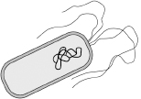
Animal
 |  | 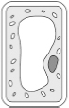
Bacterium
 |  | 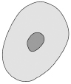
Plant
 |  | 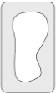
(3)
(b) Cells contain structures. These structures have different functions.
Draw one line from each function to the correct structure.

Function |  | Structure
 |  | Cell membrane
Contains genetic information
 |  | Cell wall
Controls what enters and leaves a cell
 |  | Chloroplast
Where photosynthesis happens
 |  | Nucleus
(3)
(c) Chemicals are produced in cells.
Complete the sentences.
Choose answers from the box.

cellulose | DNA | glycogen | starch | urea
A chemical excreted by animals is ____________________.
A chemical stored in animal cells is____________________.
A chemical stored in plant cells is ____________________.
A chemical that strengthens plant cell walls is ____________________.
(4)
The figure below shows a diagram of muscle cells.
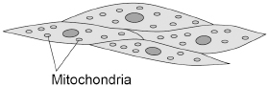
(d) Give one function of muscle cells.
___________________________________________________________________
___________________________________________________________________
(1)
(e) Explain how muscle cells are adapted for their function.
Use the figure above.
___________________________________________________________________
___________________________________________________________________
___________________________________________________________________
___________________________________________________________________
(2)
(f) One muscle cell was 0.05 mm wide.
When viewed using a microscope the image of the muscle cell was 2 mm wide.
Calculate the magnification used to view the cell.
Use the equation:
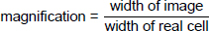
___________________________________________________________________
___________________________________________________________________
___________________________________________________________________
Magnification = × _______________
(2)
(Total 15 marks)
Q9.
This question is about plant transport systems.
(a) Which organ in a plant absorbs water from the soil?
___________________________________________________________________
(1)
(b) The concentration of nitrate ions in the soil is lower than the concentration of nitrate ions inside a plant.
How would the nitrate ions move from the soil into the cells of this plant?
Tick (✓) one box.

By active transport
By diffusion
By osmosis
(1)
Dissolved sugars are transported in the phloem.
(c) What is the name of the process that moves dissolved sugars through the phloem?
Tick (✓) one box.

Evaporation
Osmosis
Translocation
(1)
(d) Give one use of sugars in a plant.
___________________________________________________________________
___________________________________________________________________
(1)
Stomata are openings on the surface of a leaf.
Stomata allow gases to move into and out of a leaf.
The figure below shows the surface of a leaf.
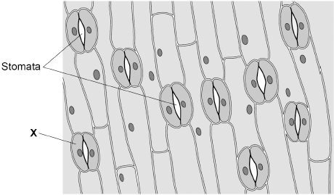
(e) What is cell X?
Tick (✓) one box.

Guard cell
Meristem cell
Palisade cell
(1)
(f) Why do the stomata open during the day?
Tick (✓) one box.

To allow carbon dioxide in
To allow nitrogen in
To allow oxygen in
(1)
(g) The area of the leaf shown in the figure above is 0.25 mm².
Calculate the number of stomata per mm² for the leaf in the figure above.
Use the equation:
___________________________________________________________________
___________________________________________________________________
___________________________________________________________________
Number of stomata per mm² = _______________
(2)
A student investigated the number of stomata per mm² on the upper and lower surfaces of leaves.
The leaves were taken from the same plant.
The table below shows the results.

Leaf | Number of stomata per mm²
Leaf | Upper surface | Lower surface
1 | 0 | 37
2 | 1 | 36
3 | 2 | 30
4 | 1 | 32
5 | 1 | 35
Mean | 1 | X
(h) Calculate mean value X in the table above.
___________________________________________________________________
___________________________________________________________________
___________________________________________________________________
X = _______________
(2)
(i) Water vapour is lost through stomata.
Explain the difference in the number of stomata on the upper and lower surfaces of the leaves.
Use the table above.
___________________________________________________________________
___________________________________________________________________
___________________________________________________________________
___________________________________________________________________
___________________________________________________________________
___________________________________________________________________
(3)
(Total 13 marks)
Q10.
The figure below shows the human heart.
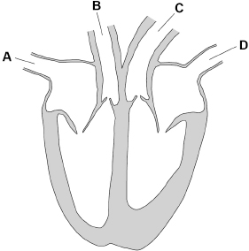
(a) Which blood vessel transports blood with the highest oxygen concentration into the heart?
Tick (✓) one box.

A |  | B |  | C |  | D
(1)
(b) Blood pressure is a measure of the force of the blood against the walls of the blood vessels.
Which blood vessel transports blood at the highest pressure?
Tick (✓) one box.

A |  | B |  | C |  | D
(1)
(c) What is the correct order for blood flowing through the heart to the lungs?
Tick (✓) one box.

left atrium → left ventricle → pulmonary artery
left atrium → left ventricle → pulmonary vein
right atrium → right ventricle → pulmonary artery
right atrium → right ventricle → pulmonary vein
(1)
Every year thousands of people in the UK have heart attacks.
A heart attack is caused when the heart muscle cells do not get enough oxygen, causing the cells to die.
(d) Statins and stents are two treatments used to reduce the risk of someone having a heart attack.
Evaluate the use of statins compared with the use of a stent to reduce the risk of a heart attack.
___________________________________________________________________
___________________________________________________________________
___________________________________________________________________
___________________________________________________________________
___________________________________________________________________
___________________________________________________________________
___________________________________________________________________
___________________________________________________________________
___________________________________________________________________
___________________________________________________________________
___________________________________________________________________
___________________________________________________________________
(6)
(e) Many people who survive a heart attack get out of breath easily when they exercise gently.
Explain why heart attack survivors get out of breath easily.
___________________________________________________________________
___________________________________________________________________
___________________________________________________________________
___________________________________________________________________
___________________________________________________________________
___________________________________________________________________
___________________________________________________________________
___________________________________________________________________
(4)
Scientists have developed patches of beating heart cells to repair damaged heart tissue.
The patches are placed onto areas of the heart where cells have died. New cells grow to replace the dead cells.
The patches are made using a person’s own cells that are converted into stem cells.
(f) Explain why stem cells are used to make the patches.
___________________________________________________________________
___________________________________________________________________
___________________________________________________________________
___________________________________________________________________
(2)
(g) The scientists could have used human embryonic stem cells to make the patches.
Give two advantages of using stem cells made from the person’s own cells, rather than using embryonic stem cells.
1 ________________________________________________________________
___________________________________________________________________
2 ________________________________________________________________
___________________________________________________________________
(2)
(Total 17 marks)
Q11.
This question is about plant transport systems.
(a) Describe how water is transported from the soil to the atmosphere through a plant.
___________________________________________________________________
___________________________________________________________________
___________________________________________________________________
___________________________________________________________________
___________________________________________________________________
___________________________________________________________________
___________________________________________________________________
___________________________________________________________________
(4)
(b) Dissolved sugars are moved through a plant in phloem tissue.
What is the name of the process that moves dissolved sugars through phloem tissue?
___________________________________________________________________
(1)
Phloem tissue is made of sieve tube cells and companion cells.
The figure below shows a section of phloem tissue.
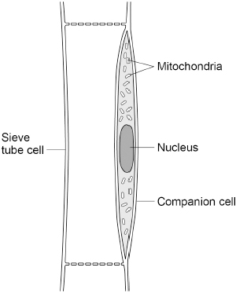
(c) Explain one way sieve tube cells are specialised for their function.
Use the figure above.
___________________________________________________________________
___________________________________________________________________
___________________________________________________________________
___________________________________________________________________
(2)
(d) What does the structure of the companion cells suggest about the process that moves dissolved sugars through the phloem tissue?
Give a reason for your answer.
Use the figure above.
___________________________________________________________________
___________________________________________________________________
___________________________________________________________________
___________________________________________________________________
(2)
(e) Describe why it is important that dissolved sugars are moved both upwards and downwards in a plant.
___________________________________________________________________
___________________________________________________________________
___________________________________________________________________
___________________________________________________________________
___________________________________________________________________
___________________________________________________________________
(3)
(Total 12 marks)
Q12.
A student investigated the effect of different concentrations of sugar solution on pieces of potato.
This is the method used.
1. Cut five pieces of potato.
2. Record the starting mass of each piece of potato.
3. Place each piece of potato in a different concentration of sugar solution.
4. After 24 hours remove the pieces of potato from the solutions.
5. Record the final mass of each piece of potato.
6. Calculate the change in mass for each piece of potato.
(a) What is the independent variable?
Tick (✓) one box.

Change in mass of the pieces of potato
Concentration of the sugar solution
Length of time the pieces of potato are in the solution
Starting mass of the pieces of potato
(1)
The table below shows the results.

Concentration of sugar solution in mol/dm³ | Mass of potato at start in grams | Mass of potato after 24 hours in grams | Change in mass in grams
0.0 | 7.94 | 10.14 | 2.20
0.1 | 7.95 | 9.10 | 1.15
0.2 | 7.96 | 8.21 | 0.25
0.3 | 7.93 | 7.53 | –0.40
0.4 | 7.93 | 7.18 | –0.75
0.5 | 7.95 | 7.00 | –0.95
(b) Explain why the potato in 0.0 mol/dm³ sugar solution increased in mass.
___________________________________________________________________
___________________________________________________________________
___________________________________________________________________
___________________________________________________________________
(2)
(c) Complete the graph below.
Some of the results have been plotted for you.
You should:
• plot the data from table above
• draw a line of best fit through all the points.
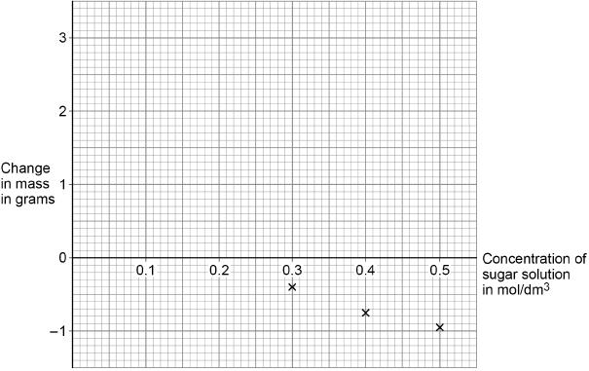
(2)
(d) The mass of a piece of potato does not change when:
concentration of solution inside cells = concentration of solution outside cells
Determine the concentration of sugar solution inside the potato cells.
Use the graph above.
Concentration = _______________ mol/dm³
(1)
The table is repeated below.

Concentration of sugar solution in mol/dm³ | Mass of potato at start in grams | Mass of potato after 24 hours in grams | Change in mass in grams
0.0 | 7.94 | 10.14 | 2.20
0.1 | 7.95 | 9.10 | 1.15
0.2 | 7.96 | 8.21 | 0.25
0.3 | 7.93 | 7.53 | –0.40
0.4 | 7.93 | 7.18 | –0.75
0.5 | 7.95 | 7.00 | –0.95
(e) Calculate the percentage change in mass for the potato in 0.2 mol/dm³ sugar solution.
Use table above.
Use the equation:
Give your answer to 3 significant figures.
___________________________________________________________________
___________________________________________________________________
___________________________________________________________________
___________________________________________________________________
___________________________________________________________________
Percentage change in mass (3 significant figures) = _______________ %
(3)
(Total 9 marks)
Q13.
Starch is digested to form sugar molecules in the digestive system.
(a) What is the name of the enzyme that digests starch?
___________________________________________________________________
(1)
(b) Where are most food molecules absorbed?
Tick (✓) one box.

Large intestine
Liver
Small intestine
Stomach
(1)
Figure 1 shows two villi.
Figure 1 also shows one cell on the surface of a villus as seen using an electron microscope.
Figure 1
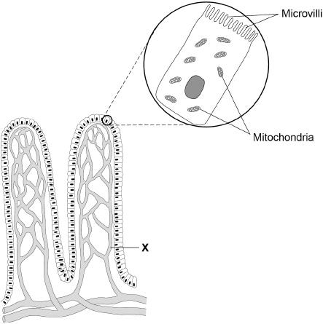
(c) Give one advantage of using an electron microscope compared with using a light microscope.
___________________________________________________________________
___________________________________________________________________
(1)
(d) What type of blood vessel is labelled X?
Tick (✓) one box.

Artery
Capillary
Vein
(1)
(e) The real length of one villus is 0.8 mm
Calculate the image length if the villus is viewed at a magnification of ×20
Use the equation:
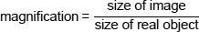
___________________________________________________________________
___________________________________________________________________
___________________________________________________________________
___________________________________________________________________
Image length = _______________ mm
(3)
Figure 2 shows two cells from the surface of a villus.
There are sugar molecules inside and next to each cell.
Figure 2
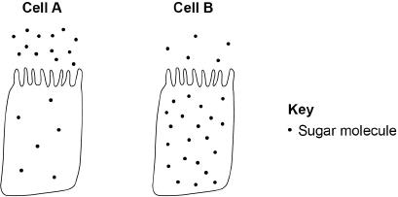
(f) Name the process by which sugar moves into cell A.
___________________________________________________________________
(1)
(g) Name the process by which sugar moves into cell B.
___________________________________________________________________
(1)
(h) Give one use of sugar in the body.
___________________________________________________________________
(1)
(i) Figure 1 is repeated below.
Figure 1
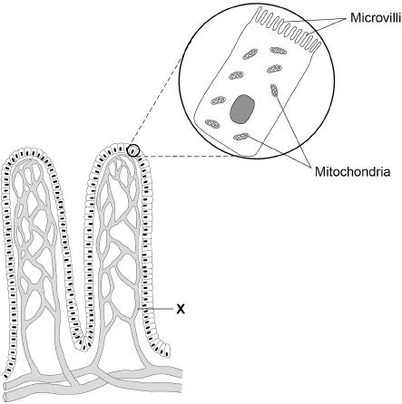
Explain how villi are adapted for efficient absorption of sugar molecules.
___________________________________________________________________
___________________________________________________________________
___________________________________________________________________
___________________________________________________________________
___________________________________________________________________
___________________________________________________________________
___________________________________________________________________
___________________________________________________________________
(4)
(Total 14 marks)
Q14.
Figure 1 shows a root hair viewed using a microscope.
Figure 1
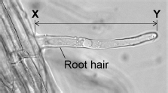
(a) The root hair was viewed at a magnification of ×50
The image length of the root hair X–Y is 43 mm
Calculate the real length of the root hair in micrometres (µm).
___________________________________________________________________
___________________________________________________________________
___________________________________________________________________
___________________________________________________________________
___________________________________________________________________
___________________________________________________________________
Real length = ___________________________ µm
(4)
(b) A microscope has a ×5 eyepiece lens.
Describe how to use this microscope to observe a prepared slide of root hair cells at a magnification of ×50
___________________________________________________________________
___________________________________________________________________
___________________________________________________________________
___________________________________________________________________
___________________________________________________________________
___________________________________________________________________
___________________________________________________________________
___________________________________________________________________
___________________________________________________________________
___________________________________________________________________
___________________________________________________________________
___________________________________________________________________
(4)
Root hair cells absorb water and mineral ions from the soil.
A scientist investigated the rate of nitrate ion uptake by two seedlings.
Figure 2 shows how the investigation was set up.
Figure 2
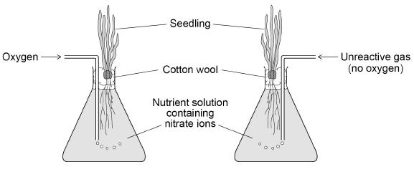
The scientist determined the mass of nitrate ions absorbed by each seedling every 30 minutes for 4 hours.
The table shows the results.

Time in hours | Total mass of nitrate ions absorbed by seedling in arbitrary units
Time in hours | With oxygen added | With no oxygen added
0 | 0 | 0
0.5 | 100 | 60
1.0 | 145 | 95
1.5 | 170 | 105
2.0 | 195 | 115
2.5 | 215 | 120
3.0 | 235 | 125
3.5 | 250 | 130
4.0 | 265 | 130
(c) Describe the changes in the rate of absorption of nitrate ions for the seedling with no oxygen added.
Use information from the table.
___________________________________________________________________
___________________________________________________________________
___________________________________________________________________
___________________________________________________________________
___________________________________________________________________
___________________________________________________________________
(3)
(d) Explain what the results in the table above show about how nitrate ions are absorbed.
___________________________________________________________________
___________________________________________________________________
___________________________________________________________________
___________________________________________________________________
___________________________________________________________________
___________________________________________________________________
___________________________________________________________________
___________________________________________________________________
(4)
(e) Nitrate ions are essential for plants to grow.
Describe how nitrate ions are used in a plant to help the plant grow.
___________________________________________________________________
___________________________________________________________________
___________________________________________________________________
___________________________________________________________________
___________________________________________________________________
___________________________________________________________________
(3)
(Total 18 marks)
Q15.
A student investigated the effect of different concentrations of sugar solution on pieces of potato.
This is the method used.
1. Cut three pieces of potato to the same length.
2. Dry each piece on a paper towel.
3. Weigh each piece.
4. Place each piece in a different concentration of sugar solution.
5. Leave all three pieces for 2 hours.
6. Remove the three pieces of potato from the solutions.
7. Dry each piece on a paper towel.
8. Measure the length and mass of each piece of potato.
Figure 1 shows how the investigation was set up.
Figure 1
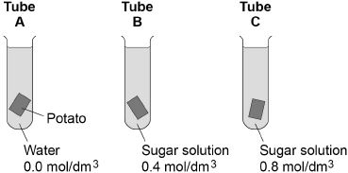
(a) Why did the student dry each piece of potato before weighing it?
___________________________________________________________________
___________________________________________________________________
(1)
(b) What two changes would you expect in the potato in tube A after 2 hours?
Tick two boxes.

Breaks into pieces
Decrease in hardness
Decrease in size
Increase in mass
Increase in length
(2)
(c) Complete the sentences.
Water moves into and out of cells by a process called ____________________ .
Water would move ____________________ the potato cells in tube A.
The solution outside the potato in tube A is at a ____________________
concentration than the solution inside the potato cells.
(3)
(d) The potato in tube B did not change.
Give one conclusion that can be made from this observation.
___________________________________________________________________
___________________________________________________________________
(1)
(e) Figure 2 shows the root of a germinating seed.
Figure 2
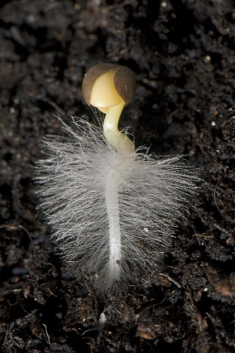
Describe two ways the root is adapted to absorb water efficiently.
1. _________________________________________________________________
___________________________________________________________________
2. _________________________________________________________________
___________________________________________________________________
(2)
(Total 9 marks)
Q16.
This question is about cell structures.
(a) Draw one line from each cell structure to the type of cell where the structure is found.

Cell Structure |  | Type of cell where the structure is found
Nucleus |  | Prokaryotic cells
Permanent vacuole |  | Plant cells only
Plasmid |  | Eukaryotic cells
(2)
(b) Figure 1 shows a plant cell.
Figure 1
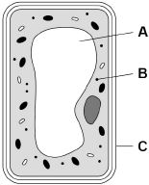
What are the names of structures A, B and C?
Tick one box.

Structure A | Structure B | Structure C
Chloroplast | Vacuole | Cell wall | 
Nucleus | Chloroplast | Cell membrane
Vacuole | Mitochondrion | Cell membrane
Vacuole | Ribosome | Cell wall
(1)
A student observed slides of onion cells using a microscope.
Figure 2 shows two of the slides the student observed.
Figure 2
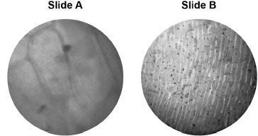
The cells on the slides are not clear to see.
(c) Describe how the student should adjust the microscope to see the cells on Slide A more clearly.
___________________________________________________________________
___________________________________________________________________
(1)
(d) Describe how the student should adjust the microscope to see the cells on Slide B more clearly.
___________________________________________________________________
___________________________________________________________________
___________________________________________________________________
(2)
(e) The student made the necessary adjustments to get a clear image.
Figure 3 shows the student’s drawing of one of the cells.
Figure 3
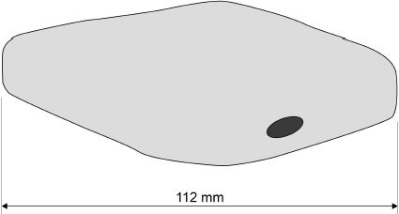
The real length of the cell was 280 micrometres (µm).
Calculate the magnification of the drawing.
___________________________________________________________________
___________________________________________________________________
___________________________________________________________________
___________________________________________________________________
___________________________________________________________________
Magnification = × _________________________
(3)
(Total 9 marks)

