  B1 and B2 PPQ
  Year 11 Revision
  Name: | ________________________
  Class: | ________________________
  Date: | ________________________

Time: | 79 minutes
Marks: | 74 marks
Comments:

Q1.
Describe how to test a sample of food for protein, starch and sugar.
Give the colours that would be seen if the food sample contained protein, starch and sugar.
___________________________________________________________________
___________________________________________________________________
___________________________________________________________________
___________________________________________________________________
___________________________________________________________________
___________________________________________________________________
___________________________________________________________________
___________________________________________________________________
___________________________________________________________________
___________________________________________________________________
___________________________________________________________________
___________________________________________________________________
(Total 6 marks)
Q2.
Proteins are an important part of the human diet.
(a) Proteins are large food molecules that must be broken down in the digestive system.
Which enzyme breaks down proteins?
Tick (✓) one box.

Carbohydrase | 
Lipase
Protease
(1)
Proteins are digested into amino acids.
The body breaks down unwanted amino acids.
(b) Which organ breaks down unwanted amino acids?
Tick (✓) one box.

Brain |  | Liver |  | Lung
(1)
(c) What is produced by the breakdown of unwanted amino acids?
Tick (✓) one box.

Fat |  | Starch |  | Urea
(1)
Mycoprotein is a protein made from a fungus.
The table below shows information about mycoprotein sausages and meat sausages.

Nutrient | Mass of nutrient in grams per 100 grams
Nutrient | Mycoprotein sausages | Meat sausages
Protein | 14.3 | 18.3
Carbohydrate | 4.5 | 0.0
Fat | 2.0 | 19.8
Salt | 0.9 | 1.1
(d) Give three differences between the nutrient content of mycoprotein sausages and meat sausages.
1 _________________________________________________________________
___________________________________________________________________
2 _________________________________________________________________
___________________________________________________________________
3 _________________________________________________________________
___________________________________________________________________
(3)
A student tested the mycoprotein sausage and the meat sausage for protein.
(e) What is used to test for protein?
Tick (✓) one box.

Biuret reagent
Iodine solution
pH indicator solution
(1)
(f) What colour is the positive result for the test for protein?
Tick (✓) one box.

Black
Lilac
Red
White
(1)
(g) The student investigated the sugar content of the mycoprotein sausage and the meat sausage.
The figure below shows some of the apparatus used.
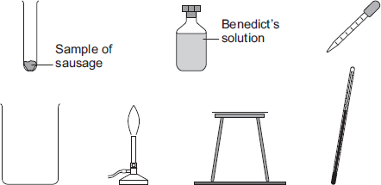
Describe a method to compare the amount of sugar in the two types of sausage.
Use the apparatus in the figure above in your answer.
___________________________________________________________________
___________________________________________________________________
___________________________________________________________________
___________________________________________________________________
___________________________________________________________________
___________________________________________________________________
___________________________________________________________________
___________________________________________________________________
___________________________________________________________________
___________________________________________________________________
___________________________________________________________________
___________________________________________________________________
(6)
(Total 14 marks)
Q3.
This question is about digestion.
(a) Name the enzyme that digests starch in the human digestive system.
___________________________________________________________________
(1)
A student set up a model to represent the digestion and absorption of food molecules in the digestive system.
The diagram shows the student’s model.
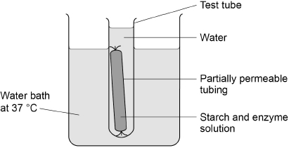
This is the method used.
1. Fill a test tube with water at 37 °C
2. Test the water for starch and for sugar.
3. Mix together starch and enzyme solution and immediately test it for starch and for sugar.
4. Fill some partially permeable tubing with the starch and enzyme mixture.
5. Seal the tubing and place it in the test tube of water.
6. Place the test tube in a water bath at 37 °C
7. After 30 minutes, test the mixture inside the partially permeable tubing and test the water in the test tube for starch and for sugar.
(b) Suggest which parts of the body the partially permeable tubing and the water in the test tube represent.
Partially permeable tubing ____________________________________________
Water in the test tube ________________________________________________
(2)
The table below shows the results.

Test | Description of liquid | Result of starch test | Result of sugar test
1 | Mixture inside tubing at start | ✓ | ✘
2 | Water in the test tube at start | ✘ | ✘
3 | Mixture inside tubing after 30 minutes | ✓ | ✓
4 | Water in the test tube after 30 minutes | ✘ | ✓
Key
✓ = Present
✘ = Not present
(c) Name the reagents used to test for starch and for sugar.
Starch _____________________________________________________________
Sugar _____________________________________________________________
(2)
(d) Why was there no sugar present in test 1?
___________________________________________________________________
___________________________________________________________________
(1)
(e) Explain the results for test 3.
___________________________________________________________________
___________________________________________________________________
___________________________________________________________________
___________________________________________________________________
___________________________________________________________________
(2)
(f) Explain the results for test 4.
___________________________________________________________________
___________________________________________________________________
___________________________________________________________________
___________________________________________________________________
___________________________________________________________________
___________________________________________________________________
(2)
(Total 10 marks)
Q4.
Foods are digested before they are absorbed into the blood.
The diagram below shows organs in the human digestive system.
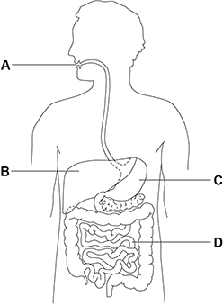
(a) Which organ is the stomach?
Tick (✓) one box.

A |  | B |  | C |  | D
(1)
(b) What type of enzyme is produced in the stomach?
Tick (✓) one box.

Carbohydrase
Lipase
Protease
(1)
(c) Which term describes the pH in the stomach?
Give one reason why the stomach is this pH.
Tick (✓) one box.

Acidic
Alkaline
Neutral
Reason ____________________________________________________________
___________________________________________________________________
(2)
(d) Which organ produces bile?
Tick (✓) one box.

Large intestine
Liver
Mouth
Pancreas
(1)
(e) How does bile help in the digestion of foods?
Tick (✓) one box.

It increases the surface area of fats.
It is an enzyme that digests protein.
It makes the pH in the small intestine acidic.
(1)
A student tested different foods for the presence of protein, starch and sugar.
(f) Draw one line from each food molecule to the reagent used to test for the food molecule.

Food molecule |  | Reagent
Protein |  | Benedict’s solution
Starch |  | Biuret reagent
Sugar |  | Iodine solution
(2)
(g) Give one safety precaution a student should take when using Benedict’s solution.
___________________________________________________________________
___________________________________________________________________
(1)
(h) The table below shows the results for one food sample.

Test | Benedict’s test | Biuret test | Iodine test
Colour after test | Red | Blue | Black
Which of the tests show positive results?
Tick (✓) one box.

All three tests
Benedict’s and Biuret tests only
Benedict’s and iodine tests only
Biuret and iodine tests only
(1)
(i) Starch molecules are not absorbed into the blood from the digestive system.
Give one reason why.
___________________________________________________________________
___________________________________________________________________
(1)
(Total 11 marks)
Q5.
Exercise can improve health.
A student measured her breathing rate at rest, when walking and when jogging.
Figure 1 shows her results.
Figure 1
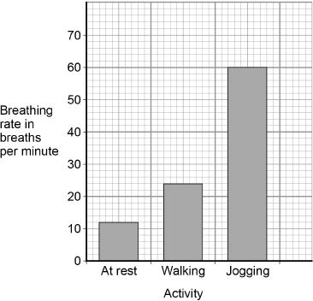
(a) Compare the breathing rates when doing the three different activities.
Use values from Figure 1 in your answer.
___________________________________________________________________
___________________________________________________________________
___________________________________________________________________
___________________________________________________________________
___________________________________________________________________
___________________________________________________________________
(3)
(b) Explain why the breathing rate changes when doing different activities.
___________________________________________________________________
___________________________________________________________________
___________________________________________________________________
___________________________________________________________________
___________________________________________________________________
___________________________________________________________________
(3)
Figure 2 shows the heart in the circulatory system.
Figure 2
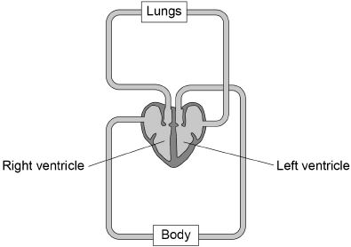
(c) The heart is a double pump.
Describe what this means.
Use Figure 2 to help you.
___________________________________________________________________
___________________________________________________________________
___________________________________________________________________
___________________________________________________________________
(2)
(d) The wall of the left ventricle is much thicker than the wall of the right ventricle.
Suggest one reason for this.
___________________________________________________________________
___________________________________________________________________
___________________________________________________________________
(1)
(e) People are encouraged to exercise after recovering from a heart attack.
Suggest one reason why.
___________________________________________________________________
___________________________________________________________________
(1)
(Total 10 marks)
Q6.
Figure 1 shows part of the lungs.
Figure 1
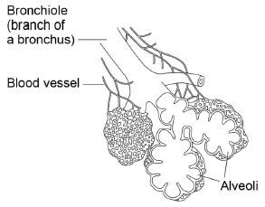
(a) Give two ways the lungs are adapted for efficient exchange of gases.
Describe how each adaptation helps to maintain efficient gas exchange.
Adaptation 1 ________________________________________________________
___________________________________________________________________
Description _________________________________________________________
___________________________________________________________________
Adaptation 2 ________________________________________________________
___________________________________________________________________
Description _________________________________________________________
___________________________________________________________________
(4)
(b) There are 5.4 million people with asthma in the UK.
What type of disease is asthma?
Tick one box.

An allergy | 
A bacterial infection
A cancer
A viral infection
(1)
(c) Figure 2 shows cross-sections of bronchioles of two people.
Figure 2
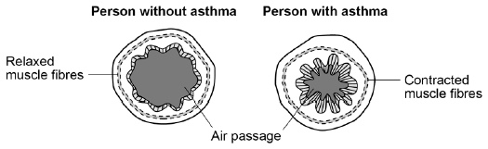
Suggest why people with asthma often find it difficult to breathe.
___________________________________________________________________
___________________________________________________________________
(1)
(d) People with asthma often have a reduced lung volume.
Figure 3 shows the apparatus a student used to measure his lung volume.
Figure 3
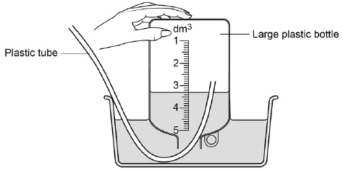
This is the method used.
1 Fill the bottle with water.
2 Breathe out through the tube.
The volume of water pushed out of the bottle is equal to his lung volume.
What is the student’s lung volume?
Volume = ____________________ dm³
(1)
Scientists tested a new drug to treat asthma.
The scientists measured the lung volume of:
• volunteers without asthma
• some volunteers during a mild asthma attack
• other volunteers during a severe asthma attack.
Half the people in each group were given a placebo.
The other half of the people in each group were given the new drug.
The tests were carried out as a double blind trial.
(e) What is a placebo?
___________________________________________________________________
___________________________________________________________________
(1)
(f) Who knows which volunteers in a double blind trial are given the drug and which volunteers are given the placebo?
Tick one box.

The scientists but not the volunteers
The scientists and the volunteers
The volunteers but not the scientists
Neither the volunteers nor the scientists
(1)
(g) Suggest why it is a good idea that double blind trials should be used in drug testing?
___________________________________________________________________
___________________________________________________________________
(1)
(h) Figure 4 shows the results of the drug tests.
Figure 4
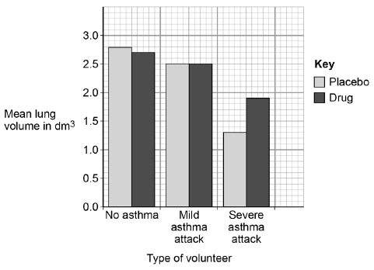
Give two conclusions that can be made about the usefulness of the drug.
1. _________________________________________________________________
___________________________________________________________________
2. _________________________________________________________________
___________________________________________________________________
(2)
(Total 12 marks)
Q7.
Gas exchange takes place in the lungs.
The diagram shows an alveolus next to a blood capillary in a lung.
The arrows show the movement of two gases, A and B.
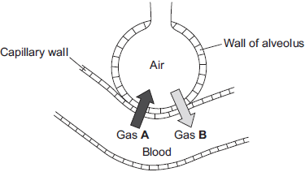
(a) (i) Draw a ring around the correct answer to complete the sentence.

Gases A and B move by | diffusion.  osmosis.  respiration.
(1)
(ii) Gas A moves from the blood to the air in the lungs.
Gas A is then breathed out.
Name Gas A.
______________________________________________________________
(1)
(iii) Which cells in the blood carry Gas B?
Draw a ring around the correct answer.
platelets red blood cells white blood cells
(1)
(b) The average number of alveoli in each human lung is 280 million.
The average surface area of 1 million alveoli is 0.25 m².
Calculate the total surface area of a human lung.
___________________________________________________________________
Answer ___________________________________ m²
(2)
(c) An athlete trains to run a marathon. The surface area of each of the athlete’s lungs has increased to 80 m².
Give one way in which this increase will help the athlete.
___________________________________________________________________
___________________________________________________________________
(1)
(Total 6 marks)
Q8.
The table shows the composition of blood entering and leaving the lungs.

Gas | Concentration in arbitrary units
 | Blood entering lungs | Blood leaving lungs
Oxygen | 40 | 100
Carbon dioxide | 46 | 40
(a) Describe, in as much detail as you can, the changes that take place in the composition of blood as it passes through the lungs.
___________________________________________________________________
___________________________________________________________________
___________________________________________________________________
___________________________________________________________________
___________________________________________________________________
___________________________________________________________________
(3)
(b) Which part of the blood:
(i) transports most carbon dioxide; __________________________________
(ii) transports most oxygen? ________________________________________
(2)
(Total 5 marks)

