1. **Changes of State – States of matter**
2. What are the three types of strong chemical bond?
3. What particles are found in:
   1. Ionic bonding
   2. Covalent bonding
   3. Metallic bonding?
4. Which type of bonds occurs when metals combine with non-metals?
5. What type of bonding occurs in carbon dioxide? Why?
6. What type of bonding occurs in alloys?
7. What happens to the electrons in ionic bonding?

5. What is the link between the charge number on the ions in groups 1, 2 and 3 and their group number ?

1. What is the link between the charge number on the ions in Groups 1, 2, 6 and 7 and their group?
2. What is an ionic compound?
3. How are ionic compounds held together?
4. Why is the ball and stick model not an accurate representation of the structure of an ionic compound?
5. Draw a diagram to show how potassium and chlorine atoms join together to form ions.
6. Explain how you can use the following model of sodium chloride to work out the empirical formula.

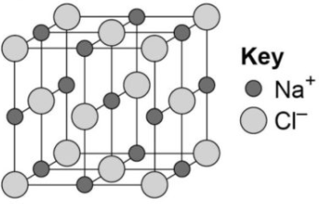

1. **Bonding part 2 – Covalent bonding, metallic bonding**
2. What How are strong covalent bonds formed?
3. What are the three types of structure that can be formed by covalent bonding?
4. What are polymers an example of?
5. What type of structure do the following covalently bonded substances have?
6. Water H2O
7. Silicon dioxide SO2
8. Diamond C
9. 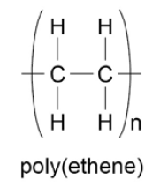Poly(ethene)
10. What are the limitations of using dot and cross diagrams to represent covalent bonds?
11. How are atoms arranged in a metal?
12. Why are metallic bonds so strong?
13. What is the formula of the following model?

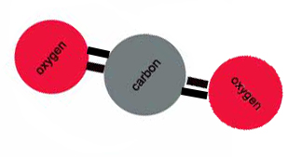

1. Draw a dot and cross diagram for water.
2. Describe the arrangement of particles in a metal.
3. Why are the particles that make up a metal described as positively charged?
4. What are delocalised electrons?
5. **Properties of substances part 1 – states of matter, state symbols**
6. What are the three states of matter?
7. What is used to represent particles in the simple particle model?
8. What takes place at the melting point?
9. What takes place at the boiling point?
10. What factor affects the amount of energy needed to change state?
11. In chemical equations what symbols are used to show the states of matter?
12. In what state of matter do particles have the most energy?
13. What would eventually happen to a gas if pressure is increased?
14. HT ONLY: Explain the limitations of the particle model.
15. The following represents the heating of ice:
    1. What change in state happens at stage 2?
    2. What change in state happens at stage 4?

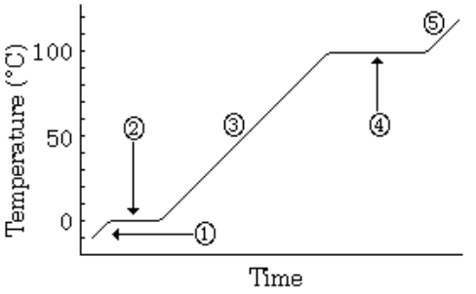

1. **Properties of substances part 2 – Ionic compounds, small molecules, polymers, giant covalent structures, metals and alloys**
2. Describe the structure of ionic compounds.
3. Why do ionic compounds have high melting and boiling points?
4. Why can ionic compounds conduct electricity when melted or dissolved in water?
5. What state of matter are small molecules normally found in?
6. Why do small molecules have low melting and boiling points?
7. What happens to the melting and boiling points as small molecules get bigger? Why?
8. Why don’t small molecules conduct electricity?
9. What are polymers?
10. How are the atoms in a polymer linked together?
11. Why are polymers normally solid at room temperature?
12. Give an example of a giant covalent structure.
13. Why do giant covalent structures have very high melting and boiling points?
14. Why do most metals have high melting and boiling points?
15. How are atoms arranged in pure metals?
16. What is an alloy?
17. Why do we use alloys, rather than pure metals, for many uses?
18. Why are metals good conductors of electricity?
19. What is thermal energy?
20. Why are metals good conductors of thermal energy?
21. **Properties of substances part 3 – Diamond, graphite, graphene and fullerenes**
22. In a diamond, how many covalent bonds does each carbon make?
23. Diamond does not conduct electricity. Why?
24. Name 2 other properties of diamond.
25. In graphite, how many covalent bonds does each carbon make?
26. Describe the structure of graphite.
27. Why is graphite soft?
28. Why does graphite conduct electricity?
29. How is graphite similar to metals?
30. What is graphene?
31. What are fullerenes?
32. What was the first fullerene to be discovered?
33. What are carbon nanotubes?
34. What are carbon nanotubes useful for?
35. **Nanoparticles (Chemistry ONLY) – Size of particles and their properties, uses of nanoparticles**
36. What does nanoscience refer to?
37. What are nanoparticles?
38. What are coarse particles?
39. Why do nanoparticles have different properties from those for the same materials in bulk?
40. Name 5 uses of nanoparticles.