1. **Changes of State – States of matter**

1. Explain why different substances have different melting points. (2)

***strength of attractive forces between particles varies in different substances, [1] stronger forces of attraction → higher melting points [1]***

1. Describe the general properties of solids, liquids and gases, including the arrangement and movement of particles. (4)

***SOLID: fixed shape, incompressible, touching particles, regular pattern, vibrate on the spot***

***LIQUID: no fixed shape, very difficult to compress, most particles are touching, irregular and random arrangement, particles slip and slide over each other***

***GAS: no fixed shape, spreads out to fill a container, easily compressed, particles cover large distances, irregular pattern, move very quickly, move randomly***

***1 mark– correct arrangement***

***1 mark – correct movement***

***2 marks – any other correct statements***

1. **Extended response question:**

Describe what happens to particles during changes of state, as a gas is cooled down to a temperature below its freezing point. (6)

* ***Level 3 (5-6 marks)***

***explanation of two changes of state using both particle arrangement and movement***

* ***Level 2 (3-4 marks)***

***explanation of one change of state using both particle arrangement and movement OR two changes of state using either particle arrangement OR movement***

* ***Level 1 (1-2 marks)***

***explanation of one change of state using either particle arrangement OR movement***

***Chemistry points:***

* ***as particles cool, average speed decreases***
* ***particles become much closer together at condensation point,***
* ***form liquid where particles move randomly, slipping over and around each other.***
* ***As liquid cools average speed of particles decreases***
* ***at freezing point particles remain in fixed positions,***
* ***vibrating,***
* ***vibrations decrease as solid cools.***

1. Evaporation is the change of state that occurs when some liquid changes into a gas. Many factors can affect the rate of evaporation. Plan an investigation into one factor that might affect the rate of evaporation using wet cotton wool and a high resolution digital balance. (5)

***Varying one factor, [1] e.g. temperature of water or surface area of paper towel, keeping all other variables constant, [1] monitor rate of evaporation by measuring mass of wet paper towel [1] on electric balance at regular time intervals [1] then calculate the difference/loss of mass from the paper towel [1]***

1. **Ionic Bonding part 1 – Joining of atoms and Ionic compounds**

1. Explain the charges on the following ions:

1. Na+

***Sodium has lost one electron***

1. O2-

***Oxygen has gained two electrons***

2. Sodium chloride NaCl and sodium oxide has ionic bonds.

1. Draw dot and cross diagrams to show what happens to sodium and chlorine atoms when they react to form sodium chloride. You only need to show the outer electrons in your diagrams. (3)

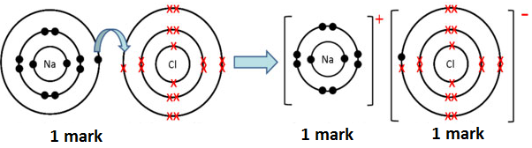

1. Draw dot and cross diagrams to show what happens to sodium and oxygen atoms when they react to form sodium oxide. (3)

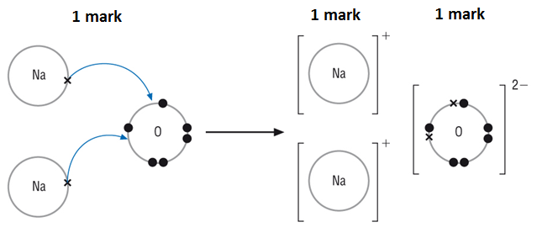

3. What is the chemical formula for:

1. Calcium oxide (1)

***CaO***

1. Magnesium fluoride (1)

***MgF2***

1. Aluminum oxide (1)

***Al2O3***

**C.** **Ionic Bonding part 2 – Properties of ionic compounds**

1. Explain why ionic compounds have high melting points and boiling points. (2)

***Ionic bonds are very strong (1) a lot of energy is needed to break them (1)***

2. Why can ionic compounds conduct electricity when they are molten or dissolved in water? (1)

***Only conduct electricity if their ions are free to move such as when dissolved in water or melted (1)***

3. Why is seawater a better conductor of electricity than freshwater? (1)

***higher concentration of ions from dissolved salts in seawater than in freshwater [1]***

**D.** **Covalent Bonding part 1 – Joining of atoms and small molecules**

1. Draw a diagram to represent the covalent bonding between two chlorine atoms. (2)

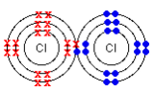

***1 mark – correct number of electrons in outer shell***

***1 mark – one pair of shared electrons***

***(Accept diagram with outer shell only drawn)***

1. The melting point of ammonia, NH3, is -78°C and its boiling point is 33°C. What state is ammonia at 20°C? (1)

***Gas (1)***

1. Why don’t simple molecular substances conduct electricity? (1)

***There is no overall charge (1)***

1. Nitrogen gas has a very strong triple covalent bond holding the atoms together. Explain why nitrogen has a boiling point of -196°C. (2)

***molecules / weak intermolecular forces between N2 molecules, [1] so molecules easily separated from each other [1]***

1. Describe what is meant by intermolecular forces. (1)

***The attraction between the individual molecules in a covalently bonded structure (1)***

**E.** **Covalent Bonding part 2 – Giant structures**

1. Graphite is sometimes used to reduce the friction between two surfaces that rub together. Explain how it does this. (2)

***Graphite is made up of layers of carbon atoms, which can easily slide over each other (1). This means that graphite is slippery (1), making it a good lubricant.***

1. **Extended response question:**

Describe how the structures of diamond and graphite are similar and explain why graphite can conduct electricity, but diamond cannot. (6)

* ***Level 3 (5-6 marks)***
* ***Describes the similarities in the structures, why diamond cannot conduct electricity and why graphite can .***
* ***Level 2 (3-4 marks)***

***L2 Describes the similarities in the structures AND why diamond cannot conduct electricity OR Describes the similarities in the structures AND why graphite can conduct electricity OR Describes why diamond cannot conduct electricity AND why graphite can.***

***Level 1 (1-2 marks)***

***Describes the similarities in the structure OR, why diamond cannot conduct electricity OR why graphite can.***

***Chemistry points:***

***Similarities – giant structures/carbon atoms/covalent bonds***

***Graphite:***

***hexagons of C atoms arranged in layers,***

***each C atom forming three strong covalent bonds to its nearest neighbours,***

***as C atoms have 4 electrons in outer shell, this leaves one free outer electron on each,***

***free electrons drift freely along layers, enabling graphite to conduct electricity***

***Diamond:***

***all outer shell electrons involved in covalent bonding,***

***no free electrons carry electrical charge***

1. State which properties of graphene make it useful in the manufacture of bullet-proof vests. (2)

***flexibility [1] strength [1]***

1. Explain why Graphene is such a good conductor of electricity (5)

***Atoms in each layer of graphene arranged in hexagons, [1] each C atom only forms three strong covalent bonds, [1] leaving one spare outer electron on each C atom [1] free to move along layer of C atoms, [1] these mobile delocalised electrons can drift along the layer conducting electricity [1]***

1. Ethene C2H4 can be polymerised to Poly(ethene).

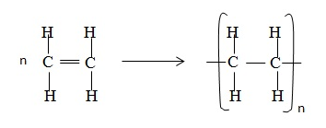

1. Explain in terms of its structure why ethene is a gas at room temperature. (2)

***Simple molecules/small molecules/weak intermolecular forces/weak attraction between molecules/little energy needed to break them (1) and therefore has a low boiling point (1)***

1. Explain in terms of its structure why poly(ethene) is a polymer. (2)

***Long chained molecule (1) made from smaller repeating units (1)***

1. Explain why poly(ethene) has a high melting point. (1)

***A lot of energy is needed to break the many bonds (in the long-chained molecule) (1)***

**F.** **Metallic Bonding part 1 – Joining of atoms**

1. This diagram shows a model of metallic bonding:

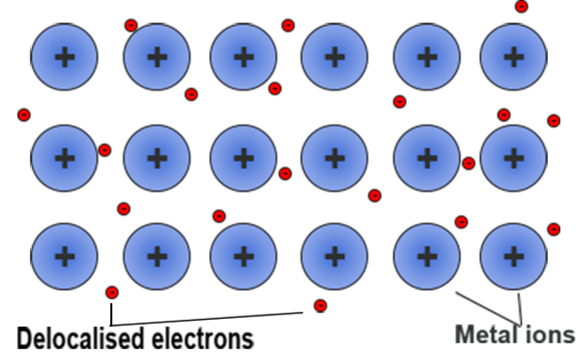

1. Why are the particles that makeup a metal described as positively charged ions? (2)

***Because metal atoms lose outer shell electrons [1] more protons (+) than electrons (−) [1]***

1. What are delocalised electrons? (2)

***Free-moving electrons within structure, [1] not associated with a particular atom [1]***

1. Explain the bonding in a metal using the theory of metallic bonding (4)

***Electrons in metals outer shell, [1] donated into ‘sea’ of free-moving delocalised electrons, [1] electrostatic attraction [1] of negatively charged delocalised electrons for metals ions bonds***

***ions in giant metallic lattice [1]***

**G.** **Metallic Bonding part 2 – Properties of metals and alloys**

1. Copper can be hammered into shape. The structure of copper metal can be represented by the following diagram:

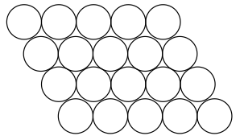

1. Explain why copper can be hammered into shape. (1)

***Layers of atoms can slide/move over each other***

1. Copper can be mixed with zinc to make the alloy brass. Brass is much harder than copper. Explain why. (2)

***Zinc atoms are a different size from copper atoms (1) and they disrupt the structure/making it more difficult to slide/move (1)***

1. **Extended response question:**

Copper is a good metal for making a kettle because it has a high melting point. Explain why copper has a high melting point. You should describe the structure and bonding of a metal in your answer.

* ***Level 3 (5-6 marks)***

***Clear and detailed scientific description of why copper has a high melting point including details of the structure and bonding in a metal.***

* ***Level 2 (3-4 marks)***

***A scientific description of why copper has a high melting point with some detail of the structure and bonding of metals.***

* ***Level 1 (1-2 marks)***

***A brief description of the structure of a metal and why it has a high melting point.***

***Chemistry points:***

* ***Giant structure/lattice/atoms arranged in a regular pattern or in layers***
* ***Sea of electrons or delocalised electrons or free electrons***
* ***Awareness that outer electrons are involved***
* ***Positive ions***
* ***Electrostatic attraction/bond between electrons and positive ions***
* ***Bond/attraction between atoms/ions/electrons are strong***
* ***A lot of energy/heat is needed to break the bonds/attractions***

1. Explain why magnesium sulfide has melting point of 2000°C, whereas sodium chloride has one of 801°C. (3)

***The elements that make up the compounds are in the same period [1] the charges on M and S are twice those on Na and Cl [1] and this gives them approximately twice the melting point [1]***

**H.** **Nanoparticles – Chemistry only**

1. How many nanometres make up 1 millimetre? (1)

***1000000***

2. What is a nanoparticle? (1)

***Structures that are 1–100 nm in size***

3. Explain why nanoparticles would make very efficient catalysts. (2)

***Nanoparticles may have properties different from those for the same materials in bulk because of their high surface area to volume ratio (1) which means they are often able to react very quickly (1)***

4. Describe one social and one economic benefit of nanoscience. (2)

***Social benefits: Nanoscience brings us useful products such as new drug delivery systems, better sports equipment, invisible sunblock creams.***

***Economic benefits: Nanoscience brings financial gain to the companies that make useful products from substances made up of nanoparticles.***

***1 mark for social benefit and 1 mark for economic benefit***