[AQA GCSE Geography Paper 3 Warm Up (2023) | 3A - The Pre-release - YouTube](https://www.youtube.com/watch?v=jiJyUDcdlkY)

[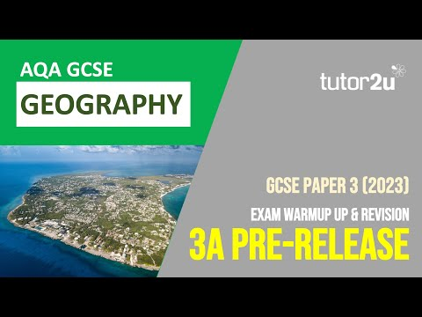](https://www.youtube.com/watch?v=jiJyUDcdlkY)

[AQA GCSE Geography 2022 | Warmup for Paper 3 | Unfamiliar Fieldwork - YouTube](https://www.youtube.com/watch?v=qsjA_Z1rmwk)

[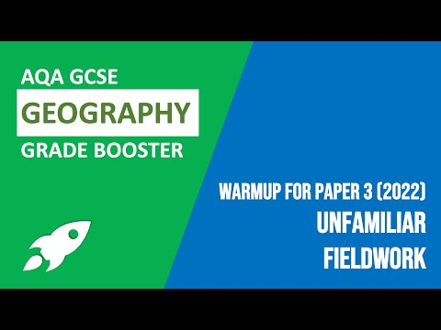](https://www.youtube.com/watch?v=qsjA_Z1rmwk)

**THIS ONE IS FOR 2022 BUT THE QUESTIONS IN THIS SECTION WILL BE THE SAME**