Q1.
Assess the importance of inaccessibility and extreme temperatures as challenges to development in one of the following environments.
Hot desert environment Cold environment
Use a case study and your own understanding.
Tick ✓ the box to show which environment you have chosen.

Hot desert environment | 
Cold environment
(Total 6 marks)
Q2.
Study Figure 1, information about the climate and vegetation of tropical rainforests.
Figure 1
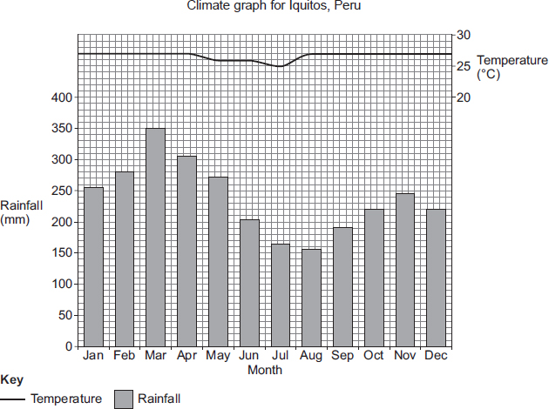
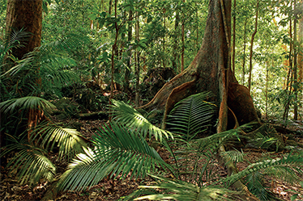
Suggest how plants are adapted to the climate in tropical rainforests.
Use Figure 1 and your own understanding.
(Total 6 marks)
Q3.
Study the photograph showing part of the tropical rainforest in Central Africa.
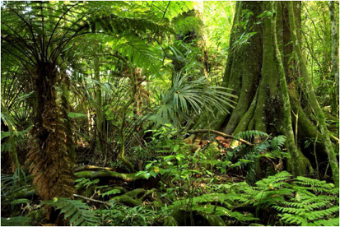
Describe and explain the features of the vegetation shown in the photograph.
(Total 6 marks)
Q4.
Study the diagram showing the nutrient cycle.
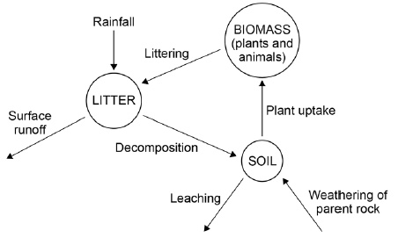
Explain why the diagram shown is an example of nature’s recycling system.
(Total 6 marks)
Q5.
Study the information below about Carajás mine in Brazil, South America.
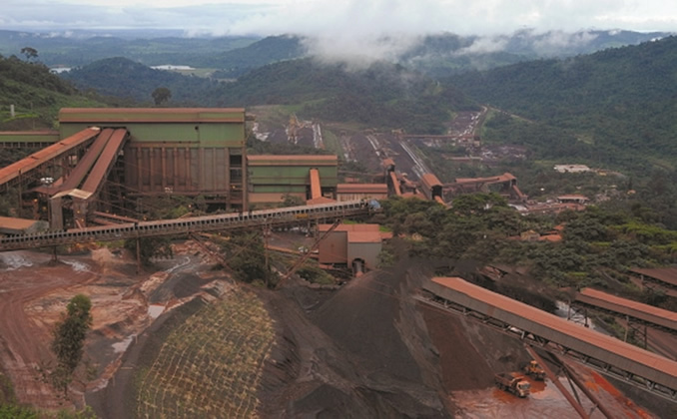
Factfile
Carajás Mine
• Largest iron ore mine in the world.
• Area is estimated to contain over 6.5 billion tonnes of iron ore.
• Over 100 million tonnes iron ore mined each year, with much exported to Asia.
• Gold, manganese, copper, bauxite and nickel mined in smaller mines.
• Powered by Tucuruí hydro-electric power station.
• 900 km railway link built to the coast.
• Recent development of a new iron-ore mine to the south.
• Local Indians now unable to carry on their traditional farming.
• Many local Indians have died because of imported diseases such as measles.
• Some drinking water polluted by mercury, affecting the health of the local farmers.
Using the information and your own understanding, explain how deforestation can have economic impacts.
(Total 6 marks)
Q6.
The information below shows strategies used to balance the needs of economic development and conservation in cold environments.

Wildlife conservation |  | Water pipes raised above the ground in Svalbard
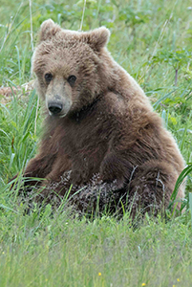 | The Alaskan Wildlife Conservation Centre (AWCC) is dedicated to preserving Alaska’s wildlife through research, education, conservation and animal care. | 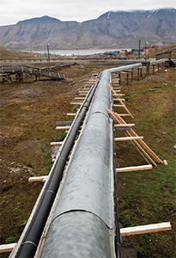
Suggest how different strategies are used to reduce environmental damage in a cold environment.
Use the information above and your own understanding.
(Total 6 marks)
Q7.
Study the two photographs below showing different parts of a tropical rainforest.
Figure 1
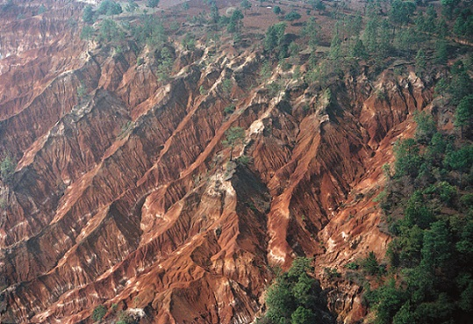
Figure 2
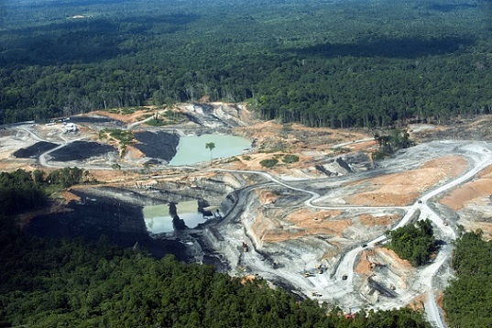
Using the two photographs and your own understanding, explain how development in tropical rainforests creates economic advantages but at a cost to the environment.
(6)
Q8.
Study the information in the Notes, ‘Deforestation of tropical rainforests’.
‘Some activities in areas of tropical rainforests are more damaging than others.’
To what extent do you agree with this statement?
(Total 6 marks)
Q9.
Study the information in the Notes, ‘Tropical rainforests’.
‘Tropical rainforests are important at both the local and global scales.’
Discuss this statement.
(Total 6 marks)
Q10.
Study either Figure 1 or Figure 2.
Figure 1 (plants and animals in a hot desert)
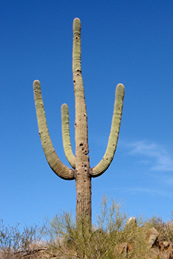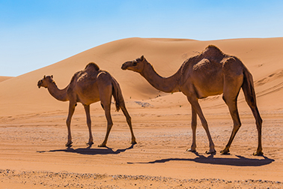
Figure 2 (plants and animals in a cold environment)
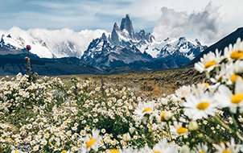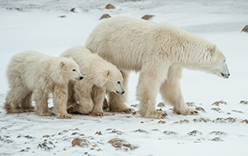
‘Plants and animals adapt in order to survive in a hostile environment.’
Explain this statement.
Use either Figure 1 or Figure 2 and your own understanding.
Tick (✓) the box to show which environment you have chosen.

Hot desert environment (Figure 1)
Cold environment (Figure 2)
(Total 6 marks)
Mark schemes
Q1.
Mark Scheme – Hot desert environment

Level | Marks | Description
3 (Detailed) | 5 – 6 | AO2 Demonstrates detailed understanding of challenges to development in hot deserts.  AO3 Demonstrates application of knowledge and understanding in a coherent and reasoned way in evaluating the importance of challenges to development in hot deserts.
2 (Clear) | 3 – 4 | AO2 Demonstrates clear understanding of challenge(s) to development in hot deserts.  AO3 Demonstrates reasonable application of knowledge and understanding in evaluating the importance of challenges to development in hot deserts.
1 (Basic) | 1 – 2 | AO2 Demonstrates limited understanding of challenge(s) to development in hot deserts.  AO3 Demonstrates limited application of knowledge and understanding in evaluating the importance of challenges to development in hot deserts.
 | 0 | No relevant content.
• Level 3 (detailed) responses will be well developed and make accurate use of geographical terms. Reasoned evaluation of challenges to development in hot deserts with clear case study support.
• Level 2 (clear) responses will have linked or elaborated statements and some accurate use of geographical terms. May start to make an evaluation of the importance of challenge(s) to development. May include some case study support.
• Level 1 (basic) responses are likely to consist of simple statements, with limited use of subject vocabulary. Might be limited to generic statements. May make a limited evaluation.
• If candidate writes about both environments, credit the more convincing answer for one environment only.
Indicative content - Hot desert environment
• The command “assess the importance” means that responses may state the degree to which one or more challenges affect economic development, with some support for the view expressed. e.g. the statement may be completely untrue, true to some extent (partly but not completely true), to a great extent, or completely true.
• Understanding of challenges to development:
Extreme temperatures. Due to the lack of cloud cover, daily temperatures can range from over 40 °C during the day to below freezing at night. Exposure to high temperatures can cause illness or death, and healthcare may be a long distance away.
Inaccessibility. Some hot deserts are huge – people and materials have to travel long distances, often by air, which is expensive. It’s difficult to provide services, e.g. medical care, to remote regions, making it hard for them to develop. Expensive pipelines have to be built to transport oil and gas from remote areas.
• Case study support e.g. Thar Desert. Extreme temperatures – temperatures in the Thar Desert can exceed 50°C in the summer months. It is hard for people to farm, work in mines or as tourist guides during these months as it is simply too hot. This makes development difficult.
• Inaccessibility – the desert covers a huge area of 200 000 sq km. Most of the desert is inaccessible due to the extreme environmental conditions and poor infrastructure. Beyond the city of Jaisalmer, development is limited. This has created a honeypot site for tourists in Jaisalmer but not beyond. Inaccessibility to many parts of the desert has led to greater differences between rich and poor.
• Evaluation should consider the importance of one or more factors in limiting development.
[6]
Q2.

Level | Marks | Description
3 (Detailed) | 5 – 6 | AO2 Shows thorough geographical understanding of ways that plants are adapted to the climate of tropical rainforests.  AO3 Demonstrates thorough application of knowledge and understanding in interpreting the characteristics shown in the photograph in relation to the climate of tropical rainforest environments.
2 (Clear) | 3 – 4 | AO2 Shows some geographical understanding of ways that plants are adapted to the climate of tropical rainforests.  AO3 Demonstrates reasonable application of knowledge and understanding in interpreting the characteristic(s) shown in the photograph in relation to the climate of tropical rainforest environments.
1 (Basic) | 1 – 2 | AO2 Shows limited geographical understanding of ways that plants are adapted to the climate of tropical rainforests.  AO3 May include limited application of knowledge and understanding in interpreting the characteristic(s) shown in the photograph in relation to the climate of tropical rainforest environments.
 | 0 | No relevant content.
• Level 3 (detailed) responses will be developed, with supporting evidence for answer. Appropriate use of Figure 1 (direct or inferred) and specific own understanding.
• Level 2 (clear) responses are likely to be linked statements with some elaboration. Some use of Figure 1 (direct or inferred) and own understanding.
• Level 1 (basic) responses are likely to consist of simple statements, with limited use of subject vocabulary. May consist of listed points, using information derived from Figure 1.
• Responses should refer to the photograph and information in the climate graph in Figure 1 (directly or inferred) to access Level 3.
• Credit is given at all levels for features of vegetation and their adaptation to climate beyond those shown in Figure 1.
Indicative content
• The command word ‘suggest’ is used, which means to provide an informed account of the ways plants adapt to the tropical rainforest climate illustrated in Figure 1. Interpretation of the characteristics of the vegetation as evidenced in Figure 1, eg the buttress roots of the trees, limited undergrowth, straight trunks, climbing plants or lianas, ferns, trees with different widths and heights, few branches.
• Interpretation of the climate of tropical rainforest environments as shown in Figure 1. The climate is much the same all year round and there are no seasons. The graph shows uniformly high monthly temperatures (28–29 °C). There is high to very high rainfall in every month, varying from a low of 150 mm in August to a high of 350 mm in March, with a total of over 2000 mm. There are two rainfall maxima (Nov and March), perhaps linked to the position of the overhead sun. The atmosphere is therefore hot and humid.
• Consistently high temperatures mean that plants grow all year, and will be competing for sunlight. High rainfall and high humidity encourage rapid growth of tall trees and fast rates of nutrient cycling.
• Because of the favourable climate, tropical rainforests have high levels of biodiversity. Around 50–60% of all plant species are indigenous to the rainforests. Two-thirds of all flowering plants can be found in rainforests.
• Plants drop their leaves gradually throughout the year, meaning they can go on growing all year round.
• Due to the high rainfall, leaves often have drip tips which allow the water to be channelled to the end and fall so the leaf does not break.
• Leaf stems are flexible to allow leaves to move with the sun.
• The bark on the trees is thin and smooth to allow free flow of water. Because of high temperatures, there is no need for protection against cold.
• The waxy upper surface of the leaves protects against the heat.
• Some plants, such as lianas, climb up the trees to reach sunlight for photosynthesis, while others live on branches in the canopy for the same reason ie epiphytes.
• Buttress roots support the trees as they grow very tall (over 50 m in some cases) as there is great competition for sunlight.
• The high humidity and plentiful rain of the rainforest enable some plants to actually grow without soil – called air plants or aerial plants. They get nutrients from plant debris and bird droppings that land on their roots and are not dependent on the poor soil of the forest.
• The forest floor receives only 2% of the sunlight. Only plants adapted to low light can grow in this layer apart from river banks, swamps and clearings, where dense undergrowth is found. Decaying plant and animal matter disappear quickly, because the warm, humid conditions promote rapid decay. Many types of fungi help to decay the plant waste.
• The understory includes mid-range trees and smaller plants. This area typically receives only about 5% of the sunlight in the area, because of the density of the overhead canopy. Even the largest plants in this area don’t typically grow over 3 m, and include shrubs, herbs and vines.
• The canopy is the highest level of the rainforest, consisting of branches and leaves of the area’s largest trees. Many trees reach over 40 metres and have dense foliage, so little to no sunlight reaches lower areas of the rainforest.
• Emergent trees can be found above the canopy. They are successful in maximising the greatest amount of sunlight but must endure high temperatures, lower humidity, and strong winds.
• Large evergreen trees typically dominate the sunlight of the rainforest canopy.
• Smaller orchids, bromeliads, and types of moss and lichen are also found in the canopy level, accessing sunlight and living in harmony with the larger trees.
AO2 – 3 marks
AO3 – 3 marks
[6]
Q3.

Level | Marks | Description
3  (Detailed) | 5–6 | AO3 Applies detailed knowledge of rainforest vegetation to interpret the features identified.  AO3 Clearly relates characteristic(s) shown in the photograph to the climate of tropical rainforest environments.
2  (Clear) | 3–4 | AO1 Demonstrates accurate knowledge of the features of vegetation and climate to support the explanation.  AO4 Makes clear and effective use of the photograph
1  (Basic) | 1–2 | AO1 Demonstrates limited knowledge of vegetation and climate in rainforest areas  AO4 Makes limited use of the photograph
 | 0 | No relevant content.
Indicative content
• Responses should include description and explanation. There should be clear evidence that the photograph has been used, e.g. the buttress roots of the trees, limited undergrowth, straight trunks. No credit for features not observed in the photograph.
• Due to the high rainfall, leaves often have drip tips which allow the water to be channelled to the end and fall so the leaf does not break. Leaf stems are also flexible to allow leaves to move with the sun.
• The bark on the trees is thin and smooth to allow free flow of water and because the high temperatures mean that there is no need for protection against cold.
• The waxy upper surface of the leaves protects against the heat.
• Some plants, such as lianas, climb up the trees to reach sunlight for photosynthesis, while others live on branches in the canopy for the same reason i.e. epiphytes.
• Buttress roots support the trees as they grow incredibly tall (over 50 m in some cases) as there is great competition for sunlight.
• Max level 1 for either description or explanation.
AO1 = 2
AO3 = 2
AO4 = 2
[6]
Q4.

Level | Marks | Description
3  (Detailed) | 5 – 6 | AO2 Shows thorough geographical understanding of the nutrient cycle as an example of recycling.  AO3 Demonstrates sound application of knowledge and understanding in a reasoned way in evaluating the nutrient cycle as a means of recycling.
2  (Clear) | 3 – 4 | AO2 Shows some geographical understanding of the nutrient cycle as an example of recycling.  AO3 Demonstrates some application of knowledge and understanding in evaluating the nutrient cycle as a means of recycling.
1  (Basic) | 1 – 2 | AO2 Shows limited geographical understanding of the nutrient cycle as an example of recycling.  AO3 Demonstrates limited application of knowledge and understanding and makes a simple evaluation of the nutrient cycle as a means of recycling.
 | 0 | No relevant content.
Indicative content
• Focus must be on the nutrient cycle as an example of recycling.
• Decomposers are responsible for the breakdown of organic material such as leaves, twigs and dead animals.
• Decomposers include bacteria and fungi and are vital in recycling nutrients.
• They convert dead matter into a form that can be re-used and chemicals /nutrients can be absorbed by the vegetation.
• At the higher levels expect students to show a greater understanding of the nutrient cycle as an example of recycling through an appreciation of links between elements.
• Use of biological terminology may be an indication of higher levels but is not a pre-requisite for higher levels.
AO2 = 3
AO3 = 3
[6]
Q5.

Level | Marks | Description
3  (Detailed) | 5 – 6 | AO2 Shows thorough geographical understanding of the economic impacts of deforestation  AO4 Detailed and relevant reference made to the information about economic impacts of deforestation shown in the figure.
2  (Clear) | 3 – 4 | AO2 Shows some geographical understanding of the economic impacts of deforestation  AO4 Clear and mainly relevant reference made to the information about economic impacts of deforestation shown in the figure.
1  (Basic) | 1 – 2 | AO2 Shows limited geographical understanding of the economic impacts of deforestation  AO4 Limited or partial reference made to the information about economic impacts of deforestation shown in the figure.
 | 0 | No relevant content.
Indicative content
• Level 3 responses will be detailed and well developed. Some use of the figure (direct or inferred) and specific own knowledge. Impacts can be positive and/or negative.
• Level 2 responses will be linked statements with some elaboration. Some use of the figure (direct or inferred) and own knowledge. Impacts can be positive and/or negative.
• Level 1 responses likely to consist of simple statements, with limited use of subject vocabulary. May only use information in the figure or own knowledge.
• The command word “explain” is used, which means to provide a reasoned account of how and why deforestation has economic impacts.
• Understanding of positive impacts. Deforestation is associated with some economic development. Development of land for mining, farming and energy will lead to jobs both directly (construction, farming) and indirectly (supply and support industries).
• Companies will pay taxes to the government which can be used to improve public services, such as education and water supply.
• Forest is cleared to make space for cattle grazing, from which large commercial companies can make profit.
• Improved transport infrastructure opens up new areas for industrial development and tourism. Products such as oil palm, soya and rubber provide raw materials for processing industries.
• Hydro-electric power provides cheap and plentiful energy, which can be used by all types of industry.
• Commercial logging companies and pulp processing / paper making can make sizable profits as a result of deforestation.
• Minerals such as gold and cobalt are very valuable, and earn large amounts of foreign exchange, as well as providing an industrial base.
• Impacts are more likely to be seen as positive but credit idea that damage to forests, rivers, and marine life through deforestation could significantly reduce the overall wealth of a country as resources are lost and habitats destroyed. Deforestation can rob a country of potential renewable revenues, replacing valuable productive lands with virtually useless scrub and grassland.
• Short-term economic exploitation through deforestation can be devastating to the long term, destroying valuable forest products and ecosystems. Plants that could bring huge medical benefits and high profits may become extinct. Ecotourism also suffers with deforestation, especially if forests are removed and rivers polluted.
• Livelihoods of some local people are destroyed. Deforestation can cause loss of animals and plants they rely on to make a living. Illegal logging causes billions of dollars of losses to national economies annually.
• Often the land is left ruined and many pollutants wash into rivers. Water quality is affected, shortages occur, with knock on effect on industry and wider economy.
• Use of the figure. The photograph indicates the large scale of operations, processing, huge structural works, many buildings, transport of iron ore. Indicates huge investment of money, considerable employment of workers, possibly large commercial returns.
• Use of fact file information. The Carajas scheme covers a vast area, and has a mix of economic activities. It is dominated by the massive iron ore mine, with some recent expansion nearby. Rail connection to coast ensures access to export markets. HEP generated locally, providing some employment and generating electricity for local industry. Major long-term reserves, likely to last for at least 70 years, ensuring continued economic development. Other minerals are exploited, likely to be exported abroad. Other economic activities may help to provide work and revenue. However the scheme affects the local economy, disrupting lives of Indian population, affecting their ability to work and carry out traditional lifestyles.
• Responses must refer to the figure (directly or inferred) to access Level 2 marks.
AO2 = 3
AO4 = 3
[6]
Q6.

Level | Marks | Description
3 (Detailed) | 5 – 6 | AO2 Shows thorough geographical understanding of how different strategies are used to reduce environmental damage in the cold environment.  AO3 Demonstrates thorough application of knowledge and understanding in evaluating the role of different management strategies in reducing environmental damage.
2 (Clear) | 3 – 4 | AO2 Shows some geographical understanding of how one or more strategies are used to reduce environmental damage in the cold environment.  AO3 Demonstrates reasonable application of knowledge and understanding in evaluating the role of one or more management strategies in reducing environmental damage.
1 (Basic) | 1 – 2 | AO2 Shows limited geographical understanding of how one or more strategies are used to reduce environmental damage in the cold environment.  AO3 May include limited application of knowledge and understanding in evaluating the role of one or more management strategies in reducing environmental damage.
 | 0 | No relevant content.
• Level 3 (detailed) will be developed responses with supporting evidence for answer. Appropriate use of the information (direct or inferred) and specific own understanding.
• Level 2 (clear) responses are likely to be linked statements with some elaboration. Some use of the information (direct or inferred) and own understanding.
• Level 1 (basic) responses will be simple statements with limited understanding or development. May consist of listed points, using information taken largely from the information.
Indicative content
• The command is ‘suggest’, so responses should provide detail about how different management strategies can work to reduce environmental damage in cold environments.
Cold environments
Understanding of management strategies for cold environments shown in the information provided..
• Hot water pipes/insulated utilidors (utility tunnels) raised above the ground so they do not melt or damage the permafrost.
• An extract about the role of the Alaskan Wildlife Conservation Centre which cares for orphaned and injured animals.
Other management strategies for cold environments include:
• Technological developments such as the Trans-Alaskan pipeline which is insulated to retain the heat of the oil and prevent melting of the permafrost, raised above the ground so wild animals can continue to migrate across the area and has special slides built in to allow movement during an earthquake.
• International agreements. An example is the Antarctic Treaty which has successfully protected Antarctica since it was signed in 1959. It states that Antarctica should only be used for peaceful purposes, it bans the disposal of nuclear waste, it ensures that tourism takes place sustainably and it promotes international cooperation.
• Conservation groups such as the WWF work with governments, communities and businesses to protect the biodiversity of cold environments. For example, the WWF Arctic Programme.
• Action by governments: the US government has sought to protect Alaska since oil was discovered in the 1960s. The Western Arctic reserve protects the north of Alaska from development whilst fisheries and marine habitats are protected by the National Oceanographic and Atmospheric Administration (NOAA).
Answers should make it clear how each strategy reduces environmental damage.
AO2 – 3 marks
AO3 – 3 marks
[6]
Q7.

Level | Marks | Description
3  (Detailed) | 5 – 6 | AO2 Shows thorough geographical understanding of the economic advantages and environmental costs of deforestation.  AO4 Relevant reference made to the information about economic advantages of deforestation and environmental costs shown in Figure 1 and 2.
2  (Clear) | 3 – 4 | AO2 Shows some geographical understanding of the economic advantages and / or environmental costs of deforestation.  AO4 Some reference made to the information about economic advantages of deforestation and / or environmental costs shown in Figure 1 and 2.
1  (Basic) | 1 – 2 | AO2 Shows limited geographical understanding of the economic advantages of deforestation and / or the environmental costs.  AO4 Limited or partial reference made to the information about economic advantages of deforestation and / or environmental costs shown in Figure 1 and 2.
 | 0 | No relevant content.
• Level 3 (detailed) responses will be developed. Some use of Figure 1 (direct or inferred) and specific own understanding.
• Level 2 (clear) responses are likely to be linked statements with some elaboration. Some use of Figure 1 and 2 (direct or inferred) and / or own understanding.
• Level 1 (basic) responses are likely to consist of simple statements, with limited use of subject vocabulary. May only use information in Figure 1 and 2 or own understanding.
Indicative content
• The command word “explain” is used, which means to provide a reasoned account of the economic advantages and environmental costs.
• Understanding of economic advantages.
E.g. Development of land for mining, farming and energy leads to jobs such as construction and farming.
Companies pay taxes; public services, such as education and water supply are improved.
Forest is cleared to make space for cattle grazing, so large companies can make profit.
Improved transport opens up new areas for industrial development and tourism. Products such as oil palm, soya and rubber provide raw materials for processing industries.
Hydro-electric power provides cheap energy, which can be used by all types of industry.
Commercial logging companies and paper making can make profits.
Minerals such as gold and cobalt are very valuable, and may support industry.
• Use of Figure 1 (1st photo) – indicating environmental damage. Image shows severe soil erosion which may be direct result of deforestation. There is still some forestry on the right but deep gullies have formed on the sloping land with water cutting into the surface, removing entire layers of soil, making the land unusable. Soils and other sediment have washed away into rivers. Likely cause is removal of forestry, possibly for grazing or cultivation-roots no longer able to hold soil in place, surface unprotected, exposed to heavy rain, leading to gully erosion.
• Credit understanding of environmental costs not shown in Figure 1 and 2.
E.g. The long term effect of economic development can be destruction of valuable forest products and ecosystems.
Plants (that could bring huge medical benefits and high profits) may become extinct.
Land may be left ruined and many pollutants wash into rivers.
Water quality is affected, shortages occur.
Local impact of climate change-disruption to water cycle, reduced evaporation; wider impact-increased CO₂ in atmosphere, temperature changes.
• Use of Figure 2 (2nd photo). The photograph indicates the large scale of mining operations (open cast, possibly coal), with forestry cover removed, exposed to wind and rain, some deeper terraced pits, roads built. Indicates huge investment of money, employment of workers, possibly large profits.
• Conclusion may emphasise that short-term economic benefits may lead to long-term environmental harm. However an overall conclusion is not essential to access maximum marks.
• Responses should refer to one or both photographs in Figure 1 and 2 (directly or inferred) to access Level 3.
• Max Level 2 for reference to economic advantages or environmental costs only.
AO2 = 3 marks
AO4 = 3 marks
[6]
Q8.

Level | Marks | Description
3  (Detailed) | 5 – 6 | AO3 – Demonstrates detailed evaluation of how different activities may have varying impacts on the rainforest environment.  AO4 – Communicates ideas with clarity and good use of geographical language.
2  (Clear) | 3 – 4 | AO3 – Demonstrates a clear evaluation of how different activities may have varying impacts on the rainforest environment.  AO4 – Communicates ideas effectively with some use of geographical language.
1  (Basic) | 1 – 2 | AO3 – Demonstrates a basic evaluation of how different activities may have varying impacts on the rainforest environment.  AO4 – Communicates ideas using basic language.
 | 0 | No relevant content.
“Activities” can be expressed in terms of;
– specific type
– legal / illegal
– scale
– short term / long term.
“Damaging” can be seen in terms of the environment and/or local communities.
• Level 3 – Detailed reference to the resources to identify why different activities may have greater / less impact on the rainforest environment, with the relative impacts considered in an evaluative way. Ideas coherently expressed with sound use of geographical language.
• Level 2 – Clear reference to the resources which identifies why some activities may be more damaging than others. Some descriptive reasoning about why this might be (implied difference-a particular activity is especially damaging) OR relative judgement about the impacts of different activities. Ideas clearly expressed with some use of geographical language.
• Level 1 – Uses the resources to identify how some activities might impact the rainforest environment. Largely descriptive account with a narrow range of ideas. Written expression allows observations to be interpreted effectively.
Indicative content
There are a number of possibilities within the resources to consider, but also be open to students who bring in other ideas, for examples points about ecotourism or more sustainable forms of development (as long as there is a clear comparative judgement which references the resource information as well):
• different activities require varying amounts of land and consequently varying amounts of deforestation
• some activities may be more sympathetic to the natural environment
• some activities may have a broader effect on different parts of the ecosystem (mining may not only damage the land but also affect water courses)
• activities that use chemical inputs can affect both the land and water systems
• some activities have a larger spread effect (affecting land outside of the initial development footprint).
A03 = 3 marks
A04 = 3 marks
[6]
Q9.

Level | Marks | Description
3  (Detailed) | 5 – 6 | AO3 – Analyses the information effectively to identify factors that suggest that tropical rainforests are important at both the local and global level.  AO3 – Demonstrates detailed evaluation of why tropical rainforests are important at both a local and global level.
2  (Clear) | 3 – 4 | AO3 – Analyses the information effectively to identify some of the factors that suggest that tropical rainforests are important at both the local and global level.  AO3 – Demonstrates a clear evaluation of why tropical rainforests are important at both a local and global level.
1  (Basic) | 1 – 2 | AO3 – Analyses the information in a limited way to identify why rainforests are important with only tentative reference to the idea of local and global importance.  AO3 – Demonstrates a basic evaluation of why tropical rainforests are important at both a local and global level.
 | 0 | No relevant content.
• Level 3 – Detailed response based on resources which identifies factors and explains them in relation to the importance of tropical rainforests at both a local and global level. A more balanced appreciation of local and global.
• Level 2 – Clear response based on resources which identifies reasons why tropical rainforests are important at both local and global level, with some development. Observations may be largely descriptive and lack detail and there may be an imbalance between local and global factors (one clearly referenced local and global reason sufficient for Level 2).
• Level 1 – Identifies factors which express the value of tropical rainforests with limited explanation (provides a lot of medicine / produces a lot of food) and limited awareness of local / global.
Max L1 for straight lift from Notes with no attempt to develop.
Indicative content
• There are a number of clearly local and global factors and also some that can be considered important at both scales so there is a need to be careful with ideas that might legitimately fit into both categories.
Ideas might include observations about:
• the ecological significance at both local and global level
• providing local sources of food / medicine
• providing medicine at a global level
• providing raw materials at both a local and global level
• important in maintaining local indigenous populations
• important in relation to local weather patterns/water sources
• important in managing soil erosion locally
• broader ideas about carbon sinks / links to global climate.
A03 = 6 marks
[6]
Q10.

Level | Marks | Description
3  (Detailed) | 5 – 6 | AO2 Shows thorough geographical understanding of the ways that plants and animals survive in a hostile environment.  AO4 Demonstrates relevant and effective use of photographic evidence of plant and animal adaptations.
2  (Clear) | 3 – 4 | AO2 Shows some geographical understanding of the ways that plants and/or animals survive in a hostile environment.  AO4 Demonstrates reasonable use of photographic evidence of plant and/or animal adaptations.
1  (Basic) | 1 – 2 | AO2 Shows limited geographical understanding of the ways that plants and/or animals survive in a hostile environment.  AO4 Demonstrates limited use of photographic evidence of plant and/or animal adaptations.
 | 0 | No relevant content.
• Level 3 (detailed) responses will be developed. Appropriate use of Figure 1 or 2 (direct or inferred) and specific own understanding.
• Level 2 (clear) responses are likely to be linked statements with some elaboration. Some use of Figure 1 or 2 (direct or inferred) and/or own understanding.
• Level 1 (basic) responses are likely to consist of simple statements, with limited use of subject vocabulary. May only use information derived from Figure 1 or 2.
• Responses should refer to one or both photographs in Figure 1 or 2 (directly or inferred) to access Level 3.
• Both plant and animal adaptation(s) are required to access Level 3.
Indicative content
• The command word “explain” is used, which means to provide a reasoned account of the ways that animals and plants adapt to either a hot desert or cold environment.
Hot desert environment (based on Figure 1)
• Understanding of hot desert as a hostile environment. Rainfall less than 250mm per year, high daytime temperatures (up to 50 °C) but cool at night. Plants and animals have developed adaptations which allow them to survive in hot and dry conditions. Very little biodiversity in hot deserts because of the harsh climate.
• Understanding of plant adaptations. These include:
◦ No leaves or small seasonal leaves that only grow after it rains – this helps reduce water loss during photosynthesis.
◦ Many plants have long root systems – these spread out wide or go deep into the ground to absorb water.
◦ Short life cycles – some plants germinate in response to rain, grow, flower, produce new seeds and die over a short period.
◦ Leaves with hair – these help shade the plant, reducing water loss. Other plants have leaves that turn throughout the day to expose a minimum surface area to the heat.
◦ Waxy coating on stems and leaves – this helps to reduce water loss.
◦ Many plants are slower growing – this requires less energy. The plants don't have to make as much food and therefore do not lose as much water.
• Use of Figure 1.
Cacti are well adapted for survival in the desert. They have:
◦ Stems that can store water.
◦ Spines instead of leaves. These minimise the surface area and so reduce water loss. The spines may also protect the cacti from animals that might eat them.
◦ Thick waxy skin to reduce water loss through pores.
• General density of vegetation is low. Plants are spread out across the landscape so they can draw in water without competition from other plants. Photo shows thorny shrubs with few leaves. Prickly pear cactus in background, storing water in its pads.
• Understanding of animal adaptations. Animals may have large ears to give off heat (e.g. Fennec fox), produce little urine to save water, are active only at night to avoid heat (e.g. cottontail rabbit).
• Use of Figure 1.
Camels are well adapted and can cope with wind-blown sand and cold at night. They have:
◦ Thick fur on the top of the body for shade, and thin fur elsewhere to allow easy heat loss.
◦ Large surface area which maximises heat loss.
◦ Large, flat feet to spread their weight on the sand.
◦ Ability to go for a long time without water – they lose very little through urination and sweating.
◦ A fatty hump which provides energy in times of food shortages.
◦ Ability to tolerate body temperatures up to 42°C.
◦ Slit-like nostrils and two rows of eyelashes to help keep the sand out of their eyes.
Cold environments (based on Figure 2)
• Understanding of cold hostile environments. Credit reference to polar and/or tundra landscapes. These ecosystems have long cold winters and short cool summers. The tundra has low precipitation (less than 200 mm per year) and dry winds. These conditions make the Arctic tundra a desert-like climate. Ground consists of permafrost, with thin active layer in summer. Very short growing season.
• Understanding of plant adaptations. Plants in the tundra have adapted in a variety of ways;
Plants grow close together, low to the ground and they remain small.
Soils are often waterlogged because of the permafrost underneath, so only hardy plants like moss can cope with seasonal drought and waterlogging.
Some plants have a waxy, hairy coating which helps to shield them from the cold and the wind, and protects plant seeds.
They have small leaves, which helps the plants to retain moisture. Only the top layer of soil thaws out, therefore plants have very shallow root systems. Plants like lichens and moss can survive on bare rock with a bit of moisture. Most plants don’t die off in the winter; they have long life cycles to help with the short growing season. This means photosynthesis can begin immediately once the sunlight is strong enough as plants don’t need to regrow leaves.
• Use of Figure 2
Harsh environment means that very little vegetation grows. Some plants like arctic poppy flower quickly, even whilst the snow is still melting. They also have cup shaped flowers that face the sun to capture as much sunlight as possible. They appear to grow in clumps in stony soil that absorbs the sun's heat and provide shelter for the roots.
• Understanding of animal adaptations.
Animals need shelter and insulation in tundra and polar regions. They tend to have thicker and warmer feathers and fur. Many of them have larger bodies and shorter arms, legs and tails which helps them retain their heat better and prevent heat loss.
Many birds have two coats of feathers to help keep them warm. Animals often have feet lined with fur to help keep them warm. Many also migrate to warmer climates during the harsh winter months.
Some animals (bears, marmot, arctic squirrels) hibernate for the winter and others will burrow (lemmings, ermine).
Many insects spend entire life buried in the soil, rocks or plants which acts as a shelter.
• Use of Figure 2
Polar bears have thick fur, an insulating layer of fat, with a black nose and footpads to absorb sunshine. Front feet are large, flat and oar-like, making them excellent swimmers. Sharp claws and teeth are ideal for catching and eating prey, and small ears reduce heat loss.
• Credit idea of adaptation to climate change – forcing some animals to migrate longer distances, to forage more widely e.g. polar bears and arctic foxes.
AO2 = 3 marks
AO4 = 3 marks
[6]

