Q1.
Deforestation is the cutting down of trees. Describe the effect of deforestation on soils.
(Total 4 marks)
Q2.
Describe the characteristics of the vegetation of tropical rainforest.
(Total 4 marks)
Q3.
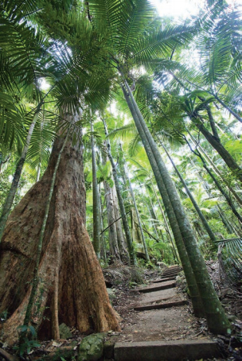
Study the photograph above, of vegetation in a tropical rainforest.
Explain how vegetation in tropical rainforests adapts to the climate.
(4)
(Total 7 marks)
Q4.
Explain how ecotourism can contribute to sustainable development.
(Total 4 marks)
Q5.
Describe two ways ecotourism can bring benefits to an area.
(Total 4 marks)
Q6.
The figure below shows the amount of desertified land and the level of desertification in two continents.
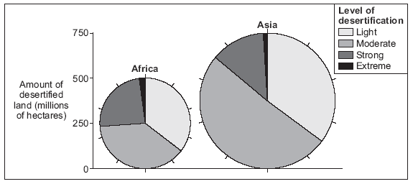
Describe the differences between Africa and Asia shown on the figure above.
(Total 4 marks)
Q7.
Study the figure below, an extract from a geographical publication about an ecolodge in the tropical rainforest in Costa Rica, a country in Central America

On the Caribbean coast, the Selva Bananito lodge provides holiday accommodation and associated activities. The lodge was built from wood discarded by loggers and the number of guests is limited. There is no electricity; solar energy is used to heat the water.
Biodegradable soaps are used for washing. Glass and plastic are recycled. Water used for drinking and cooking is purified using bacteria, enzymes and water lilies. The owners have set up a charitable trust to educate people about the rainforest and to provide activities such as jungle hikes and birdwatching.
Explain why this lodge is attractive to ecotourists.
(Total 4 marks)
Q8.
Explain how tropical rainforest vegetation adapts to the climate.
(Total 4 marks)
Q9.
Study the extracts below, from geography textbooks about one way to reduce tropical rainforest deforestation.
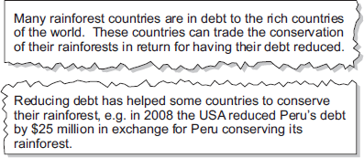
With the help of the extracts, explain how reducing debt can reduce tropical rainforest deforestation.
(Total 4 marks)
Mark schemes
Q1.
This mark scheme is from a question paper that assessed a previous specification and has not been edited.
Click [here] to access a document explaining the differences that might apply to it.
Two components should be identified here – soil erosion as a result of the protective cover of the forest being removed and the rain hitting the ground directly. The roots no longer being present mean that there is nothing to hold the soil in place. In addition, the removal of the trees takes away the source of nutrients, as there is no leaf fall.
Nutrients present are quickly leached downwards or washed out via throughflow leaving the soil infertile.
Level 1 (1-2 marks)
Basic statements, possible listing, e.g. soil will be washed away, it will become infertile.
Level 2 (3-4 marks)
Clear developed statements, aware of sequence of events, e.g. there is no protection from the leaves and no roots to hold the soil in place so it is washed away.
[4]
Q2.
This mark scheme is from a question paper that assessed a previous specification and has not been edited.
Click [here] to access a document explaining the differences that might apply to it.
Level 1 (Basic) 1-2 marks
Basic e.g. there are tall trees, a canopy, ferns and small shrubs, buttress roots, bare ground, mainly hardwoods.
Level 2 (Clear) 3-4 marks
Clear achieved by developed points e.g. the tallest trees are emergents at over 40 metres tall. There is a canopy of trees at about 30m high, the tallest trees have buttress roots, mainly hardwoods with examples.
[4]
Q3.
This mark scheme is from a question paper that assessed a previous specification and has not been edited.
(b) Leaves grow at the top of the trees in the canopy area mainly as they need to grow tall to reach sunlight. This competition means that there are some very tall trees above the general height – emergents – as they compete for sunlight. Due to the high amount of rainfall, the leaves have drip tips which allows the water to be channelled to the end and fall to the ground so that the leaf does not break. The bark on the trees is also thin and smooth to allow the free flow of water and because the high temperatures mean there is no need for protection against cold. The waxy / leathery upper surface of the leaves protects against the heat. Some plants climb up the trees to reach sunlight for photosynthesis such as lianas, whilst other live on branches within the canopy for the same reason – epiphytes.
AO1 = 3
AO2 = 1

Level | Marks | Description
2  (Clear) | 3 – 4 | Explanation is clear and sequential – relating characteristic / adaption to the climate.  Statements are developed and linked.
1  (Basic) | 1 – 2 | Explanation is partial – begins to relate features to climate.  Statements are separate in a random order.
 | 0 | No relevant content.
[7]
Q4.
This mark scheme is from a question paper that assessed a previous specification and has not been edited.
Click [here] to access a document explaining the differences that might apply to it.
Emphasis should be that present day development of tourism should not have a detrimental effect on future
generations, due to an overuse of resources or damage to the environment. There should the utilisation of local labour and skills, so that the local people are the ones who benefit from the development of tourism and the arrival of visitors. Any development of the infrastructure must be sympathetic to the environment and have minimal visual impact.
Level 1 (Basic) (1-2 marks)
Simple statements with no reference to sustainable development.
Ecotourism does not damage the environment. Ecotourism helps the local economy. The lives of the people are not interrupted.
Level 2 (Clear) (3-4 marks)
Linked statements with indication of how ecotourism contributes to sustainable development.
The development of ecotourism allows the local people to make use of their traditional skills to build accommodation so that they are earning money. Sympathetic development of the infrastructure such as roads is useful to the local community as well as the tourists.
AO1 – 2
AO2 – 2
[4]
Q5.
This mark scheme is from a question paper that assessed a previous specification and has not been edited.
Click [here] to access a document explaining the differences that might apply to it.
2×2
No unsuitable buildings causing visual pollution. They use local
materials, which fit in with the environment. Local people are
used as guides, which improves the local economy.
Reserve (1) for benefits.
4
AO1 – 4
[4]
Q6.
This mark scheme is from a question paper that assessed a previous specification and has not been edited.
Click [here] to access a document explaining the differences that might apply to it.
4 × 1 Amount greater in Asia less in Africa (1) states figures (1).
Proportion of strong/extreme greater in Africa less in Asia (1) states
figures (1). The description of the level of desertification must be
expressed as a greater/lesser proportion or percentage. Do not
accept ‘there is more extreme desertification in Africa’ but accept
‘there is a higher proportion/percentage of desertification in Africa’.
Accept ‘there is more moderate desertification in Asia’ – as this is true.
Max 2 amount of desertified land. (Description (1) use of figure (1))
Max 2 level of desertification. (Description (1) use of figure (1)).
[4]
Q7.
This mark scheme is from a question paper that assessed a previous specification and has not been edited.
Click [here] to access a document explaining the differences that might apply to it.
There are a number of reasons suggested by the extract. The opportunity to get close to the environment by the activities on offer – such as walking, bird watching and hiking through forest. Numbers are limited as there will not be too many people to spoil the experience. The accommodation is powered by solar energy and so it renewable and non-polluting – in keeping with ecotourism as the recycling of waste and soaps that are biodegradable and therefore not harmful to the environment.
Level marking
Level 1 (Basic) 1–2 marks
Simple statements.
May rely heavily on text with just a hint of explanation.
There are activities directly within the forest itself. Visitors can go bird watching and hiking.
Waste is composted and recycled so is used again.
Level 2 (Clear) 3–4 marks
Develops points.
Explanation is to the fore – and linked to points in extract.
Eco tourists will find this area attractive as it allows them to experience the forest first-hand and close-up by getting involved in activities such as bird watching and hiking. The fact that numbers are limited will make it better experience as the forest does not have huge numbers living there.
The facility is run in an environmentally way recycling plastic and glass so that it is re-used and not wasted.
AO1 – 2
AO2 – 1
AO3 – 1
[4]
Q8.
This mark scheme is from a question paper that assessed a previous specification and has not been edited.
Click [here] to access a document explaining the differences that might apply to it.
Likely to explain the presence of the canopy and emergents as the trees fight to get to the sunlight to allow photosynthesis to take place. There may be reference to specific features such as lianas that climb the trees to reach the light, epiphytes that live on the trees to access the light; buttress roots which seek to stabilise the trees as their roots are shallow and they grow so tall. Drip tip leaves that are designed to shed the large amount of rain as is the smooth bark.
Level 1 (Basic) (1–2 marks)
Simple statements.
Statements are generalised and separate.
May describe climate and/or adaptations.
Explanation is tentative, partial understanding.
Climate is very hot and wet. Trees grow very tall. Water drips off pointed leaves.
Level 2 (Clear) (3–4 marks)
Develops points.
Linked statements – may have specific species.
Climate linked to adaptations.
Explanation is clear.
The trees grow very tall as they are trying to reach sunlight and compete with each other. Epiphytes live on the higher branches so that they can get sunlight.
The leaves on the trees come to a point – known as drip tip, so that the large amount of rainfall can flow off them easily, without them breaking.
AO1 – 3
AO2 – 1
[4]
Q9.
This mark scheme is from a question paper that assessed a previous specification and has not been edited.
Click [here] to access a document explaining the differences that might apply to it.
The extract indicates how foreign debt – money owed to other countries as a result of borrowing – can be cut. This means that countries do not need so urgently to chop the trees down to pay back money owed. Therefore more trees will be left and the rainforest conserved. This is part of a deal so the areas with tropical rainforest have to do their part as in Peru in the example in the extract.
Level 1 (Basic) (1 – 2 marks)
Simple general statements, perhaps list-like at lower end.
Relies on the extract – likely to be descriptive.
Countries are in debt to richer ones. Debt is reduced. The rainforest is conserved.
Level 2 (Clear) (3 – 4 marks)
Develops and links statements. Uses the extract to explain.
Poorer countries with rainforest like Peru owe money to richer countries like USA as they have borrowed it to develop. If the richer country decides the poorer country does not need to pay back all they owe, but must not chop down as many trees, deforestation will be lessened.
AO2 – 2
AO3 – 2
[4]

