Q1.
What is the role of decomposers in an ecosystem?
(Total 2 marks)
Q2.
Outline one possible environmental impact of deforestation.
(Total 2 marks)
Q3.
Suggest one way that international co-operation can help make tropical rainforests more sustainable.
(Total 2 marks)
Q4.
Study the figure below, a world map showing some large scale global ecosystems.
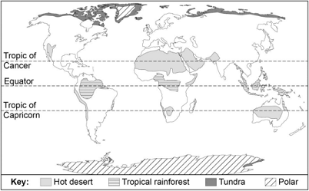
(a) Using the map, which one of the following statements is correct?
Shade one circle only.

A | Most areas of tundra are found on the edges of land masses.
B | The largest polar area is found north of the equator.
C | There are no areas of tundra south of the equator.
D | There are no polar areas south of the Tropic of Capricorn.
(1)
(b) Describe the distribution of hot deserts shown on the map.
(2)
(Total 3 marks)
Q5.
Study the pie charts showing deforestation in Borneo, a country in south east Asia between 1980 and 2020 (estimate).
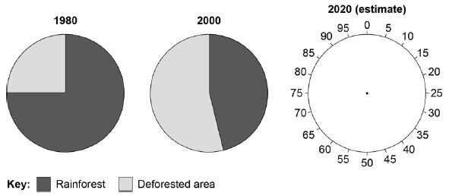
Complete the pie chart for 2020 (estimate).
Use the following information:

Rainforest = 35% | Deforested area = 65%
(Total 1 mark)
Q6.
Study the graph, which shows how the forested regions of the world changed between 2005 and 2009.
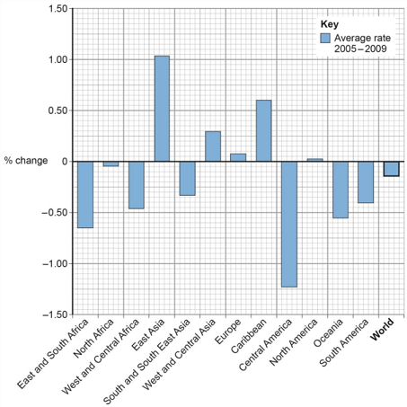
(a) Which region of the world had the greatest rate of deforestation between 2005 and 2009?
(1)
(b) State the number of regions of the world where the rate of deforestation was greater than the world average rate of deforestation between 2005 and 2009.
(1)
(Total 2 marks)
Q7.
Which one of the following statements describes the climate of a tropical rainforest?
Shade one circle only.

A | Mild temperatures (10–18°C), rainfall all year (approximately 1000 mm)
B | High temperatures all year (over 30°C), very dry (250 mm of rainfall per year)
C | High temperatures all year (25–27°C), rainfall in every month (1800–2000 mm per year)
D | Wide range of temperatures (15–30°C), seasonal rainfall (approximately 750 mm)
(Total 1 mark)
Q8.
Suggest two reasons why the rate of deforestation varies between different countries.
(Total 2 marks)
Q9.
Study the diagram showing the different plant layers in a tropical rainforest.
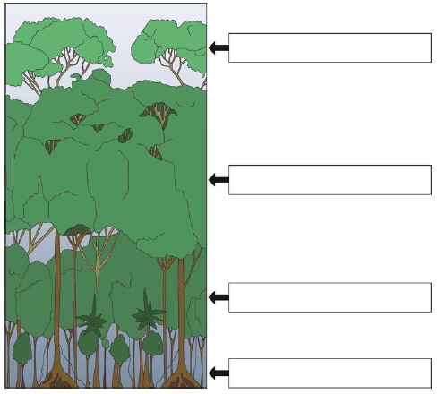
Complete the diagram above.
Write the correct label in each box.
Choose from the labels below.

Canopy | Emergents | Forest floor | Under canopy
(Total 2 marks)
Q10.
Study the table, an example of a tropical rainforest climate.

Month | Temperature (° C) | Rainfall (mm)
January | 28 | 282
February | 28 | 280
March | 28 | 300
April | 27 | 285
May | 28 | 195
June | 28 | 100
July | 28 | 73
August | 29 | 65
September | 29 | 72
October | 29 | 114
November | 28 | 167
December | 28 | 228
(a) What is the annual temperature range shown in the table?
Shade one circle only.

A | 28 °C
B | 17 °C
C | 9 °C
D | 2 °C
(1)
(b) What is the total annual rainfall shown in the table?
Shade one circle only.

A | 3875 mm
B | 2161 mm
C | 1521 mm
D | 742 mm
(1)
(c) Which one of the following describes the length of the growing season in a tropical rainforest climate?
Shade one circle only.

A | 12 months
B | 9 months
C | 7 months
D | 1 months
(1)
(Total 3 marks)
Q11.
Explain how either international hardwood agreements or selective logging can encourage the sustainable management of tropical rainforests.
(Total 2 marks)
Q12.
Study the image, a world map showing the distribution of tropical rainforest.
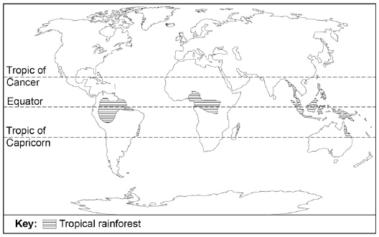
In which two of the following continents are tropical rainforests found?
Shade two circles only.

A | North America
B | South America
C | Asia
D | Antarctica
E | Europe
(Total 2 marks)
Q13.
Study the diagram below showing energy flows in an ecosystem in the UK.
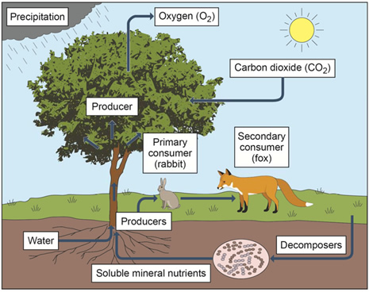
(a) Describe the role of producers in an ecosystem.
(1)
(b) Give one reason why energy is lost at each level in a food chain.
(1)
(c) Using the diagram and your own understanding, complete the following sentences.
If a disease reduced the number of primary consumers, one effect on the food chain would be that
Decomposers help to return nutrients to the soil by
(2)
(Total 4 marks)
Q14.
Outline one reason for the high levels of biodiversity in tropical rainforests.
(Total 2 marks)
Q15.
Study the photograph of part of an ecotourism scheme in the Amazon rainforest, Brazil.
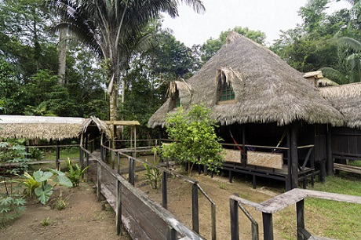
Using the photo above suggest how ecotourism can help in managing tropical rainforests sustainably.
(Total 2 marks)
Q16.
The living world
Study the map below showing global forest cover.
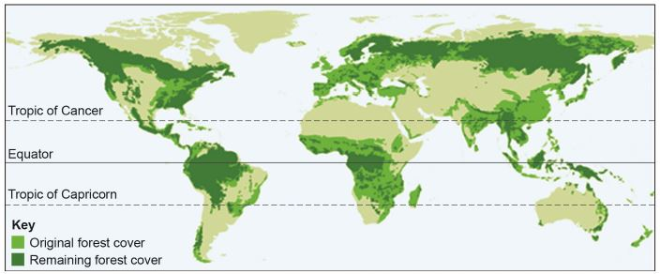
Using the map, which one of the following statements is true?
Shade one circle only.

A | Most of the world’s forests are situated between the Tropic of Cancer and the Tropic of Capricorn.
B | The greatest amount of deforestation has occurred in North and South America.
C | A high proportion of the original forest cover has been removed in Africa and Europe.
D | Most of the original forest cover in south and east Asia still remains today.
(Total 1 mark)
Q17.
Give one reason why polar regions have low temperatures throughout the year.
(Total 1 mark)
Q18.
Study the graph below which is a typical climate graph for one global ecosystem.
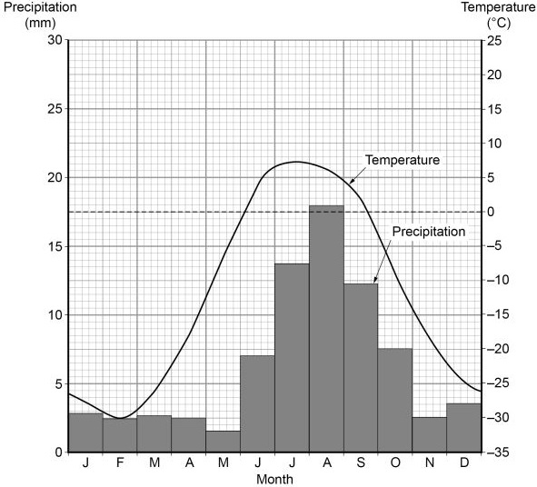
(a) Which global ecosystem is most likely to have the temperature and precipitation pattern shown in the graph above.
Shade one circle only.

A | temperate deciduous forest
B | tundra
C | hot desert
D | savanna
(1)
(b) State the minimum temperature shown in the graph above.
Shade one circle only.

A | –26°C
B | –28°C
C | –30°C
D | –32°C
(1)
(Total 2 marks)
Q19.
Outline one reason why wildfires are a threat to global climate.
(Total 2 marks)
Q20.
Study the world map below showing some global ecosystems.
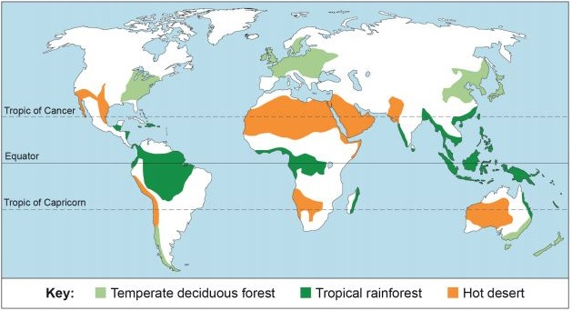
(a) Using the world map above which one of the following statements is true?
Shade one circle only.

A | There is a greater area of hot desert in the Southern Hemisphere than the Northern Hemisphere.
B | The largest single area of tropical rainforest is in South America.
C | Temperate deciduous forests are all found on the western side of continents
D | Hot desert areas are all found between the two tropics.
(1)
(b) Outline one reason for the distribution of tropical rainforest.
(2)
(Total 3 marks)
Q21.
Give one effect of deforestation on the soils of the rainforest.
(Total 1 mark)
Q22.
Study the diagram showing the structure of the tropical rainforest.
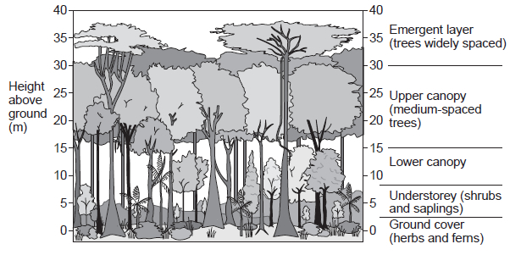
(a) Using the diagram, which part of the rainforest matches the following description?
‘An almost continuous layer of branches and leaves between 15 and 30 metres high.’
Shade one circle only.

A | Emergent layer
B | Upper canopy
C | Lower canopy
D | Understorey
(1)
(b) Using the diagram, describe one characteristic of the base of the taller trees.
(1)
(Total 2 marks)
Q23.
Study the graph below showing the biomass at different levels of a food chain.
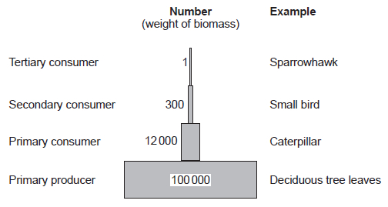
Biomass is the total quantity or weight of organisms in a given area.
(a) Calculate the percentage loss in biomass between the primary consumer and secondary consumer levels.
Shade one circle only.

A | 2.5%
B | 97.5%
C | 25.2%
D | 95.5%
(1)
(b) Give two reasons why the biomass changes between each level in the food chain.
(2)
(Total 3 marks)
Q24.
State one role of decomposers in an ecosystem.
(Total 1 mark)
Q25.
The living world
Study the diagram below showing a food web for a small scale ecosystem in the UK.
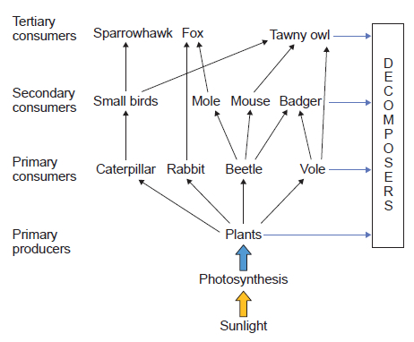
(a) Using the diagram, which one of the following statements is true?
Shade one circle only.

A | Sparrowhawks eat plants
B | Voles eat moles
C | Moles eat beetles
D | Badgers eat small birds
(1)
(b) Suggest what would happen in the food web shown in the diagram if foxes became extinct.
(2)
(Total 3 marks)
Q26.
The living world
Which one of the following phrases defines the term biodiversity?
Shade one circle only.

A | How living things affect each other and the environment.
B | The number and types of plants and animals that live in an area.
C | Energy flows between living things when they eat or are eaten.
D | How plants and animals are adapted to their habitats.
(Total 1 mark)
Q27.
Study the newspaper article below about wildfires in Brazil.
oUsing the article above, give one feature of the pattern of wildfires in Brazil.
(Total 1 mark)
Q28.
Which global ecosystem matches the following description?
An area with trees which drop their leaves in winter.
Shade one circle only.

A | Tundra.
B | Tropical grassland.
C | Deciduous forest.
D | Tropical rainforest.
(Total 1 mark)
Q29.
State one way that debt reduction can help to make tropical rainforests more sustainable.
(Total 1 mark)
Q30.
Study the data below which shows annual climate data for two different environments.

Place A
Month | Jan | Feb | Mar | Apr | May | Jun | Jul | Aug | Sep | Oct | Nov | Dec
Rainfall  (mm) | 3 | 2 | 1 | 1 | 0 | 1 | 0 | 0 | 0 | 4 | 7 | 8
Average temp.  (°C) | 16.0 | 16.7 | 17.9 | 18.6 | 20.3 | 21.4 | 23.3 | 23.9 | 23.3 | 22.3 | 20.1 | 15.4

Place B
Month | Jan | Feb | Mar | Apr | May | Jun | Jul | Aug | Sep | Oct | Nov | Dec
Rainfall  (mm) | 16 | 20 | 21 | 12 | 9 | 11 | 16 | 28 | 26 | 17 | 19 | 18
Average temp.  (°C) | -14.0 | -14.5 | -13.3 | -10.6 | -3.5 | 2.6 | 6.2 | 5.1 | 1.0 | -4.9 | -8.7 | -12.2
(a) Using the data above, calculate the temperature range in Place A.
(1)
(b) Using the data above, state two differences between the climate in Place A and Place B.
(2)
(Total 3 marks)
Q31.
(a) The living world
For a small scale ecosystem you have studied, name one producer and one consumer.
(2)
(b) What is the role of producers in an ecosystem?
(1)
(Total 3 marks)
Q32.
Study the world map below showing global biodiversity levels.
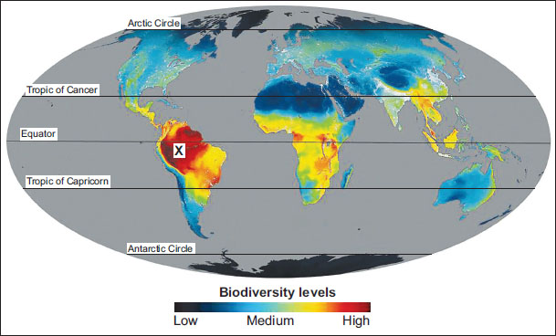
(a) Using the map above, describe the location of areas with low biodiversity levels.
(2)
(b) Using the map above, suggest one reason for the high biodiversity levels in area X.
(2)
(Total 4 marks)
Q33.
Study the graph below showing global forest loss from 2011 to 2017.
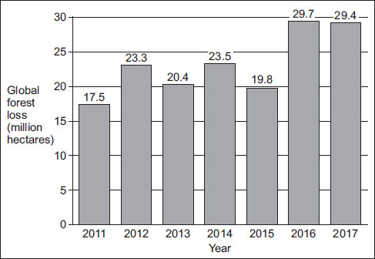
(a) Using the graph above, calculate the mean global forest loss from 2011 to 2017.
Give your answer to one decimal place.
(1)
(b) Calculate the percentage change in global forest loss between 2011 and 2017.
Shade one circle only.

A | 62%
B | 68%
C | 74%
D | 80%
(1)
(Total 2 marks)
Q34.
Outline one way that plants are adapted to the climate in either hot deserts or cold environments.
(Total 2 marks)
Mark schemes
Q1.
This mark scheme is from a question paper that assessed a previous specification and has not been edited.
Click [here] to access a document explaining the differences that might apply to it.
A decomposer is either bacteria or fungi (or 2 alternative examples) which are responsible for the breakdown of dead organic matter in the soil, such as leaves. This process leads to the recycling of nutrients. 2 × 1 per simple point, 1 + 1 for an elaborated point.
AO1 = 2
[2]
Q2.
Credit one impact only. Impact must be environmental, not economic or social.
One mark for stating an impact, e.g:
• forest habitats are destroyed (1)
• soil erosion increases as the tree cover is removed (1)
• burning the rainforest releases CO₂ (1).
Second mark for developing the point, e.g:
• forest habitats are destroyed leading to reduction and possible decimation of species (2)
• soil erosion increases as the tree cover is removed which can cause barren land, flooding and landslides (2)
• burning the rainforest releases CO₂ which contributes to world climate change (2).
AO2 = 2
[2]
Q3.
Credit one way only. The answer must focus on the international implication of sustainable forest management and show understanding of a worldwide initiative.
One mark for stating the method, e.g:
• countries can be relieved of some of their debt, known as debt for nature schemes (1)
• international organisations such as the Forest Stewardship Council (FSC) promote sustainable forestry (1).
Second mark for a developed explanation, e.g:
• countries can be relieved of some of their debt, known as debt for nature schemes (1) in return for retaining their rainforest areas (2)
• international organisations such as the Forest Stewardship Council (FSC) promote sustainable forestry (1) by guaranteeing that timber products are sourced from sustainable managed forests (2).
AO2 = 2
[2]
Q4.
One mark for the correct answer:
(a) A Most areas of tundra are found on the edges of land masses.
No credit if two or more statements are shaded
AO4 = 1
(b) Credit statements about distribution of hot deserts using information on the map, eg
• most of the world's hot deserts lie between 15° and 35° north and south of the equator (1)
• several deserts are found on the western side of continents, for example the deserts of South America and southern Africa (1)
• the largest desert (the Sahara) stretches across northern Africa into the Middle East (1)
• some hot deserts extend much closer to the equator, for instance the Atacama desert on the western side of South America (1).
No credit for simply listing continents or places where the deserts are found.
AO4 = 2
[3]
Q5.
1 mark for accurate completion of pie graph, including shading.
AO4 = 1
[1]
Q6.
(a) One mark for the correct answer: Central America. No credit for stating more than one region.
AO4 = 1
(b) One mark for the correct answer: Six/6 (regions).
AO4 = 1
[2]
Q7.
One mark for the correct answer:
C High temperatures all year (25–27 °C), rainfall in every month
(1800–2000 mm per year).
No credit if two or more statements are shaded.
AO1 = 1
[1]
Q8.
Any two reasonable points (2 × 1 marks)
Indicative content
• Different levels of development.
• Population density/building settlements.
• Mining/mineral resource exploitation.
• Improved infrastructure/building roads.
• Political stability.
• Development of hydro-electricity systems.
• Foreign investment.
• Conservation measures.
AO1 = 2
[2]
Q9.
Three or four correct, 2 marks
One or two correct, 1 mark
AO3 = 2
[2]
Q10.
(a) 2 °C
AO4 = 1
(b) 2161 mm
AO4 = 1
(c) 12 months
AO4 = 1
[3]
Q11.
Credit explanation of one strategy only.
Developed point required for 2 marks.
Either:
International agreements.
The International Tropical Timber agreement (1) ensures that wood from tropical areas is legally sourced / sustainable (d)(1).
The Forestry Stewardship Council (1) requires that products from sustainably managed forests have the FSC label (d) (1) / aims to reduce demand for rare hardwood trees. (d)(1).
Or:
Selective logging
Involves felling trees only when fully grown (1), and letting younger trees mature (d) (1) / and therefore continue protecting the ground from erosion (d) (1).
Loggers remove the most valuable trees from the forest leaving the rest behind (1) and the area regrows as secondary forest (d) (1).
Only some trees are felled(1), which helps to protect the ecosystem (d) (1)
Loggers remove dead or diseased trees(1), meaning that the vegetation is largely preserved (d) (1).
AO2 = 2 marks
[2]
Q12.
South America and Asia (2 × 1 marks)
AO4 = 2
[2]
Q13.
(a) One mark for an appropriate description of the role.
E.g. Producers are organisms that produce their own food (1).
They take energy from the Sun and make it into chemical energy (food) (1)
Plants produce chemical energy by the process of photosynthesis (1).
They are at the bottom of the food chain and may be eaten by consumers (1)
AO2 = 1
(b) One mark for an appropriate reason.
E.g. The entire organism is not consumed or digested (1).
Parts such as roots, woody stems, bones, scales, feathers etc aren't eaten (1).
Energy is used up by organisms in each trophic level for movement and transport inside their bodies (1).
Energy is used in respiration and is released from the body of the organism as heat(1). Energy becomes lost in excretion.(1)
AO1 = 1
(c) One mark for each correct description or inference
If a disease reduced the number of primary consumers, one effect on the food chain would be that carnivore populations may decrease rapidly / only omnivores would survive / plant life will flourish and grow rapidly (1)
Decomposers help to return nutrients to the soil by breaking down dead plants and animals / breaking down organic waste or excreted material / releasing energy built up inside a plant or animal so that it can be recycled (1)
Credit other plausible statements.
AO2 = 1
AO3 = 1
[4]
Q14.
One mark for each reason or two marks for single developed explanation.
E.g. Rainfall and temperatures are high all year round (1). This encourages rapid growth of a large number of plants (d) (1)
Because rainforests are located in tropical regions, they receive a lot of sunlight (1), which is converted to energy by photosynthesis, so there are many plants. (d) (1)
The canopy structure of the rainforest provides many places for plants to grow and animals to live (1). The canopy offers sources of food, shelter, and hiding places (d) (1)
The rainforest nutrient cycling is rapid in hot, damp conditions on the forest floor (1), so there is rapid decay of dead plant material and plentiful nutrients easily absorbed by plant roots (d) (1).
No credit for description of plants or plant adaptations to climate.
AO1 = 2
[2]
Q15.
The question requires application of knowledge and understanding to the photograph.
Answer can be 2 separate points or 1 developed idea. There should be direct or inferred use of the photograph.
E.g. the ecotourism development appears to be small scale (1), making little impact on the rainforest (d) (1).
Few trees are cut down/ people stay in wooden lodges / resources used for building are from the local area (1) This helps to protect natural habitats and endangered species (d) (1).
People may stay in the huts on holiday(1) and the money they spend may be used for conservation (d) (1), which helps to support the local economy (d) (1).
No credit for links to ecotourism that cannot reasonably be inferred from the photograph.
AO3 = 2 marks
[2]
Q16.
One mark for the correct answer:
C. A high proportion of the original forest cover has been removed in Africa and Europe.
No credit if two or more statements are shaded
AO4 = 1
[1]
Q17.
(The low angle of the sun means) energy is more dispersed (less concentrated) on the earth’s surface (1).
The sun’s energy is scattered and reflected by the atmosphere (1).
Ice, water and snow are good reflectors of solar radiation (1).
Because of the tilt of the earth, polar regions receive no sunlight for up to 6 months of the year (1).
Reject idea that polar regions are further from sun than equatorial regions.
AO1 = 1 mark
[1]
Q18.
The question requires application of knowledge and understanding to the climate graph shown in the question.
(a) One mark for the correct answer:
B. Tundra
No credit if two or more statements are shaded.
AO3 = 1 mark
(b) One mark for the correct answer:
C. -30° C
No credit if two or more statements are shaded.
AO4 = 1 mark
[2]
Q19.
The Amazon rainforest acts as a huge carbon sink/absorbing and storing carbon dioxide (1). If the trees are destroyed, this carbon sink is lost (d) (1). The forests help to cool global temperatures (1) so burning would lead to rising temperatures (d) (1).
The burning of trees releases CO₂ into the atmosphere (1) contributing to the greenhouse effect (d)(1).
AO2 – 2 marks
[2]
Q20.
(a) One mark for the correct answer:
B. The largest single area of tropical rainforest is in South America.
No credit if two or more statements are shaded.
AO4 = 1 mark
(b) One mark for basic point and 2nd mark for development of that point.
E.g. Rainforest areas all have high humidity / high rainfall (1)
They are areas with high temperatures (all year round) (1)
They have a continuous growing season (1)
Heat from the sun causes the air to rise (1) leading to heavy convectional rain / thunderstorms all year round (d)(1)
High temperatures (and heavy all seasonal rain) (1) create ideal conditions for the growth of trees all year round (d)(1)
Rainforest areas all have high humidity / rainfall (1) so they are found near the equator where there is lots of convectional rain (d)(1).
They are in areas with low air pressure (1), which are associated with high rainfall (d) (1)
AO1 = 2 marks
Q21.
They become less fertile (1).
They become drier (as there is less protection) (1).
They are eroded/washed away (as roots no longer hold them in place) (1).
They lose their nutrients/rainwater may cause leaching (1).
They turn red/they may have a reddish colour due to presence of iron oxide (1).
A01 = 1 mark
[1]
Q22.
(a) B. Upper canopy.
No credit if two or more statements are shaded.
A04 = 1 mark
(b) Buttressed roots (1).
The base is wider than the rest of the trunk (as roots extend into the ground) (1).
Wide base (1).
AO4 = 1 mark
[2]
Q23.
(a) B. 97.5%
No credit if two or more statements are shaded.
AO4 = 1 mark
(b) E.g. (Loss of energy through) respiration (1).
(Loss of energy through) movement (1).
(Loss of energy through) excretion (1).
(Loss of energy through) digestion (1).
Energy loss through heat (1).
Energy is used for life processes (1).
Faeces and remains are passed to decomposers (1).
The entire organism is not consumed or digested / Parts such as roots, woody stems, bones, scales, feathers aren't eaten (1).
AO1 = 2 marks
[3]
Q24.
Decomposers help to return nutrients/energy to the soil (1).
They break down dead plants and animals/organic waste or excreted material (1).
They release energy from a plant or animal so that it can be recycled (1).
AO1 = 1 mark
[1]
Q25.
(a) One mark for the correct answer:
C. Moles eat beetles
No credit if two or more statements are shaded.
AO4 = 1 mark
(b) One mark for each basic point or two marks for developed suggestion.
Possible increase in the number of some primary and secondary consumers (1). particularly moles/rabbits. (d) (1).
There would be fewer predators (1).
Increase in number of moles/ rabbits (1).
However the number of beetles might eventually decrease (1).
Possible fewer plants as numbers of primary consumers / rabbits increase (1).
Fewer beetles means fewer mice / tawny owls (1).
AO3 = 2 marks
[3]
Q26.
B. The number and types of plants and animals that live in an area.
No credit if two or more statements are shaded.
AO1 – 1 mark
[1]
Q27.
Concentrated largely south of the Amazon river (1).
North of Brasilia (1).
There is a significant band running from west to east across the centre of Brazil (1).
There are relatively few in coastal areas (1).
Central Brazil (1). Northern Brazil (1)
AO4 – 1 mark
[1]
Q28.
C Deciduous forest
No credit if two or more answers are circled.
AO1 – 1 mark
[1]
Q29.
Countries are relieved of some of their debt in return for protecting their rainforests (1).
The USA signed an agreement to convert some of Brazil’s debt into a fund to protect large areas of tropical forest (1).
Some HICs agree to write off the debts of some poor LICs (1).
There are debt for nature/conservation swaps (1).
Debt is paid off in exchange for a guarantee that money is spent on conservation (1).
AO2 – 1 mark
[1]
Q30.
(a) 8.5 (°C)
Working and units not needed.
AO4 – 1 mark
(b) Rainfall is (much) lower in Place A, (totalling 27 mm per year in comparison to 213 mm in Place B) (1).
The variation in rainfall is (much) higher in Place B (19mm) than Place A (8mm) (1).
The highest average temperature in Place A is 23.9°C compared with 6.2°C in Place B (1).
The lowest average temperature is (much) lower in Place B (-14.5°C) compared with Place A (at 15.4°C)(1).
Place B has a higher yearly temperature range (of 20.7°C compared to 8.5°C in Place A).
B has wetter climate (1). B has a cooler climate (1).
2 clear contrasts (differences) are needed for 2 marks.
AO4 – 2 marks
[3]
Q31.
(a) Producer: Any green plants, lichens and algae, phytoplankton, seaweeds, sea grass. Max 1 mark for producer.
Consumer: Any part of the ecosystem that feeds from the producer such as flea, tadpoles, fish, heron etc. The answer does not have to be a primary consumer. Max 1 mark for consumer.
Both species should be found in the same ecosystem.
Max 1 mark if the two species are not from same ecosystem.
AO1 – 2 marks
(b) One mark for an appropriate description of the role.
Producers are organisms that produce their own food (1).
They convert the sun’s energy into food (1).
They produce food for other animals to eat (1).
They produce chemical energy by the process of photosynthesis (1).
They convert water, sunlight and CO2 into carbohydrates (1).
Plants can also make other nutrients for other organisms to eat (1).
They are at the bottom of the food chain and may be eaten by consumers (1).
Do not credit examples of producers.
AO2 – 1 mark
[3]
Q32.
(a) Low levels are found in (hot and cold) desert areas (1) such as the
Sahara/Arabian/Atacama desert (d) (1)
Mountainous areas have low levels (1) such as the Himalayas/Andes (d) (1) Tundra/polar areas have low levels (1) such as northern Canada/northern Russia/Greenland/Antarctica (d) (1)
Much of northern Africa/northern Canada has low biodiversity levels (1) Areas inside the Arctic Circle have low levels (1)
Max 1 mark for list of locations.
Credit two separate points or one developed point for 2 marks
No credit for explanation of biodiversity levels.
AO4 – 2 marks
(b) Area X receives very high rainfall (1) which allows many plants to grow (d) (1).
Area X experiences high temperatures and high rainfall (1) which means that plants grow rapidly (d) (1).
Area X receives some rain in every month (1) which means that plants grow throughout the year (d) (1).
There is a hot wet climate (1) which leads to the growth of many plants in a tropical rainforest (d) (1).
AO2 – 2 marks
[4]
Q33.
(a) 23.4 (accept 23.3) million hectares
AO4 – 1 mark
(b) B. 68%.
No credit if two or more statements are shaded.
AO4 – 1 mark
[2]
Q34.
Hot deserts
Plant roots may be extremely long (1) to reach deep water supplies (d) (1).
Roots may be spread out very wide near the surface (1) to catch as much water as possible when it rains (d) (1).
Many plants, (e.g. cacti) are succulents (1). They have large, fleshy stems for storing water (d) (1) and thick waxy skin to reduce water loss (d) (1).
Some plants have small leaves (1) reducing water loss (d)(1).
The seeds of some plants only germinate when it rains (1) which means they only grow when there’s enough water to survive (d)(1).
Cold environments
Most plants become dormant (1) to survive the cold, dark winters (d) (1).
Plants are small/round-shaped (1) to provide protection from the wind (d) (1). Most plants have shallow roots (1) because of the layer of permafrost/ice beneath the soil layer (d) (1).
Leaves are generally small (1) to limit the amount of moisture lost (d) (1). Many plants use underground runners or bulbs instead of seeds (1) because the growing season is so short (d) (1).
Credit valid points about one environment only.
Max 1 mark for two separate points.
No credit for reference to animal adaptation.
AO1 – 2 marks
[2]

