TITLE: **AN INVESTIGATION INTO LONGSHORE DRIFT AT DAWLISH WARREN**

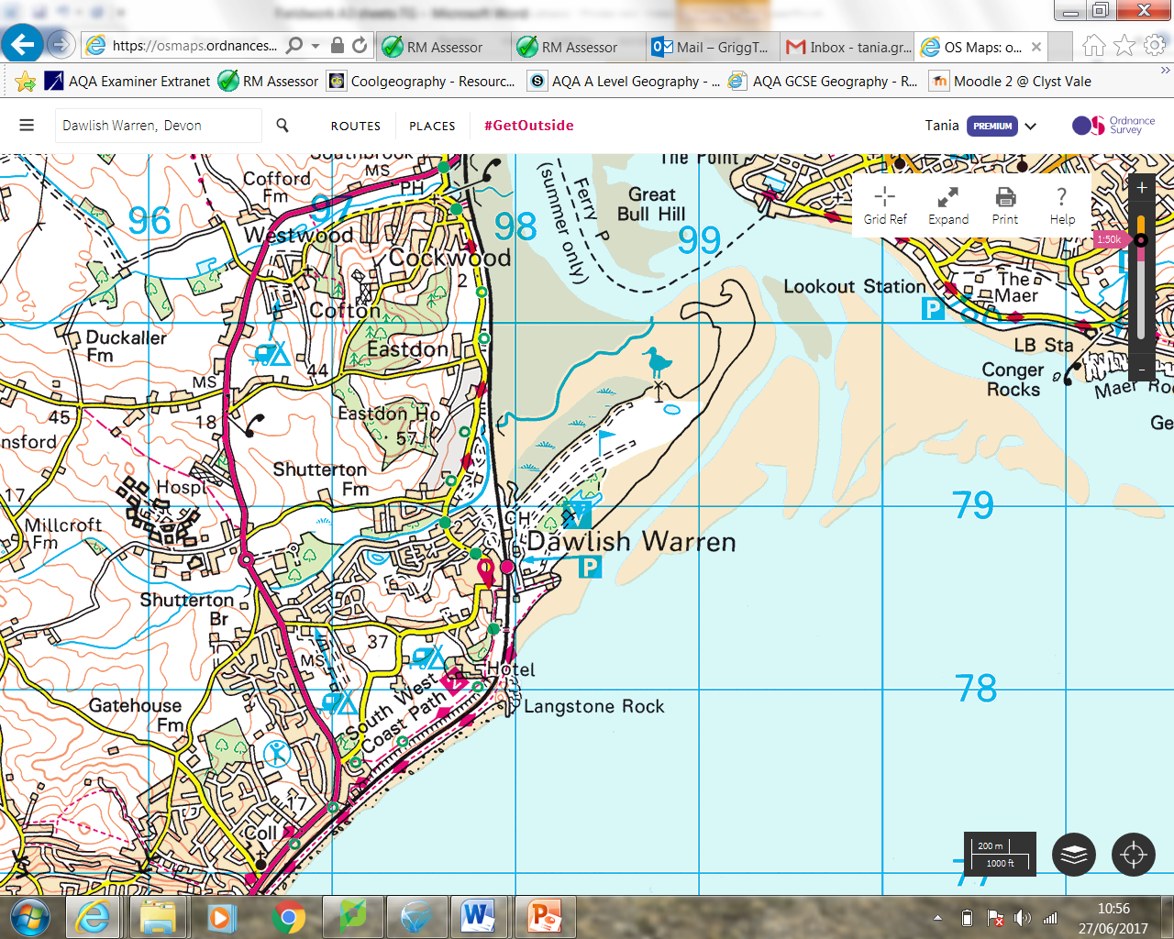

**Assessing the Risks:**

Before any fieldwork it is important to assess any risks which might be present and consider what we could do to prevent or reduce the risks.

[](http://www.google.co.uk/url?sa=i&rct=j&q=&esrc=s&source=images&cd=&cad=rja&uact=8&ved=0ahUKEwi2isue4abUAhXH7BQKHbxdAcEQjRwIBw&url=http://www.clipartpanda.com/categories/pencil-clipart-black-and-white&psig=AFQjCNEvNGIsK8M2td_EZZtQWsHH9S-n1A&ust=1496753973503223) Complete the table below for the fieldwork we will do at Dawlish Warren:

|  |  |  |
| --- | --- | --- |
| ACTIVITY: | RISKS: | WHAT CAN BE DONE TO REDUCE THE RISK? |
| Travel to Dawlish Warren by coach | Road Traffic Accident  Accident when getting off coach | Remind students to wear seat belts  Carry first Aid Kits  Remind students to look both ways when leaving the coach  Unload coach in a safe position |
| Weather |  |  |
| Walking on the Beach |  |  |
|  |  |  |

Hypothesis: These are the questions you are aiming to prove or disprove based on the data you collect.

1. **Long-shore drift goes from west to east at Dawlish Warren beach**
2. **The beach will get wider as you go from west to east.**

**Locations of Dawlish Warren data Collection:**

[](http://www.google.co.uk/url?sa=i&rct=j&q=&esrc=s&source=images&cd=&cad=rja&uact=8&ved=0ahUKEwi2isue4abUAhXH7BQKHbxdAcEQjRwIBw&url=http://www.clipartpanda.com/categories/pencil-clipart-black-and-white&psig=AFQjCNEvNGIsK8M2td_EZZtQWsHH9S-n1A&ust=1496753973503223) On the map name your data collection techniques and mark where they were carried out:

**We will plan the fieldwork, assess the risks, decide the location, collect data and then analyse and present the data, draw conclusions and evaluate our piece of work.**

**The theory of Longshore Drift:**

[](http://www.google.co.uk/url?sa=i&rct=j&q=&esrc=s&source=images&cd=&cad=rja&uact=8&ved=0ahUKEwi2isue4abUAhXH7BQKHbxdAcEQjRwIBw&url=http://www.clipartpanda.com/categories/pencil-clipart-black-and-white&psig=AFQjCNEvNGIsK8M2td_EZZtQWsHH9S-n1A&ust=1496753973503223)Explain what Longshore drift is. Use the diagram below to help you.

[](http://www.google.co.uk/url?sa=i&rct=j&q=&esrc=s&source=images&cd=&cad=rja&uact=8&ved=0ahUKEwi2isue4abUAhXH7BQKHbxdAcEQjRwIBw&url=http://www.clipartpanda.com/categories/pencil-clipart-black-and-white&psig=AFQjCNEvNGIsK8M2td_EZZtQWsHH9S-n1A&ust=1496753973503223) What will happen to the shape of the beach as you move towards the East?

[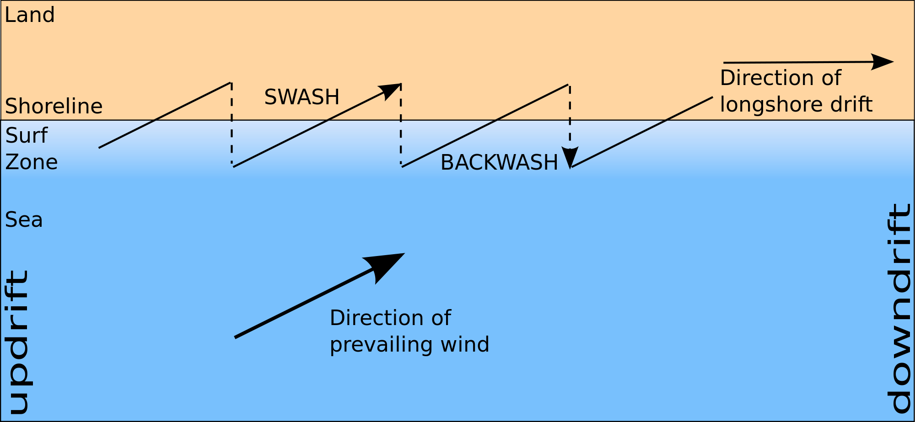](https://www.google.co.uk/url?sa=i&rct=j&q=&esrc=s&source=images&cd=&cad=rja&uact=8&ved=0ahUKEwj_56Kl393UAhVMXhoKHU1uB_wQjRwIBw&url=https://www.geocaching.com/seek/cache_details.aspx?guid%3D5e2b552c-fdf0-4808-a8ea-106fcc820df4&psig=AFQjCNG1aYjhhYN-NS5K8h5HzIEq40YOyA&ust=1498643239025177)

[](http://www.google.co.uk/url?sa=i&rct=j&q=&esrc=s&source=images&cd=&cad=rja&uact=8&ved=0ahUKEwi2isue4abUAhXH7BQKHbxdAcEQjRwIBw&url=http://www.clipartpanda.com/categories/pencil-clipart-black-and-white&psig=AFQjCNEvNGIsK8M2td_EZZtQWsHH9S-n1A&ust=1496753973503223)Why do we expect the direction of longshore drift to be West to East at Dawlish Warren?

[](http://www.google.co.uk/url?sa=i&rct=j&q=&esrc=s&source=images&cd=&cad=rja&uact=8&ved=0ahUKEwi2isue4abUAhXH7BQKHbxdAcEQjRwIBw&url=http://www.clipartpanda.com/categories/pencil-clipart-black-and-white&psig=AFQjCNEvNGIsK8M2td_EZZtQWsHH9S-n1A&ust=1496753973503223)Why do we expect the direction of Longshore Drift to be West to East at Dawlish?

**Why is Dawlish Warren a good location for this piece of fieldwork?**

It is a stretch of coastline with a beach

It is accessible to the public so we can get on to the site and walk around and through the dunes and collect data.

It is within 40 minutes travelling distance of the school so we can get there and back and collect the data in one school day

[](http://www.google.co.uk/url?sa=i&rct=j&q=&esrc=s&source=images&cd=&cad=rja&uact=8&ved=0ahUKEwi2isue4abUAhXH7BQKHbxdAcEQjRwIBw&url=http://www.clipartpanda.com/categories/pencil-clipart-black-and-white&psig=AFQjCNEvNGIsK8M2td_EZZtQWsHH9S-n1A&ust=1496753973503223) Another reason:

[](http://www.google.co.uk/url?sa=i&rct=j&q=&esrc=s&source=images&cd=&cad=rja&uact=8&ved=0ahUKEwi2isue4abUAhXH7BQKHbxdAcEQjRwIBw&url=http://www.clipartpanda.com/categories/pencil-clipart-black-and-white&psig=AFQjCNEvNGIsK8M2td_EZZtQWsHH9S-n1A&ust=1496753973503223) Can you think of a disadvantage of the location?

**[](http://www.google.co.uk/url?sa=i&rct=j&q=&esrc=s&source=images&cd=&cad=rja&uact=8&ved=0ahUKEwi2isue4abUAhXH7BQKHbxdAcEQjRwIBw&url=http://www.clipartpanda.com/categories/pencil-clipart-black-and-white&psig=AFQjCNEvNGIsK8M2td_EZZtQWsHH9S-n1A&ust=1496753973503223) Method 1: Long shore drift________________________________________________________________**

**WHY a**re we measuring this? (Link to how it will help us to answer the hypothesis)

**HOW** did we collect the data – Describe the method of data collection:

Sampling types used:

**SELECTING, MEASURING AND RECORDING DATA TO ANSWER OUR QUESTION:**

**Types of Data:**

**PRIMARY DATA:** Data we collect ourselves – this is what we will do on the fieldwork – see below.

**SECONDARY DATA**: Data collected by someone else or an organisation e.g. OS map used to identify landforms and sites

**QUANTIITATIVE DATA**: Data which is numerical e.g. the length of a measurement in centimetres

**QUALITATIVE DATA:** Information which is descriptive e.g. a description of the site

**What do you expect to find when you go to Dawlish?**

We are going to test two hypotheses…

1. **Longshore drift moves material from west to east.**
2. **The beach will get wider as you go from west to east.**

[](http://www.google.co.uk/url?sa=i&rct=j&q=&esrc=s&source=images&cd=&cad=rja&uact=8&ved=0ahUKEwi2isue4abUAhXH7BQKHbxdAcEQjRwIBw&url=http://www.clipartpanda.com/categories/pencil-clipart-black-and-white&psig=AFQjCNEvNGIsK8M2td_EZZtQWsHH9S-n1A&ust=1496753973503223) What evidence might there be for longshore drift moving west to east? What do you need to look out for?

[](http://www.google.co.uk/url?sa=i&rct=j&q=&esrc=s&source=images&cd=&cad=rja&uact=8&ved=0ahUKEwi2isue4abUAhXH7BQKHbxdAcEQjRwIBw&url=http://www.clipartpanda.com/categories/pencil-clipart-black-and-white&psig=AFQjCNEvNGIsK8M2td_EZZtQWsHH9S-n1A&ust=1496753973503223) What evidence might there be for the beach getting wider? What do you need to look out for?

Equipment needed;

**What do you expect to find when you go to Dawlish?**

We are going to test two hypotheses…

1. **Longshore drift moves material from west to east.**
2. **The beach will get wider as you go from west to east.**

[](http://www.google.co.uk/url?sa=i&rct=j&q=&esrc=s&source=images&cd=&cad=rja&uact=8&ved=0ahUKEwi2isue4abUAhXH7BQKHbxdAcEQjRwIBw&url=http://www.clipartpanda.com/categories/pencil-clipart-black-and-white&psig=AFQjCNEvNGIsK8M2td_EZZtQWsHH9S-n1A&ust=1496753973503223) What evidence might there be for longshore drift moving west to east? What do you need to look out for?

[](http://www.google.co.uk/url?sa=i&rct=j&q=&esrc=s&source=images&cd=&cad=rja&uact=8&ved=0ahUKEwi2isue4abUAhXH7BQKHbxdAcEQjRwIBw&url=http://www.clipartpanda.com/categories/pencil-clipart-black-and-white&psig=AFQjCNEvNGIsK8M2td_EZZtQWsHH9S-n1A&ust=1496753973503223) What evidence might there be for the beach getting wider? What do you need to look out for?

[](http://www.google.co.uk/url?sa=i&rct=j&q=&esrc=s&source=images&cd=&cad=rja&uact=8&ved=0ahUKEwi2isue4abUAhXH7BQKHbxdAcEQjRwIBw&url=http://www.clipartpanda.com/categories/pencil-clipart-black-and-white&psig=AFQjCNEvNGIsK8M2td_EZZtQWsHH9S-n1A&ust=1496753973503223) **Method 3: Beach profile ________________________________________________________________**

**WHY a**re we measuring this? (Link to how it will help us to answer the hypothesis)

**HOW** did we collect the data – Describe the method of data collection:

Sampling types used:

**Types of Sampling:**

You can’t collect data on everything at Dawlish, we have to take some samples and draw conclusions based on our samples. There are a number of different types of sampling including:

**STRATIFIED SAMPLING**: This is where you choose where to take a measurement – we measured the angle of the beach at every change in gradient.

**SYSTEMATIC SAMPLING:** This is where a sample is taken at regular intervals, e.g. we measured longshore drift at 5 sites 200m apart

[](http://www.google.co.uk/url?sa=i&rct=j&q=&esrc=s&source=images&cd=&cad=rja&uact=8&ved=0ahUKEwi2isue4abUAhXH7BQKHbxdAcEQjRwIBw&url=http://www.clipartpanda.com/categories/pencil-clipart-black-and-white&psig=AFQjCNEvNGIsK8M2td_EZZtQWsHH9S-n1A&ust=1496753973503223)What are the advantages and disadvantages of these types of sampling?

|  |  |  |
| --- | --- | --- |
| **Sampling technique** | **Advantage** | **Disadvantage** |
| **Stratified** |  |  |
| **Systematic** |  |  |

[](http://www.google.co.uk/url?sa=i&rct=j&q=&esrc=s&source=images&cd=&cad=rja&uact=8&ved=0ahUKEwi2isue4abUAhXH7BQKHbxdAcEQjRwIBw&url=http://www.clipartpanda.com/categories/pencil-clipart-black-and-white&psig=AFQjCNEvNGIsK8M2td_EZZtQWsHH9S-n1A&ust=1496753973503223) **Method 2: Groyne Height___________________________________________________________________**

**WHY a**re we measuring this? (Link to how it will help us to answer the hypothesis)

**HOW** did we collect the data – Describe the method of data collection:

Sampling types used:

**The equation: R= 1- 6**https://geographyfieldwork.com/sumof.gif**d²**

**n³-n**

Calculation (show your working)

Answer:

What does this tell us?

**Statistical analysis- Spearmans rank**

|  |  |  |  |  |  |
| --- | --- | --- | --- | --- | --- |
| Distance (m) | Rank | Beach width (m) | Rank | Difference between ranks(d) | Rank D² |
| 50 | **10** | 10 | **10** | 0 | 0 |
| 100 | **9** | 12 | **9** | 0 | 0 |
| 150 | **8** | 15 | **7** | 1 | 1 |
| 200 | **7** | 14 | **8** | -1 | 1 |
| 250 | **6** | 19 | **6** | 0 | 0 |
| 300 | **5** | 25 | **5** | 0 | 0 |
| 350 | **4** | 29 | **4** | 0 | 0 |
| 400 | **3** | 33 | **3** | 0 | 0 |
| 450 | **2** | 35 | **2** | 0 | 0 |
| 500 | **1** | 45 | **1** | 0 | 0 |
|  |  |  |  | https://geographyfieldwork.com/sumof.gif**d²=** | 2 |

[](http://www.google.co.uk/url?sa=i&rct=j&q=&esrc=s&source=images&cd=&cad=rja&uact=8&ved=0ahUKEwi2isue4abUAhXH7BQKHbxdAcEQjRwIBw&url=http://www.clipartpanda.com/categories/pencil-clipart-black-and-white&psig=AFQjCNEvNGIsK8M2td_EZZtQWsHH9S-n1A&ust=1496753973503223) **PRESENTING OUR DATA:**

**Presentation Method chosen for the Beach Profile:**

[](http://www.google.co.uk/url?sa=i&rct=j&q=&esrc=s&source=images&cd=&cad=rja&uact=8&ved=0ahUKEwi2isue4abUAhXH7BQKHbxdAcEQjRwIBw&url=http://www.clipartpanda.com/categories/pencil-clipart-black-and-white&psig=AFQjCNEvNGIsK8M2td_EZZtQWsHH9S-n1A&ust=1496753973503223) What method did you choose to present the length and clinometer measurements for the beach profile and why?

How effective was this method at presenting your data and helping you answer the question?

|  |  |
| --- | --- |
| **Strengths** | **Weaknesses** |
|  |  |

**Presentation Method chosen for Groyne Height:**

[](http://www.google.co.uk/url?sa=i&rct=j&q=&esrc=s&source=images&cd=&cad=rja&uact=8&ved=0ahUKEwi2isue4abUAhXH7BQKHbxdAcEQjRwIBw&url=http://www.clipartpanda.com/categories/pencil-clipart-black-and-white&psig=AFQjCNEvNGIsK8M2td_EZZtQWsHH9S-n1A&ust=1496753973503223) What method did you choose to present the measurement of longshore drift and why?

How effective was this method at presenting your data and helping you answer the question?

|  |  |
| --- | --- |
| **Strengths** | **Weaknesses** |
|  |  |

**Presentation Method chosen for the LSD:**

[](http://www.google.co.uk/url?sa=i&rct=j&q=&esrc=s&source=images&cd=&cad=rja&uact=8&ved=0ahUKEwi2isue4abUAhXH7BQKHbxdAcEQjRwIBw&url=http://www.clipartpanda.com/categories/pencil-clipart-black-and-white&psig=AFQjCNEvNGIsK8M2td_EZZtQWsHH9S-n1A&ust=1496753973503223) What method did you choose to present the length and clinometer measurements for the beach profile and why?

How effective was this method at presenting your data and helping you answer the question?

|  |  |
| --- | --- |
| **Strengths** | **Weaknesses** |
|  |  |

**DESCRIBING, ANAYLYSING AND EXPLAINING OUR RESULTS:**

**[](http://www.google.co.uk/url?sa=i&rct=j&q=&esrc=s&source=images&cd=&cad=rja&uact=8&ved=0ahUKEwi2isue4abUAhXH7BQKHbxdAcEQjRwIBw&url=http://www.clipartpanda.com/categories/pencil-clipart-black-and-white&psig=AFQjCNEvNGIsK8M2td_EZZtQWsHH9S-n1A&ust=1496753973503223) Method 2: Groyne Height**

Describe your results referring to specific data

Are the results as expected?

Do any of your other data collection methods support these findings?

What does this tell us?

**[](http://www.google.co.uk/url?sa=i&rct=j&q=&esrc=s&source=images&cd=&cad=rja&uact=8&ved=0ahUKEwi2isue4abUAhXH7BQKHbxdAcEQjRwIBw&url=http://www.clipartpanda.com/categories/pencil-clipart-black-and-white&psig=AFQjCNEvNGIsK8M2td_EZZtQWsHH9S-n1A&ust=1496753973503223) Method 1: LONGSHORE DRIFT**

Describe your results referring to specific data

Are the results as expected?

Do any of your other data collection methods support these findings?

How does this help us prove our hypothesis: Longshore Drift goes from West to East?

**[](http://www.google.co.uk/url?sa=i&rct=j&q=&esrc=s&source=images&cd=&cad=rja&uact=8&ved=0ahUKEwi2isue4abUAhXH7BQKHbxdAcEQjRwIBw&url=http://www.clipartpanda.com/categories/pencil-clipart-black-and-white&psig=AFQjCNEvNGIsK8M2td_EZZtQWsHH9S-n1A&ust=1496753973503223) Method 4: Wind speed and direction**

Describe your results referring to specific data

Are the results as expected?

Do any of your other data collection methods support these findings?

What does this tell us?

[](http://www.google.co.uk/url?sa=i&rct=j&q=&esrc=s&source=images&cd=&cad=rja&uact=8&ved=0ahUKEwi2isue4abUAhXH7BQKHbxdAcEQjRwIBw&url=http://www.clipartpanda.com/categories/pencil-clipart-black-and-white&psig=AFQjCNEvNGIsK8M2td_EZZtQWsHH9S-n1A&ust=1496753973503223) **Method 3: BEACH PROFILE**

Describe your results referring to specific data

Are the results as expected?

Do any of your other data collection methods support these findings?

How does this help us to prove our hypothesis: The beach will get wider as you go from West to East

**EVALUATION OF YOUR WORK:**

**CONCLUSION:**

**[](http://www.google.co.uk/url?sa=i&rct=j&q=&esrc=s&source=images&cd=&cad=rja&uact=8&ved=0ahUKEwi2isue4abUAhXH7BQKHbxdAcEQjRwIBw&url=http://www.clipartpanda.com/categories/pencil-clipart-black-and-white&psig=AFQjCNEvNGIsK8M2td_EZZtQWsHH9S-n1A&ust=1496753973503223) What did you find out? (were your hypothesis True, False or Inconclusive?)**

**[](http://www.google.co.uk/url?sa=i&rct=j&q=&esrc=s&source=images&cd=&cad=rja&uact=8&ved=0ahUKEwi2isue4abUAhXH7BQKHbxdAcEQjRwIBw&url=http://www.clipartpanda.com/categories/pencil-clipart-black-and-white&psig=AFQjCNEvNGIsK8M2td_EZZtQWsHH9S-n1A&ust=1496753973503223) What may have influenced your results? (think about management)**

**[](http://www.google.co.uk/url?sa=i&rct=j&q=&esrc=s&source=images&cd=&cad=rja&uact=8&ved=0ahUKEwi2isue4abUAhXH7BQKHbxdAcEQjRwIBw&url=http://www.clipartpanda.com/categories/pencil-clipart-black-and-white&psig=AFQjCNEvNGIsK8M2td_EZZtQWsHH9S-n1A&ust=1496753973503223) Limitations of data collection**

Did you have any problems collecting your data?

|  |  |  |  |
| --- | --- | --- | --- |
| **Method** | **Advantage of method** | **Disadvantage of method** | **How this could be improved** |
|  |  |  |  |
|  |  |  |  |

**EXAM QUESTIONS**

Suggest **one** reason why risk assessment was important when planning your enquiry.

**[2 marks]**

Explain the advantage(s) of the location(s) used for your fieldwork enquiry.

**[2 marks]**

Justify the use of maps **or** photographs **or** field sketches in your physical geography

enquiry.

**[3 marks]**

Justify **one** primary data collection method used in your physical/humangeography enquiry.

**[3 marks]**

Justify **one** primary data collection method used in your **physical** geography enquiry.

**[3 marks]**

To what extent were the data collected useful in satisfying the original aim(s) of the

enquiry?

**[6 marks]**

Assess the effectiveness of your data collection method(s).

**[6 marks]**

Assess how effective your presentation technique(s) were in representing the data collected in this enquiry.

**[6 marks]**

With reference to your methods, results and conclusions, suggest how your geographical enquiry could be improved.

**[9 marks] [+ 3 SPaG marks]**

To what extent did the result(s) and the conclusion(s) meet the original aim(s)?

**[9 marks] [+ 3 SPaG marks]**

For **one** of your geography enquiries, to what extent were results of this enquiry helpful in reaching a reliable conclusion(s)?

**[9 marks] [+ 3 SPaG marks]**

[](http://www.google.co.uk/url?sa=i&rct=j&q=&esrc=s&source=images&cd=&cad=rja&uact=8&ved=0ahUKEwi2isue4abUAhXH7BQKHbxdAcEQjRwIBw&url=http://www.clipartpanda.com/categories/pencil-clipart-black-and-white&psig=AFQjCNEvNGIsK8M2td_EZZtQWsHH9S-n1A&ust=1496753973503223)  **How could the investigation be improved?**

[](http://www.google.co.uk/url?sa=i&rct=j&q=&esrc=s&source=images&cd=&cad=rja&uact=8&ved=0ahUKEwi2isue4abUAhXH7BQKHbxdAcEQjRwIBw&url=http://www.clipartpanda.com/categories/pencil-clipart-black-and-white&psig=AFQjCNEvNGIsK8M2td_EZZtQWsHH9S-n1A&ust=1496753973503223)  **To what extent were your conclusions reliable?**