Q1.
Study the map below showing life expectancy at selected places along the East Coast main railway.
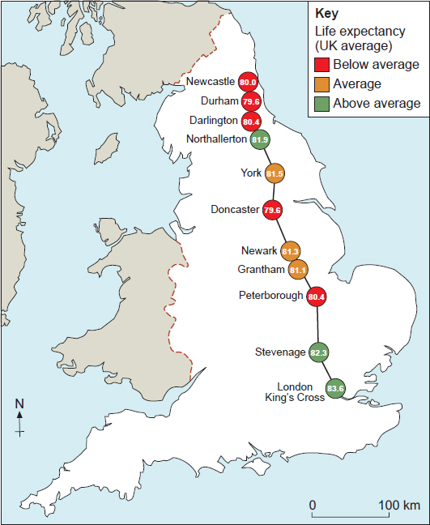
(a) Calculate the median life expectancy shown in the map above.

(2)
(b) How might the data in the map suggest a north-south divide in the UK?
(2)
(Total 4 marks)
Q2.
Figure 1 is a 1:50 000 Ordnance Survey map of an area to the east of Sheffield, a city in the UK.
Figure 1
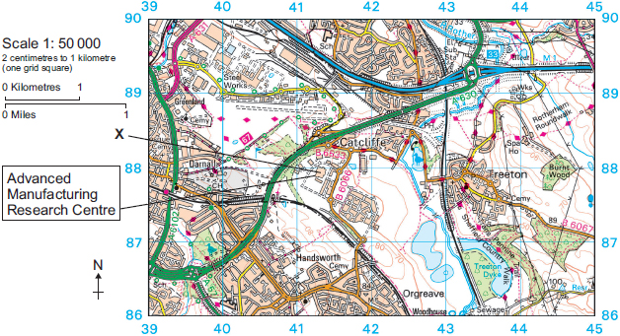
Study Figure 2, a photograph of part of the area shown in Figure 1.
Figure 2
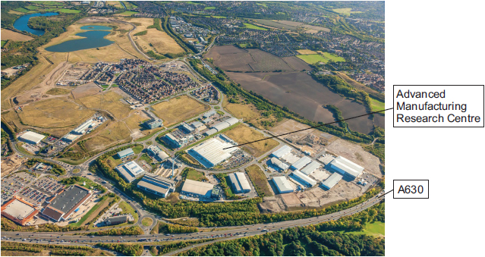
(a) Using Figure 1 and Figure 2, in which direction was the photographer facing when the photograph was taken?
Shade one circle only.

A | North west
B | North east
C | South west
D | South east
(1)
(b) Figure 2 shows the location of Sheffield University's Advanced Manufacturing Research Centre.
Use Figure 2 to describe one characteristic of the Centre's location.
(1)
(Total 2 marks)
Q3.
Study the information below about the planned spending on transport infrastructure in England’s regions 2016–2021.
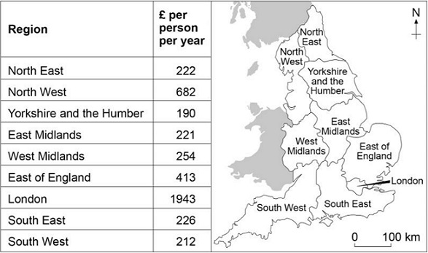
Using the information above, calculate the mean planned spending per person per year 2016–2021 in the nine English regions.

Show your working here.

(Total 2 marks)
Q4.
Give two reasons why there has been a growth in the number of science parks in the UK.
(Total 2 marks)
Q5.
(i) What is meant by ‘sustainability’?
(2)
(ii) Describe two ways in which industrial development is managed sustainably.
(4)
(Total 6 marks)
Q6.
Give two advantages to a local area of the development of a Science Park.
(Total 2 marks)
Q7.
Outline one or more reasons for the decline of traditional industries in the UK.
(Total 3 marks)
Q8.
Study Figure 1, a graph showing the percentage of employment in different industrial sectors in the UK.
Figure 1
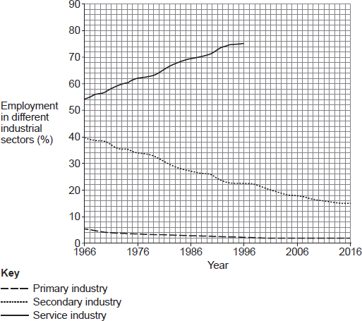
(a) Complete Figure 1 using the following data.

Year | % employment in service industry
2006 | 81
2016 | 84
(2)
(b) Calculate the difference between employment (%) in primary industry and secondary industry in 2016.
Shade one circle only.

A | 13%
B | 17%
C | 69%
D | 82%
(1)
(c) Which one of the following describes the change in employment in secondary industry from 1966 to 2016?
Shade one circle only.

A | It halves
B | It more than halves
C | It stays the same
D | It doubles
(1)
(Total 4 marks)
Mark schemes
Q1.
(a) One mark for working, one mark for correct answer.
Two marks if answer correct with no apparent working.
81.1
AO4 = 2 marks
(b) 1 + 1 or 1 × 2
Comments should show use of the figure at least implicitly.
The highest life expectancy is in London, in the south (1) and as you go further north life expectancy declines. (d)(1) The three most northern places all have below average life expectancy (1) and the majority of those further south are higher. (d)(1) The figure doesn’t show a clear N/S divide (1) for example Northallerton is the third highest and yet clearly in the north. (d)(1) There is a general trend of declining life expectancy as you go further north (1) which supports the idea that the north is worse off (d)(1).
Credit comments which suggest the data has limited value for the UK N/S divide as it only shows data for England.
No credit for stating figures or description of north-south divide in isolation.
AO3 = 2 marks
[4]
Q2.
(a) One mark for the correct answer.
D South east
No credit if two or more statements are shaded.
AO4 = 1 mark
(b) Accept any valid characteristic that can be seen in the photograph, provided it refers to location:
e.g. Just off a main road junction; south of / near the A630; out of town yet still quite close.
AO4 = 1 mark
[2]
Q3.
Award 2 marks if answer correct even if no working.
Allow one mark if evidence of attempting to work out correctly e.g. adding of figures on the table and division by nine if answer subsequently wrong.
£484.78 / £484.8 allow £485
AO4 = 2 marks
[2]
Q4.
Two reasons should be given, e.g.
• they help to support new and growing businesses through research and new ideas (1)
• many of the firms located in science parks are connected with information, high-technology and electronic industries (1)
• the growth in demand for new products such as mobile phones means that new technology needs to be developed, which builds on research in science parks (1)
• they have grown in the UK because of the high reputation of some university science research departments (1).
No credit for vague statements such as growing demand for products, highly skilled labour supply, close to universities, money to develop parks, etc.
AO1 = 2
[2]
Q5.
This mark scheme is from a question paper that assessed a previous specification and has not been edited.
Click [here] to access a document explaining the differences that might apply to it.
(i) Sustainability is the possibility of development today that does
not damage the environment (including resource availability)
and people’s ways of life in the future.
Point mark. 1 mark for a basic definition, 2nd mark for some
development/elaboration/exemplification.
Example response
Sustainability means doing things that don’t harm the environment
(1) and people’s lives in the future (2).
2
(ii) ‘Green factory’ schemes such as those of BASF, Honda, VW and
Sharp manage impacts of development in various ways. Recycled
materials are used in low emission factories (BASF plans to reduce
emission by 25% by 2020) to manufacture products that are
themselves less consuming of finite resources and are made of
recyclable materials. Large sums of money are being invested in
researching green options such as alternative materials and
increased use of non-fossil fuel energy sources.
Point mark. 1 mark each for identifying two examples of ways in
which the impacts of industrial development are sustainably managed.
Credit description of their sustainability for further marks.
Example response
1. BASF has a green factories scheme to reduce its factories’
greenhouse gas emissions (1) by 25% by 2020 (1).
BASF makes environmentally-friendly products for other
companies to use in their manufacturing (1). These include light
plastics for making cars that use less resources by cutting future
fuel consumption (1).
4
[6]
Q6.
This mark scheme is from a question paper that assessed a previous specification and has not been edited.
Click [here] to access a document explaining the differences that might apply to it.
2 × 1
Advantages – brought new jobs to the area / brought prosperity / the
multiplier effect / non polluting industrial area / led to innovation / increase
in house prices.
[2]
Q7.
1+1+1
Or 1+1+1(d)
Or 1+1(d)+1(d)
Candidates should show that they can apply knowledge and understanding linking the factors to the resultant decline. Expect comments on increased mechanisation / robots, globalisation, outdated locations and practices, and government policy. Also credit reference to more recent trends such as ‘green’ policies reducing the demand for coal. Credit any reasonable explanation eg:
Machines and increasingly robots have reduced the need for labour (1) which leads to loss of jobs (1) and the closure of some plants with increased efficiency (1). Labour costs are lower abroad (1) which means they can produce goods more cheaply (1) so UK manufacturing close as they can’t compete (1). Many traditional UK industrial areas are inland e.g. Sheffield (1) which adds to costs of transporting materials / importing raw materials as they are far from large ports (1) and so they are uncompetitive and close (1). Government policies such as privatisation (1) meant that state run industries were sold off (1) and many jobs were lost to make the companies more competitive (1).
AO2 = 3 marks
[3]
Q8.
(a) 1 mark for each point correctly plotted and then joined with a solid line.
Max 1 mark if points plotted without being joined correctly by a solid line.
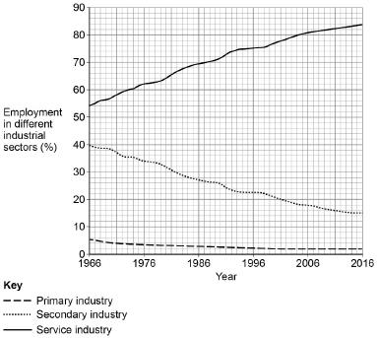
AO4 = 2 marks
(b) One mark for the correct answer:
A – 13%
No credit if two or more answers are shaded.
AO4 = 1 mark
(c) One mark for the correct answer.
B – It more than halves
No credit if two or more answers are shaded.
AO4 = 1 mark
[4]

