Q1.
(a) In which stage of the Demographic Transition Model does total population steadily decline?
(1)
(b) Explain the impact of population decline at this stage of the Demographic Transition Model (DTM) on economic development.
(4)
(Total 5 marks)
Q2.
Study Figure 1 below, a scattergraph showing the link between life expectancy and the percentage of the population with access to safe water supply.
Figure 1
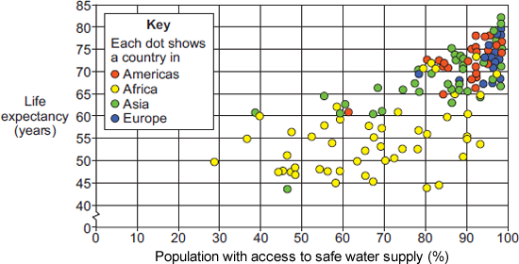
Figure 2 is a black and white copy of Figure 1.
Figure 2
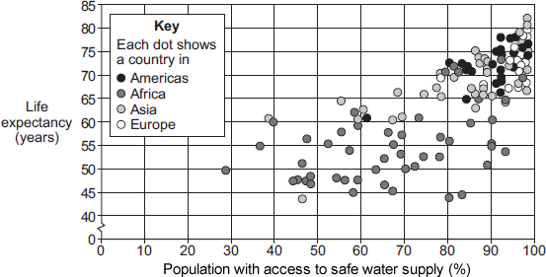
(a) Draw a best fit line on Figure 2.
(1)
(b) Describe how improvements in the quality and quantity of water can change people’s lives.
(4)
(c) Explain the disadvantages of using a single measure of development.
(4)
(Total 9 marks)
Q3.
Study the figure below, population pyramids for two different countries.
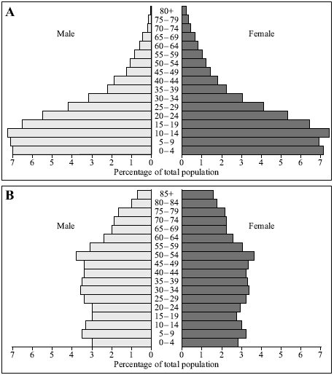
(i) Compare the shapes of the two population pyramids.
(4)
(ii) Explain how these population pyramids suggest that these countries are in different stages of the Demographic Transition Model.
(4)
(iii) Give two ways that population structure changes when a country has entered Stage 5 of the Demographic Transition Model.
(2)
(Total 10 marks)
Q4.
Infant mortality is the rate of child deaths.
Kolkata has a very high infant mortality rate.
Why is infant mortality a useful indicator of economic development?
(Total 4 marks)
Q5.
Explain how mass tourism contributes to the economy of a country.
(Total 4 marks)
Q6.
Cadbury is a TNC that makes chocolate in the UK using cocoa that is grown in Ghana.
Cadbury has tried to help reduce the development gap between Ghana and the UK. In the figure below, a manager outlines some actions that Cadbury has taken in Ghana.
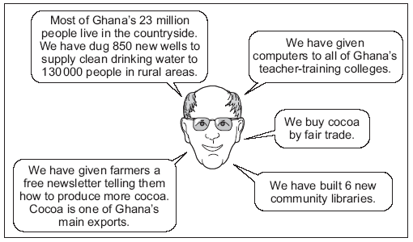
(i) What is meant by ‘fair trade’?
(2)
(ii) Explain how the actions taken by Cadbury could help to improve the standard of living for people in Ghana.
(6)
(Total 8 marks)
Q7.
Study the text below, an extract from a website about a microfinance programme in Africa.

The Hunger Project’s Microfinance Programme is a training, savings and credit programme which began in 1999. One of its schemes involved the setting up of Rural Banks. By the end of 2009 twenty Rural Banks had started to operate. The Rural Banks are independent of the main banks, and they are community owned and led by women.
The Hunger Project helps women to gain access to credit and it teaches the importance of saving. This means that the women can invest in their businesses and increase their incomes. They can then pay their children’s school fees, build pit latrines, buy medicines, pay for health care, and make home improvements or build new homes.
Also, by taking part in the programme, women leaders develop self-confidence and assertiveness, gaining higher status in their households and communities.
Use the extract and your own knowledge to explain how people in the poorer part of the world can attempt to improve their own quality of life.
(Total 4 marks)
Q8.
Study the diagram below, a simplified model of the link between the Demographic Transition Model (DTM) and economic development.
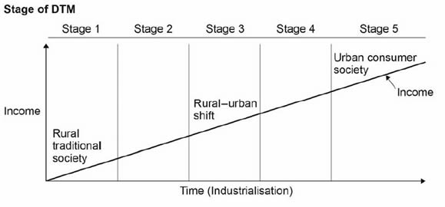
Using the diagram and your own understanding, explain the link between the DTM and a country’s level of development.
(Total 4 marks)
Q9.
Explain how fairtrade can reduce the development gap.
(Total 4 marks)
Q10.
Explain how physical and economic factors have caused uneven development.
(Total 4 marks)
Mark schemes
Q1.
This mark scheme is from a question paper that assessed a previous specification and has not been edited.
Click [here] to access a document explaining the differences that might apply to it.
(a) Stage 5
AO1 = 1
(b) Possible to answer at a range of scales though likely to be at national level. No need for reference to named countries, though credit should be given if this aids clarity. Expect reference to established EU countries / Scandinavia / Japan where examples given. Focus must be on the impact on the economic development. Expect comment on: increasingly less affordable costs of care; declining tax revenues; reduced workforce and possibly productivity; changing balance of spending priorities. Credit comments re positive economic opportunities of an ageing population.
AO2 = 3
AO1 = 1

Level | Marks | Description
2  (Clear) | 3 – 4 | Linked statements showing some explanation of the link between population decline and economic development.  With a smaller working population the government has less income from taxes. This means that it cannot invest in things such as infrastructure that help grow the economy and so it will suffer as a result. A smaller working age population means fewer workers and so potentially lower productivity from businesses.
1  (Basic) | 1 – 2 | Simple statements either with no clear link to impact or impacts stated with no link to population decline.  There are fewer workers in the country. More of the population just has a pension and doesn’t work. The economy declines. The country makes less money.
 | 0 | No relevant content.
[5]
Q2.
This mark scheme is from a question paper that assessed a previous specification and has not been edited.
Click [here] to access a document explaining the differences that might apply to it.
(a) Best fit line should have left to right inclination and be roughly in the centre of the scatter. Straight line only.
AO3 – 1
1
(b) 2 × 2 or 1 × 3 + 1 × 1
Candidates need to show how quality of life improves. Maximum 1 mark each for naming way either quality or quantity improves.
Quality – water purification, treatment works, covering of wells, filtering, separation from sewage.
Quantity – wells, boreholes, dams, stand pipes in shanty towns. Improvements in quality of life can relate to such things as reduced illness and disease, less time spent fetching water, reduced stress / danger and increased ability to work and earn as a result of any of the former.
AO1 – 3
AO2 – 1
4
(c) Candidates should show an awareness of how using a single measure can be misleading for any number of reasons. These might include the fact that they are averages and so don’t reflect elites or spatial variations, that different aspects develop at different rates, a country might score well on one measure but not another. Credit use of examples to illustrate.
Level 1 (Basic) (1–2 marks)
Simple statements indicating the disadvantages but no attempt to explain.
It is misleading to use just one because it is an average figure. A country might score better on one thing than another and you could look at the wrong thing.
Level 2 (Clear) (3–4 marks)
Linked statements showing some explanation of the disadvantages. Max 3 marks for one disadvantage clearly explained. Must have 2 or more disadvantages for full marks.
The measures are misleading because they are an average for the country e.g. Saudi Arabia where the GNP is high but most of the money is held by a very few extremely rich people. This might means you get the impression it is more developed than it is. Some aspects of development change before others such as death rate which falls before birth rate so if you just looked at death rate you would not really be able to tell which stage of development a country is at.
AO1 – 2
AO2 – 2
4
[9]
Q3.
This mark scheme is from a question paper that assessed a previous specification and has not been edited.
Click [here] to access a document explaining the differences that might apply to it.
(i) Level 1 (Basic) 1-2 Marks
The question is about the SHAPES of the population pyramids.
Simple statements with no attempt to compare the two pyramids.
The information can be about the shape or details taken from the pyramid.
Pyramid A has a wide base. There are lots of children. The age
range with the greatest number is between 10 and 14. There are
relatively few people living beyond 60. It is narrow at the top.
Pyramid B has a narrow base. The sides are relatively straight.
The age range with the greatest number is between 50 and 54.
Relatively large numbers live to old age.
Level 2 (Clear) 3-4 Marks
There must be some attempt to compare with at least two clear
differences to reach the top of Level 2.
Pyramid A has a wider base than Pyramid B. More people live beyond
70 in Pyramid B.
The highest age range in Pyramid A is 10-14, whereas in
Pyramid B it is 50-54.
4
(ii) Level 1 (Basic) 1-2 Marks
Simple statements with little attempt to relate shape of pyramid
to reasons why it can be placed in a particular stage of the DTM.
Pyramid A is in Stage 1 or 2. Pyramid B is in Stage 4/5.
Level 2 (Clear) 3-4 Marks
Statements showing link between the shape of the pyramid
and reasons why it can be considered to be in a particular
stage of the DTM. For 4 marks must refer to BOTH pyramids.
Pyramid A is in Stage 2, because the wide base suggests a high
birth rate. The narrow top suggests a high death rate, which is
typical of this stage. Pyramid B’s narrower base suggests the use
of contraception and so a lower birth rate typical of Stage 4/5.
The better medical facilities mean that there is a lower death
rate and so more people are living to older ages. Pyramid A
has reached Stage 3 as there is a reduction in the number of
children in the 0-10 age group so the birth rate is beginning to drop.
4
(iii) 2 × 1
Upside down pyramid/wider top/narrower bottom/ageing
population/fewer children/more elderly females/dependency
if related to elderly/greater life expectancy.
2
[10]
Q4.
This mark scheme is from a question paper that assessed a previous specification and has not been edited.
Click [here] to access a document explaining the differences that might apply to it.
Level 1 (1-2 marks)
Basic ideas which suggest that if many children die it must show poor
living standards/healthcare etc or if more survive it might show better
levels of economic development.
Level 2 (3-4 marks)
Clear links to other factors which might include links to
education/diet/clean water/housing quality. Clear understanding that
economic development can increase spending on social conditions.
[4]
Q5.
This mark scheme is from a question paper that assessed a previous specification and has not been edited.
Click [here] to access a document explaining the differences that might apply to it.
Candidates should show an understanding of the different contributions of tourism to the economy. They should refer to things such as the development of infrastructure, widening the economic base, the support of local industries and the value of foreign currency. They may comment on this as both negative and positive and either is acceptable. May well refer to a poorer country, but do not have to. Credit use of examples and figures to illustrate. Could be the home (origin) or destination economy.
Level 1 (Basic) (1–2 marks)
Simple statements indicating contributions but no attempt to explain.
Jobs and money as single statements are not credited. More jobs = L1 (low).
Tourists spend a lot of money. Jobs in hotels are created. There is a multiplier effect.
Level 2 (Clear) (3–4 marks)
Linked statements showing some explanation of the contribution.
Tourism accounts for 15% of Kenya’s economy – this is quite a large percentage. The money made can be used to develop the country such as building roads. Tourists also create a market for local handicrafts such as Masai bracelets which can keep people in work. The money brought in is foreign currency such as dollars which has more value than Kenyan money and so this makes the economy stronger.
AO1 – 2
AO2 – 2
[4]
Q6.
This mark scheme is from a question paper that assessed a previous specification and has not been edited.
Click [here] to access a document explaining the differences that might apply to it.
(i) Fair trade is buying from poorer producers at reasonable prices
that help sustain their livelihoods, (even though these prices may
be above the market rate). Point mark. 1 mark for basic definition,
2nd mark for development/elaboration.
Example response
Fair trade is paying reasonable prices to people like poor
farmers (1) to keep them going (1) financially.
2
(ii) Level 1 Basic (1–4 marks)
Simple ideas as to why Cadbury’s action/s such as shown in
the figure may improve social/economic conditions. Likely to
show limited development from the figure.
Example response
Free newsletter to tell 75 000 farmers how to produce more
cocoa makes them be better off.
Level 2 Clear (5–6 marks)
Some clear explanation of why Cadbury action/s may improve
social/economic conditions in Ghana. Likely to clearly develop
points from the figure.
Example response
The newsletter telling 75 000 farmers how to produce more
cocoa should also help because they will have more cocoa to
sell and so increase earnings.
6
[8]
Q7.
This mark scheme is from a question paper that assessed a previous specification and has not been edited.
Click [here] to access a document explaining the differences that might apply to it.
Evidence of use of the extract and own knowledge should be discernible, although either may be slight. The extract will be things such as the community owning the banks; women increasing incomes, sending children to school.
Own knowledge may be seen via clarity re other community-led development schemes or in comment upon elements of the programme such as the importance of empowering women or the contribution they make to the quality of life of the household.
Level 1 (Basic) (1 – 2 marks)
Simple statements with no mention of improvement in quality of life or poor people themselves.
Straight lifts with no comment. The extract or own knowledge only.
They can send their children to school. There are latrines now. The women themselves get to run the programme. The people who will be affected by the development are the ones responsible.
Level 2 (Clear) (3 – 4 marks)
Linked statements showing improvement, clarity with reference to people’s own actions.
Both the extract and own knowledge.
The scheme is like Farm Africa where the locals run a goat programme. This means that the people themselves are making their lives better because they don’t rely on outsiders. The Grameen Bank which I have studied also gives loans to people so they can start trading and making money and so improve their own lives. In the extract they can pay for their healthcare now so they will feel much better. They can then have the energy to try and develop their own businesses and be self-sufficient.
AO1 – 2
AO2 – 1
AO3 – 1
4
[4]
Q8.

Level | Marks | Description
2  (Clear) | 3 – 4 | AO2 – Shows clear understanding of the process of development and the concept of the DTM.  AO3 – Uses the figure effectively and offers development to clearly evaluate the links between the DTM and levels of development.
1  (Basic) | 1 – 2 | AO2 – Shows limited understanding of the process of development and the concept of the DTM.  AO3 – use the figure OR own knowledge to begin to simply evaluate the links between the DTM and levels of development.
 | 0 | No relevant content.
Indicative content
• Level 2 answers will provide reasoning that connects the processes of economic and social development.
• Level 1 answers will provide basic reasons or merely assert the connections between economic and social development.
• Answers should make use of the figure which shows a process of industrialisation over time and corresponding urbanisation and income growth.
• Students should also make it apparent that they are familiar with the Demographic Transition Model through reference to elements such as its stages, the corresponding population structures and countries that represent these stages.
Answers might draw straightforward connections such that the link between the two are clear:
• Stage 2 countries are at lower levels of economic development, LICs, with corresponding low incomes and a predominantly rural and agrarian society.
• Stage 3 would generally be associated with NEEs who utilise the demographic dividend of their population structure in creating rapid industrialisation and income growth.
• Stages 4 / 5 are HICs with well developed economies, a predominantly urban society and declining or static populations.
• The explanation may take economic growth as the driver so that development means that populations become more focussed on material wealth so that they no longer wish to have expensive larger families. Also that development allows better health care reducing infant mortality and the imperative to replace children.
• The opposite direction may be taken so that as the population growth slows and family size falls surplus income becomes available for investment and growth.
• More sophisticated answers might argue that the two are co-dependent and that a causal link cannot easily be established.
• Credit should also be given if the link is qualified suggesting that other factors such as the emancipation of women or state priorities might change populations without economic development e.g. Cuba.
No credit for description of either the Demographic Transition Model or economic development in isolation.
AO2 = 2
AO3 = 2
[4]
Q9.

Level | Marks | Description
2  (Clear) | 3 – 4 | AO1 – Demonstrates clear knowledge of the principles / operation of fairtrade.  AO2 – Shows clear understanding of the process of development.
1  (Basic) | 1 – 2 | AO1 – Demonstrates basic knowledge of the principles / operation of fairtrade.  AO2 – Shows limited understanding of the process of development.
 | 0 | No relevant content.
• Level 2 answers will provide reasoning that connects the operation of fairtrade with a reduction in development problems.
• Level 1 answers will provide basic reasons or merely assert the connections between fairtrade and reducing development problems.
• No credit for description of economic development in isolation.
Indicative content
• Answers might draw straightforward connections such that the link between the two are clear.
• The specification does not require an example and nor does the question expect one, but candidates may structure their answer around the use of an example.
• Fair prices for primary products means that farmers and therefore countries will be much less subject to changing prices on world markets and can have a more stable income.
• Fairtrade means that farmers in LICs are paid a fair price for their goods, e.g. coffee and bananas so they can provide an income for their families.
• Increasing individual farmer income means they will no longer be as poor and may be able to plan for the future.
• Improvements may also follow in education or health care, sometimes funded by the fairtrade organisations which will improve social measures of development e.g. a rise in HDI or literacy scores.
AO1 = 2 marks
AO1 = 2 marks
[4]
Q10.

Level | Marks | Description
2  (Clear) | 3 – 4 | AO1 – Clear knowledge of physical and economic factors affecting development.  AO2 – Shows clear understanding of physical and economic factors on development.
1  (Basic) | 1 – 2 | AO1 – Limited knowledge of physical and / or economic factors affecting development.  AO2 – Shows limited understanding of physical and / or economic factors on development.
 | 0 | No relevant content.
• Level 2 answers will apply geographical knowledge and understanding to present a reasoned explanation.
• Level 1 answers will be simplistic, perhaps simply descriptive of varying development with limited reasoning.
• Max L1 for only one of physical or economic factors.
Indicative content
• Development need not be through named places but use of an example is likely to add clarity. Development may also be found in explanation of processes of development.
• It is likely that answers will focus on the negative but it would be legitimate to offer and answer focussed on positive aspects of development factors and / or and answer of contrasting fortunes.
• Physical factors:
◦ Landlocked countries will struggle to trade goods easily without ports, many of the world’s landlocked countries are LIC/NEEs.
◦ Natural Hazards may limit economic growth as infrastructure will be damaged, limiting industrial output and trade and funds will be needed for repairing damage rather than new development which would allow progress.
◦ Climate related diseases and pests will limit the ability of a population to work and irregular / limited rainfall will limit water supply, essential for settled farming. This is the least secure physical and developmental link.
• Economic factors:
◦ HICs and TNCs pay as little as possible for their commodities and raw materials and LICs are further vulnerable to world market fluctuations.
◦ Many LICs are trapped in primary product dependency and rely for a large % of their income on a single primary product eg Zambia 60% GDP from copper.
◦ Processing of raw materials takes place in HICs so LIC/NEEs are unable to add value to their products eg Cocoa Ivory Coast vs HIC chocolatiers.
No credit for factors other than physical and economic.
AO1 = 2 marks
AO2 = 2 marks
[4]

