Q1.
Outline how uneven development can cause international migration.
(Total 3 marks)
Q2.
Outline the limitations of economic measures of development.
(Total 3 marks)
Q3.
The changing economic world
Study the scattergraph showing Gross National Income (GNI) and birth rate for selected countries in 2016.
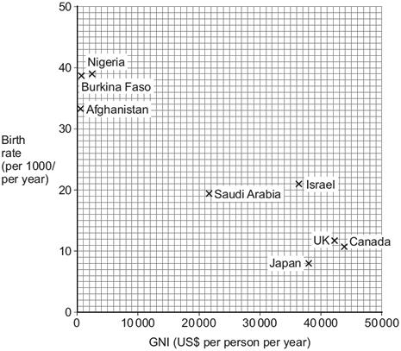
(a) Plot the following data on the scattergraph.

Country | Birth rate  (per 1000/per year) | GNI (US$ per person)
Germany | 9 | 44 000
(1)
(b) Draw a best fit line on the scattergraph.
(1)
(c) ‘Japan is in stage 5 of the Demographic Transition Model (DTM) and is a highly developed country.’
Explain this statement.
Use the scattergraph and your own understanding.
(3)
(Total 5 marks)
Q4.
Outline how one historical factor can lead to uneven development.
(Total 2 marks)
Q5.
(i) What is the meaning of the term ‘birth rate’?
(2)
(ii) Complete the following table by working out the natural increase in population for India.

 | Per 1000 per year
Birth rate | 30
Death rate | 11
Natural increase
(1)
(Total 3 marks)
Q6.
Study Figure 1, the Demographic Transition Model.
Figure 1
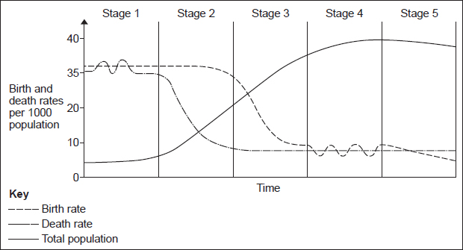
Using Figure 1, suggest how population change in Stage 3 may have economic benefits.
(Total 3 marks)
Q7.
What is meant by infant mortality rate?
(Total 2 marks)
Q8.
Study the table below showing the Gross National Income (GNI) data for selected countries in 2016.

Country name | GNI  US$ per person
Argentina | 11 960
Belgium | 41 860
China | 8 260
Finland | 44 730
Haiti | 780
India | 1 680
Kenya | 1 380
Mali | 750
Poland | 12 680
Spain | 27 520
United Kingdom | 42 390
(a) Calculate the median value for the GNI data in the table above.

Space for working

(2)
(b) Suggest one reason why the GNI per person varies between the countries shown in the table above.
(1)
(Total 3 marks)
Q9.
There are various measures of a country’s development.
(i) Choose one measure and explain its advantage(s) as a measure of a country’s development.
(3)
(ii) Choose one measure and explain its disadvantages as a measure of a country’s development.
(3)
(Total 6 marks)
Q10.
The figure below shows the Human Development Index (HDI) for the UK and Ghana, a country in Africa.

Country | HDI ranking (out of 177 countries)
UK | 16
Ghana | 133
The following statements describe differences between the UK and Ghana.
Which three statements are likely to be true? Tick the three correct boxes.

Ghana is more developed than the UK. | 
Life expectancy is higher in the UK than in Ghana.
Literacy rates are higher in Ghana than in the UK.
Average income per person is higher in the UK than in Ghana.
The birth rate is higher in Ghana than in the UK.
(Total 3 marks)
Q11.
Study the figure below, population pyramids of two different countries.
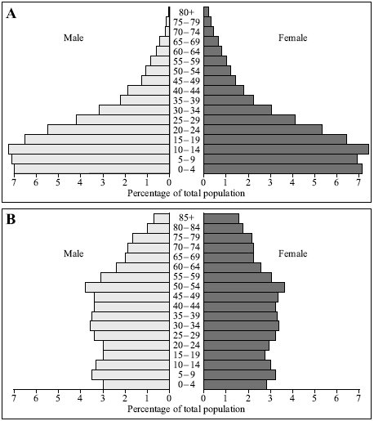
(i) Which age group has the highest percentage in pyramid A?
(1)
(ii) What percentage of the population are females aged between 10 and 14 years of age in pyramid B?
(1)
(Total 2 marks)
Q12.
The figure below shows the Human Development Index (HDI) for the UK and Ghana, a country in Africa.

Country | HDI ranking (out of 177 countries)
UK | 16
Ghana | 133
(i) Name two indicators that are used to produce the HDI ranking.
(2)
(ii) Name one other indicator of a country’s level of development.
(1)
(Total 3 marks)
Q13.
Development Gap
Study the figure, a scattergraph showing the link between Gross Domestic Product (GDP) and infant mortality. Each dot represents a different country.
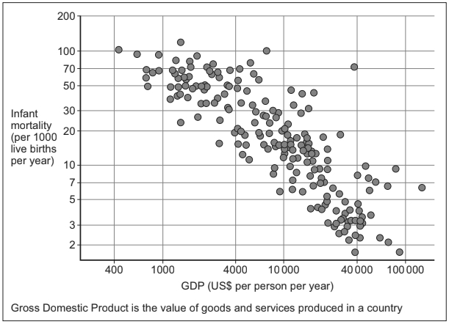
(a) Draw a best fit line on the scattergraph above.
(1)
(b) Describe the relationship shown by the graph.
(2)
(c) Suggest a reason(s) for the relationship shown in the figure above.
(3)
(Total 6 marks)
Q14.
Outline one disadvantage of using a single measure of development such as income.
(Total 2 marks)
Q15.
Give one disadvantage of using an economic measure of development such as GNI.
(Total 1 mark)
Q16.
Study the figure below, a world map showing the global distribution of Human Development Index (HDI) values.
HDI combines data on life expectancy, educational levels and income, with values ranging from 0 (worst) to 1 (best).
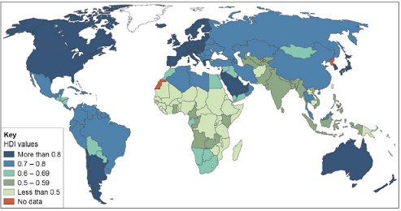
Using the figure above, compare HDI values in Africa and South America.
(Total 2 marks)
Q17.
Suggest two ways that the level of economic development of a country might affect the quality of life of its people.
(Total 4 marks)
Q18.
Study Figure 1, a table showing Gross National Income (GNI $) and Infant Mortality for a number of South American countries.
Figure 1

Country | Gross National Income  2013  ($ per person) | Infant Mortality  2013  (per 1000 births)
Argentina | 17 250 | 12
Brazil | 11 690 | 12
Bolivia | 2 550 | 31
Colombia | 7 590 | 15
Chile | 15 230 | 7
Ecuador | 5 760 | 19
Guyana | 3 750 | 30
Paraguay | 4 010 | 19
Peru | 6 270 | 13
Suriname | 9 370 | 20
Uruguay | 15 180 | 10
Venezuela | 12 550 | 13
Study Figure 2, a scattergraph showing the information in Figure 1.
Figure 2
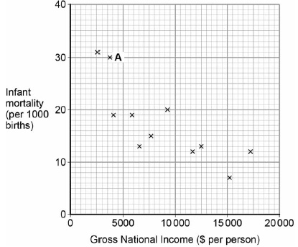
(a) Name the country at point A on the scattergraph.
(1)
(b) Complete the scattergraph by plotting the data for Uruguay.
GNI: 15 180
Infant mortality: 10
(1)
(c) Draw a line of best fit (trend line) on the scattergraph to show the relationship between NI and infant mortality.
(1)
(d) Suggest one reason for the relationship between GNI and infant mortality shown on the scattergraph.
(2)
(e) Using the data in Figure 1, calculate the average infant mortality rate for the twelve countries shown.
Show your working.
(2)
(Total 7 marks)
Q19.
The changing economic world
Study the table showing the results of a survey of life satisfaction for a number of European countries in 2011.
Life satisfaction is how happy people are with their quality of life.
0 = lowest possible life satisfaction score
10 = highest possible life satisfaction score

Country | Life satisfaction score
Bulgaria | 5.5
Croatia | 6.8
Denmark | 8.4
Estonia | 6.3
Finland | 8.1
Germany | 7.2
Hungary | 5.8
Italy | 6.9
Netherlands | 7.7
Portugal | 6.8
UK | 7.3
(a) Calculate the median value for the life satisfaction data in the table.

Show your working here:
Median =
(2)
(b) Suggest one reason why life satisfaction scores vary between countries.
(1)
(c) Give one disadvantage of using a social measure of development such as life satisfaction.
(1)
(Total 4 marks)
Q20.
Study the graph below showing the Fairtrade price and the London market price for one type of coffee, 1989–2010.
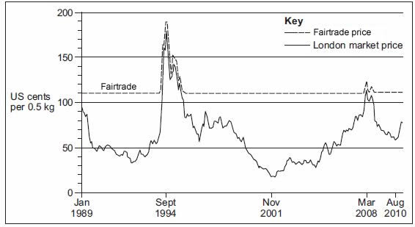
(a) Use the graph above to describe the link between the Fairtade price and the London market price of coffee.
(2)
(b) Describe one way a poorer country benefits from being part of a trading group.
(2)
(Total 4 marks)
Q21.
Suggest one reason why Fairtrade schemes are not always successful.
(Total 2 marks)
Q22.
Outline one way that Fairtrade helps to deal with the problems of unequal development.
(Total 2 marks)
Q23.
Study the information below, which describes the effects of a microfinance project in Ghana, a country in Africa.

Before microfinance was available in the area the crops were failing and the people were going from crisis to crisis, especially in the dry season where they would often have no food or money. The children would have so little to eat that they had become extremely malnourished and there was a very high mortality rate.
Education showed villagers how to plant and grow dry season crops like tomatoes, onions and cabbages.
The difference in the crops was amazing. Villagers now had food all through the year for themselves and had a surplus to sell. This meant they could afford to buy health care, school uniforms and pay for labour on their small farms meaning they could farm much bigger areas of land which increased their food supplies.
(a) Using the information, state two challenges faced by the people of the area.
(2)
(b) Suggest one way microfinance loans can help to reduce the development gap.
(1)
(Total 3 marks)
Mark schemes
Q1.
Candidates are not expected to make any use of Figure 6 and there is no credit for doing so, however they may use this to inform their answer by realising that the migration has taken place in the opposite direction to that shown by the remittance flows.
People move from poorer countries to richer ones for better paid jobs / as economic migrants (1) and for a higher quality of life. (1) The wealth difference need not be large, it is the development gap which causes people to move (1) for example the estimated 900 000 Polish migrants in the UK. (1) Many people flee conflict in LICs and move to safer HICs (1) for example more than one million migrants to Europe from sub Saharan Africa 2010-2017. (1) Migrants may also be encouraged to move to other countries as a source of cheap labour (1) illustrated by the number of poorly paid Indian Sub-continent workers in gulf states such as Qatar / Mexicans moving to the USA. (1)
No credit for description or use of Figure.
AO1 – 3 marks
[3]
Q2.
Candidates should show an awareness of how economic measures, especially simplistic measures such as GNI, can be misleading eg Economic measures do not take any account of people’s quality of life (1) which is important in social terms (1) as development involves aspects other than simply economic (1) Economic measures tend to be per person (1) so do not allow for extremes of wealth and poverty (1) eg Saudi Arabia has vast oil wealth and high GNI which is not shared (1) Many economic measures are in US$ so do not allow for the relative spending power of different currencies (1) Economic measures have limited value in the poorest countries (1) because many people are subsistence farmers / work in the informal sector (1) so are economically active but will not feature in such measures (1).
Max 2 for 2 separate points.
1x3, or (1+1)+1
No credit for general answers regarding the unreliability of single measures other than economic.
No credit for outlining the advantages of non-economic measures.
AO1 = 3 marks
[3]
Q3.
(a) One mark for the correct alignment of each value in the plot.
Germany does not have to be named.
AO4 = 1 mark
(b) Line should be straight, approximately in the centre of the scatter and inclined top left to bottom right.
AO4 = 1 mark
(c) Candidates should make reference to the graph through using country name(s) and / or data provided. They should show that they can apply knowledge and understanding in analysing Japan’s position on the graph. Expect recognition of Japan’s place in a negative correlation showing that with a high level of wealth the birth rate has fallen very low. The connection should be made with the DTM such that it marks a general progression of population structure associated with corresponding economic changes.
The graph shows a negative correlation between GNI and birth rate (1). The birth rate falls as the DTM progresses, which generally happens alongside economic growth, shown here by Japan’s high GNI / low BR (1). As people become wealthier they realise they don’t need to have so many children (1) As countries’ GNI grows they can invest in health care which means lower infant mortality so fewer children need to be born in an effort to make sure some survive (1). As the birth rate begins to fall more money will become available in households and more widely in the economy for investment which will increase GNI (1). At stage 5 will be Japan with very low birth rate and high wealth (1).
Max 1 mark if no reference to the graph, at least implicitly.
Reserve 3rd mark for the link between DTM and development.
AO3 = 3 marks
[5]
Q4.
Candidates should clarify the factor and its resultant impact upon development.
There is no requirement for an example though it may aid clarity and development.
Specification states this in the context of LIC / NEE but question does not, therefore allow valid positive points re HICs.
One mark for a basic statement, e.g.
• countries used to be colonies (1).
• past wars left the country worse off (1).
Two marks for a developed idea, e.g.
• many African countries were European colonies (1) this meant their resources were exploited for European gain and hindered their independent development (d) (1).
• past civil wars such as Mozambique 1977-1992 (1) left much of the infrastructure damaged and therefore hampered development (d) (1).
No credit for factors other than historic ones.
AO1 = 2 marks
[2]
Q5.
This mark scheme is from a question paper that assessed a previous specification and has not been edited.
Click [here] to access a document explaining the differences that might apply to it.
(i) Number of live births/how many/the number (of babies) born (1)
per 1000 (head of population) NOT per year (1).
2
(ii) 19
1
[3]
Q6.
1+1+1
Or 1+1+1(d)
Or 1+1(d)+1(d)
Candidates should make reference to Figure 1 through reference to the birth and death rates and total population change shown in stage 3. They should show that they can apply knowledge and understanding by making the connection between stage 3 of the DTM and economic benefits.
Figure 1 shows birth rates falling, which means more money will be available in households (1) which can lead to increased spending in the country (1). Fewer babies being born can reduce the amount of money needed for maternity services and schools (1) which allows more to be spent on developing industry (1). As the total population increases there are more people to work in industry (1) so the country can increase its GNI (1).
Max 1 mark if no reference to Figure 1, at least implicitly.
AO3 = 3 marks
[3]
Q7.
1+1
1 mark for accuracy in terms of death – ‘children/babies who die under the age of 1’.
1 mark for the accurate description of rate – ‘per 1000 (live) births per year’.
Can still gain credit if ‘live’ is not included.
1 mark overall can be given for the correct rate if the concept of death is included in the answer but the age given is incorrect.
AO1 =2 marks
[2]
Q8.
Award 2 marks if answer correct even if no working.
(a) Award 2 marks if answer correct even if no working.
Allow one mark if evidence of attempting to work out correctly e.g. ranking of figures on the table but answer subsequently wrong.
Dollar sign not necessary.
Median = 11 960
AO4 = 2 marks
(b) Credit any reasonable suggestion.
Candidates should make reference to table showing the Gross National Income through using country name(s) and / or data provided, e.g.
Some of the countries are poor e.g. Kenya (1)
Haiti has a lower GNI than most other countries because it has a poorly developed economy (1)
European countries have the highest GNI scores because they have economies based around high value services (1)
The GNI scores in the middle of the range are in NEEs as their economies have developed to create higher value. (1)
AO3 = 1 mark
[3]
Q9.
This mark scheme is from a question paper that assessed a previous specification and has not been edited.
Click [here] to access a document explaining the differences that might apply to it.
(i) Point Marking. Max 1 if not clear which measure is being explained.
(3 × 1 or 1 × 2 and 1 × 1). Allow any (credible) measure of development.
Advantages
E.g. Death rates – A high death rate would suggest that there are
more diseases or fewer doctors, which would suggest that the country
is less developed
GNP - Will give a indication of how rich a country is as it is the value of
the goods and services earned by a country, so the higher the GNP
the more developed a country is likely to be.
Urban population – The higher the urban population the more
developed a country is, as it is more industrialised.
Birth rates – A country with a high birth rate could be considered to be
at a low level of development because the number of children is
important in determining a man’s status and is an insurance against
the high level of infant mortality. Might also be connected with poor
access to family planning, contraception, low levels of female literacy.
Other measures may be given.
3
(ii) Disadvantages
Point Marking – max 1 mark if the measure is not clear.
E.g.
Death rates – Many MEDCs have higher death rates than LEDCs
because of the ageing population or death from cancer or traffic
accidents. It is an average figure only.
GNP - The GNP may not be evenly distributed, there may be an elite
which represents the bulk of the GNP and the majority of the
population is poor.
Urban population – LEDCs have a more rapidly increasing urban
population so they are likely to become more urbanised but still remain
LEDCs due to lack of employment opportunities or poor development
of resources.
Birth rates – In places like Kerala in S India where health care has
been made a priority and the rate of infant mortality is low but is still
least developed part of India. Other measure may be considered.
3
[6]
Q10.
This mark scheme is from a question paper that assessed a previous specification and has not been edited.
Click [here] to access a document explaining the differences that might apply to it.
1 mark per correct tick. More than 3 ticks = 0 marks.

Ghana is more developed than the UK.
Life expectancy is higher in the UK than in Ghana.
Literacy rates are higher in Ghana than in the UK.
Average income per person is higher in the UK than in Ghana.
The birth rate is higher in Ghana than the UK.
[3]
Q11.
This mark scheme is from a question paper that assessed a previous specification and has not been edited.
Click [here] to access a document explaining the differences that might apply to it.
(i) 10 – 14 (years).
1
(ii) 3 (%).
1
[2]
Q12.
This mark scheme is from a question paper that assessed a previous specification and has not been edited.
Click [here] to access a document explaining the differences that might apply to it.
(i) Possible indicators: life expectancy, standard of living (e.g. GDP/GNI)
and level of education (e.g. school enrolment, literacy level). Vague
words such as ‘health’, ‘wealth’, ‘education’ are not creditworthy.
Point mark. 1 mark per indicator.
Example response
1. GNI (1)
2. How many people go to school (1)
2
(ii) Possibilities include: mobile phones (per 1000), internet
use (per 1000), infant mortality, birth rate, clean water
access. Must be other than the candidate’s answer to (i).
1
[3]
Q13.
This mark scheme is from a question paper that assessed a previous specification and has not been edited.
Click [here] to access a document explaining the differences that might apply to it.
(a) Should have upper left to lower right inclination and be roughly in the centre of the scatter. Straight line only.
AO3 = 1
(b) 1 + 1
Marks can be achieved either through developed or separate points: Negative correlation / relationship (1), which means that as GDP goes up, infant mortality goes down (1) countries with a low GDP have a high infant mortality (1). Credit figures if used in support of statement of the relationship. Credit accurate reference to anomalies.
AO1 = 1
AO2 = 1
(c) 3 × 1, or (1 + 1) + 1 1 × 3
No credit for simply describing the relationship, candidates need to offer and / or develop reasons for it. There are many possibilities and credit should be given to any reasonable link. Examples range from the simplistic: higher incomes means more money available for better standard of living / more doctors / spent on health care and so mortality rates fall, to the more detailed: GDP increase will suggest that money can be invested in basic infrastructure such as clean water supplies and sanitation which will prevent the simple infections from which many infants die, GDP increase allows governments to spend on programmes such as vaccination so that fewer children die and as initiatives such as these take hold adults will have fewer children in the knowledge that survival rates are better, allowing more care of those children they do have and thereby reducing mortality.
AO1 = 1
AO2 = 2
[6]
Q14.
Credit one reason only.
Candidates should show an awareness of how using a single measure can be misleading.
One mark for a basic statement, e.g.
• a single measure might just consider income and nothing else (1)
• average figures of one indicator are misleading because of huge differences in a country (1).
Two marks for a developed idea, e.g.
• a single measure may only measure the economic state of the country. Combined measures such as HDI take into account social indicators such as education levels (2)
• using one measure can be misleading because it is an average for the country, e.g. Saudi Arabia where the GNI is high but most of the money is held by a very few extremely rich people (2)
• some aspects of development change before others, such as death rate which falls before birth rate, so if you just looked at death rate you would not really be able to tell the stage of development of a country (2).
AO2 = 2
[2]
Q15.
Credit one reason only, there is no requirement to use the Figure.
They should show an awareness of how economic measures, especially simplistic measures such as GNI, can be misleading e.g.
• Economic measures do take any account of people’s quality of life which is important in social terms (1)
• Economic measures tend to be per person / are an average figure so do not allow for extremes of wealth and poverty (1)
• Many economic measures are in US$ so do not allow for the relative spending power of different currencies (1).
No credit for general answers regarding the unreliability of single measures other than economic.
AO2 = 1 mark
[1]
Q16.
Responses should focus on differences in HDI values between Africa and South America. Expect statements backed up by data from the map, e.g.
• HDI values in South America are generally higher than in Africa (1)
• the vast majority of countries in South America have values above 0.7, whereas most countries in Africa show HDI values under 0.6 (1)
• the highest figures for HDI are in the extreme north and south of Africa showing values exceeding 0.6 (1). The highest in South America are in the southern part, with values above 0.8 (1).
Credit reference to individual countries where relevant.
No credit for statements about other parts of the world.
AO4 = 2
[2]
Q17.
‘Might affect the quality of life’ could mean a positive or a negative impact.
2 × 2 marks
1 mark – For an identified point.
2nd mark – for some extension of the identified point or some appropriate development.
Indicative content
• Wider provision of medical services.
• Increased access to education.
• Higher rates of adult literacy.
• Improved food security.
• Improvements infrastructure.
• Less disease- safe water, sewage disposal.
AO2 = 4
[4]
Q18.
(a) Guyana
AO4 = 1
(b) Infant mortality must clearly be on 10 line, GNI somewhere between 15 000–16 000
AO4 = 1
(c) A line which down left to right (negative), somewhere within the range of points.
AO4 = 1
(d) 1 mark – Basic idea – degree of wealth linked to level of medical care, health services, social services, education, family income, food supply and diet.
2nd mark – Some development based on link to infant mortality.
AO3 = 2
(e) 1 mark – for calculating the average infant mortality rate at 16.75 (per 1000 births) accept any number between 16 and 17.
2nd mark – for showing working out.
AO4 = 2
[7]
Q19.
(a) One mark for working. One mark for answer.
Median = 6.9
AO4 = 2
(b) Credit any reasonable suggestion.
Students should make reference to the figure through using country name(s) and/or data provided, e.g.
Bulgaria has a life satisfaction score of just 5.5 because it is poorer than the other countries (1)
The more economically developed north-west European countries have better social care provision hence their higher scores (1)
In Germany people are well off so can buy material goods giving them a higher score (1)
AO3 = 1
(c) Credit one reason only, there is no requirement to use the figure.
They should show an awareness of how social measures, especially something as difficult to define as ’life satisfaction‘, can be misleading e.g.
• Social measures are not as reliable as ’hard‘ data such as GNI (1)
• ’Life satisfaction‘ is a difficult thing to measure and different people‘s idea of satisfaction will vary (1)
• The scale is only 0-10 so people may just score themselves in the middle (1)
No credit for general answers regarding the unreliability of single measures other than social.
AO2 = 1
[4]
Q20.
This mark scheme is from a question paper that assessed a previous specification and has not been edited.
Click [here] to access a document explaining the differences that might apply to it.
(a) 1 + 1
First mark for statement, second for elaboration. Note that marks are allocated for skills so it must be clear the candidate has responded to the resource. Fairtrade has a minimum price of 110 cents (1) which goes up if the market price does (1) and when the market price goes up it’s still more (1) by a premium of 10 cents (1).
AO3 = 2
(b) 1+1
First mark for statement, second for elaboration. Credit any reasonable benefit that accrues from membership, e.g. when a country joins it will have greater power / influence than it would alone (1), so it can charge more for its goods (1) / negotiate a better deal (1). Gaining more money from being in a trading group (1) means a country can spend more on developing (1).
AO1 = 2
[4]
Q21.
Credit one reason only.
One mark for stating a reason, e.g.
• prices of Fairtrade products are often more expensive (1)
• large companies such as TNCs may control production of a commodity (1).
Second mark for elaboration and development of the reason, e.g.
• prices of Fairtrade products are often more expensive, so people may not buy them as much (2)
• large companies such as TNCs may control production of a commodity, so there is less opportunity to introduce Fairtrade schemes (2).
AO2 = 2
[2]
Q22.
Credit one way only.
One mark for stating a way of dealing with unequal development, e.g.
• fairtrade gives farmers a guaranteed price for their products (by setting up co-operatives) (1)
• profits from fair wages are spent in the country (1).
Second mark for development of the idea, e.g.
• fairtrade gives farmers a guaranteed price for their products (by setting up co-operatives); this money can provide the basic needs for their families (2)
• profits from fair wages are spent in the country and these can be invested in health, education and infrastructure (2).
No credit for second way.
AO2 = 2
[2]
Q23.
(a) One mark for each correct identification.
A dry season; failing crops; low food availability / malnutrition; high mortality rates
AO4 = 2
(b) Students need not make reference to the figure though to do so would be a valid approach provided answers move beyond it or adapt it in some way.
Students should show an awareness of how microfinance operates for poorer countries e.g.
• People are given small loans appropriate to their needs (1)
• Microloans work by allowing subsistence farmers or those in the informal sector to escape poverty (1)
• Loans are not a handout so people feel empowered (1)
No credit for repetition of the figure only.
AO1 = 1
[3]

