Q1.
Study the information below about Asha. Asha is an aid project in Delhi, a city in India.

Asha is a charity which aims to work with the urban poor to bring long-term and sustainable improvement to their quality of life, regardless of their background or religion.
Around 700 000 people in 91 slums have benefited from Asha’s work.
The charity receives money from a number of sources, including Indian, British and Australian governments, some UK schools, international banks, and other charities.
Asha allows slum residents access to banks. They can open accounts with no money and can benefit from loans at extremely good rates. Some people have tripled their incomes and 99% make loan repayments on time.
Asha provides resource centres, all of which have computers and broadband internet, and children are encouraged to take a basic computer course. English classes help children grow in confidence and develop skills that narrow the gap between them and better-off youngsters.
‘Aid is the best way to reduce the development gap.’
To what extent do you agree?
Use the above information and your own understanding.
(Total 6 marks)
Q2.
Study the information below about tourism in Africa.
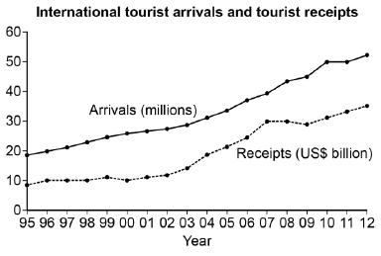
Botswana in Africa has large areas of unspoilt wilderness. Safari tourism is becoming an important source of income, both locally and nationally.
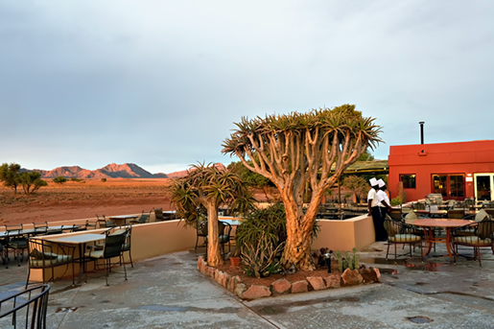
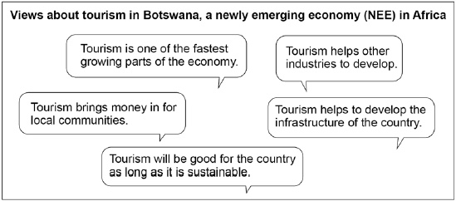
Evaluate the effectiveness of tourism in reducing the development gap.
Use the information above and your own knowledge.
(Total 9 marks)
Mark schemes
Q1.

Level | Marks | Description
3 (Detailed) | 5 – 6 | AO2 – Shows thorough understanding of ways to reduce the development gap.  AO3 – Demonstrates thorough application of knowledge and understanding to evaluate the options for reducing the development gap.
2 (Clear) | 3 – 4 | AO2 – Shows clear understanding of way(s) to reduce the development gap.  AO3 – Demonstrates reasonable application of knowledge and understanding to evaluate the option(s) for reducing the development gap.
1 (Basic) | 1 – 2 | AO2 – Shows limited understanding of way(s) to reduce the development gap.  AO3 – Demonstrates limited application of knowledge and understanding to make limited evaluation of the option(s) for reducing the development gap.
 | 0 | No relevant content.
• Level 3 responses will provide reasoned assessment of the efficacy of aid in comparison to other options for development supported by evidence from the figure.
• Level 2 responses will either provide reasoned assessment of the efficacy of aid with implicit use of the evidence or generic assessment of aid’s value with precise use of the evidence.
• Level 1 responses will give basic link(s) between aid and development or merely assert the value or lack of it.
• Max Level 2 if options other than aid are not considered.
Indicative content
• The specification lists: investment, industrial development, tourism, aid, intermediate technology, Fairtrade, debt relief and microfinance loans as strategies to reduce the development gap.
• Clearly these are far too numerous to all be expected in any one answer and candidates need only refer to one other in addition to aid to fulfil the comparative element of the question.
• The information use should be indicated by referencing the ‘bottom up’ / direct to those in most need aspect of aid and may be addressed as microfinance. Some development beyond quoting the text would be needed for credit beyond L1.
• Credit should be given to any reasoned points regarding strategies and any view regarding aid as the best strategy. Some suggested comments are:
• Aid – can help if spent on projects such as schools and health clinics but can be mis-spent and encourage dependency.
• Investment – can improve technology and infrastructure but is easily withdrawn by foreign investors.
• Tourism – generates increased income but much of the money is lost in leakage.
• Intermediate technology – simple and effective at a ‘grassroots’ level but can be limited in scale.
• Fairtrade – helps secure income for farmers but prices remain low.
• Debt relief – frees money to be spent on development projects but relies on goodwill of HICs.
• Microfinance loans – allow financial independence, especially for women but scale and impact remain small.
AO2 – 3 marks
AO3 – 3 marks
[6]
Q2.

Level | Marks | Description
3  (Detailed) | 7 – 9 | AO1 Demonstrates detailed knowledge of how the development of tourism can be used to reduce the development gap.  AO2 Shows thorough geographical understanding of how the development of tourism can be used to reduce the development gap.  AO3 Demonstrates sound application of knowledge and understanding in a reasoned way to evaluate the effectiveness of tourism development as a way of reducing the development gap.
2  (Clear) | 4 – 6 | AO1 Demonstrates clear knowledge of how the development of tourism can be used to reduce the development gap.  AO2 Shows some geographical understanding of the development of tourism can be used to reduce the development gap.  AO3 Demonstrates some application of knowledge and understanding to evaluate the effectiveness of tourism development as a way of reducing the development gap.
1  (Basic) | 1 – 3 | AO1 Demonstrates limited knowledge which identifies how the development of tourism can improve living standards.  AO2 Shows limited geographical understanding of how the development of tourism can be used to reduce the development gap.  AO3 Demonstrates limited application of knowledge and understanding and makes simple evaluative statements about the effectiveness of tourism development as a way of reducing the development gap.
 | 0 | No relevant content.
Indicative content
• At the highest level students are expected to show some understanding of the development gap.
• At the lower levels reducing the development gap may be implied by an appreciation of how the development of tourism can create socio-economic opportunities.
• Economic factors considered may include the creation of jobs (direct and through the multiplier); increases in income; opportunity for the development of skills; the development of infrastructure and improvement of services.
• Social opportunities may include the development and improvement of services; the opportunity to improve general living conditions and general improvement to health and welfare.
• Students may include examples where particular tourism developments have included the building of social facilities such as schools; health clinics; water and sanitation systems; electricity systems.
AO1 = 3
AO2 = 3
AO3 = 3
[9]

