Q1.
Study the pie charts showing information about the changing industrial structure of the United Kingdom.
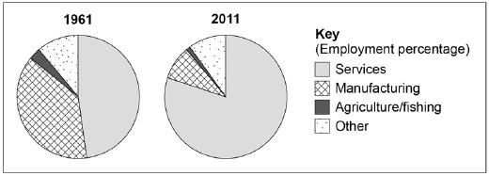
(a) Describe the changes to the industrial structure shown in the pie charts.
(2)
(b) Suggest reasons for the changes shown in the pie charts.
(4)
(Total 6 marks)
Q2.
Study the photograph showing a modern industrial development.
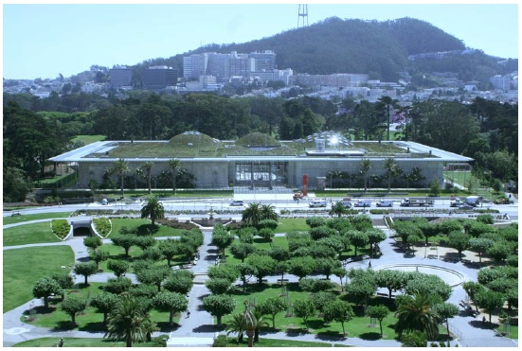
Using the photograph to help you, explain how modern industrial developments can be made more environmentally sustainable.
(Total 4 marks)
Q3.
Some rural areas have experienced decline rather than growth.
Use a named example to describe the effects of decline in remote rural areas.
(6)
(SPaG: 3)
(Total 9 marks)
Q4.
(i) Give two features of a ‘Science Park’?
(2)
(ii) Why is there pressure from developers to build Science Parks in the rural–urban fringes of settlements?
(4)
(Total 6 marks)
Mark schemes
Q1.
(a) Change(s) suggests a need for more than one change or an overall understanding of a change in structure.
1 mark – identifies a single change.
2 marks – identifies two or more changes or an overall understanding of structural change (which will generally include an identification of more than one change).
AO4 = 2

(b) | Level | Marks | Description
 | 2  (Clear) | 3 – 4 | AO1 Produces some accurate descriptive knowledge about why industrial structures change.  AO2 Shows some clear understanding of why industrial structures change.
 | 1  (Basic) | 1 – 2 | AO1 Limited knowledge with basic points which largely describe changes with only tentative explanation.  AO2 Shows a limited understanding of industrial change.
 |  | 0 | No relevant content.
Indicative content
• Mechanisation of primary / secondary activity.
• The movement of manufacturing to other countries.
• Increasing wealth leading to the growth of services.
• The growth of technology – services / research and development.
• The growth of particular industrial activities; tourism; transport; recreation, etc.
AO1 = 2
AO2 = 2
[6]
Q2.

Level | Marks | Description
2  (Clear) | 3 – 4 | AO2 Shows some geographical understanding of how particular features of industrial development will help to make them more sustainable.  AO3 Uses the figure effectively and offers development to identify a range of features that will help to make industrial developments sustainable.
1  (Basic) | 1 – 2 | AO2 Shows limited geographical understanding of how particular features of industrial development will help to make them more sustainable.  AO3 Uses the figure OR individual ideas to identify a range of features that will help to make industrial developments sustainable.
 | 0 | No relevant content.
Indicative content
• There are a number of factors identified on the figure which could be considered as important to the sustainable development of industrial areas.
• There is an expectation that students will use the figure and add their own knowledge by developing points from the figure or adding additional ideas.
• Ideas might include; use of renewable energy; grey water systems; waste management systems; pollution monitoring and management; green landscaping; communal transport systems; encouragement of the use of cycling; specific facilities for staff; flexible working patterns, etc.
AO2 = 2
AO3 = 2
[4]
Q3.
This mark scheme is from a question paper that assessed a previous specification and has not been edited.
Click [here] to access a document explaining the differences that might apply to it.
Responses will depend on case study selected. Likely examples are Snowdonia and Cornwall. Need not be in the UK. Shops, post offices and pubs close leaving areas without services. Public transport is limited. Communities become isolated with an increasing elderly population and few newcomers except retirees. Rural depopulation, especially of the young. Housing can be poor quality and un-modernised in less desirable areas. Substantial numbers converted into second homes and holiday lets in the attractive areas, with associated increases in house prices, often out of the reach of locals. Unemployment can be high.
Jobs are often low paid and seasonal in agriculture and/or tourism.
Level 1 (Basic) (1–4 marks)
Simple statements, with no real development and no named example.
People are leaving villages. The shops / pub / PO have shut. Rural areas have only old people left. Locals cannot afford to buy houses in the countryside.
There are lots of second homes. There are no good jobs for people.
Level 2 (Clear) (5–6 marks)
Linked statements with some clarity of effect and at least a named example.
The shops / pub / PO in lots of villages in Cornwall have shut. So people leave villages because there are no services. Places like Snowdonia are attractive for holidays so people buy up houses to use for second homes. Young people then cannot afford to buy houses so they leave. Lots of the young people have left so the villages are mainly full of elderly residents.
AO1 – 4
AO2 – 2
6
Spelling, Punctuation and Grammar
Threshold performance
Candidates spell, punctuate and use the rules of grammar with reasonable accuracy in the context of the demands of the question. Any errors do not hinder meaning in the response. Where required, they use a limited range of specialist terms appropriately.
1
Intermediate performance
Candidates spell, punctuate and use the rules of grammar with considerable accuracy and general control of meaning in the context of the demands of the question. Where required, they use a good range of specialist terms with facility.
2
High performance
Candidates spell, punctuate and use the rules of grammar with consistent accuracy and effective control of meaning in the context of the demands of the question. Where required, they use a wide range of specialist terms adeptly and with precision.
3
[9]
Q4.
This mark scheme is from a question paper that assessed a previous specification and has not been edited.
Click [here] to access a document explaining the differences that might apply to it.
(i) 2 × 1. An industrial estate of high-tech industries (1) / developed by or
near to a university. (1) / in the rural urban fringe. Accept features of
the buildings and environment.
2
(ii) Level Marking
Level 1 (Basic) 1-2 marks
Simple statements.
The land is cheaper. There will be good road connections. It has a
pleasant environment. No room in city centre.
Level 2 (Clear) 3-4 marks
Linked statements.
They need to be in a pleasant area with low levels of pollution
because of the need for the air to be clean when making electronics.
They rely on road transport and so need good access to road rather
than rail. The land is cheaper and easier to develop than older
industrial sites nearer the centre of the city.
4
[6]

