Q1.
Study the map below showing some of the main regional trade groupings in the world.
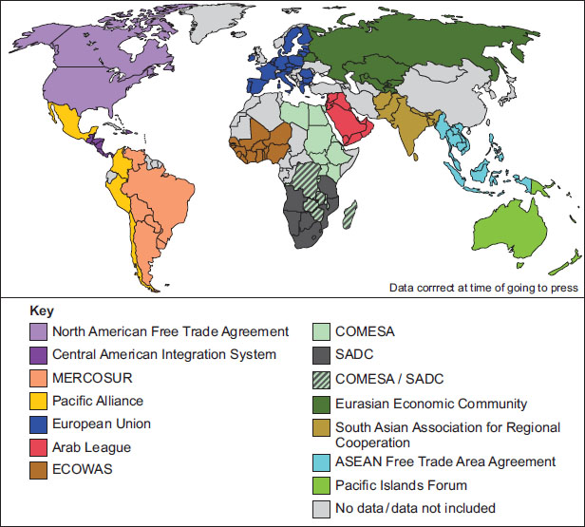
(a) Using the map above, which trading group in South America has the most member countries?
(1)
(b) Explain how one country’s trading relationships with the wider world have changed.
Use the map above and an LIC/NEE you have studied.
(4)
(Total 5 marks)
Q2.
Study the information in the Notes, ‘Road development in the Peruvian Amazon’.
What does the information in the ‘Peru: development fact file’ suggest about levels of development in Peru?
(Total 4 marks)
Q3.
Study the diagram below to explain the impact of tourism on a country.
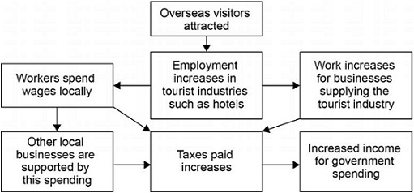
Using the diagram and your own understanding, suggest how the growth of tourism in a LIC or NEE might help to reduce the development gap.
(Total 4 marks)
Q4.
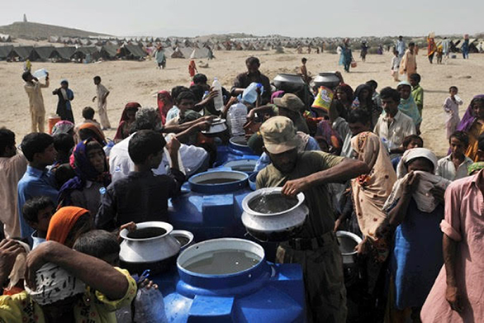
Study the photograph above, showing soldiers from South Korea delivering water to a refugee camp in South Sudan.
Use the photograph and your own knowledge to explain the advantages of this type of aid for the recipient countries.
(Total 4 marks)
Q5.
Describe the effects of air pollution and water pollution in urban areas in poorer parts of the world.
(6)
[SPaG 3 marks]
(Total 9 marks)
Q6.
Cadbury is a TNC that makes chocolate in the UK using cocoa that is grown in Ghana.
Cadbury has tried to help reduce the development gap between Ghana and the UK. In the figure below, a manager outlines some actions that Cadbury has taken in Ghana.
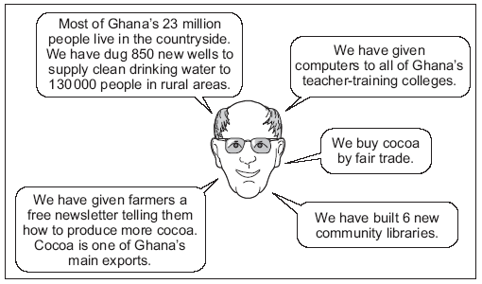
(i) What is meant by ‘fair trade’?
(2)
(ii) Explain how the actions taken by Cadbury could help to improve the standard of living for people in Ghana.
(6)
(Total 8 marks)
Q7.
Describe one or more impacts that international aid has had on a named LIC/NEE country.
(Total 4 marks)
Mark schemes
Q1.
(a) MERCOSUR
AO4 – 1 mark

(b) | Level | Marks | Description
 | 2 (Clear) | 3 – 4 | AO2 – Shows clear understanding of changing trading relationships.  AO3 – Applies knowledge and understanding to the map effectively and offers development to interpret changes in trading relationships.
 | 1 (Basic) | 1 – 2 | AO2 – Shows limited understanding of changing trading relationships.  AO3 - Applies knowledge and understanding to the map or uses own understanding to begin to interpret changes in trading relationships.
 |  | 0 | No relevant content.
• Level 2 answers will apply geographical knowledge and understanding in combination with the figure to present a reasoned explanation.
• Level 1 answers will be simplistic, perhaps simply descriptive with limited reasoning.
• Max L1 if no named LIC/NEE country or country is not LIC/NEE.
Indicative content
• Case study content will clearly much depend on country chosen.
• The map use will be from naming trading blocs shown on the map.
• Countries that were once colonies used to serve as sources for primary products solely for the colonising country which was an unfair / exploitative relationship.
• This has changed because these countries are now independent and can choose with whom to trade and it is more equal and intra-continental trade has increased.
• Arguably colonial relationships have simply been replaced by ‘economic colonialism’ through FDI by companies such as Glencore in Zambia (copper) and the DRC (cobalt); Shell in Nigeria or even countries such as the $60 billion China pledged to invest in Africa in 2018 alone.
• Because they now choose trading partners many countries now are part of regional trading blocs, therefore reducing the dominance of the former colonising countries. E.g. Nigeria , from being a colony dependant on the UK now only has $1.2 bn of trade with the UK but $15 bn with the USA and India combined.
• From being suppliers or sources of raw materials some LIC/NEE and rather a ‘junior partner’ in trade, some are now significant service providers, eg India now gaining 45% of its GDP from services provided to HICs
No credit for description of the map shown.
AO2 – 2 marks
AO3 – 2 marks
[5]
Q2.

Level | Marks | Description
2  (Clear) | 3 – 4 | AO2 – Shows a clear understanding of the idea of socio-economic development  AO3 – Demonstrates clear application of knowledge to offer interpretive observations about what the data suggests about the level of development of Peru.
1  (Basic) | 1 – 2 | AO2 – Basic understanding of what is meant by socio-economic development.  AO3 – Demonstrates limited application of knowledge to offer simplistic interpretive observations about the level of development of Peru.
 | 0 | No relevant content.
No credit for simply copying the data with no attempt to explain / link to the idea of development.
• Level 2 – Clear reference to the resources which clearly identifies the socio-economic conditions within Peru. Some clear relative understanding of the data (high / low in relation to levels of development) and how rural / urban differences suggest a lack of development.
• Level 1 – Uses data from the resource to identify the level of development of Peru, with limited relative understanding (they don’t have many doctors / not many people have internet access). Quoting urban / rural differences with limited explanation.
The question requires candidates to make appropriate links between content from different parts of the course.
Indicative content
• General socio-economic data suggests a low level of development.
• Extreme poverty in many areas.
• Lack of social facilities in many areas.
• Distinct differences between rural-urban areas.
• Suggestion of almost a “dual” socio-economic structure between rural-urban areas.
A02 = 2 marks
A03 = 2 marks
[4]
Q3.

Level | Marks | Description
2  (Clear) | 3 – 4 | AO2 – Shows clear understanding of the process of development.  AO3 – Uses the diagram to explain the impact of tourism on a country effectively and offers clear development to clearly evaluate the link between tourism and reducing the development gap.
1  (Basic) | 1 – 2 | AO2 – Shows limited understanding of the process of development.  AO3 – use the diagram to explain the impact of tourism on a country and / or own knowledge to begin to simply evaluate the link between tourism and reducing the development gap.
 | 0 | No relevant content.
• Level 2 (clear) responses will provide reasoning that connects the processes of tourism growth and reduction of the development gap.
• Level 1 (basic) responses will provide basic reasons or merely assert the connections between tourism and wider development.
Indicative content
• Answers should make use of the diagram to explain the impact of tourism on a country which shows a process of change and the multiplier effect linked to tourist industry growth. Use of the diagram to explain the impact of tourism on a country need only be slight such as a term that is used in the figure to fulfil the question requirement.
• Answers might draw straightforward connections such that the link between the two are clear.
• The question does not require an example but candidates may provide one or even base their answer around one.
• Tourism makes use of a valuable primary resource in the form of landscape and environment including wildlife so that LIC / NEEs can improve their GDP when they have few other resources to exploit.
• Servicing this tourism both directly and indirectly will create employment e.g.
600 000 in Kenya and subsequent tax revenue which can fund infrastructure.
• Infrastructural improvements may directly improve economic measures of development to improve the country’s relative position through trade and thus close the development gap.
• Other infrastructure may be in education or health care which will improve social measures of development e.g. a rise in HDI or literacy scores.
No credit for description of either the diagram shown or economic development in isolation.
AO2 = 2 marks
AO3 = 2 marks
[4]
Q4.
This mark scheme is from a question paper that assessed a previous specification and has not been edited.
Click [here] to access a document explaining the differences that might apply to it.
Needs to show use of the photograph through reference to something visible in the photograph, though this may be slight. Own knowledge may be evidenced through exemplars and / or elaboration of the nature of the situation regarding short term aid and the nature of a refugee crisis. Must be for the recipient country. There are a great many possible aspects for the candidates to mention and credit should be given for any reasonable suggestion. Expect comment on:
Advantages – a number of countries acting in concert will be more effective than individually, the UN will be allowed to go where donor countries might not be welcome, water is the most essential need so this will help the immediate problem and keep people alive.
AO1 = 1
AO2 = 1
AO3 = 2

Level | Marks | Description
2  (Clear) | 3 – 4 | Use of figure and own knowledge, though balance not required. In addition points will be expanded and developed to show clarity and understanding of the advantages of the aid shown rather than aid in general. Must have more than one advantage.
1  (Basic) | 1 – 2 | Simple statements or listed points with no development. Use of figure or own knowledge only. Likely to be assertions and / or direct lifts from the figure without comment on advantage.
 | 0 | No relevant content.
[4]
Q5.
This mark scheme is from a question paper that assessed a previous specification and has not been edited.
Click [here] to access a document explaining the differences that might apply to it.
Candidates should be given credit for use of a case study if related to air and water pollution. Air and water pollution can be implicit through the description if not named. Candidates are likely to refer to the health hazards of fumes from vehicles / factories causing poor air quality and disease such as asthma. They may also refer to hazards such as smog. Water borne disease may be mentioned along with more general comments about the smell of dirty water and toxic waste in rivers and danger of poisoning.
Level 1 (Basic) (1 – 4 marks)
Simple statements and / or listed points with no real development and little attempt to describe effects. Air or water pollution only. Credit general answers if applicable to urban areas.
There are lots of fumes. The water is dirty. The air and water are health hazards.
Level 2 (Clear) (5 – 6 marks)
Linked statements with effects made clear. Both air and water pollution covered. Balance not required. Clearly relevant to poorer part of the world.
There is lots of air pollution which causes smog and can make it hard for people to breathe. Being on the streets of Beijing for a day is as bad as smoking. Water that isn’t cleaned just lies stagnant and can really smell bad. Diseases like cholera happen with dirty water.
AO1 – 4
AO2 – 2
6
(Spag 3 marks)
[9]
Q6.
This mark scheme is from a question paper that assessed a previous specification and has not been edited.
Click [here] to access a document explaining the differences that might apply to it.
(i) Fair trade is buying from poorer producers at reasonable prices
that help sustain their livelihoods, (even though these prices may
be above the market rate). Point mark. 1 mark for basic definition,
2nd mark for development/elaboration.
Example response
Fair trade is paying reasonable prices to people like poor
farmers (1) to keep them going (1) financially.
2
(ii) Level 1 Basic (1–4 marks)
Simple ideas as to why Cadbury’s action/s such as shown in
the figure may improve social/economic conditions. Likely to
show limited development from the figure.
Example response
Free newsletter to tell 75 000 farmers how to produce more
cocoa makes them be better off.
Level 2 Clear (5–6 marks)
Some clear explanation of why Cadbury action/s may improve
social/economic conditions in Ghana. Likely to clearly develop
points from the figure.
Example response
The newsletter telling 75 000 farmers how to produce more
cocoa should also help because they will have more cocoa to
sell and so increase earnings.
6
[8]
Q7.

Level | Marks | Description
2 (Clear) | 3 – 4 | AO1 – Demonstrates clear knowledge of international aid in a named country.  AO2 – Shows clear understanding of the impact(s) of international aid.
1 (Basic) | 1 – 2 | AO1 – Demonstrates partial or basic knowledge of international aid.  AO2 – Shows limited understanding of the impact(s) of international aid.
 | 0 | No relevant content.
• Level 2 responses will provide clear knowledge of international aid and a developed understanding of the specific impact(s) on a named country.
• Level 1 responses will be simplistic with basic knowledge of international aid and limited understanding of the impact(s), which may be generic.
• Max L1 if no country named or if HIC country named but points still applicable.
Indicative content
• Full marks are possible for one well developed impact.
• Credit aid only. No credit for comments about debt, fairtrade or microfinance loans.
• There should be a link between the aid and the impact on the receiving country.
• Answers given will depend on the country but may involve funding for education, water supply and sewerage, disease prevention, improvements to infrastructure or farming techniques.
• Negative impacts are also creditworthy – such as tied aid, government corruption or aid being spent unwisely.
• Eg The UK gave £45 million to Tanzania to fund a family planning programme. This will allow women to control the size of their family and improve their quality of life.
• Eg Water Aid has helped provide clean water to over 12 000 people in their villages in Malawi. Their children can now spend more time getting educated, rather than walking to collect water, and villagers can grow more food, some of which can be sold, providing income.
• Eg The UK gave aid to Malaysia to build the Pergau Dam to make electricity to improve the standard of living of people in the cities. However in return Malaysia had to spend more money buying weapons from the UK so their government had less to spend on schools and hospitals.
AO1 = 2 marks
AO2 = 2 marks
[4]

