Q1.
Describe the social or cultural background of a named LIC/NEE country.
(Total 2 marks)
Q2.
Study the information below about Asha. Asha is an aid project in Delhi, a city in India.

Asha is a charity which aims to work with the urban poor to bring long-term and sustainable improvement to their quality of life, regardless of their background or religion.
Around 700 000 people in 91 slums have benefited from Asha’s work.
The charity receives money from a number of sources, including Indian, British and Australian governments, some UK schools, international banks, and other charities.
Asha allows slum residents access to banks. They can open accounts with no money and can benefit from loans at extremely good rates. Some people have tripled their incomes and 99% make loan repayments on time.
Asha provides resource centres, all of which have computers and broadband internet, and children are encouraged to take a basic computer course. English classes help children grow in confidence and develop skills that narrow the gap between them and better-off youngsters.
(a) Use the above information to state one source of Asha’s funding.
(1)
(b) Use the above information to state one way that Asha helps slum dwellers financially.
(1)
(Total 2 marks)
Q3.
Study the photograph below which describes the effects of an intermediate technology project in an area of Malawi, a country in Africa.
Bicycle Ambulances
There are two small Health Centres in the area serving 45 000 people. 1 in 6 women die in childbirth.
People have to travel vast distances to be seen by a nurse or doctor. Travel to the clinics is usually by ox and cart but this is an expensive and slow mode of transport.
A project was started to build bicycle ambulances and to provide training to the people in the area so more patients can make their way to a health centre. It is hoped that these bicycle ambulances will help save many lives.
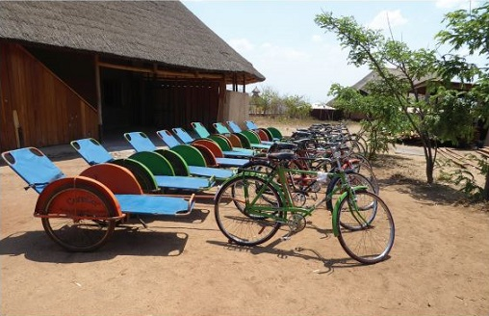
State two challenges faced by the people living in the area described in the photograph above.
(Total 2 marks)
Q4.
State one characteristic of intermediate technology.
(Total 1 mark)
Q5.
Outline one way in which international aid has had an impact on a named LIC or NEE country.
(Total 2 marks)
Q6.
Outline one way the political or trading relationship of a named LIC / NEE country with the wider world has changed.
(Total 2 marks)
Q7.
Study Figure 1, a population pyramid for Chad (2019).
Figure 1
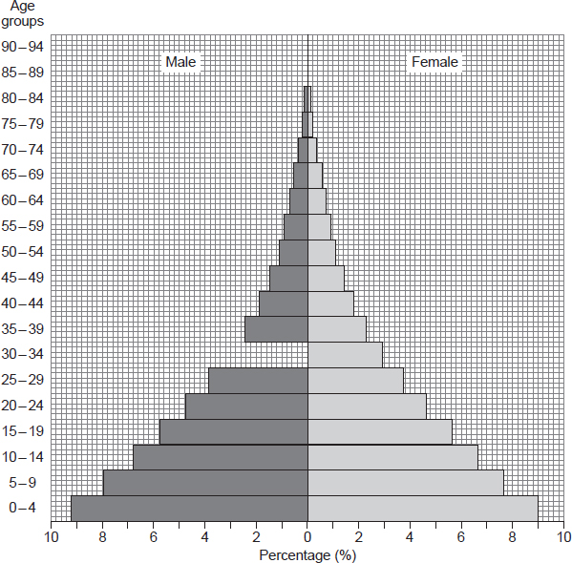
(a) Complete Figure 1 using the following data.

Males aged 30 – 34 | 3%
(1)
(b) Using Figure 1, calculate the percentage (%) of children aged 0 – 4 years old.
Shade one circle only.

A | 9.0%
B | 9.2%
C | 15.6%
D | 18.2%
(1)
(Total 2 marks)
Q8.
Study Figure 1 which shows how the share of world manufacturing production changed between 1970 and 2010.
Figure 1
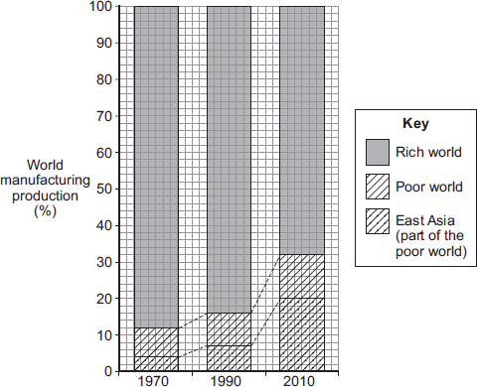
Year
Describe the changes that have happened between 1970 and 2010.
(Total 3 marks)
Mark schemes
Q1.
One mark for a basic statement, e.g.:
• There are a number of different ethnic groups in Nigeria. (1)
• Three tribal groups dominate Nigeria. (1)
• There is religious conflict in Nigeria. (1)
Two marks for a developed idea, e.g.:
• There are a number of different ethnic groups in Nigeria (1) who have religious differences as some are Christian and others Muslim. (d) (1)
• Three tribal groups dominate Nigeria (1) the Hausa in the north and Igbo and Yoruba in the south. (d) (1)
• There is religious conflict in Nigeria (1) which has led to the rise of the Boko Haram terror group. (d) (1)
No credit for environmental or political.
AO1 – 2 marks
[2]
Q2.
(a) Any one from: Indian/British/Australian governments, some UK schools, international banks, other charities.
AO4 – 1 mark
(b) Access to banks; open accounts with no money; benefit from loans at extremely good rates; tripled their incomes.
AO4 – 1 mark
[2]
Q3.
One mark for each correct identification.
Lack of transport; transport is expensive and slow; limited health care; 22 500 people per clinic; having to travel vast distances to see a nurse or doctor; 1 in 6 women die in childbirth.
AO4 = 2 marks
[2]
Q4.
Candidates need not make reference to image of the Bicycle Ambulances though to do so would be a valid approach provided answers move beyond it or adapt it in some way.
Candidates should show an awareness of how intermediate technology can be appropriate for poorer countries e.g.
• The tools / systems are simple and affordable (1)
• By providing simple machines / tools people can develop businesses and earn money (1)
• It involves local communities so is ‘bottom up’ development (1).
Credit negative comments clarifying the difference between intermediate and other technology e.g. It is not expensive / complicated.
No credit for repetition of the image of the Bicycle Ambulances only.
AO1 = 1 mark
[1]
Q5.
Credit one impact only.
Credit aid only.
Candidates should clarify the link between aid and its resultant impact. The country should be named. Much will depend on the country selected and may involve funding schools, improving farming methods, funding major infrastructure. Credit negative answers which might draw a link between aid and dependency or which illustrate the ease with which aid can fall into corrupt hands.
One mark for a basic statement or one which does not name a country, e.g.
• Countries benefit from funding of projects (1)
• Aid can be targeted specifically on development projects such as providing clean water (1).
Two marks for a developed idea which relates to the named country, e.g
• Aid can fund major infrastructure projects (1) such as the Inga 3 Dam in the Democratic Republic of the Congo (d)(1)
• The UK has given £350million to Pakistan (1) which has been spent to improve education facilities (d)(1).
Max 1 mark if country named is not LIC / NEE but comment still valid.
AO1 = 2 marks
[2]
Q6.
Credit one reason only.
Students should clarify the link between politics or trade and importance on a global scale. The country should be named. Much will depend on the country selected but common themes may be previous colonisation or conflict leading to a reduced importance. Positive responses such as improved profile due to hosting major sporting events should also be credited.
One mark for a basic statement or one which does not name a country, e.g.
• Many countries do not have a political voice as they are busy dealing with internal conflict (1)
• As a previous colony India did not control its own economy (1)
Two marks for a developed idea which relates to the named country, e.g.
• Civil war and terrorism from Boko Haram in Nigeria (1) mean that it has a poor political reputation and some countries do not wish to deal with it (d) (1)
• India has developed its own successful companies such as Tata Steel (1) so that it now owns and controls industries elsewhere in the world (d) (1)
Max 1 mark if country named is not LIC/NEE but comment still valid
AO1 = 2
[2]
Q7.
(a) 1 mark for correct completion of bar.
Shading is not necessary.
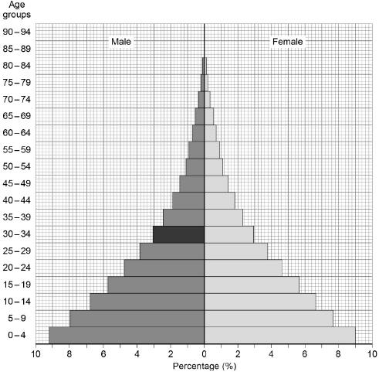
AO4 = 1 mark
(b) One mark for the correct answer.
D – 18.2%
No credit if two or more answers are circled.
AO4 = 1 mark
[2]
Q8.
This mark scheme is from a question paper that assessed a previous specification and has not been edited.
Click [here] to access a document explaining the differences that might apply to it.
3 × 1 or 1 × 2 + 1 × 1
Must have more than 1
There has been an increase in the proportion of manufacturing in the poor world compared to the rich world. In 1970 it was 12% and by 2010 it had risen to 32%.
The growth in the East Asia’s share of the total has increased by more than the rest of the Poor World. East Asia’s share increased the most between 1990 and 2010.
AO3 – 3
[3]

