|  |
| --- |
| GCSE |
| ENGLISH LITERATURE |
| Power and Conflict |
|  |

Total number of marks: 30 per optional question



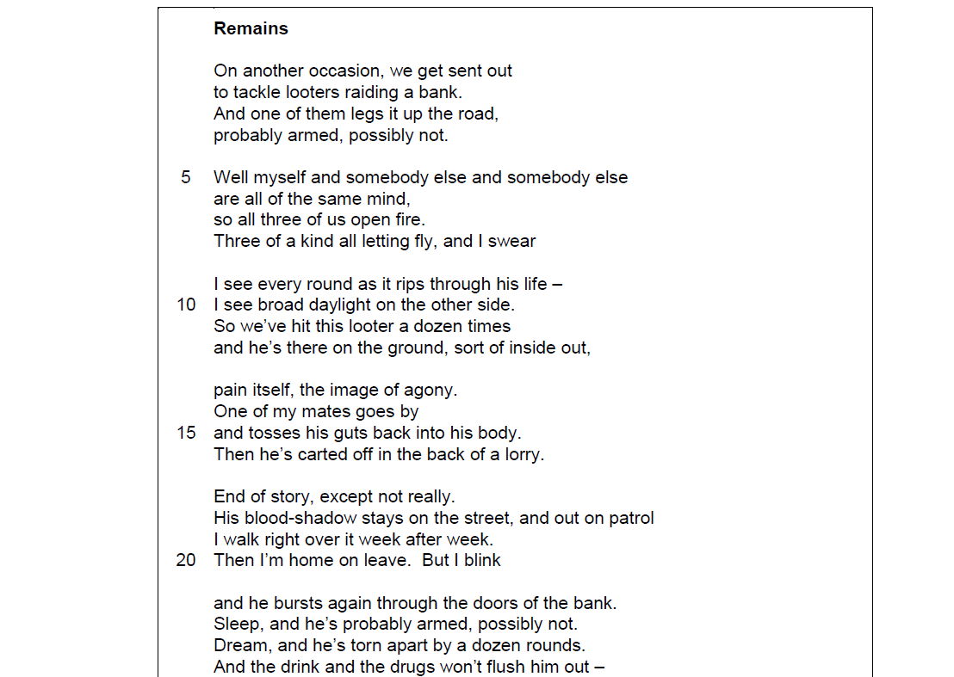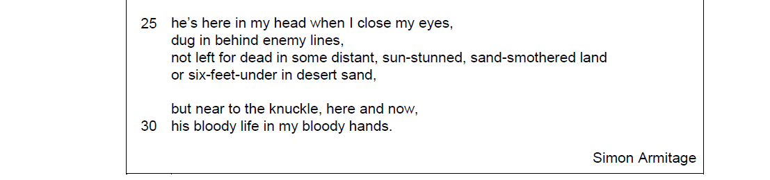



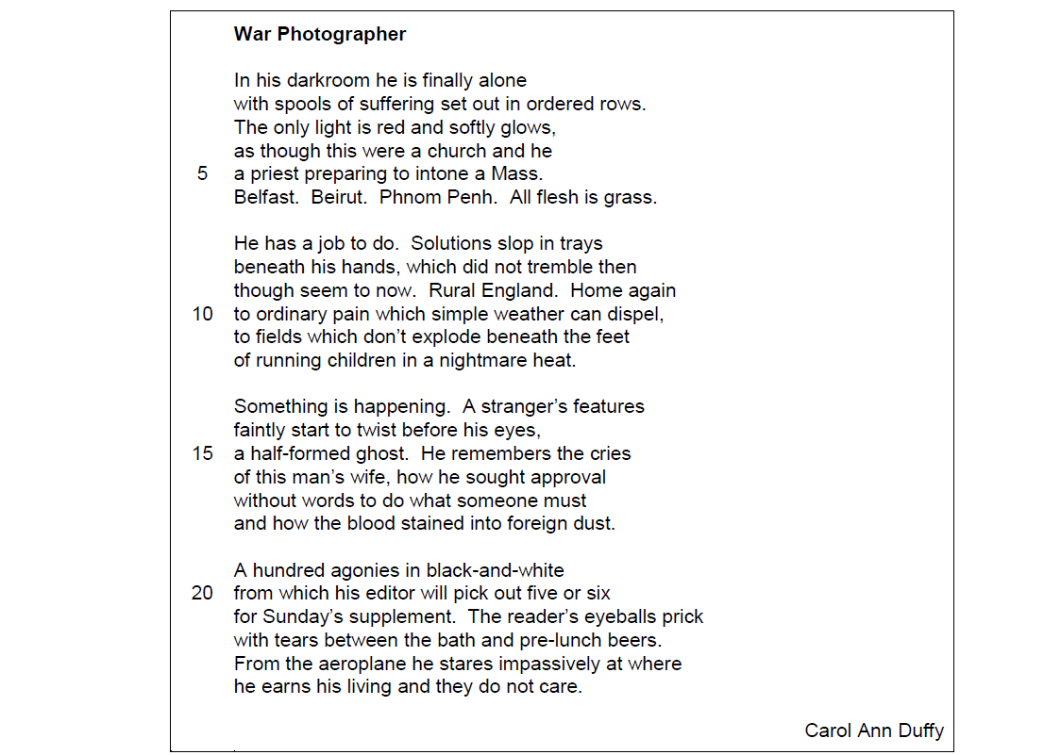



**[30 marks]**

