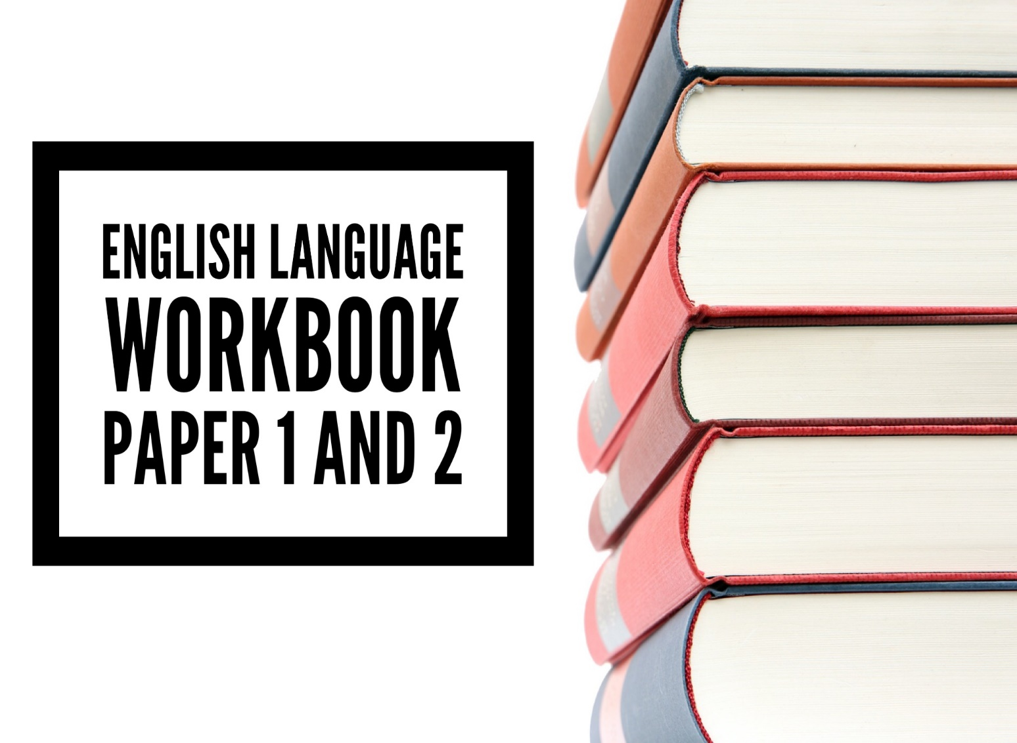


Name:

Teacher:
Contents
Lesson 1: To revise and practice Paper 1 Q2 and Paper 2 Q3 3
The ‘How’ Question… 3
Lesson 2: To independently practice Paper 1 Q2 and Paper 2 Q3 9
Lesson 3: To use language when writing creatively for paper 1 15
Lesson 4: To use interesting vocabulary when writing creatively for paper 1 21
Lesson 5: To use language when writing creatively for paper 1 26
Lesson 6: To revise and attempt the structure question 31
(paper 1 q3) 31
Lesson 7: To complete a mini paper 1 mock 38
Lesson 8: To use sentence structures when writing creatively 42
Lesson 9: To use structure when writing creatively 46
Lesson 10: To evaluate 52
Lesson 11: To complete mini mock with a focus on Q4. 58
Lesson 12: Paper 2 Q2 – Summarise 62
Lesson 13: Paper 2 Q4 – Compare 65
Lesson 14: Paper 2 mini mock – summarise and compare 69
Lesson 15: Paper 2 Q5 – Argue/persuade 75
Lesson 16: Paper 2 Q5 – Argue/persuade 80

Lesson 1: To revise and practice Paper 1 Q2 and Paper 2 Q3

The ‘How’ Question…

Method
Marks? P1 – 8……P2 – 12
Minutes? Approx. 15
Amount? 3-4 paragraphs
Skills? AO2: Explaining and analysing how the writer has used language.
How does the writer use language to…

Writing frame:
The writer uses ______________ to describe ____________________________.
For example, “_____________________________________________________”.
This suggests ______________________________________________________
___________________________________________________________________
(Where possible) This could also suggest/create imagery of _______________________________
___________________________________________________________________
The word (use subject terminology where possible verb, adjective etc) “_____________” has connotations of __________________________________
And therefore, makes the reader think __________________________________.
Do this 3 times!
Top tips for question 2:
- Don’t add an introduction or conclusion at all, just the 3 paragraphs above.
- Your explanation should focus on the language not make inferences about the character or the plot. What effect does the language have on the reader?
- Don’t over complicate the question, if there’s some obvious imagery in there, analyse it, that’s why the examiner chose it! You will be able to squeeze a lot more analysis out of some imagery than you will from a compound sentence!
- If you can’t find a specific language feature, such as a simile, you can still analyse imagery, adjectives, a semantic field.

WAGOLL

Have a look at this sample answer for Paper One Question Two:
The writer uses adjectives to describe the atmosphere when Arthur initially awakes. For example, “I sat up paralysed, frozen” as there was a “silence, ominous and dreadful”. This suggests that the atmosphere itself, despite nothing happening, is something to be feared. This could also suggests that Arthur is so fearful of the silence, that he is unable to move, foreshadowing that something foreboding and sinister is about to happen. The adjective “ominous” has connotations of being threatening and therefore makes the reader fear for Arthur as the tension builds.
The writer uses a short, declarative sentence to bring the reader to an abrupt halt. For example, “Nothing else happened”. This suggests to the reader that the noise is something supernatural as we were awaiting an answer, yet nothing was given. This could also build tension as we are left in sudden suspense as to what the noise could be. The word “nothing” has connotations of the unknown and mystery and therefore makes the reader intrigued and once again fearful the noise is the only sound in the “ominous” atmosphere.
The writer uses repetition to describe Arthur’s reaction to the atmosphere. For example, “listening, listening”. This suggests that it is unclear to Arthur what the source of the noise could possibly be. The repetition of the verb “listening” has connotations of him straining to hear in a desperate attempt to identify the noise without having to leave the bedroom and face it and therefore makes the reader tense as we impatiently await to discover the source.

Have a look at this sample answer for Paper Two Question Three:
Firstly, the writer uses a simile to describe the overall scene. For example, “Sky, beach and village lie before us as if sitting for a picture”. This suggests that the scene is beautiful and picturesque, as if it is worthy of being painted, it must be beautiful. This could also suggests that the scene is very still and undisturbed by many visitors as nothing is moving. The triple “sky, beach and village” has connotations of simplicity due to the lack of adjectives and therefore makes the reader visualise and appreciate an extremely beautiful and tranquil setting.
Secondly, the writer uses personification and a simile to describe the sea. For example, “the ocean lies winking in the sunlight like a drowsy lion”. This suggests that the sea is calm. This could also suggest that as the sea is being compared to a lion, it has the potential to be ferocious and dangerous but, just like everything else being described, is “drowsy” and therefore relaxed and peaceful. The verb “winking” has connotations of the sunlight on the sea and therefore makes the reader perceive Broadstairs as almost magical as the sea is sparkling in the sunlight.
Furthermore, the writer uses personification and a simile to describe the boats in the harbour. For example, “turn, exhausted, on their sides, like faint fish”. This suggests that the boats have been abandoned and left, upturned. This could also suggest that aspects of the beach are not what one would consider stereotypically beautiful or a typical holiday destination but the recurrent idea of the beach being uninhabited is what makes it appealing.
Finally, the writer uses a simile to describe the seaweed. For example, “as if a family of giants had been making tea here […] throwing their tea leaves on the shore”. This suggests that seaweed is strewn upon the beach and therefore the scene has been left uninterrupted by people. It’s not a typical beach destination but quiet, unlike the dusty metropolis. This could also suggest an element of fantasy as the beach is being associated with giants and therefore is unlike any typical beach but like one in a Fairy-tale. The verb “throwing” has connotations of being carefree and therefore makes the reader consider the beach to be a place free from the responsibilities and frantic routine of everyday city life.


- Use the mark scheme to highlight and annotate the following:
- Subject terminology
- Inference
- Deeper inferences/interpretations/explanations
- Effect on reader
- Reference or quotations from text
- Annotate any areas that you think could be improved
- Can you arrive at a band/grade for these responses?

Language Terminology:
Noun Adjective Verb Adverb Simile metaphor Personification Onomatopoeia Alliteration Rhetorical Question
Hyperbole Repetition
Juxtaposition Oxymoron
Direct address Imperative
Grade 1-3  Get The Basics | Grade 4-5 Hitting the Middle | Grade 6+  Going for the Top
The writer uses the word ‘shaking’. This shows how strong the wind was because it is moving the coach. | The writer uses verbs to describe the effects of the weather. For example, “shaking”. This shows how strong the wind was and emphasises its power. This also suggests that the weather was dangerous and unpredictable. The writer is trying to create an image of how severe the weather was in the reader’s mind. | The writer demonstrates the power of the storm through the use the verbs, for example “shaking, pummeling, bombarding”. This highlights to the reader how unpredictable and strong the storm is. It also conveys a darker more sinister side to the storm through the use of quite violent and powerful verbs. The word “pummeling” is particularly effective as it creates a vivid image in the reader’s mind of the coach being battered by the storm.

Practice
Read the following extract:

Her perfectly manicured hand rested on the doorknob of the tattoo parlour, the peeling white paint clinging to her clothes as she rested on the sagging doorframe. She turned to her friend. Bad idea. One glance spoke years of hidden grief. Her smoky eyes began to glint like the aftermath of a lightning strike. Clouds of grey threatened to flood, but she took a shuddering breath and gathered her strength. Turning towards the door now, she twisted the doorknob and pushed with the points of her fingernails, allowing the rush of cold air to paint the usual mask on her face.
Behind her, the morning yawn of Autumn brought a single white feather spiralling to a rest in the golden blanket that covered the cobblestone path.

Q) How has the writer used language here to portray the feelings of the character?
Step 1 – THINK, PAIR, SHARE
annotate the extract with a focus on interesting words and/or techniques that reveal the character’s feelings and possible effects. Find 3-4
(5 mins)
Step 2 – Answer the question

Peer assessment. Highlight and annotate where they have:
- Used subject terminology
- Made inferences
- Made any deeper inferences/explanations
- Explained the effect on the reader
Comment:
Target:

Lesson 2: To independently practice Paper 1 Q2 and Paper 2 Q3
Practice
Paper 1 Q2.
The War of the Worlds by H. G. Wells
Chapter Two: The Falling Star

Then came the night of the first ‘falling star’. It was seen early in the morning, rushing
over Winchester eastward, a line of flame high in the atmosphere. Hundreds must
have seen it, and taken it for an ordinary falling star.

I was at home and saw nothing of it. Some of those who saw its flight say it travelled
with a hissing sound. I myself heard nothing of that. 5

But very early in the morning poor Ogilvy, who had seen the ‘shooting star’, rose early
with the idea of finding it. Find it he did, soon after dawn, and not far from the sand
pits. An enormous hole had been made by the impact of the thing, and the sand and
gravel had been flung violently in every direction over the heath, forming heaps visible
a mile and a half away. The heather was on fire eastward, and a thin blue smoke rose 10
against the dawn.

The Thing itself lay almost entirely buried in sand, amidst the scattered splinters of a fir
tree it had shook to fragments in its descent. The uncovered part had the appearance
of a huge cylinder, caked over by a thick scaly muddy-coloured incrustation. It had a
diameter of about thirty yards. Ogilvy tentatively approached the mass, flabbergasted 15
at the size and more so at the shape, since most meteorites are round. It was,
however, still extremely hot from its flight through the air and this prevented Ogilvy
from getting too close. There was a stirring noise within its cylinder he assumed to be
the cooling of its surface; for at that time it had not occurred to him that it might be hollow.

He remained standing at the edge of the pit that the Thing had made for itself, 20
transfixed by its strange appearance, astonished chiefly at its unusual shape and
colour. The early morning was wonderfully still and he did not remember hearing any
birds that morning, there was certainly no breeze stirring, and the only sounds were
the faint movements from within the cindery cylinder. He was all alone on the common.

Q1
Read again the first part of the source, lines 1 to 11.
List four things from this part of the text about the ‘falling star’/Thing.

A

B

C

D
[4 marks]

Q2 [AO2 - language]
Look in detail at this extract from the source:

The Thing itself lay almost entirely buried in sand, amidst the scattered splinters of a fir
tree it had shook to fragments in its descent. The uncovered part had the appearance
of a huge cylinder, caked over by a thick scaly muddy-coloured incrustation. It had a
diameter of about thirty yards. Ogilvy tentatively approached the mass, flabbergasted 15
at the size and more so at the shape, since most meteorites are round. It was,
however, still extremely hot from its flight through the air and this prevented Ogilvy
from getting too close. There was a stirring noise within its cylinder he assumed to be
the cooling of its surface; for at that time it had not occurred to him that it might be hollow.

He remained standing at the edge of the pit that the Thing had made for itself, 20
transfixed by its strange appearance, astonished chiefly at its unusual shape and
colour. The early morning was wonderfully still and he did not remember hearing any
birds that morning, there was certainly no breeze stirring, and the only sounds were
the faint movements from within the cindery cylinder. He was all alone on the common.

How does the writer use language here to describe how the Ogilvy feels?
You could include the writer’s choice of:
• words and phrases
• language features and techniques
• sentence forms. [8 marks]


Paper 2 Q3.
Stormzy: ‘Respect me like you would Frank Ocean or Adele’ Miranda Sawyer

I meet Stormzy in a beautifully appointed recording studio in a chi-chi area of London. He stands out, but then he would anywhere. Stormzy, real name Michael Omari Jr, is a can’t-hide 6ft 5in in his trackie bottoms, black socks and slides, plus a T-shirt that, unexpectedly, has a picture of Louis Theroux on it. (“Louis Theroux is a G!” he insists. “I take my hat off to him, he’s good!”) Stormzy makes music, mostly grime, and in his YouTube videos, he towers over his crew, dominates the frame like a giant. When his PR suggests he try on a sweatshirt he’s been sent, he makes a face. He knows it won’t fit. He’s right. The arms only reach halfway between his elbows and his wrists.

Despite his height, and his suck-teeth video demeanour, there’s a cheekiness to Stormzy. When he MCs, there’s always a line or a facial expression that makes you smile – he farts at the beginning of WickedSkengMan 4, and in the freestyle video, he keeps laughing – and in person, he is friendly and engaged. There’s no doubt that Stormzy could be stroppy if he wanted; it’s just that, at the moment, he doesn’t want. Too busy. Too focused.
A few days ago, the tickets for his March-May UK tour went on sale. The two shows in Brixton, London sell out in seven minutes (he adds another date; it sells out too); within 12 hours, nine more venues, from Belfast to Birmingham, have no tickets left. His first album, Gang Signs & Prayer, will be released on Friday and is set to be a big deal: his singles have been getting huger, beating X Factor winners in Christmas song dust-ups, and he cancelled a series of gigs last year to finish it. Now, pre-sales have Gang Signs on target to hit No 1. Big for Your Boots, the lead single, came out last week and went in at No 8. He laughs. “I remember thinking, if SkengMan goes top 40, I’ll have a party. And I did! Now, I’m not even thinking about it.”
Stormzy’s climb has been rapid, a rocket shot into the sky. He’s so hot right now, his tweets have become front page news (this week, he tweeted a picture of the front door of his Chelsea flat, bashed in by police after reports he was burgling it: it made the cover of the Evening Standard). Still only 23, just four years ago he was in a job he hated, as project manager on an oil rig, watching Wiley videos in his lunch break. In 2013, he won a Mobo for best grime act, and then again in 2014. In the same year, Wiley tweeted that Stormzy was the “#1 grime don in this new era” and asked him to “take it to where we couldn’t my brother”. When Kanye brought the UK’s biggest grime stars on stage at the Brits 2015, Stormzy was there. He won Mobos for best male and best grime act that year. In Christmas 2016, he grabbed himself a No 8 by rereleasing his YouTube track Shut Up. I saw him perform at the Skepta-JME Brixton show around that time. He only did Shut Up, but the crowd went bananas. You could see he was about to become even bigger.
Q1. Read again the first paragraph
Choose four statements below which are TRUE.

a. Stormzy is wearing all black
b. Stormzy is 6ft 5
c. Stormzy is wearing black socks
d. Stormzy is 6ft
e. Stormzy is grimy
f. Stormzy is scary
g. Stormzy likes Louis Theroux
h. Stormzy’s real name is Michael Omari Jr
4 marks

Q3. Read again paragraph one and two. How does the writer use language to convey her first impressions of Stormzy? (12 marks)
Focus on this section and identify:
- words and phrases
- techniques
- sentence forms

Lesson 3: To use language when writing creatively for paper 1

Method
Marks? 40 (24 for content and organisation and 16 for technical accuracy)
Minutes? Approx. 45 minutes
Amount? At least 2 sides of a4
Skills? AO5:

- Communicate clearly, effectively and imaginatively, selecting and adapting tone, style and register for different forms, purposes and audiences.

- Organise information and ideas, using structural and grammatical features to support coherence and cohesion of texts.
AO6:

- Candidates must use a range of vocabulary and sentence structures for clarity, purpose and effect, with accurate spelling and punctuation. (This requirement must constitute 20% of the marks for each specification as a whole).

You should be using the following:
- Interesting vocabulary
- Descriptive techniques
- Variety of sentences
- Variety of punctuation
- Sensory details
- Paragraphs
- Accurate spelling punctuation and grammar

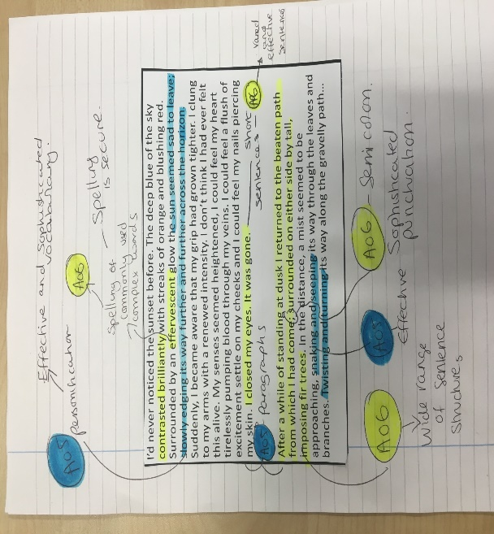
Read the following example. Highlight and annotate the above criteria – can you identify the AO?
I’d never noticed the sunset before. The deep blue of the sky contrasted brilliantly with streaks of orange and blushing red. Surrounded by an effervescent glow the sun seemed sad to leave; slowly edging its way further and further across the horizon. Suddenly, I became aware that my grip had grown tighter. I clung to my arms with a renewed intensity. I don’t think I had ever felt this alive. My senses seemed heightened, I could feel my heart tirelessly pumping blood through my veins. I could feel a flush of excitement settle on my cheeks and I could feel my nails piercing my skin. I closed my eyes. It was gone.
After a while of standing at dusk I returned to the beaten path from which I had come; surrounded on either side by tall, imposing fir trees. In the distance, a mist seemed to be approaching, snaking and seeping its way through the leaves and branches. Twisting and turning its way along the gravelly path…
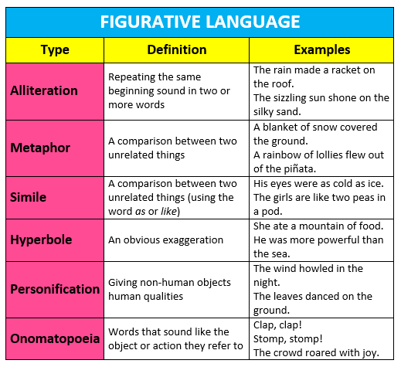

Sentence starters:  Adverb starter  Rhetorical question starter  Metaphor starter  One word sentence  Simile starter  Adjectives starter | Language techniques to include:  5 senses Adjective Verb Adverb  Simile Metaphor Personification Onomatopoeia  Alliteration Rhetorical Question  Hyperbole Repetition  Juxtaposition Oxymoron  SHOW don’t TELL! | Technical accuracy:  Accurate spelling  A range of punctuation marks .?! , ‘ … ;  Accurate grammar  Varied paragraph lengths  Varied sentence lengths  Ambitious vocabulary  Proofread carefully!
Grade 1-3 Get The Basics | Grade 4-5 Hitting the Middle | Grade 6+ Going for the Top
It was a cold, wet day. The powerful waves crashed on the sand. The weather was terrible. | Cold, wet, grey. It was typical for this part of the world. Dark clouds covered the sky and the rain poured. Huge, powerful waves violently crashed into the murky, brown sands, leaving piles of salty seaweed across the shoreline. | Violent winds whipped my skin as I gazed into the distance. Rain poured incessantly from the jet-black sky and the thunder growled above me. Wild waves crashed into the rocks, sending continual sprays of salty water over the deserted restaurants. A man stood, alone, on the pier…

Sensory Details Word List
Keep the following lists of words to help you improve your writing. Using sensory words can help you provide more details and examples in your writing. Add to this list as you learn more sensory words.

Sight | Sound | Touch | Taste | Smell
bleary  blurred  brilliant colourless dazzling dim dingy faded faint flashy gaudy glance gleaming glimpse glistening glittering gloomy glossy glowing grimy hazy indistinct misty peer radiant shadowy shimmering shiny smudged sparkling streaked striped tarnished twinkling | bellow blare buzz cackle cheer clamour clang crackle creak grumble gurgle hiss howl hush jabber mumble murmur mutter rant rave roar rumble rustle screech shriek shrill sizzle snarl squawk squeal swish thud thump whimper yelp | balmy biting bristly bumpy chilly coarse cold cool crawly creepy cuddly dusty feathery feverish fluffy furry fuzzy gooey greasy gritty hairy hot icy limp lumpy moist oily powdery prickly scratchy shivery silky slimy slippery spongy springy squashy sticky sweaty velvety | appetising bitter bland creamy delectable delicious flavourful flavourless gingery luscious nauseating palatable peppery piquant refreshing ripe rotten salty savoury scrumptious sharp sour spicy spoiled stale sugary sweet tangy tasteless tasty unappetising unripe vinegary yummy zesty | acrid aroma aromatic fetid foul-smelling fragrant mouldy musty inodorous odourless old perfumed pungent putrid rancid rank reeking scent scented smell spicy steno sweet waft whiff

Practice
Write a short description inspired by the image
20 minutes



Self-assessment. Highlight and annotate where you have:
- Used descriptive techniques
- Used sensory details
Comment:
Target:

Lesson 4: To use interesting vocabulary when writing creatively for paper 1

Method
You should use interesting words to describe. You can do this by describing colour, characters, setting and senses.
Think – Pair – share
Annotate any interesting words in the below extract. Consider the effect these words have.

Charlotte Hobson: Black Earth City

The human overpopulation was equally intense. There were at least three and often closer to six people to each room, in which the occupants slept, worked, had parties, ate, drank, sulked, wrote letters, cooked, smoked and hung out their washing. In Room 179, which Emily and I shared with Ira, a kind, velvety-eyed girl from a town in the Voronezh region, our belongings were thrust under the beds and into two thin, coffin-shaped cupboards by the door. The fridge chugged like an idling truck. The Voronezh-made television, which Ira turned on as soon as she woke up, crackled and buzzed. The brand-new orange wallpaper peeled gently away from the walls and the rug we bought from the Univermag gave off puffs of red and purple powder at every tread.
We followed him over the tram tracks, up the street, and into a yard in which stray dogs were picking over a pile of smouldering rubbish. In front of us stood a squat, flat-fronted block: Hostel No 4. The entrance hall was underwater green; against one wall sat a babushka whose metal teeth glinted in the half-light. Heaps of rubble lay in the corners. On the fourth floor, halfway down the corridor, Emily and I were shown into a long, low room, empty but for three iron bed-frames. The stink of the rust-coloured paint that had been splashed over the ceiling and the grimy lino floor rose up to meet us, along with a stale, sweaty smell. There was a pause.

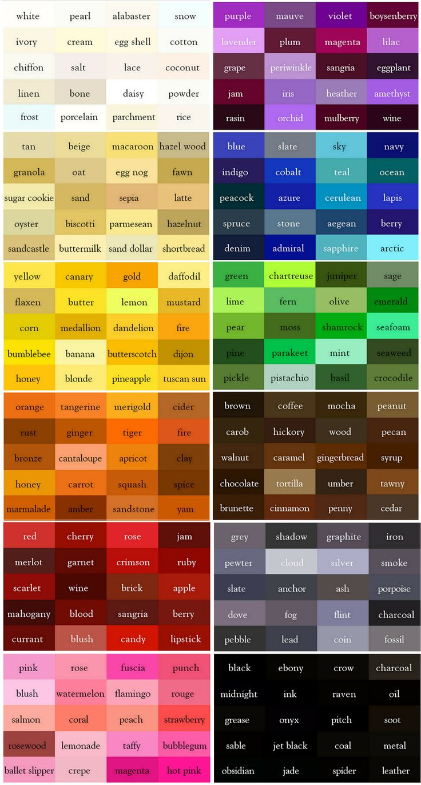

Practice
Write a descriptive paragraph for each image focusing on interesting vocabulary and the techniques that you re-capped last lesson.

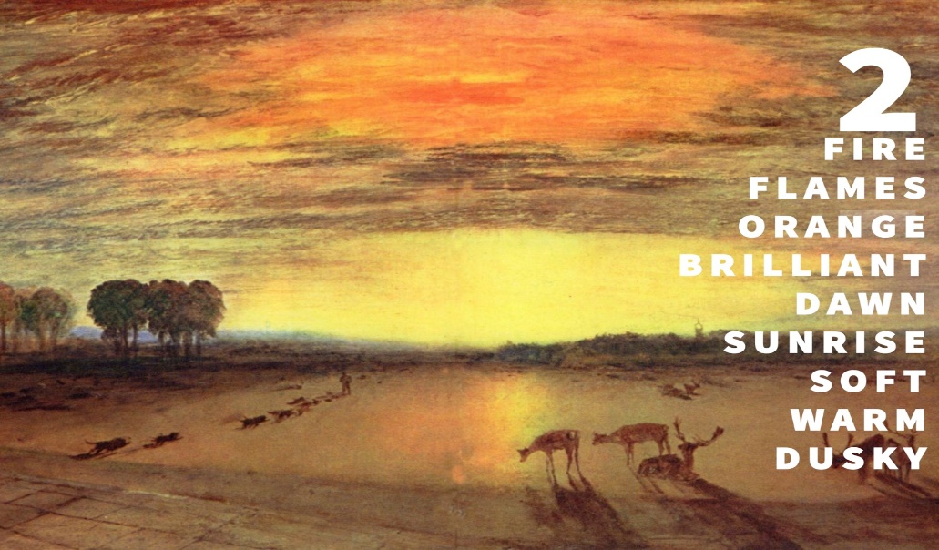

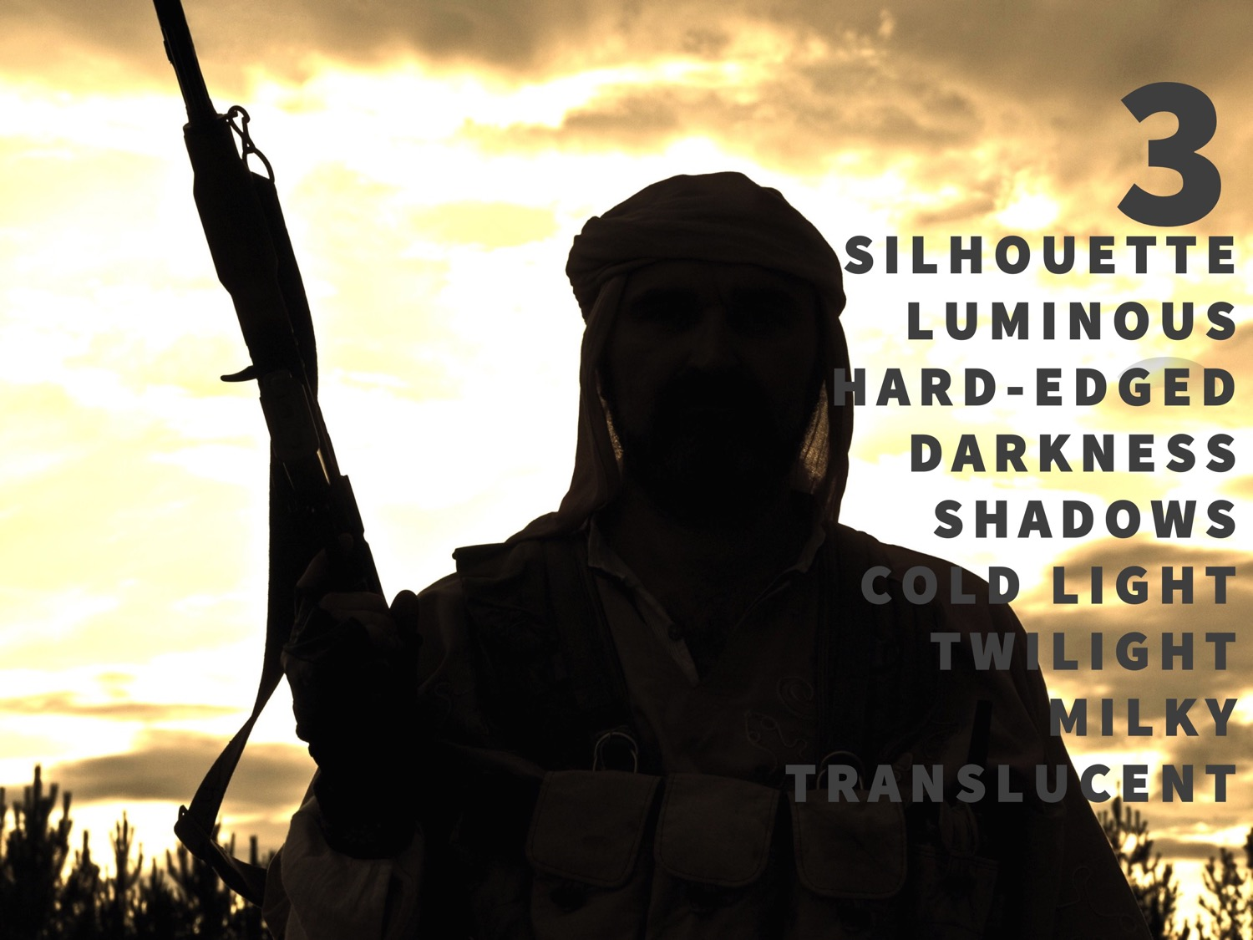

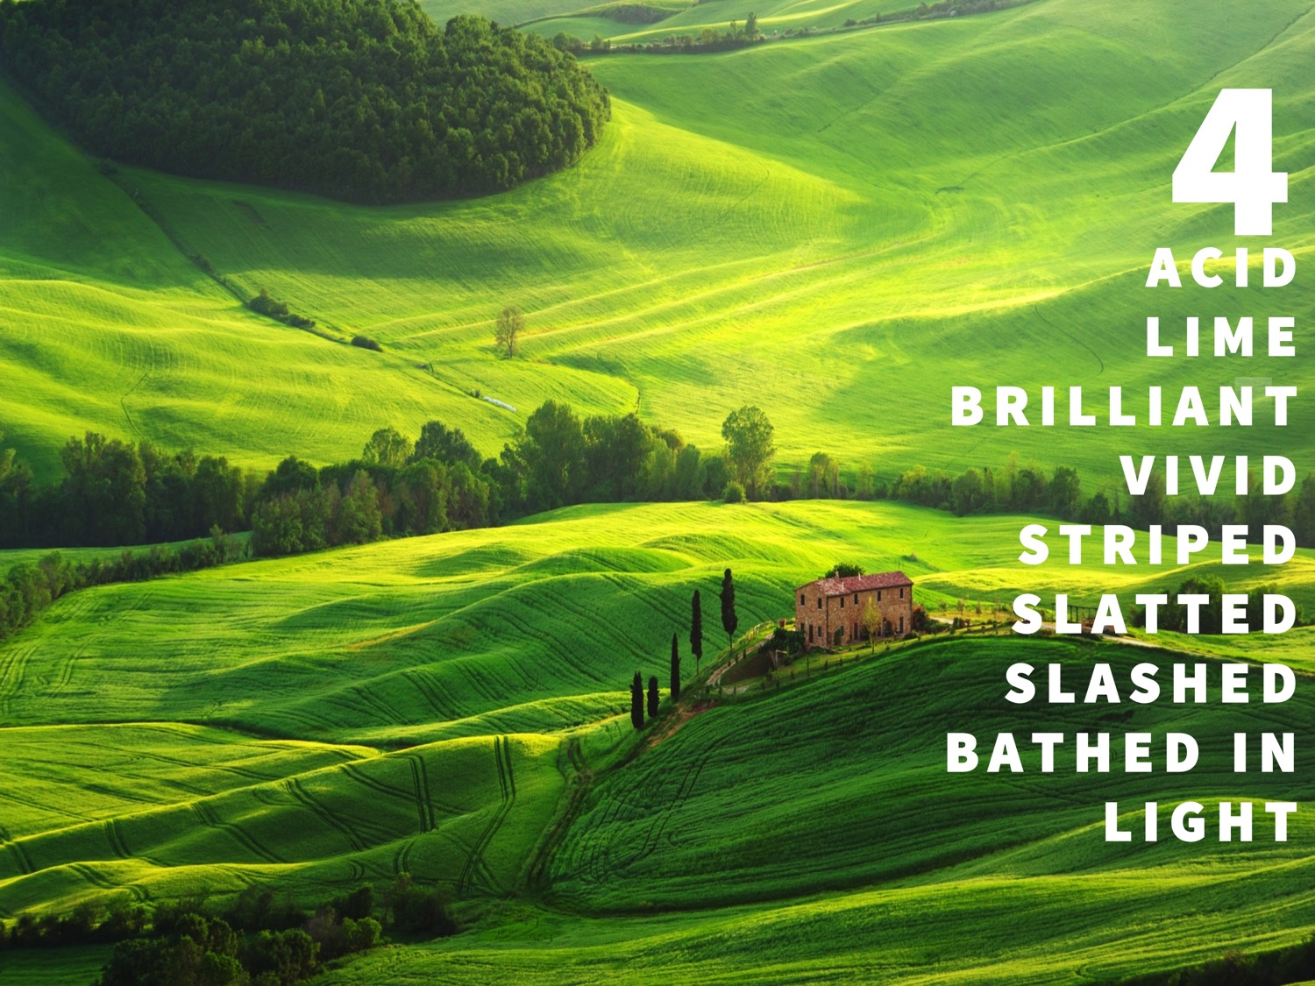

Reflection.
You should have learnt some new impressive vocabulary today.
Note down five words that you are going to attempt to use in your exam.
1.
2.
3.
4.
5.

Lesson 5: To use language when writing creatively for paper 1
Practice

Today you are going to write under timed conditions.
Use all the skills you have revised so far and your prior knowledge about q5.

Q5) Write a story/description inspired by the following image (40 marks)
45 minutes
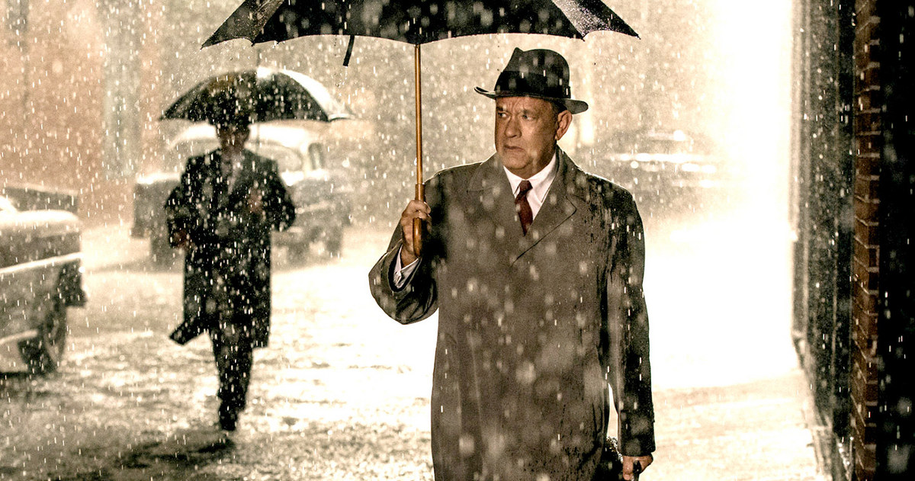

Progress Task

Lesson 6: To revise and attempt the structure question

(paper 1 q3)
Method

Marks? 8
Minutes? 15
Amount? 3-4 paragraphs
Skills?
- AO2: Explaining and analysing how the writer has used structure.
- How has the writer structured the text to…

Things to consider when analysing structure:
- How does the pace progress / change?
- Does the writer hold back any information and if so why?
- Are there any similarities or contrasts between the beginning and end of the passage? What is the effect?
- How does the writer use the length of the paragraphs to affect the reader?
- What is the tone / mood / atmosphere of the text? Is it the same or does it change and why? Trace the evidence throughout the text.
- What is the writer making the reader focus on in the text? Does this stay the same, develop or change? Trace the evidence throughout the text.
- Can I name the structural features I have found using subject terminology (e.g. repetition / pathetic fallacy / change)
- Does the writer create tension through the source? How?
- Whose point of view is it from? Why?
- Is the passage in chronological order? What is the effect of this?

Question Three Writing frame:
Point
- Introduce point linked to question
- Name structural techniques (subject terminology)
Evidence
- (Usually) use at least two quotations / references
Analysis
- Writer’s intentions (and effect on reader)

In the beginning the writer focuses the reader’s attention on……(evidence and analysis)…….
The writer then shifts the focus to……

Top tips for question 3:
- Don’t add an introduction or conclusion at all, just the 3 paragraphs above.
- Your explanation should focus on the effect on the reader, how does this interest you?
- Your explanation should be specific. For example, first person narration always allows you to understand the thoughts and feelings of a character but how does this particularly interest you as a reader here?
- Don’t over complicate the question, if there’s some obvious building of tension or shifting of focus in there, analyse it, that’s why the examiner chose it! You will be able to squeeze a lot more analysis out of some tension and suspense than you will from paragraph length!
- If you can’t find a specific structural feature, such as withholding information, you can still analyse the beginning, middle and end.

WAGOLL
Have a look at this sample answer for Question Three:
The writer uses a first person narrative throughout the extract to allow us to follow Arthur’s emotional turmoil. For example, the extract opens with, “At first, all seemed very quiet”. By opening with the phrase “at first” the reader is immediately aware that this is about to change and we therefore fear for Arthur as he is soon “paralysed with fear” yet we are unaware as to why. This narration enables us to follow Arthur through his journey and experience the noise as he does, in the present tense.
The writer withholds information throughout the extract in order to build tension and suspense. For example, a short, declarative sentence is used to bring the reader to an abrupt halt part way through the description of the noise. For example, “Nothing else happened”. This suggests to the reader that the noise is something supernatural as we were awaiting an answer, yet nothing was given. This could also build tension as we are left in sudden suspense as to what the noise could be. The writer has done this to create a sense of the unknown and mystery and therefore makes the reader intrigued and once again fearful as the noise is the only sound in the “ominous” atmosphere.
Finally, the writer structures the extract in chronological order with a slow pace to build tension and suspense. For example, we are made aware of the noise in the opening paragraph yet are still only revealed that it is a repetitious, “Bump bump” by the end. This is an anti-climatic ending to the extract as although the repetition of “Bump bump” leaves us tense, as we are aware as a reader that this is unlikely to be the last we hear of the noise, we were expecting a revelation to shock or frighten us when Arthur reached the door at the end of the corridor.

1.Use the mark scheme to highlight and annotate the following:
- Subject terminology
- Inference
- Deeper inferences/interpretations/explanations
- Effect on reader
- Reference or quotations from text
2. Annotate any areas that you think could be improved
Can you arrive at a band/grade for these responses?
Sentence starters:  The text then shifts to…  There is a shift in the text when...  The focus then shifts to…  The writer repeats to idea of…  There is a pattern of… in the text.  The narrative pace slows when…  The narrative pace increases when…  This helps to build tension in the text.  The writer is foreshadowing… | Structure Terminology:  Shifts  Focus  Develops  Repeats  Pattern  Contrast  Narrative pace  Foreshadows  Short sentence  Tone  Tension
Grade 1-3 Get The Basics | Grade 4-5 Hitting the Middle | Grade 6+ Going for the Top
At the beginning the writer focuses on the weather saying, “the wind came in gusts”. This makes the reader think that something bad is going to happen next. | At the beginning the writer focuses on the weather to foreshadow danger as “the wind came in gusts”, which indicates to the reader that the storm represents danger or a hazard for the character. The description of the weather encourages the reader to picture the conditions. | At the beginning the writer focuses on the weather to foreshadow danger as “the wind came in gusts” suggesting that the storm represents a potential threat. This is further reinforced by further detailed description of the impact of the storm. This emphasises to the reader the threat that the storm brings, both literally and metaphorically.

Level 4 | 7-8 | - Shows detailed, perceptive understanding of structural features  - Analyses the effects of the writer’s choice of structural features  - Selects a judicious range of examples. Uses a range of subject terminology appropriately
Level 3 | 5-6 | - Shows clear understanding of structural features  - Clearly explains the effects of the writer’s choice of structural features  - Selects a range of relevant examples. Uses subject terminology accurately
Level 2 | 3-4 | - Shows some understanding of structural features  - Attempts to comment on the effect of structural features  - Selects some relevant examples  - Uses some subject terminology, not always appropriately
Level 1 | `1-2 | - Shows simple awareness of structure  - Offers simple comment on the effect of structure  - Simple references or examples  - Simple mention of subject terminology

Practice
The Book Thief By Markus Zusek
First up is something white. Of the blinding kind.
Some of you are most likely thinking that white is not really a colour and all of that tired sort of nonsense. Well I’m here to tell you that it is. White is without question a colour, and personally, I don’t think you want to argue.
A REASSURING ANNOUNCEMENT
Please, be calm, despite that previous threat.
I am all bluster –
I am not violent. I am not malicious.
I am a result.
Yes, it was white.
It felt as though the whole globe was dressed in snow. Like it had pulled it on, the way you pull on a jumper. Next to the train line, footprints were sunken to their shins. Trees wore blankets of ice.
As you might expect, someone had died.
They couldn’t just leave him on the ground. For now it wasn’t such a problem, but very soon, the track ahead would be cleared and the train would need to move on.
There were two guards.
There was a mother and her daughter. One corpse.
The mother, the girl and the corpse remained stubborn and silent.
*
‘Well, what else do you want me to do?’
The guards were tall and short. The tall one always spoke first, though he was not in charge. He looked at the smaller, rounder one. The one with the juicy red face.
‘Well,’ was the response, ‘we can’t just leave them like this, can we?’
The tall one was losing patience. ‘Why not?’
And the smaller one damn near exploded. He looked up at the tall one’s chin and cried, ‘Spinnst du? Are you stupid!?’ The abhorrence on his cheeks was growing thicker by the moment. His skin widened. ‘Come on,’ he said, traipsing through the snow. ‘We’ll carry all three of them back on if we have to. We’ll notify the next stop.’
As for me, I had already made the most elementary of mistakes. I can’t explain to you the severity of my self-disappointment. Originally, I’d done everything right: I studied the blinding, white-snow sky who stood at the window of the moving train. I practically inhaled it, but still, I wavered. I buckled – I became interested. In the girl. Curiosity got the better of me, and I resigned myself to stay as long as my schedule allowed, and I watched.
Twenty-three minutes later, when the train was stopped, I climbed out with them.
A small soul was in my arms. I stood a little to the right.

Question Three (8 marks)
You now need to think about the whole of the source.
The extract is from the opening of the novel.
How has the writer structured the text to interest you as a reader?
You could write about:
- The narrative voice
- The location and setting
- The way characters are introduced
- The way action and events develop throughout the extract.
- Paragraphs and sentence length.

Peer assessment.
USE THE MARK SCHEME
Comment:
Target:

Lesson 7: To complete a mini paper 1 mock
Practice
You have focused on q2 and q3 so far, it’s time to practice under timed conditions.

Enduring Love from chapter 1
The narrator, Gadd and other men are trying to stop a hot air balloon from
flying off. Inside the basket is a terrified boy.

A mighty fist of wind socked the balloon in two rapid blows, one-two, the
second more vicious than the first. It jerked Gadd right out of the basket on to
the ground, and with Gadd's considerable weight removed from the equation, it
lifted the balloon five feet or so, straight into the air. The rope ran through my
grip, scorching my palms, but I managed to keep hold, with two feet of line
spare, The others kept hold too. The basket was right above our heads now,
and we stood with arms upraised like Sunday bell ringers. Into our amazed
silence, before the shouting could resume, the second punch came and
knocked the balloon up and westwards. Suddenly we were treading the air
with all our weight in the grip of our fists.

Almost simultaneous, with the desire to stay on the rope and save the boy,
came other thoughts, thoughts of self preservation and fear. We were rising,
and the ground was dropping away as the balloon was pushed upwards. I
knew I had to get my legs and feet locked round the rope. But the end of the
line barely reached below my waist and my grip was slipping. My legs flailed in
the empty air. Every fraction of a second that passed increased the drop, and
the point must come when to let go would be impossible or fatal. Then,
someone did let go. Immediately, the balloon and its hangers on lurched
upwards another several feet.

But letting go was in our nature too. The child was not my child, and I was not
going to die for it. Then I glimpsed another body fall away and I felt the balloon
lurch upwards. The matter was settled. Altruism had no place. Being good
made no sense. I let go and fell, I reckon, about twelve feet. I landed heavily on
my side, I got away with a bruised thigh. Around me - before or after, I'm not so
sure - bodies were thumping to the ground.
By the time I got to my feet the balloon was fifty yards away, and one man was
still dangling by his rope, all his energies concentrated in his weakening grip. He
was already a tiny figure and as the balloon and its basket lifted away and
westwards, the smaller he became and the more terrible it was. Our silence was
a kind of acceptance, a death warrant. Or it was horrified shame. He had been on the rope so long that I began to think he might stay there until the balloon
drifted down. But even as I had that hope we saw him slip down right to the end
of the rope. And still he hung there. For two seconds, three, four. And then he let
ruthless gravity played its part. And from somewhere a thin squawk cut through
go and the stilled air. He fell as he had hung, a stiff little black stick. I've never
seen such a terrible thing as that falling man.

Q2 [AO2 - language]
Look in detail at the first paragraph

How does the writer use language here to describe the scene?
You could include the writer’s choice of:
• words and phrases
• language features and techniques
• sentence forms. [8 marks]

Q3 structure
You now need to think about the whole of the source. This text is from a novel.

How has the writer structured the text to interest you as a reader?
You could write about:
• what the writer focuses your attention on at the beginning
• how and why the writer changes this focus as the extract develops
• any other structural features that interest you. [8 marks]

Lesson 8: To use sentence structures when writing creatively

Method
Look at the different ways a sentence can be written to create interest:
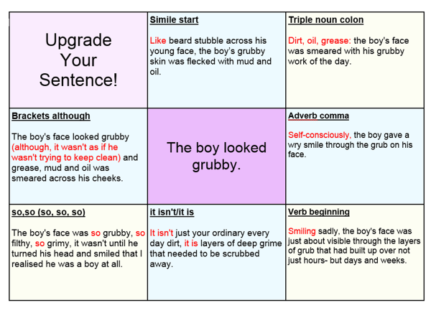
https://www.youtube.com/watch?v=ydLJtKlVVZw
https://www.youtube.com/watch?v=hplpQt424Ls
Practice
The night sky was very black. It was as black as coal. The birds were flying around the night sky wildly. It was as if they were scared. The wind was also wild and felt very cold. It was as cold as ice. The wind was so cold I thought I might die. It was not a very welcoming place to be. The fact I was here on my own made it worse.

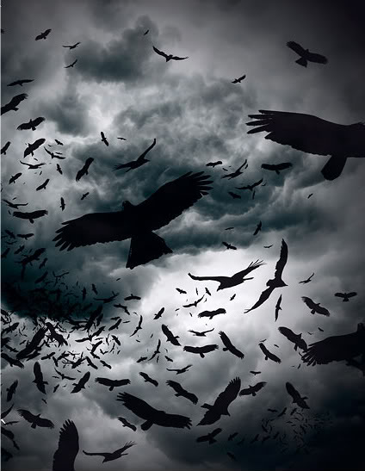
Think – Pair – Share

Improve the above paragraph by varying the sentences. Challenge – use all the ones on the ‘Upgrade your sentence’ sheet.

Method
You can also create interest by varying sentence length.
Look at this extract from Edgar Allan Poe’s A Tell Tale Heart, what do you notice about the sentence lengths and punctuation?
TRUE! --nervous --very, very dreadfully nervous I had been and am; but why will you say that I am mad? The disease had sharpened my senses --not destroyed --not dulled them. Above all was the sense of hearing acute. I heard all things in the heaven and in the earth. I heard many things in hell. How, then, am I mad? Hearken! and observe how healthily --how calmly I can tell you the whole story.
It is impossible to say how first the idea entered my brain; but once conceived, it haunted me day and night. Object there was none. Passion there was none. I loved the old man. He had never wronged me. He had never given me insult. For his gold I had no desire. I think it was his eye! yes, it was this! He had the eye of a vulture --a pale blue eye, with a film over it. Whenever it fell upon me, my blood ran cold; and so by degrees --very gradually --I made up my mind to take the life of the old man, and thus rid myself of the eye forever.

Practice
Write the opening to a story inspired by the image. (and video clip) https://www.youtube.com/watch?v=LpxwR_9EhlY
- Begin with a one word sentence that ends with an exclamation mark
- You must use repetition
- You must use a rhetorical question
- You must use a dash
- You must use three short sentences in a row
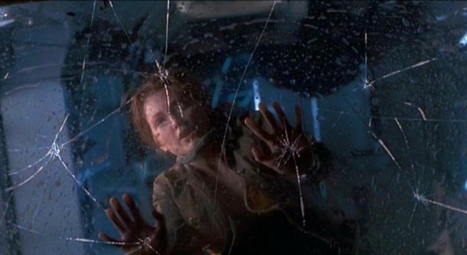

Lesson 9: To use structure when writing creatively
Method
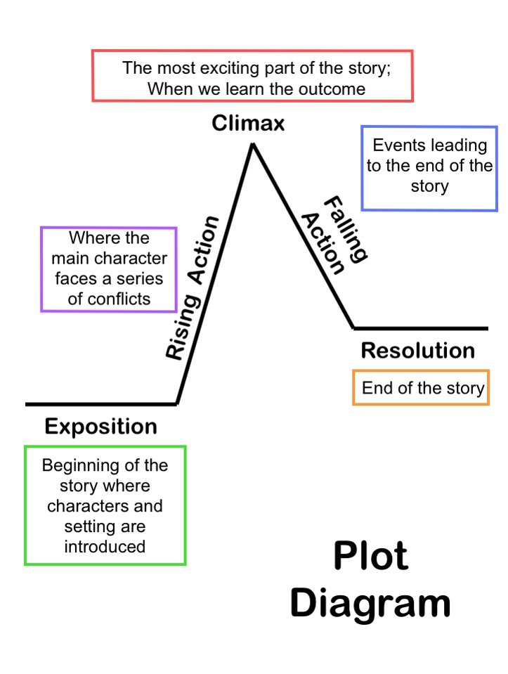
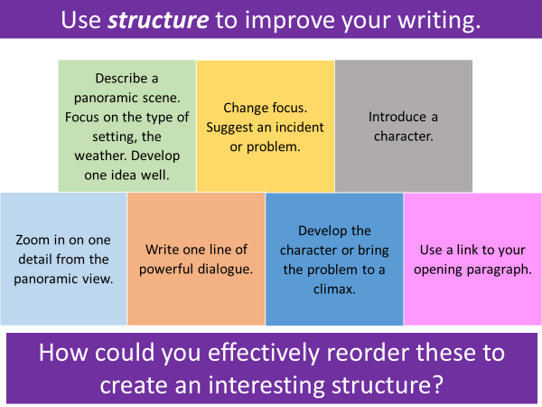
Practice

Write a story where animals become the top of the food chain and humans are at the bottom.
Watch the video clip for inspiration.

https://www.youtube.com/watch?v=33hKjL6ZVMs&list=PLeoeGQEdHe0DWGuC4kynmLD8NrhjoS7ut&index=12

Progress Task

Lesson 10: To evaluate
Method
Marks? 20
Minutes? 20
Amount? 4 paragraphs
Skills?
A04: Evaluating the text critically, considering the methods used by the writer (language, structure).
A student having read this section of the text said “….” To what extent do you agree?
Top tips:

- Underline the focus of the question - make sure your points are linked to this.
- Make sure you only choose quotes from the lines they have given you.
- Agree or partially agree with the statement!
- Try to use short quotes (a few words/one word).
- Refer to the methods used by the writer (language, form). Explain why certain words or phrases have been used and the impact they have.
- Explain if the writer is successful in relation to the statement.
- Use ‘word’ or ‘phrase’ if you do not know the correct terminology.
Sentence starters:
P: I agree that the writer… because… OR One way the writer…. is when….
E: For example “__________”. OR This can be seen where…
I: This shows that…It also suggests/infers/implies that…
The effect on the reader is…OR The writer is trying to… OR This is effective because… OR The writer is successful because… OR At this part in the extract, the reader feels…

Writing frame:
Introduction- I agree with the statement because___________________________
___________________________________________________________________.

Main- Firstly, the writer uses ____________ to create ______________________.
For example, “_____________________________________________________”.
This is successful in creating __________________________________________
___________________________________________________________________.
(Where possible) This also creates______________________________________
___________________________________________________________________.
The word “_____________” has connotations of ___________________________
and therefore makes the reader think ___________________________________.
Overall, the writer’s intention/overall effect on the reader is_________________
___________________________________________________________________.

Do this 3- 4 times!
Conclusion- Overall, the effect on the reader is_____________________________.
I think the most effective method is ____________ because____________________
_____________________________________________________________________.

Top tips for Question 4:
- Always agree with the statement.
- Always bring it back to the effect on the reader and the writer’s intention.
- Use the phrase “this is successful in creating” to show you’re evaluating.
- Use some of the ideas from Question 1 and 2 if they’re in the same section you’ve been asked to focus on.
- Never miss this question out, it’s worth 20 marks!
- This answer should be considerably more developed than your analysis in questions 2 and 3 as you have longer and it’s worth more marks.

Have a look at this sample answer:
I agree with the statement because Hill creates a tense atmosphere that makes the reader feel anxious and the presentation of the characters shows us how nervous Arthur is.
Firstly, the writer uses the character of Spider to create a sense of danger. For example, “I put my hand on her collar, stroked the rough, short hair […] I could feel the tension in her limbs”. This imagery is successful in creating anxiety in the reader as a dog is often described to have a sixth sense with regards to supernatural entities. Therefore, if the dog can sense something, as well as Spider, the reader feels sure that something sinister is lurking. This also creates the impression that Arthur is particularly nervous as he has to stroke the dog to comfort her but we are under the impression that this is also to comfort himself and to reassure himself that he is not alone. The word “tension” has connotations of being rigid with fear and therefore makes the reader think that if the dog is afraid, we should be too. Overall, the writer’s intention is to make us aware that Arthur’s nervousness is not irrational as Spider also fears the noise and therefore we are anxious of what the source could be.
Secondly, the writer uses the atmosphere to create tension. For example, “a silence, a seething, blanketing, almost tangible silence, and a musty darkness, thick as felt”. This listing, coupled with a simile is successful in creating a sinister atmosphere, typical of the Gothic genre, in which we know something Supernatural will be the cause of the noise and therefore tension and suspense is built as we await to discover what. This also creates the idea that Arthur is vulnerable as the simile describes the darkness as impenetrable, suggesting that Arthur is blindly making his way towards the noise, unaware of what could be around him. The word “blanketing” has connotations of being covered and therefore makes the reader think that Arthur is surrounded and trapped. Overall, the writer’s intention is to build tension and suspense as we recognise this atmosphere to be typically Gothic and therefore anxiously await the inevitable arrival of the Supernatural.
Moreover, the writer uses the setting to create a stereotypical Gothic house. For example, “This was the door without a keyhole”. This imagery is successful in creating a typical Gothic setting of a haunted house. This also creates mystery as we are aware that if the noise is emitting from the locked room, it must have used Supernatural forces to enter. However, the writer withholds the information as to who, what or how they entered. Overall, the writer’s intention is to create a sense of mystery and build our anxiety as we fear what might come out of the room.
Finally, the writer uses the character of Arthur to create a stereotypical Gothic character. For example, “I told myself it was a rat or a trapped bird”. This first person narrative is successful in creating an understanding in the reader of Arthur’s emotional turmoil throughout this experience as we take this slow journey towards the door with him and our anxiety builds with his own. This also creates a typical Gothic character as he attempts to rationalise the noise. Here we pity Arthur as we know it will be a Supernatural entity, as is common of the genre, but Arthur doesn’t want to believe it. The phrase “told myself” has connotations of Arthur trying to convince himself and therefore makes the reader think that he doesn’t truly believe this. Overall, the writer’s intention is to highlight Arthur as a typically rational Gothic character as this is the middle of the novella and could be the point in which he begins to realise the truth.
Overall, the effect on the reader is a mounting sense of anxiety and tension as we await the discovery of what is tormenting Arthur. I think the most effective method is the depiction of the atmosphere because we can recognise the Gothic atmosphere early on and therefore the tension builds from this point.
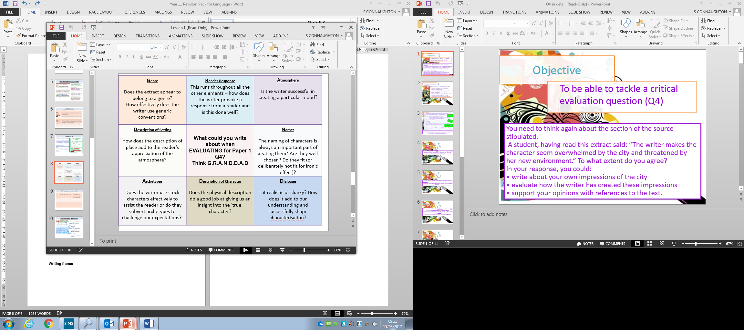
Ideas to consider:
STATEMENT  I agree that the writer… because…  One way the writer… is through… | QUOTE  For example…  The text states…  This can be seen where… | UNDERSTANDING  This shows that… | INFERENCE  This also suggests/  implies/ infers…  This creates the impression that… | DEVELOPMENT  The effect on the reader is…  At this part in the extract, the reader feels…  The writer is symbolising…  The writer is trying to…  This is effective because…  The writer is successful because…

Grade 1-3 Get The Basics | Grade 4-5 Hitting the Middle | Grade 6+ Going for the Top
Statement + Quote + Understanding  I agree that Hale is nervous. The text states ‘he didn’t feel too safe in Brighton’. This shows that he felt uncomfortable and on-edge there. | Statement + Quote + Understanding + Inference + Development  I agree that the writer presents Hale as unsafe and nervous. The text states “he didn’t feel too safe in Brighton”. This implies that he is in danger and feels uncomfortable there. This is in contrast to the crowds that surround him, who appear to be on holiday and are having fun. This creates curiosity in the reader, and helps to develop a tense atmosphere. | Statement + Quote + Understanding + Inference + Development  I agree with the statement. Hale is presented as feeling nervous and unsafe in the adverb ‘hastily’. This infers that he was hurried and perhaps felt like he was running out of time and this increases the narrative pace. The phrase ‘inky fingers and bitten nails’ also links to this, as we get the impression that he was unkempt and on-edge. By focusing the reader’s attention on this right at the start of the extract, the writer creates a tense atmosphere and the reader is intrigued about what will happen to this character.

Practice

Read ad annotate the following extract with a focus on the Q4.
Q4: Focus this part of your answer on paragraphs 3, 4 and 5. A student, having read this part of the text said: “The writer makes you feel sorry for Victor Frankenstein.”
AQA Paper 1: Explorations in Creative Reading and Writing

The extract is taken from Mary Shelley’s novel, Frankenstein, written in 1818.
In this passage, the narrator – the young scientist Victor Frankenstein – describes the night he succeeded in his experiment to bring life to a dead body.
It was on a dreary night of November that I beheld the accomplishment of my toils. With an anxiety that almost amounted to agony, I collected the instruments of life around me, that I might infuse a spark of being into the lifeless thing that lay at my feet. It was already one in the morning; the rain pattered dismally against the panes, and my candle was nearly burnt out, when, by the glimmer of the half-extinguished light, I saw the dull yellow eye of the creature open; it breathed hard, and a convulsive motion agitated its limbs.
How can I describe my emotions at this catastrophe, or how delineate the wretch whom with such infinite pains and care I had endeavoured to form? His limbs were in proportion, and I had selected his features as beautiful. Beautiful! Great God! His yellow skin scarcely covered the work of muscles and arteries beneath; his hair was of a lustrous black, and flowing; his teeth of a pearly whiteness; but these luxuriances only formed a more horrid contrast with his watery eyes, that seemed almost of the same colour as the dun-white sockets in which they were set, his shrivelled complexion and straight black lips.
The different accidents of life are not so changeable as the feelings of human nature. I had worked hard for nearly two years, for the sole purpose of infusing life into an inanimate body. For this I had deprived myself of rest and health. I had desired it with an ardour that far exceeded moderation; but now that I had finished, the beauty of the dream vanished, and breathless horror and disgust filled my heart. Unable to endure the aspect of the being I had created, I rushed out of the room and continued a long time traversing my bed-chamber, unable to compose my mind to sleep. At length lassitude succeeded to the tumult I had before endured, and I threw myself on the bed in my clothes, endeavouring to seek a few moments of forgetfulness. But it was in vain; I slept, indeed, but I was disturbed by the wildest dreams. I thought I saw Elizabeth, in the bloom of health, walking in the streets of Ingolstadt. Delighted and surprised, I embraced her, but as I imprinted the first kiss on her lips, they became livid with the hue of death; her features appeared to change, and I thought that I held the corpse of my dead mother in my arms; a shroud enveloped her form, and I saw the grave-worms crawling in the folds of the flannel. I started from my sleep with horror; a cold dew covered my forehead, my teeth chattered, and every limb became convulsed; when, by the dim and yellow light of the moon, as it forced its way through the window shutters, I beheld the wretch—the miserable monster whom I had created. He held up the curtain of the bed; and his eyes, if eyes they may be called, were fixed on me. His jaws opened, and he muttered some inarticulate sounds, while a grin wrinkled his cheeks. He might have spoken, but I did not hear; one hand was stretched out, seemingly to detain me, but I escaped and rushed downstairs. I took refuge in the courtyard belonging to the house which I inhabited, where I remained during the rest of the night, walking up and down in the greatest agitation, listening attentively, catching and fearing each sound as if it were to announce the approach of the demoniacal corpse to which I had so miserably given life.
Oh! No mortal could support the horror of that countenance. A mummy again endued with animation could not be so hideous as that wretch. I had gazed on him while unfinished; he was ugly then, but when those muscles and joints were rendered capable of motion, it became a thing such as even Dante could not have conceived.
I passed the night wretchedly. Sometimes my pulse beat so quickly and hardly that I felt the palpitation of every artery; at others, I nearly sank to the ground through languor and extreme weakness. Mingled with this horror, I felt the bitterness of disappointment; dreams that had been my food and pleasant rest for so long a space were now become a hell to me; and the change was so rapid, the overthrow so complete!

Lesson 11: To complete mini mock with a focus on Q4.
Answer q4 first
Practice
Q1: Read the second paragraph again.
List four things from this part of the text about the Creature’s appearance. [4 marks]
- ____________________________________________________
- ____________________________________________________
- ____________________________________________________
- ____________________________________________________
Q2: Read again the first paragraph.

How does the writer use language to create a spooky atmosphere? [8 marks]

You could include:
- The writer’s choice of words and phrases
- Language features and techniques
- Sentence forms
Q4: Focus this part of your answer on paragraphs 3, 4 and 5. A student, having read this part of the text said: “The writer makes you feel sorry for Victor Frankenstein.”
To what extent do you agree? [20 marks]

In your response, you should:

- Write about your own impressions of Victor Frankenstein
- Evaluate how the writer arouses our sympathy for Victor
- Support your opinions with quotations from the text

Peer assessment.
USE THE MARK SCHEME
Comment:
Target:

Lesson 12: Paper 2 Q2 – Summarise
Marks? 8
Time – 8-12
Question 2 will always ask you to write a summary of the similarities or the differences between the two sources PEE x 3/4
Writing frame:
Source A describes ______________ as_____________. Whereas Source B describes ______________ as_____________.
For example Source A states, “_______________________________________”.
Whereas Source B states, “__________________________________________”.
In Source A, this suggests ____________________________________________.
However, in Source B it suggests______________________________________.
Do this 3 times!
Top tips for Question 2:
- Don’t add an introduction or conclusion at all, just the 3 paragraphs above.
- Your explanation should make inferences, what do you learn as a reader?
- This isn’t a language question, you don’t need to look at the effect of language on the reader or connotations of key words.
- Don’t over complicate the question, if there’s an obvious difference in there, analyse it, that’s why the examiner chose it!
Have a look at this Question Two sample answer:
Source A describes Margate as having lots of entertainment. Whereas Source B describes Broadstairs as having a lack of entertainment. For example, Source A states, “There was crazy golf and the Jamaica Inn, a big puppet theatre, and a big building with a fibreglass devil at the entrance and Caves nightclub underneath”. Whereas Source B states, “a bleak chamber […] the Assembly rooms”. The quote from Source A suggests that visitors would have a range of activities to choose from and would therefore be able to entertain themselves as there would be something for everyone. However, in Source B it suggests that people do not visit for entertainment but to relax.

Secondly, Source A describes Margate as a family friendly destination. Whereas Source B describes Broadstairs as a quiet place to escape the city. For example, Source A states, “My strongest childhood memories of all undoubtedly come from summer days spent at the Lido”. Whereas Source B states, “Sky, beach and village”. In Source A, this suggests that the destination is family friendly as it offers a fun, yet safe place for children to enjoy themselves. However, in Source B it suggests the simplicity of Broadstairs and its peace and quiet.

Finally, Source A describes Margate as an exciting place to grow up. Whereas Source B describes Broadstairs as a rural, beautiful destination. For example, Source A states, “The whole of Margate at that time was alive and spirited”. Whereas Source B states, “A ripple plays among the ripening corn upon the cliff”. In Source A, this suggests that the destination is always busy and there’s always an excited atmosphere. However, in Source B it suggests the beauty and tranquillity of the destination in comparison to the dusty metropolis.

Practice

Think – Pair – Share
What are the similarities and differences in these two adverts?

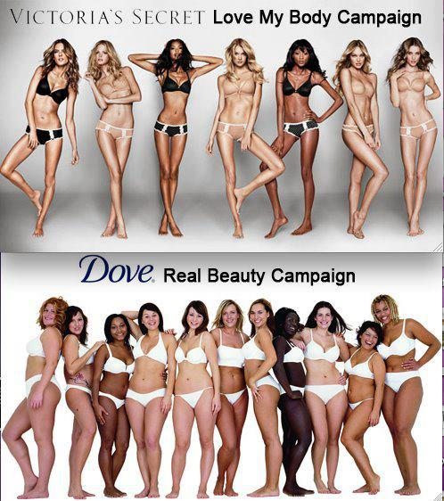

Lesson 13: Paper 2 Q4 – Compare
Method
Question 4 will ask you to look at the whole of the source and compare their different views. (Introduction, PEAL x 3, Conclusion). There are 16 marks available. You should spend no more than 20 minutes on this question.
Writing frame:
Source A describes ______________ as_____________. Whereas Source B describes ______________ as_____________.
The writer in Source A uses ______________ to describe __________________.
For example, “_____________________________________________________”.
This suggests _____________________________________________________ .
The word (use subject terminology where possible verb, adjective etc) “_____________” has connotations of __________________________________
And therefore makes the reader think __________________________________.

Whereas the writer in Source B uses ______________ to describe __________.
For example, “_____________________________________________________”.
This suggests _____________________________________________________ .
The word (use subject terminology where possible verb, adjective etc) “_____________” has connotations of __________________________________
And therefore makes the reader think __________________________________.

Do this 2-3 times!
Top tips for Question 4:
- Use your ideas from Question 2 as a plan and simply add in the methods and the effect.
- Always bring it back to the effect on the reader and the writer’s intention.
- Never miss this question out, it’s worth 16 marks!
- This answer should be considerably more developed than your analysis in questions 2 and 3 as you have longer and it’s worth more marks.
Have a look at this sample answer:
Source A describes Margate as having lots of entertainment. Whereas Source B describes Broadstairs as having a lack of entertainment. Source A uses listing to describe the entertainment. For example, “There was crazy golf and the Jamaica Inn, a big puppet theatre, and a big building with a fibreglass devil at the entrance and Caves nightclub underneath”. This suggests that visitors would have a range of activities to choose from and would therefore be able to entertain themselves as there would be something for everyone. The repetition of the adjective “big” has connotations of child-like language and therefore makes the reader think that everything in Margate seems fun and exciting, even when one has grown.
Whereas Source B uses adjectives to describe the entertainment, “a bleak chamber […] the Assembly rooms”. However, in Source B it suggests that people do not visit for entertainment but to relax. The adjective “bleak” has connotations of being dreary and miserable and therefore makes the reader think that it is the view and the peace that one would visit Broadstairs for, rather than the entertainment.

Secondly, Source A describes Margate as a family friendly destination. Whereas Source B describes Broadstairs as a quiet place to escape the city. Source A uses superlatives to describe her memories. For example, “My strongest childhood memories of all undoubtedly come from summer days spent at the Lido”. In Source A, this suggests that the destination is family friendly as it offers a fun, yet safe place for children to enjoy themselves. The word “strongest” therefore makes the reader think that Margate is particularly special as memories of it have not been diluted of the years, it has remained firm.

Whereas Source B uses triples to describe the view, “Sky, beach and village”. However, in Source B it suggests the simplicity of Broadstairs and its peace and
quiet. The lack of adjectives has connotations of simplicity and therefore makes the reader think that the simplicity and the natural beauty of Broadstairs is what makes it appealing.

Finally, Source A describes Margate as an exciting place to grow up. Whereas Source B describes Broadstairs as a rural, beautiful destination. For example Source A uses personification to describe her the atmosphere, “The whole of Margate at that time was alive and spirited”. In Source A, this suggests that the destination is always busy and there’s always an excited atmosphere. The word “spirited” has connotations of being energetic and therefore makes the reader think that Margate is full of life, almost as though all the tourists allow the destination to seem as one lively entity.

Whereas Source B uses personification to describe the destination, “A ripple plays among the ripening corn upon the cliff”. However, in Source B it suggests the beauty and tranquillity of the destination in comparison to the dusty metropolis. The word “ripple” has connotations of being a soft and delicate motion and therefore makes the reader think that Broadstairs is a calm and soothing place to be.

Practice
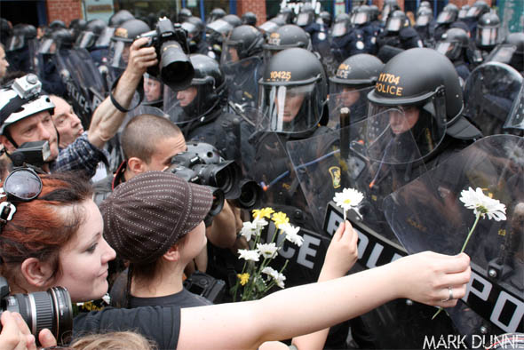
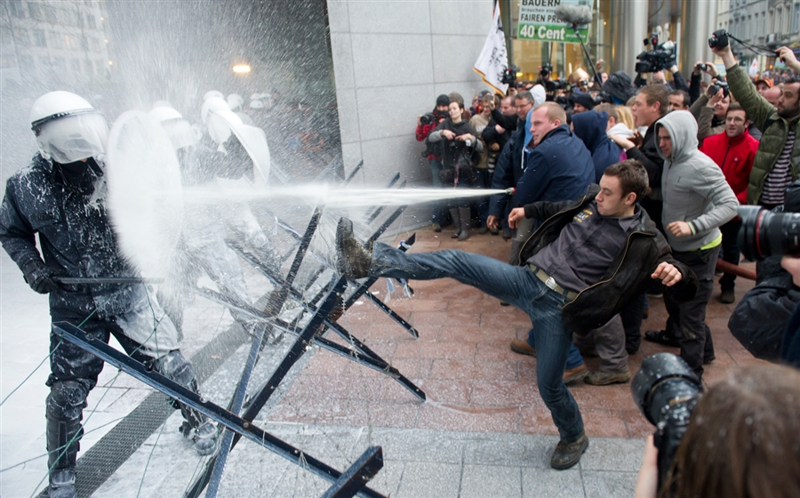

Both Images are from protests. Write a comparative paragraph in response to the following question:

Compare the different protest presented in the images.

Self-assessment.
USE THE MARK SCHEME
Comment:
Target:

Lesson 14: Paper 2 mini mock – summarise and compare
Practice
Source A
An extract from the diary of Leonid Rogozov, a Soviet general practitioner who took part in an Antarctic Expedition in 1960–1961. He developed appendicitis, which meant he had to perform an appendectomy on himself.

The Night Before Operating
I did not sleep at all last night. It hurts like the devil! A snowstorm whipping through my soul, wailing like a hundred jackals. Still no obvious symptoms that perforation is imminent, but an oppressive feeling of foreboding hangs over me ... This is it ... I have to think through the only possible way out: to operate on myself ... It's almost impossible ... but I can't just fold my arms and give up.

The Night After Operating
I worked without gloves. It was hard to see. The mirror helps, but it also hinders -- after all, it's showing things backwards. I work mainly by touch. The bleeding is quite heavy, but I take my time -- I try to work surely. Opening the peritoneum, I injured the blind gut and had to sew it up. Suddenly it flashed through my mind: there are more injuries here and I didn't notice them ... I grow weaker and weaker, my head starts to spin. Every 4-5 minutes I rest for 20-25 seconds. Finally, here it is, the cursed appendage! With horror I notice the dark stain at its base. That means just a day longer and it would have burst and ...

At the worst moment of removing the appendix I flagged: my heart seized up and noticeably slowed; my hands felt like rubber. Well, I thought, it's going to end badly. And all that was left was removing the appendix ... And then I realised that, basically, I was already saved.
Source B

An extract from a letter from Fanny Burney describing the surgery to treat her breast cancer in 1811. Victorian Surgery was performed without anaesthetic.

[The veil] was transparent, however, and I saw, through it, that the Bedstead was instantly surrounded by the 7 men and my nurse. I refused to be held; but when, Bright through the cambric, I saw the glitter of polished Steel—I closed my Eyes. I would not trust to convulsive fear the sight of the terrible incision. A silence the most profound ensued, which lasted for some minutes, during which, I imagine, they took their orders by signs, and made their examination—Oh what a horrible suspension!—I did not breathe—and M. Dubois tried vainly to find any pulse. This pause, at length, was broken by Dr Larry, who, in a voice of solemn melancholy, said “Qui me tiendra ce sein?—” (“Who will hold this breast for me?—”)

Yet—when the dreadful steel was plunged into the breast—cutting through veins—arteries—flesh—nerves—I needed no injunctions not to restrain my cries. I began a scream that lasted unintermittingly during the whole time of the incision—and I almost marvel that it rings not in my Ears still! so excruciating was the agony. When the wound was made, and the instrument was withdrawn, the pain seemed undiminished, for the air that suddenly rushed into those delicate parts felt like a mass of minute but sharp and forked poniards, that were tearing the edges of the wound—but when again I felt the instrument—describing a curve—cutting against the grain, if I may so say, while the flesh resisted in a manner so forcible as to oppose and tire the hand of the operator, who was forced to change from the right to the left—then, indeed, I thought I must have expired.
Questions
- Identify the four correct statements:
A The surgeon felt confused by his symptoms
B The weather was making the surgeon feel unwell
C The surgeon felt worried about operating upon himself
D The mirror was both useful and problematic
E During the operation the surgeon made mistakes
F The whole operation took 45 minutes
G At the point of taking out his appendix the surgeon felt like giving up
H At the point of taking out his appendix the surgeon made a mistake

2. The experiences of the anticipation of surgery that the two patients are very different. Write a summary of the two experiences of anticipating the surgery. (8 marks)

4. For this question, you need to refer to the whole of Source A, together with the whole of Source B.
Compare how the writers convey their different perspectives on the experience of the surgery.
In your answer, you could:
• compare their different perspectives on the surgery
• compare the methods the writers use to convey their different perspectives
• support your response with references to both texts.
[16 marks]

Progress Task

Lesson 15: Paper 2 Q5 – Argue/persuade
Method
- Refer to Paper 1 Q5 for skills and criteria
- It is important that you do not forget the sentence structures, vocabulary and techniques that you have practices for paper 1 as they can be used for paper 2 as well.
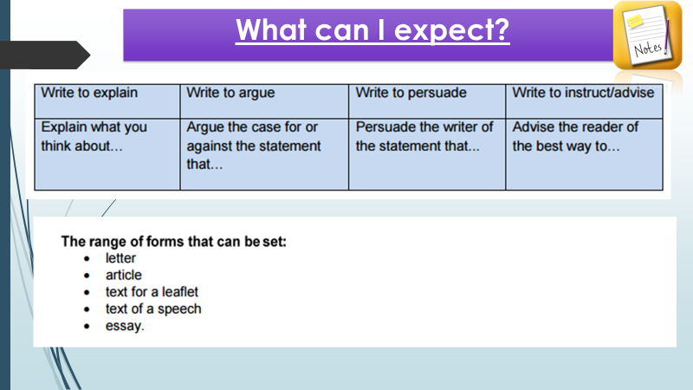
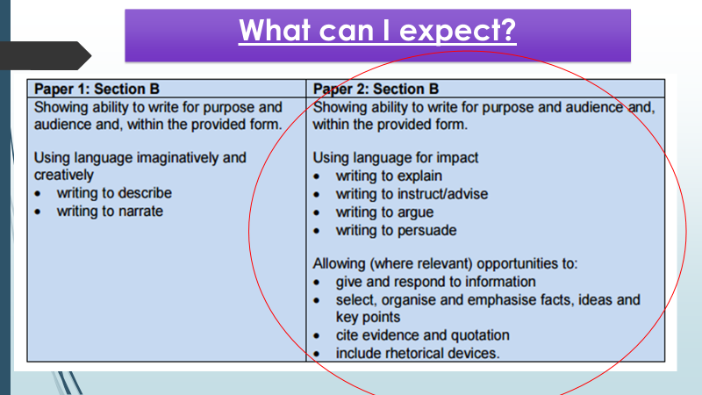

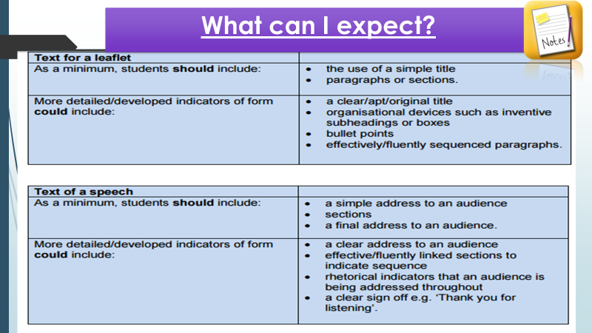
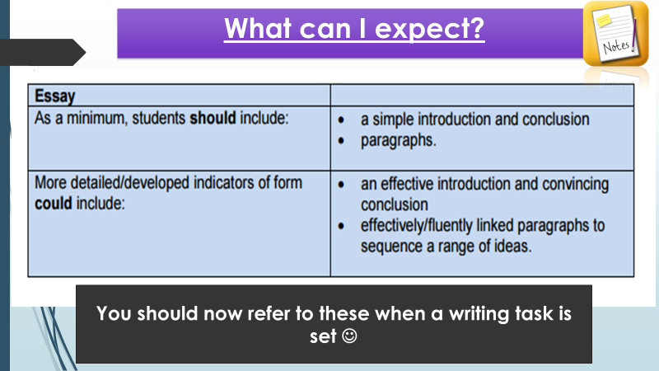
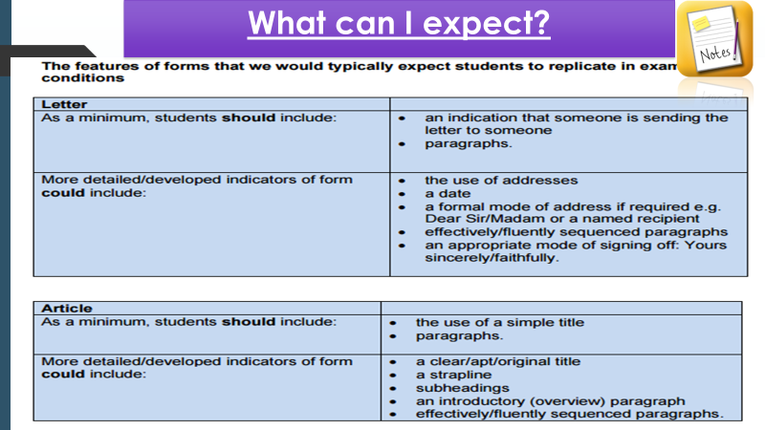

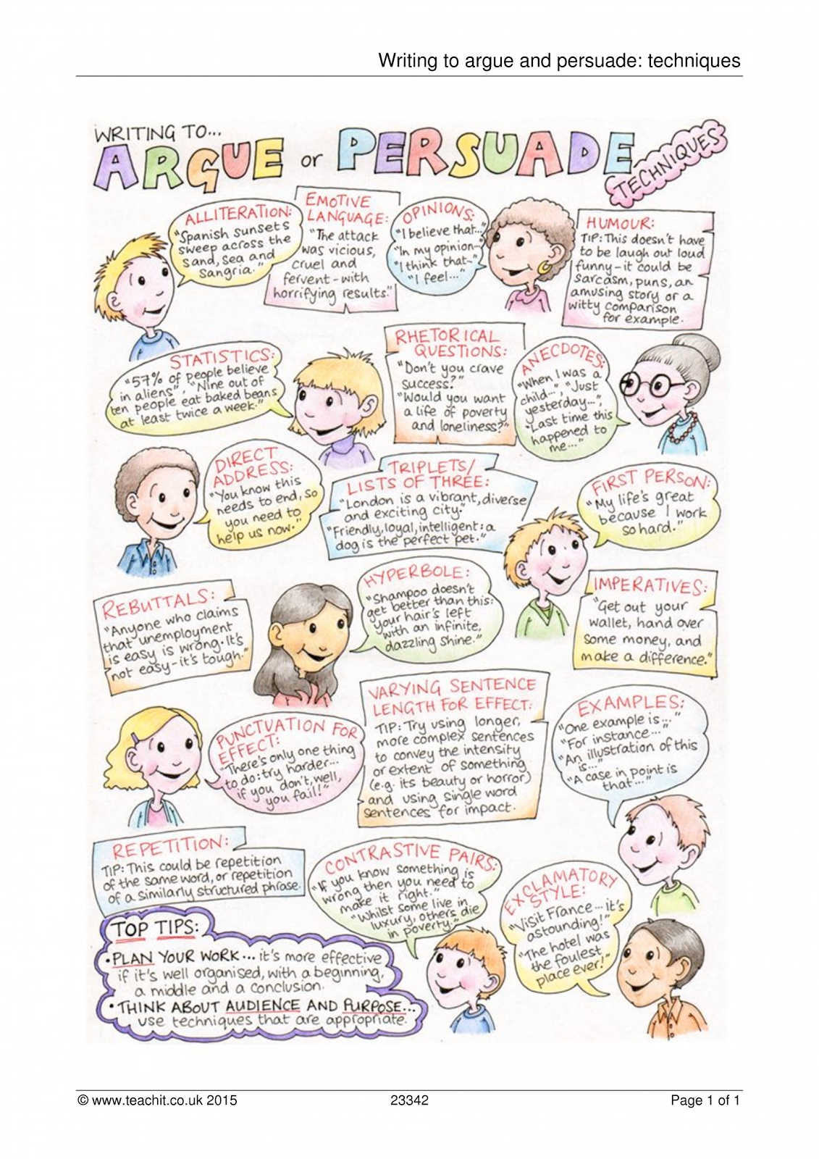
hhhhhhhh

Practice
Think – Pair – share
Annotate the opening to the following letter with a focus on techniques used.


Dear Channel 4,
I am writing to you with the hope that you will stop ruining my life. While your obsession with my ethnicity is flattering, it has become somewhat apparent to me that you might have gotten the wrong end of the stick. This is sort of awkward for me, because I don’t want to be the one to break it to you, but your documentary, ‘Big Fat Gypsy Weddings‘, is unfortunately a work of fiction. There is no need to be embarrassed, it can happen to the best of us, and thus I hope my letter will help you establish the facts, after all I’m sure you are passionate about fighting discrimination against ethnic minorities. Don’t be modest now, we know you are…right?
It surprised me to discover that 99% of Britain’s Gypsy and Traveller population are Irish. Correct me if I’m wrong, as I am sure you have done lots and lots of research on this topic, but just 10% of the Gypsy and Traveller population are actually Irish Travellers. The majority, like myself, are in fact Romany, yet your ‘documentary’ seems to ignore our existence. While I have nothing but respect for the Irish Traveller community, you seem to be unaware that we are two distinct ethnic groups and thus there are many differences between our cultures. While Irish Travellers originate from Ireland, we can trace our routes back to India, so it was hardly surprising that I was somewhat confused when you use the word Gypsy in the title of your ‘documentary’ about Irish Travellers. I was even more confused when your ‘documentary’ about Irish Travellers seemed to feature an alien culture that even most Irish Traveller’s didn’t recognise.
You correctly identified that many Gypsy and Traveller children leave school at a young age, however you failed to mention that this is not because we are all born to terrible parents, but because our communities suffer from great social exclusion. State education fails to adapt to anything but mainstream culture, thus we have to contend with a curriculum that is totally irrelevant to our way of life. Moreover, both teachers and students seem ignorant of our cultures, thus we are labelled as troublemakers and bullied for being different. The myths that you have been spreading have not helped matters. Indeed, I was subjected to physical attacks during your last series of your ‘documentary’ which ultimately led to my expulsion from school (long story), whilst my 12 year old cousin was beat up on her way home from school by a gang of girls who were calling her a prostitute.
As you can see, there are many reasons as to why Gypsy and Traveller children are failing to attend school, but you seem to have forgotten to feature those of us that do stay in education. Take myself, for example, I’m currently at college studying a range of subjects such as, History and Sociology. Moreover, my sister trained to be a hairdresser, my aunty went to university and is now a social worker and some of my cousins completed apprenticeships, thus clearly dropping out of education is not a prerequisite of living in a trailer.

What does the letter do well?
How has Pip structured her argument?
- In pairs, write the next paragraph to the letter.

Lesson 16: Paper 2 Q5 – Argue/persuade
Method
Planning
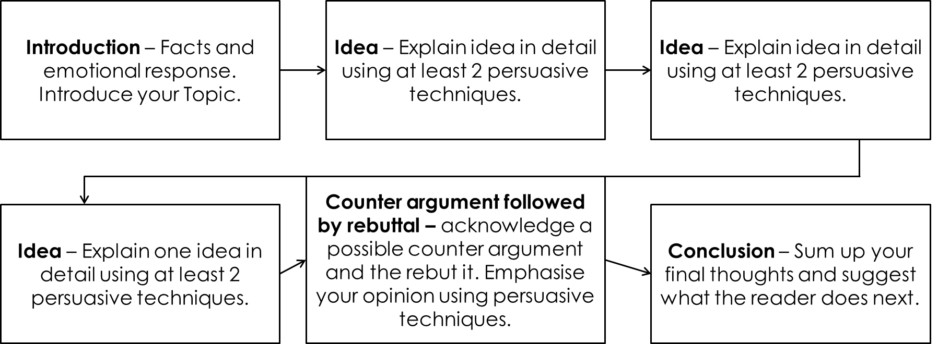

- Work individually to produce a plan to the task.
- Share your plan with the person sitting next to you and put your heads together to take the best bits from each plan to improve your original.

“The youth of today is lazy, all 16-18 year olds should complete national service”
Write a letter to the MEN arguing your opinion to the above statement.

Practice

