Blood Brothers Quotations
1 | “Did you ever hear of a mother so cruel, there's a stone in place of her heart.” | 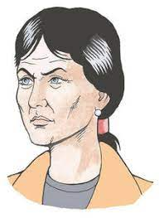 |  | “You never put new shoes on the table Mrs Lyons.” |  | 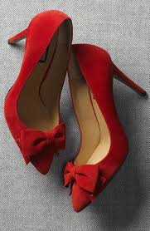
2 | “If my child was raised in a palace like this one, he wouldn't have to worry where his next meal was comin' from” | 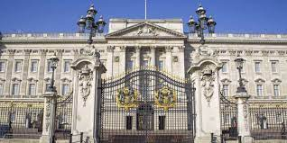   |  | “You know what they say about twins secretly parted don't you?” |  | 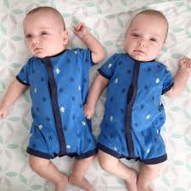
3 | “The devil's got your number.” | 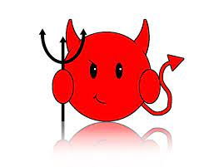 |  | “Gis a sweet.” |  | 
4 | “When I get home, I’ll look it up in the dictionary.” | 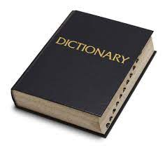 |  | “And you know that if you cross your fingers...  It doesn't matter the whole thing's just a game.'  ” |  | 
5 | “He was about to commit a serious crime, love.'  'It was more of a prank really.” | 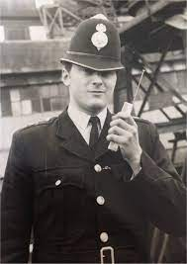 |  | “Talk of Oxbridge?” |  | 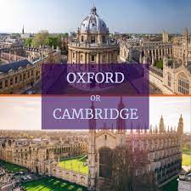
6 | 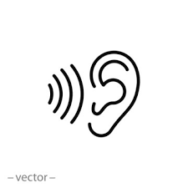  “How the hell do you hope to get a job when y' never listen to anythin?” |  | 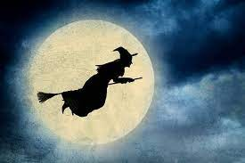“curse you, witch!” |  | “Who'd tell the girl in the middle of the pair, the price she'd pay just for being there?”
7 | I'm afraid we must fire you, we no longer require you. |  |  | Why's a job so important? |  | 
8 | “I suppose you are still a kid aren't y? |  |  | Seems like jail's sent him off the rails, just like Marilyn Monroe. |  | 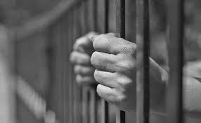
9 | That's why I take them. So I can be invisible. |  |  | It's just a light romance. |  | 
10 | And do we blame superstition for what came to pass? Or is it, what we the English, have come to know as class? | 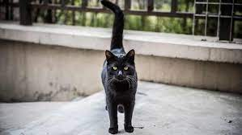 |  | ^{'I could have been...him!'}  ^{[Mickey]} |  | 

