A Christmas Carol Quotations
1. | “covetous, old sinner” | 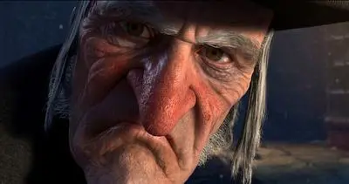 |  | “quite a baby” |  | 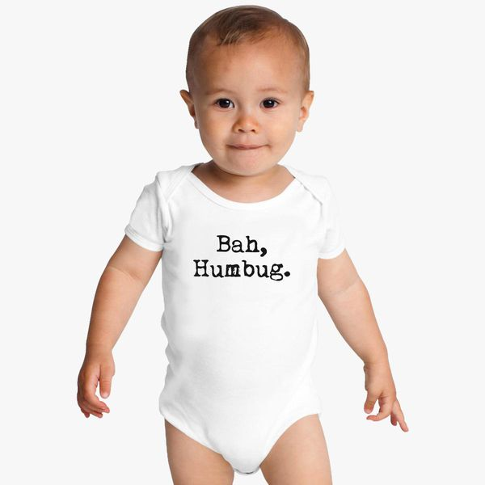
2. | “I wear the chain I forged in life” |  |  | “light as a feather” |  | 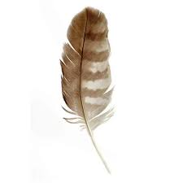
3. | “solitary as an oyster” | 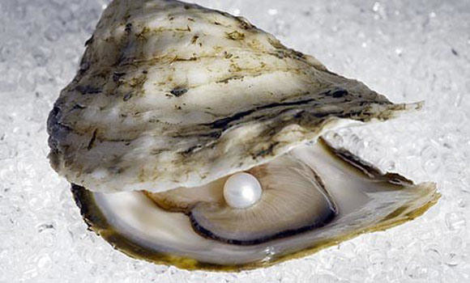 |  | “as good a man…” |  | 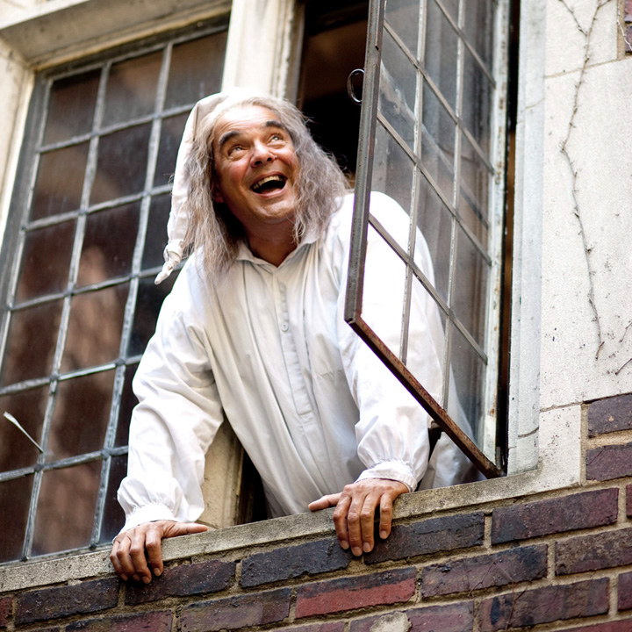
4. | “decrease the surplus population” | 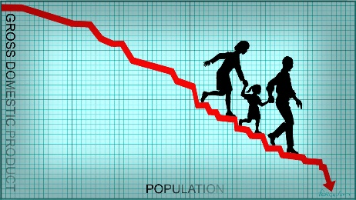 |  | “Ignorance” and “Want” |  | 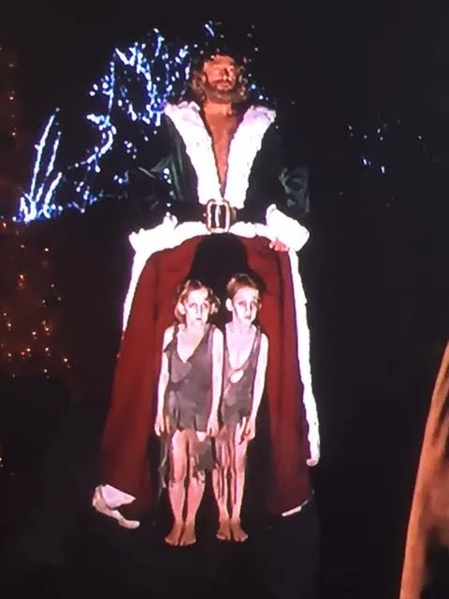
5. | “another Idol has displaced me” & “a golden one” |  |  | “as good as gold” |  | 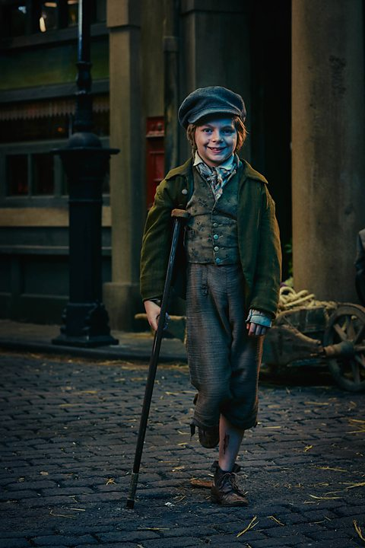
6. | “a strange figure—like a child: yet not so like a child as like an old man”  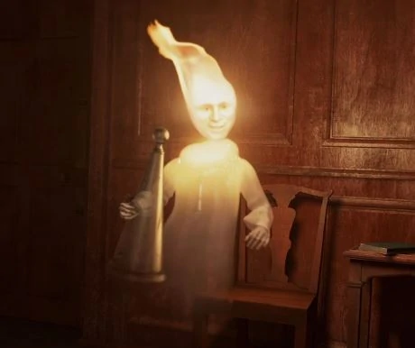 |  | “jolly giant” 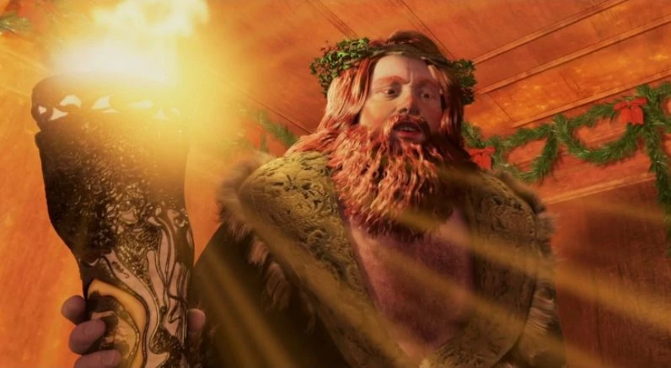 |  | “Phantom” “shrouded in a deep black garment” 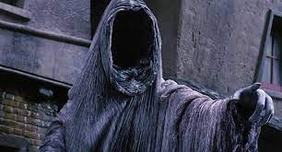
7. | The recurring motif of the bells throughout echoes the urgency for change in Victorian London. |  |  | The pathetic fallacy of the “biting weather” and “freezing fog” reflects Scrooge’s redemption at the end when it becomes “Golden sunlight”. |  | 