Name: Class:

Task 1:

Two tables, **tblEvent** and **tblPupil**, are shown below.

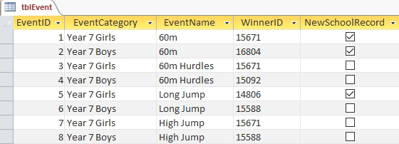

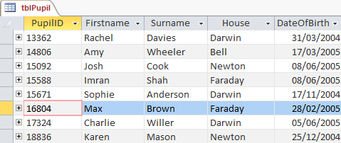

1. Write SQL statements to:

(a) select the “Firstname”, “Surname” and “DateOfBirth” columns from tblPupil.

(b) select the “EventCategory” and “EventName” columns from tblEvent for which new school records were set.

(c) select all columns from tblPupil for pupils in Darwin, Faraday or Bell.

(d) select all columns from tblEvent for which for which the Event category is Year 7 girls and the event name is either 60m or 60m Hurdles.

2. List the data that could be displayed after executing the following SQL queries on the database.

(a) SELECT FirstName, Surname, House

FROM tblPupil

WHERE House = 'Darwin'

|  |  |  |
| --- | --- | --- |
|  |  |  |
|  |  |  |
|  |  |  |
|  |  |  |

(b) SELECT EventCategory, EventName

FROM tblEvent

WHERE EventName = 'Long Jump' OR EventName = 'High Jump'

|  |  |
| --- | --- |
|  |  |
|  |  |
|  |  |
|  |  |
|  |  |

Task 2:

(a) Write an SQL statement to sort **tblEvents** in Task 1 into ascending order by EventCategory, displaying only the fields EventCategory, EventName and WinnerID.

|  |
| --- |
|  |

(b) Write an SQL statement to sort **tblPupil** in Task 1 into descending order by Surname, displaying only the fields Firstname and Surname

|  |
| --- |
|  |