Name: Class: Mark:

1. A secondhand car dealer keeps a database of cars for sale. A sample of the data is shown below. The table below is named Cars.

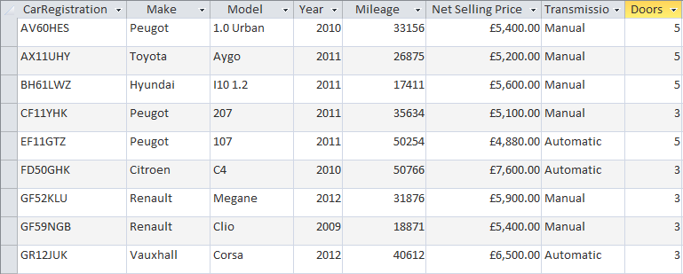

(a) State the registration number of the cars that will be found using each of the following criteria:

Mileage < 20000 [2]

Year >= 2011 and Transmission = 'Automatic' [2]

(Make = 'Peugeot' OR Make = 'Renault') AND (Net Selling Price <= 5200.00) [2]

(b) Write the SQL statement which will display the registration numbers and make of   
all cars with 5 doors made in 2011 or after. [3]

2. A school keeps a record of all the school trips that take place each school year. An extract from the table **Trips** is shown below:

|  |  |  |  |  |  |  |
| --- | --- | --- | --- | --- | --- | --- |
| **Trip ID** | **Description** | **StartDate** | **EndDate** | **Destination** | **NumberOf Students** | **TeacherInCharge** |
| 14 | DofE Gold Expedition | 09/04/2014 | 13/04/2014 | Wales | 30 | 1453 |
| 15 | Year 7 Castles Trip | 01/05/2014 | 01/05/2014 | Framlingham | 87 | 1506 |
| 16 | Year7 Geography Field Trip | 07/05/2014 | 07/05/2014 | Walton-on-the-Naze | 91 | 3035 |
| 17 | Prefects Leadership weekend | 20/06/2014 | 23/06/2014 | Bradwell | 15 | 2278 |
| 18 | Spanish Taster Trip | 26/06/2014 | 30/06/2014 | Santander | 27 | 1453 |

(a) Write an SQL query to find all trips in the **Trips** table where the number of students going is greater than 60. The Results table should display the columns labelled Description, StartDate, EndDate, Destination and NumberofStudents.   
Records should be sorted by the number of students in descending order. [4]

|  |
| --- |
|  |

A second table called **Teachers** holds the following data:

|  |  |  |  |
| --- | --- | --- | --- |
| **TeacherID** | **Title** | **FirstName** | **Surname** |
| 1453 | Miss | Catherine | Black |
| 1506 | Mr | Gerald | Bainbridge |
| 2278 | Mr | Robin | McKay |
| 3035 | Mrs | Amanda | Briers |

(b) Write an SQL query to find all teachers whose surname begins with ‘B’ and whose   
title is ‘Mr’. Show all fields from the table. [3]

|  |
| --- |
|  |

'

[Total 16 marks]