Name: Class: Mark:

# 1. (a) What would be the state of the following list after each of the first four passes in a Bubble sort, sorting into ascending sequence?

65, 34, 28, 68, 52, 21 [4]

(b) How many passes will be made through the list used in part (a) using the   
Bubble sort algorithm in order to sort it? [1]

2. The diagram below shows an algorithm in graphical form.

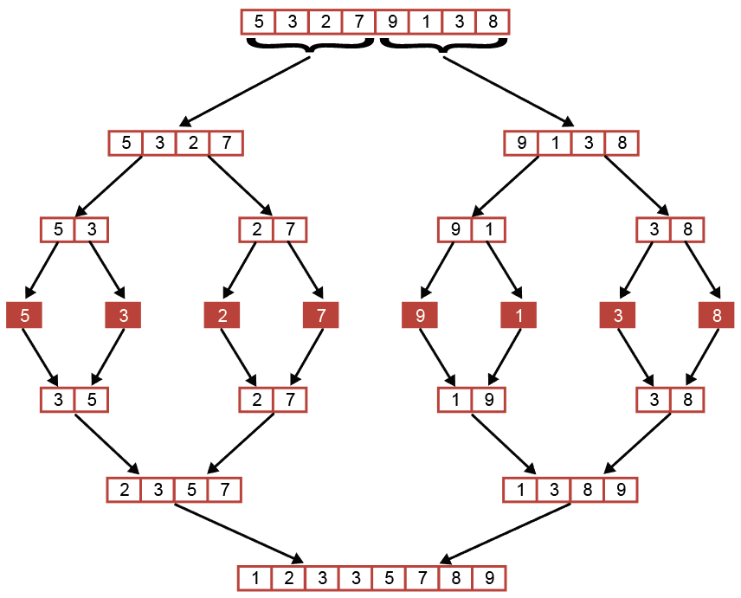

(a) What is the algorithm depicted? [1]

(b) Describe the process of sorting the following list using the above algorithm:

74, 36, 81, 25, 19, 14, 61, 40 [6]

3. An insertion sort algorithm is used to sort the following numbers:

63, 45, 73, 23, 81, 18

(a) Explain briefly how an insertion sort works. [3]

(b) Show the stages of the sort. The first stage is shown below:

Stage 1: 45, 63, 73, 23, 81, 18 [4]

Stage 2:

Stage 3:

Stage 4:

Stage 5:

(c) Give **one** reason why an Insertion sort may be chosen over a bubble sort for   
sorting a large number of items. [1]

[Total 20 Marks]